Testing Wall Temp, different radii

E0p01_wall2
Amaxs=[100], amaxw = [1,2,3], mdot = [4e-8, 4.5e-8, 5e-8, 5.25e-8, 5.5e-8, 5.75e-8, 6e-8, 6.25e-8, 6.5e-8], Tdisk = [1100, 1150, 1200, 1250, 1300], rd = [60], mu = [0.58], amaxb = [1mm, 1cm], eps = [0.01]

E0p01_wall3
Amaxs=[100], amaxw = [1], mdot = [4.5e-8, 5e-8, 5.25e-8, 5.5e-8, 5.75e-8, 6e-8, 6.25e-8], Tdisk = [1100, 1150, 1200, 1250], rd = [57,58,59,60,61,62,63], mu = [0.56, 0.57, 0.58, 0.59, 0.6], amaxb = [1cm], eps = [0.01]

Job Number, amaxs, amaxw, epsilon, mstar, tstar, rstar, dist, mdot, mdotstar, tshock, alpha, mui, rdisk, temp, altinh, fracolive, fracpyrox, fracforst, fracent, lamaxb, d2g
72, 100, 1, 0.01, 1.957, 7580, 2.198, 150.1172854670921, 6.25e-08, 6.25e-08, 8000, 0.01, 0.58, 60, 1100, 1, 0.65, 0.3, 0, 0.05, '1cm', 0.0065
857, 100, 1, 0.01, 1.957, 7580, 2.198, 150.1172854670921, 6.25e-08, 6.25e-08, 8000, 0.01, 0.56, 61, 1100, 1, 0.65, 0.3, 0, 0.05, '1cm', 0.0065

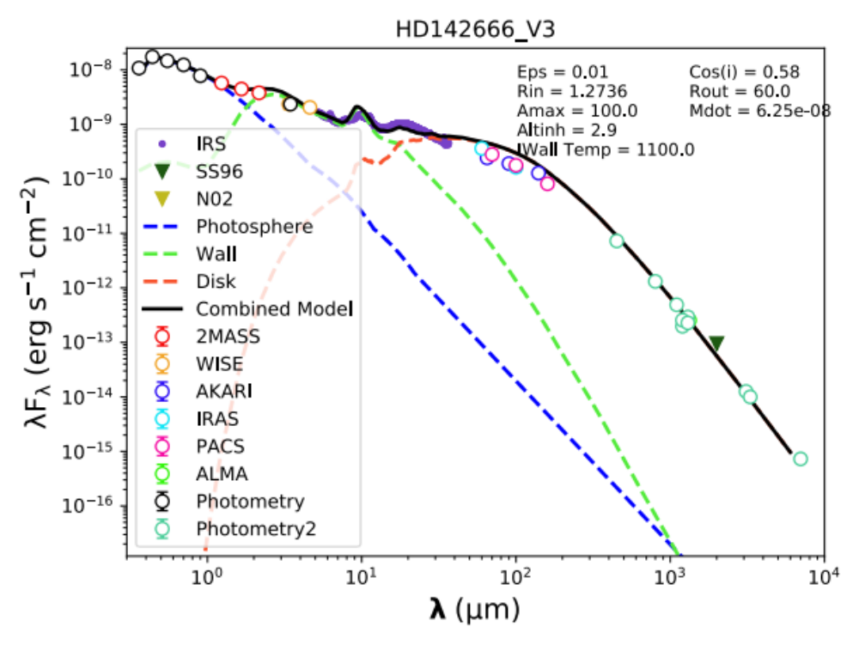[72, wall2]
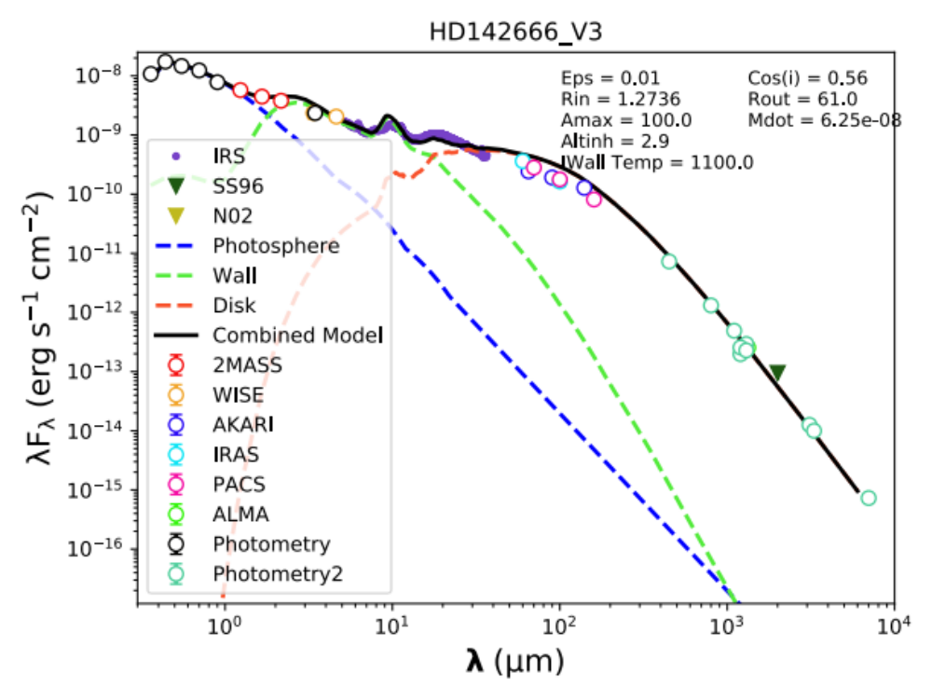[857, wall3]

Testing Radii and mdot (thought to make bigger from img)

E0p01_rdB
Amaxs=[10, 100], amaxw = [1], mdot = [4e-8, 4.25e-8, 4.5e-8, 4.75e-8, 5e-8, 5.25e-8, 5.5e-8, 5.75e-8], Tdisk = [1100], rd = [63,65,67,69,71,73,75,77,79], mu = [0.58], amaxb = [1mm, 1cm], eps = [0.01]

Job Number, amaxs, amaxw, epsilon, mstar, tstar, rstar, dist, mdot, mdotstar, tshock, alpha, mui, rdisk, temp, altinh, fracolive, fracpyrox, fracforst, fracent, lamaxb, d2g
264, 100, 1, 0.01, 1.957, 7580, 2.198, 150.1172854670921, 5.5e-08, 5.5e-08, 8000, 0.01, 0.58, 73, 1100, 1, 0.65, 0.3, 0, 0.05, '1cm', 0.0065
274, 100, 1, 0.01, 1.957, 7580, 2.198, 150.1172854670921, 5.75e-08, 5.75e-08, 8000, 0.01, 0.58, 65, 1100, 1, 0.65, 0.3, 0, 0.05, '1cm', 0.0065

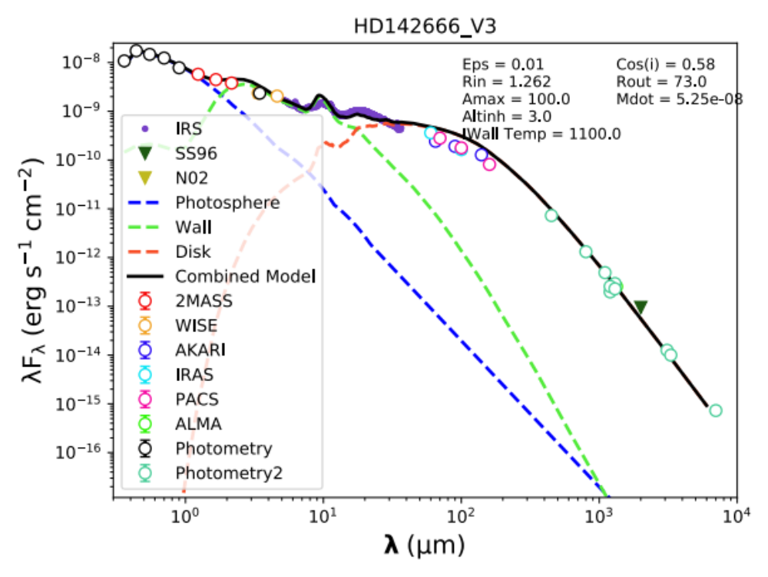[264, e0p01_rdB]
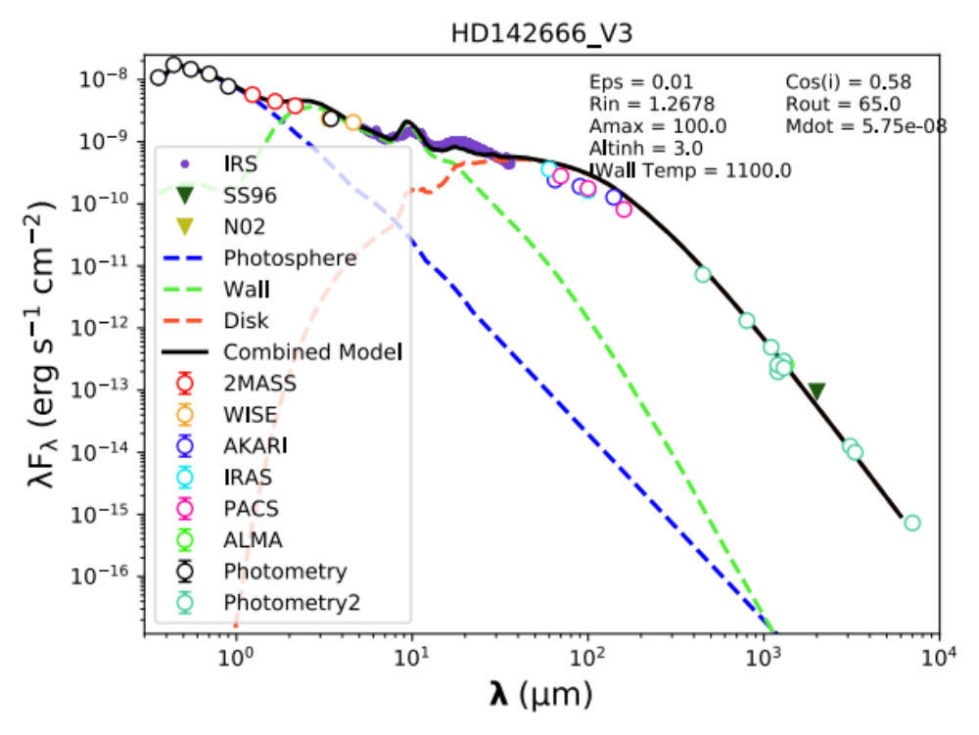[274, e0p01_rdB]
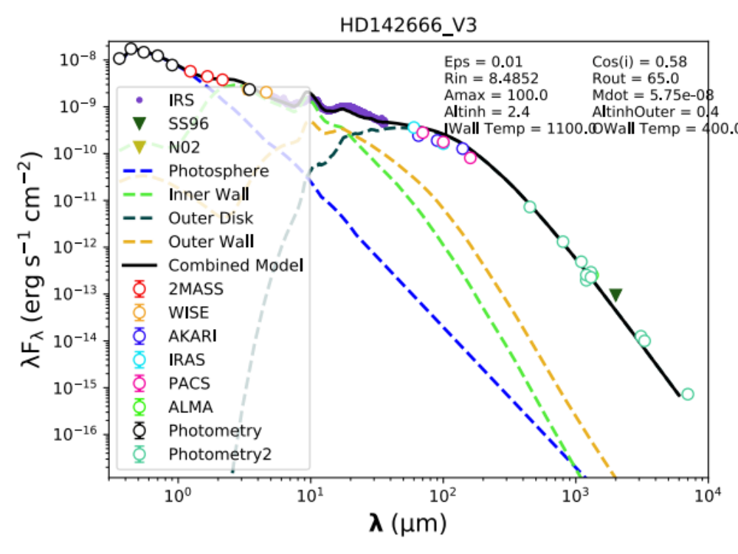[PTD_274, e0p01_rdB]

Testing if eps0p001 works better (better fit to FIR?)

E0p001_rdB
Amaxs=[2,4,5,10,100], amaxw = [1], mdot = [2.5e-8, 3e-8, 3.5e-8, 4e-8, 4.5e-8, 5e-8, 5.5e-8, 6e-8], Tdisk = [1100], rd = [63,65,67,69,71,73,75,77], mu = [0.58], amaxb = [1mm, 1cm], eps = [0.001]

E0p001_rdB2
Amaxs=[2], amaxw = [1], mdot = [5e-8, 5.5e-8, 6e-8, 6.5e-8, 7e-8, 7.5e-8, 8e-8, 8.5e-8,9e-8], Tdisk = [1100], rd = [63,65,67], mu = [0.58], amaxb = [1mm, 1cm], eps = [0.001]

Job Number, amaxs, amaxw, epsilon, mstar, tstar, rstar, dist, mdot, mdotstar, tshock, alpha, mui, rdisk, temp, altinh, fracolive, fracpyrox, fracforst, fracent, lamaxb, d2g
128, 2, 1, 0.001, 1.957, 7580, 2.198, 150.1172854670921, 6e-08, 6e-08, 8000, 0.01, 0.58, 77, 1100, 1, 0.65, 0.3, 0, 0.05, '1cm', 0.0065
612, 100, 1, 0.001, 1.957, 7580, 2.198, 150.1172854670921, 5.5e-08, 5.5e-08, 8000, 0.01, 0.58, 65, 1100, 1, 0.65, 0.3, 0, 0.05, '1cm', 0.0065
628, 100, 1, 0.001, 1.957, 7580, 2.198, 150.1172854670921, 6e-08, 6e-08, 8000, 0.01, 0.58, 65, 1100, 1, 0.65, 0.3, 0, 0.05, '1cm', 0.0065

22, 2, 1, 0.001, 1.957, 7580, 2.198, 150.1172854670921, 6.5e-08, 6.5e-08, 8000, 0.01, 0.58, 65, 1100, 1, 0.65, 0.3, 0, 0.05, '1cm', 0.0065
24, 2, 1, 0.001, 1.957, 7580, 2.198, 150.1172854670921, 6.5e-08, 6.5e-08, 8000, 0.01, 0.58, 67, 1100, 1, 0.65, 0.3, 0, 0.05, '1cm', 0.0065
26, 2, 1, 0.001, 1.957, 7580, 2.198, 150.1172854670921, 7e-08, 7e-08, 8000, 0.01, 0.58, 63, 1100, 1, 0.65, 0.3, 0, 0.05, '1cm', 0.0065
28, 2, 1, 0.001, 1.957, 7580, 2.198, 150.1172854670921, 7e-08, 7e-08, 8000, 0.01, 0.58, 65, 1100, 1, 0.65, 0.3, 0, 0.05, '1cm', 0.0065
30, 2, 1, 0.001, 1.957, 7580, 2.198, 150.1172854670921, 7e-08, 7e-08, 8000, 0.01, 0.58, 67, 1100, 1, 0.65, 0.3, 0, 0.05, '1cm', 0.0065

[128, e0p001_rdB]
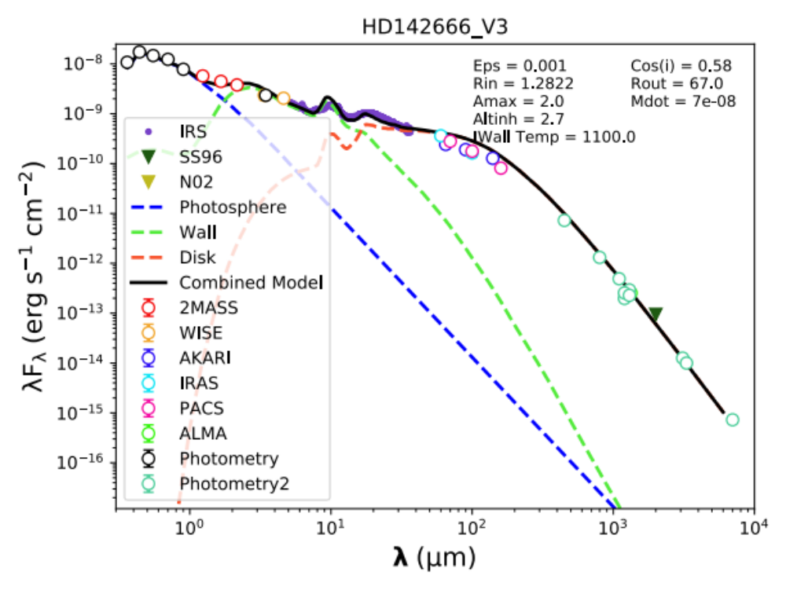[30, e0p001_rdB2]

