1. Astroisstellar — Yesterday at 7:27 PM

**for positions or feature extraction**: -background aka noise aka continuum subtract to avoid confusion with those -use an image viewer to check and note any pixel coordinates or spectral range of artifacts. -note region coordinates and dimensions (square, circle, whatever it is) of bright spots and cool features, -use region dimensions of the artifact-less bright features to make a sub-cube. might require some zooming and rescaling on the image by hand. -OR principle component analysis = advantage: you can quickly extract structures in N-dims, automated, but disadvantage: complex, not physically meaningful ///////////////////////////////////////////////////////////////////// (edited)

1. [7:32 PM]

**for spectral peaks**: -check a bright feature throughout the cube movie (or with PCA), marking it in pixel coordinates or with an aperture -measure the median, mean, or sum of that region (depending on what might statistically give the lowest background, noise, or continuum contamination) -take the averaged region and use a peak finding algorithm to extract where the lines are in wavelength (e.g. by hand, matching with a database query like SQL or astroquery.nist, etc). alternatively, use a convolutional or template matching method (basically fourier transform things, use fourier analysis) ///////////////////////////////////////////////////////////////////// (edited)

1. [7:32 PM]

**for measuring characteristics of spectral features (intensity, total profile's flux, width, etc)**: -you usually fit a gaussian, lorentzian, or voigt profile and this is hard and depends on a lotta shit gl (edited)

Astroisstellar — Yesterday at 7:40 PM

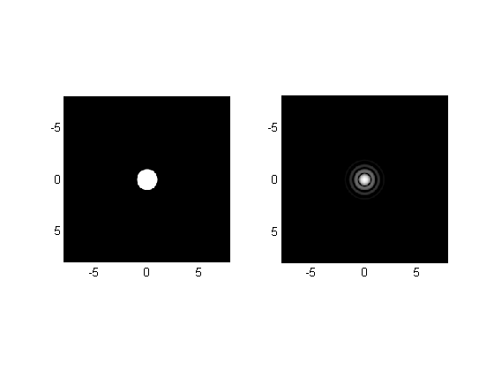

1. [7:40 PM]

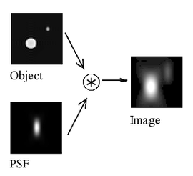

Astroisstellar — Yesterday at 7:56 PM

For analysis: <https://scikit-image.org/docs/stable/auto_examples/> For display: <https://pillow.readthedocs.io/en/stable/> (edited)

Pillow (PIL Fork)

[**Pillow**](https://pillow.readthedocs.io/en/stable/)

Pillow is the friendly PIL fork by Alex Clark and Contributors. PIL is the Python Imaging Library by Fredrik Lundh and Contributors. Pillow for enterprise is available via the Tidelift Subscription...

1. [8:00 PM]

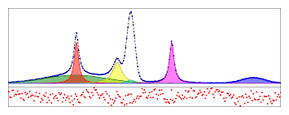

1. [8:01 PM]

If modeling or fitting is the bottleneck, need to maybe restrict space (e.g. number of pixels to fit, number of free parameters being fit, fixing a parameter like fwhm, or seeing if the algorithm is sub-optimal - like needing to relax your convergence condition based on your residuals and stat needs). (edited)

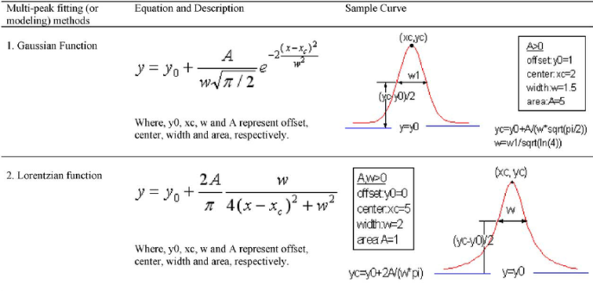

Astroisstellar — Yesterday at 8:04 PM

Another idea is to use methods from Fourier analysis, which involves filters and convolutions (can work both spatially and spectrally) (edited)

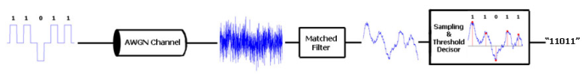

**March 10, 2023**

Astroisstellar — Today at 11:00 AM

///////////////////////////////////////////////////////////////////// So aside from PIL and scikit-image, I'm looking at the hdf5 py docs, and under examples (they call related projects), hdf5 lists: <https://docs.h5py.org/en/stable/related_projects.html#exploring-and-visualising-hdf5-files> Has 3 links for hdf5 format file tools for visualizing (helpful for step 1, noting the features and how many will be of interest). Idk if you know them already, but there's also a longer list of viewers they link there by GitHub. Maybe something will be of help? ///////////////////////////////////////////////////////////////////// (edited)

Astroisstellar — Today at 11:14 AM

**finally, for displays, figs**: -a movie paging through your spectral indices or wavelengths -you might want to display some gray scale slices with a square or circle of a bright feature, and then display a panel next to it as the average spectrum over the bright region (with lines labeled or with line profile fits) -you might want to present an rgb or 3-color (avoiding color-blindness) display to show the 3d structure using very nice, well-resolved slices (lines are usually labeled by color) -usually you want a table or histogram of the strength of lines for a feature /////////////////////////////////////////////////////////////////////

BONUS ROUND!!!

You can also use wavelets…see..

<https://docs.scipy.org/doc/scipy/reference/generated/scipy.signal.find_peaks_cwt.html#scipy.signal.find_peaks_cwt>

<https://stackoverflow.com/questions/42280725/finding-peaks-in-noisy-data-with-find-peaks-cwt>

<https://stackoverflow.com/questions/25571260/scipy-signal-find-peaks-cwt-not-finding-the-peaks-accurately>

Best article: <https://iopscience.iop.org/article/10.1086/304186/pdf>

Key search terms:

Wavelets fits to astronomical spectra

continuous wavelet transform for non periodic spectral lines

<https://ui.adsabs.harvard.edu/search/fq=%7B!type%3Daqp%20v%3D%24fq_database%7D&fq_database=database%3A%20astronomy&p_=0&q=abs%3A(wavelets%2C%20spectra)&sort=date%20desc%2C%20bibcode%20desc>

<https://www.prl.res.in/~shashi/astro_wavelets/report.pdf>

https://www.spiedigitallibrary.org/journals/journal-of-applied-remote-sensing/volume-13/issue-01/016503/Denoising-vegetation-spectra-by-combining-mathematical-morphology-and-wavelet-transform/10.1117/1.JRS.13.016503.full

<http://star-www.dur.ac.uk/~pdraper/splat/splat.html>

https://www.researchgate.net/figure/Peak-detection-using-continuous-wavelet-transform-with-the-Gaussian-wavelet-function_fig3_279156517

<https://pubs.rsc.org/en/content/articlelanding/2015/an/c5an01816a>

<https://pubs.rsc.org/en/content/articlelanding/2020/ay/c9ay02052g/unauth>

https://dsp.stackexchange.com/questions/47437/discrete-wavelet-transform-visualizing-relation-between-decomposed-detail-coef