**MARTIN MACROECONOMIC MODEL INSTRUCTIONS**

Download the respository to anywhere on your computer, the programs automatically set the path to the folder that are located in.

The following software is required if you want to run all the included programs:

* Eviews (I have tested on 10 only)
* R
* Excel

Before you start, if you want to download the source source data you will need to first register for API keys from Quandl and the St Louis Federal Reserve FRED websites:

<https://help.quandl.com/article/320-where-can-i-find-my-api-key>

<https://research.stlouisfed.org/docs/api/api_key.html>

Registering accounts is FREE. Quandl will let you download a certain number of variables per day without an API key but it’s easier to register once and not have to worry about it.

**BUILD MODEL MASTER PROGRAM**

The main program is called **build_model.** This program sets a few important strings and then calls the sub-programs.

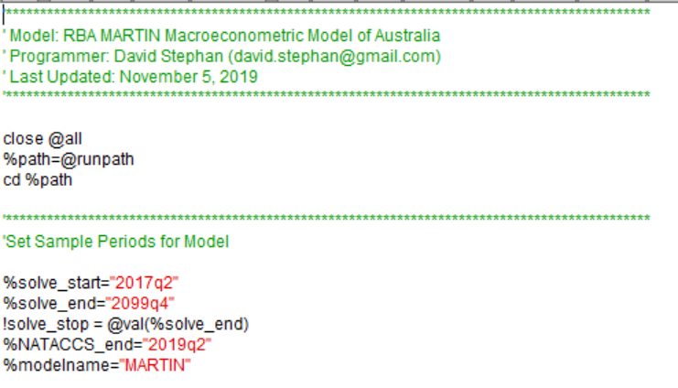

The first part to set involves the sample periods. These are:

* %solve_start -> first period of the model solution
* %solve_end -> last period of the model solution
* %NATACCS_end -> last period where National Accounts data exists
* %modelname -> name of the model object

The second part of the code sets which parts of the model code are run during the model. If they are set to 1 they are used (=0 to turn off). For some of the variables (PI_E; RSTAR; TLUR) if value is set to 0, the values are read from the MARTIN_PUBLIC workfile.

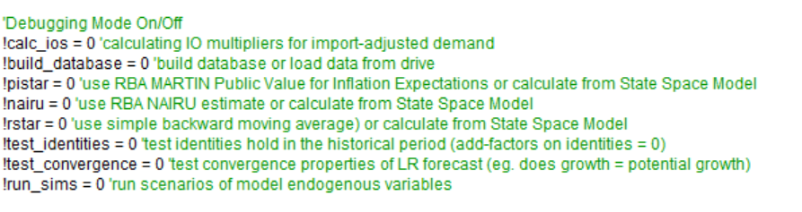

The next part of the model code is where you set your API codes for Quandl and FRED:

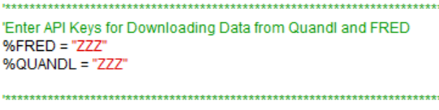

The rest of the code uses these user inputs to build the model.

**THE MAIN FOLDER**

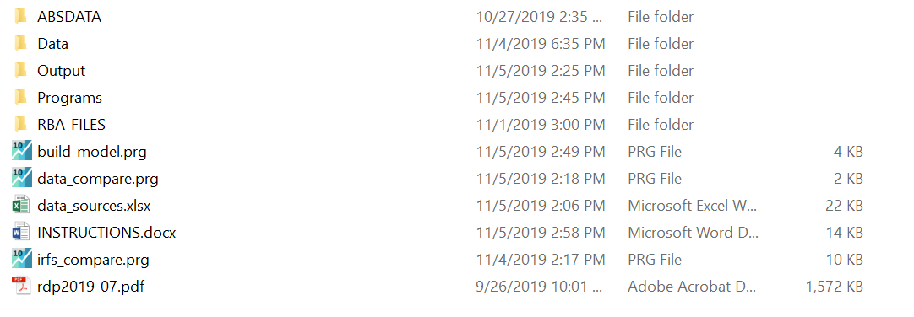

The first folder (**ABSDATA)** contains ABS Input-Output tables which are used to calculate import-adjusted demand.

The second folder (**DATA**) contains 4 files used in the model that are not downloaded from the ABS/Quandl/FRED databases.

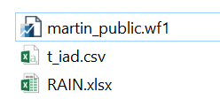

1. **martin_public.wf1** is the publicly released workfile of the RBA MARTIN model form the Discussion Papers website.
2. **t_iad.csv** are the import weights of final demand components used in the model. These are created in a separate Eviews program that can be run in the **build_model.prg**
3. **RAIN.xslx** contains the value of rain affected agricultural output from the June 2011 ABS Modellers Database (1364.0.15.003 – Table 22). This variable is only used historically to help estimate the agricultural export equation. Values after June 2011 are assumed zero.

The third folder (**OUTPUT**) contains the completed Eviews workfiles at different stages of the build process:

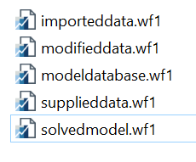

1. **Importeddata** is a workfile containing the raw data downloaded from ABS/Quandl/FRED
2. **Modifieddata** is a workfile that processes the raw data for the model (eg. creates model variables, creates quarterly variables from annual variables, etc.)
3. **Supplieddata** take the modified data and runs the state-space models to create variables such as trend hours/population/productivity.
4. **Modeldatabase** is the final workfile before estimating the model equations and solving the model
5. **Solvedmodel** is the workfile containing the estimated equations, model object and solved variables (final solution variables have an _2 suffix)

The fourth folder **(PROGRAMS)** contains all the programs called in the **build_model.prg**

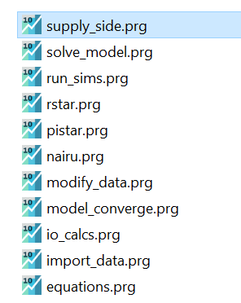

1. **io_calcs**: imports the input-output tables that have been downloaded from the ABS (manually) and uses them to contruct the import propensity of final demands.
2. **Pistar**: a state space model to construct inflation expectation variables (pi_e) from survey data
3. **NAIRU:** a state space model to estimate the NAIRU
4. **RSTAR:** a state space model to estimate the neutral interest rate
5. **import_data:** Imports all of the data from ABS/Quandl/FRED databases as well as World Bank commodity prices. The main part of the model script uses R (to use the Quandl and readabs R packages).

**NOTE:** If the build crashes during the commodity price section, check the URL is still valid for the XLS spreadsheet being downloaded in the import_data program (<https://www.worldbank.org/en/research/commodity-markets>)

1. **Modify_data:** This uses the imported data and constructs any necessary model variables (for example, real interest rates using the raw nominal interest rate and the raw inflation rate). The program also constructs dummies/trends and converts annual series into quarterly ones. This is mainly around the mining-non mining investment and capital stocks.
2. **Supply_side:** state space models to estimate the supply-side variables of the model (productivity, hours worked, population) as well as the time-varying constants in the unemployment rate equation.
3. **Equations:** builds the model object by appending the necessary identities and estimating, then appending, stochastic equations.
4. **Solve_model:** Solves the model object by creating the necessary add-factors and solving the model into the forecast period.
5. **Model_converge**: produces a series of groups/graphs to check that the LR properties of the model are consistent with the supply side and inflation expectations.
6. **Run_sims**:loops over the endogenous variables of the model and shocks them to see the impulses on the main model aggregates and the expenditure components of GDP.
7. The folder (**RDATA**) in the programs folder is used by the import_data.prg. Specifically this is used when importing ABS data using the R package readabs. Do not delete the folder or the program crashes.

The final folder (**RBAFILES)** is the zip files from the RBA website.

**DATA COMPARISON**

The **data_compare** program compares the variables built in the github version with the publicly available RBA version.

**IMPULSE RESPONSE COMPARISON**

The **irfs_compare** program runs the impulse responses from the RBA supplementary folder for the RBA version and the github version for comparison.

**DATA SOURCES**

The **data_sources** Excel file details the data sources for all the variables in the model. Variables downloaded from source have listed their source codes while transformed variables have their formulas listed.