Adam Fitzpatrick
CS_372
01/19/26
Project 1 – Sockets and HTTP

This program was created by Adam Fitzpatrick, with the help of the CS 372 modules and referencing of the course book and the authors associated you tube videos.
- https://www.youtube.com/@JimKurose
- https://canvas.oregonstate.edu/courses/2031497
- Kurose and Ross, Computer Networking: A Top-Down Approach, 8th Edition, Pearson

All code was developed in the Pycharm IDE, python version 3.12.3. In order run each of these files, simply open them up in your IDE and start them. Another option would be to save the files locally and run them in the terminal, by navigating to that directory and using python3 filename.py for Linux or python filename.py in windows.

client.py:
A simple client socket, which creates a TCP socket and connects it gaia.cs.umass.edu using PORT 80. It then sends the sever a GET request and displays the response by reading and decoding up to 1024 bytes of data. This program also displays socket information such as the details of the sent request and the length of bytes received.

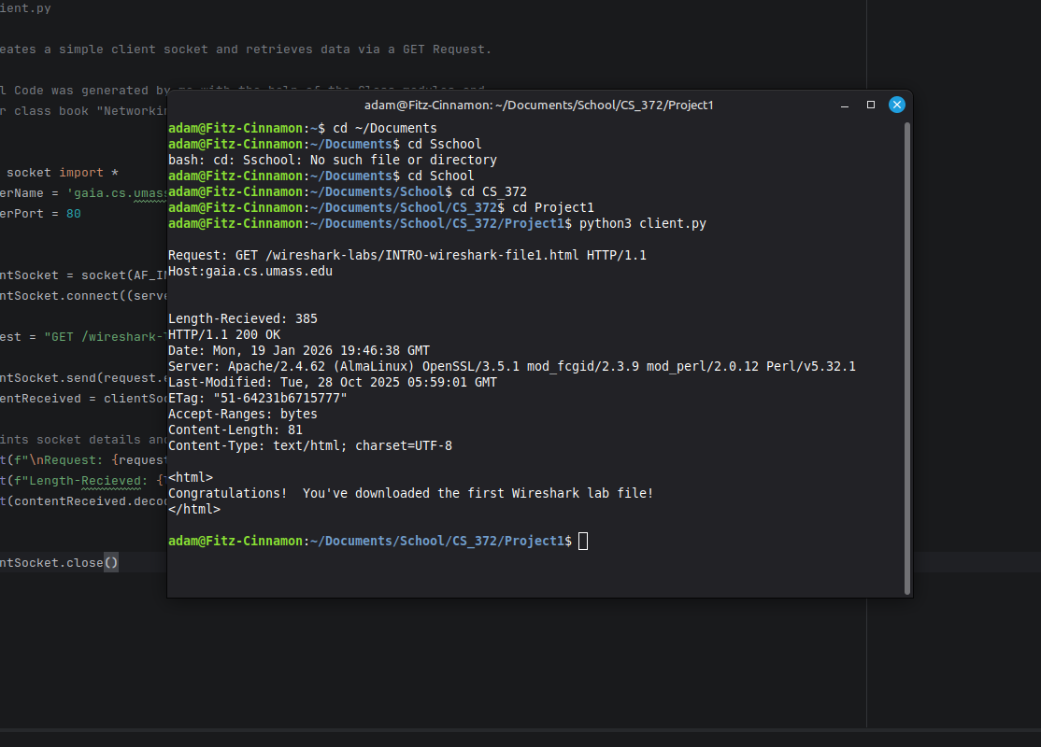
client_large.py:
This program/socket functions just like the simple client.py socket, with the exception being; after the GET request is sent the reading and printing of the response in inside of a while loop. This allows the socket to read (4096) bytes of data at a time, until the server closes the connection, in which bytes read will be equal to zero.

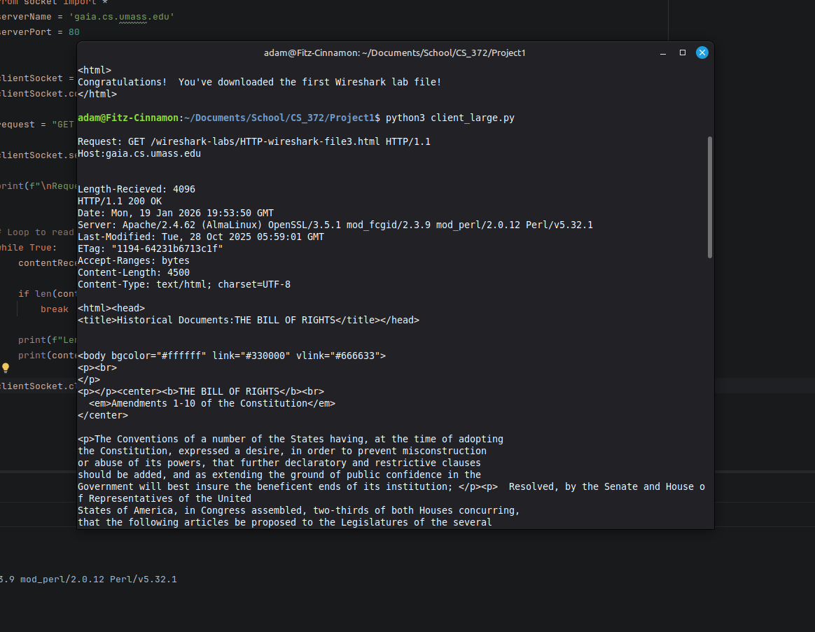
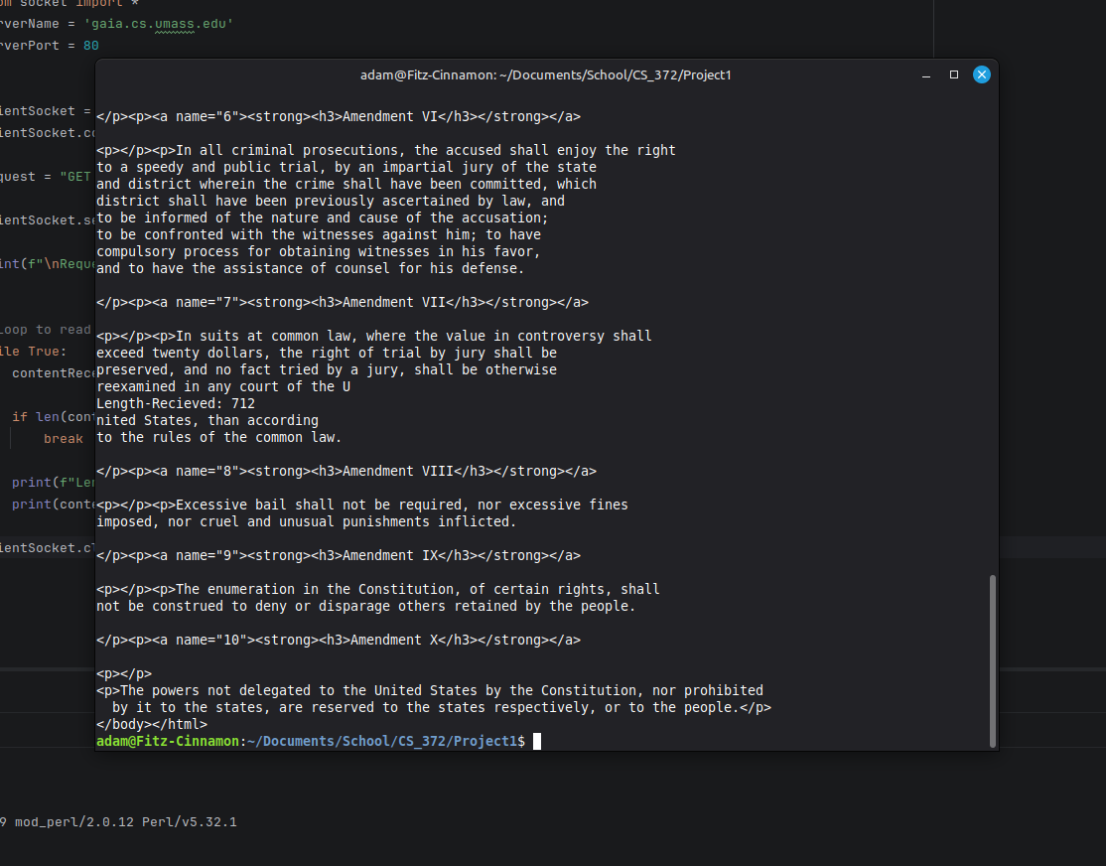

server.py:
A simple program to create a server It functions by creating two sockets, the first listens for client connection requests and the second is created upon the accepting of the client connection request. This second socket then reads up to 1024 bytes of the client request and sends back data (which is predefined).
To fully run this program first start server.py script, then in you web browser, navigate to http://localhost:5005/ to view the sent response. Upon navigating to the local host, your terminal will then display the connection information and the sent response as well.

