**Part A**

**I**

**A**

**B**

**C**

**D**

**E**

**F**

**G**

**Objective** : Name and decribe each component

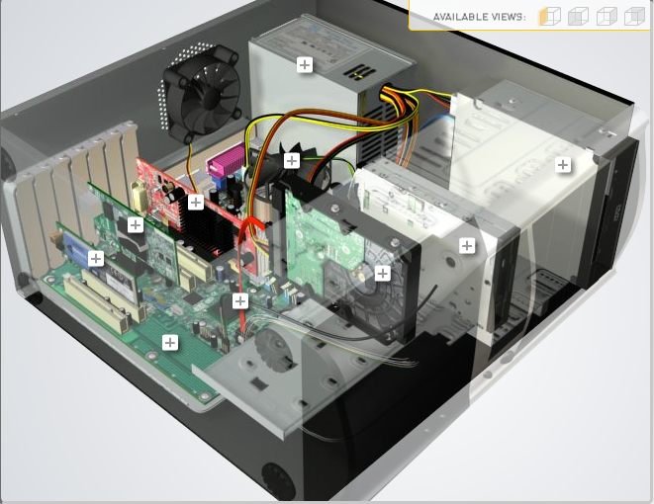

**H**

|  |  |  |
| --- | --- | --- |
| Download [**http://tinyurl.com/CW208-CAG-SIM**](http://tinyurl.com/CW208-CAG-SIM) PC Build Simulator.  Go through steps of building a PC, as you complete the simulation find and describe in detail components A to I. To run simulator first install <http://www.swffileplayer.com/> and open ***RootMovie.swf*** using SWF player. Alternatively install [Macromedia Flashplayer](https://fpdownload.macromedia.com/pub/flashplayer/updaters/32/flashplayer_32_sa.exe) . Ideally use a simulator as listed in class. | | |
| Label | Name each component | Description |
| A | Wireless nic | controller which connects to a wireless network |
| B | Video adapter card | an expansion card which generates a feed of output images to a display device |
| C | Heat sink fan | active cooling solution used to cool down integrated circuits in computer systems |
| D | Power supply | Powers everything inside the computer |
| E | Optical drive | let your computer read and interact with discs like CDs, DVDs, and Blu-rays |
| F | Floppy drive | a hardware device that reads data storage information |
| G | Hard Drive | where all your permanent computer data is stored. |
| H | SATA Cable | SATA is a connector interface used for computer bus connections |
| I | Motherboard |  |

**Part B**

**Objective**

Compare a pre-assembled system and the components that could be assembled to build a comparable system. After completing this practical, you should be able to:

1. Identify the components of a pre-assembled system
2. Locate prices for components needed to assemble a comparable system
3. Compare the cost of a pre-assembled system and a self-assembled system.

If you can’t find exact match for components, find the closest possible substitute. Use the Internet and available computer-related publications as your sources for information. Examples of websites for computer parts [www.komplett.ie](http://www.komplett.ie), [www.dell.ie](http://www.dell.ie), [www.custompc.ie](http://www.custompc.ie) [www.amazon.de](http://www.amazon.de)

MAKE SURE TO INCLUDE VALID LINKS TO WEB REFERENCES

|  |  |  |
| --- | --- | --- |
|  | **Pre-Assembled Computer Package** | **Computer Package**  **Components** |
| **CPU** | AMD RYZEN 3 2200g | AMD RYZEN 3 2200g |
| **Storage / Memory** | | |
| |  | | --- | |  | | RAM | | Hard Drive | |  | | |  | | --- | |  | | 8GB DDR4 3600MHZ | |  | |  |   Seagate mobile 1 terabyte 128MB Cache 6GB/s | 8GB DDR4 3600MHZ  Seagate mobile 1 terabyte 128MB Cache 6GB/s |
| **Input/Output** | | |
| |  | | --- | | Keyboard | | Pointing Device | | Monitor | | Speakers | | Network Adapter | |  | |  | | **Value series keyboard standard ps/2**  Cit Scroller usb Ergonomic led mouse  Philips V-Line 22”-223v5lhsb2-5ms  Pc link K6 usb powered speakers  PC link 300mps Pci 802 11n 2.4Ghz -wifi 4 | Value series keyboard standard ps/2  Cit Scroller usb Ergonomic led mouse  Philips V-Line 22”-223v5lhsb2-5ms  Pc link K6 usb powered speakers  PC link 300mps Pci 802 11n 2.4Ghz -wifi 4 |
| **Bundled Software**  (Including Operating System) | Windows 10 | Windows 11 |
| **Total Cost** | 1100 | 799 |

<https://www.custompc.ie/amd-ryzen-vega-package-deal-home-educational-series.html_custom_gaming_pcs_ireland.html_custom_gaming_pcs_components?gclid=EAIaIQobChMIl6nSxO3q8wIVi0WRBR3aFQ8JEAQYAiABEgIm5_D_BwE>

[**https://smec.shopping/de?utm_source=google&utm_medium=css**](https://smec.shopping/de?utm_source=google&utm_medium=css)

[**https://www.123ink.ie/MediaRange-wired-3-button-optical-mouse-MROS201-i70643.html?mkwid=s_dc%7Cpcrid%7C533530486749%7Cpkw%7C%7Cpmt%7C%7Cslid%7C%7Cprid%7CPF_361066_4260283117833_MROS201&pgrid=128676409110&ptaid=pla-1384994746736&gclid=EAIaIQobChMIgaHChfHq8wIVhADmCh3vZATVEAQYAiABEgK9YvD_BwE**](https://www.123ink.ie/MediaRange-wired-3-button-optical-mouse-MROS201-i70643.html?mkwid=s_dc%7Cpcrid%7C533530486749%7Cpkw%7C%7Cpmt%7C%7Cslid%7C%7Cprid%7CPF_361066_4260283117833_MROS201&pgrid=128676409110&ptaid=pla-1384994746736&gclid=EAIaIQobChMIgaHChfHq8wIVhADmCh3vZATVEAQYAiABEgK9YvD_BwE)

[**https://www.amazon.co.uk/?&tag=googamazkeywi-21&ref=pd_sl_7opj8n64qm_e&adgrpid=58074108123&hvpone=&hvptwo=&hvadid=291371202944&hvpos=&hvnetw=g&hvrand=5351618851279388996&hvqmt=e&hvdev=c&hvdvcmdl=&hvlocint=&hvlocphy=1007846&hvtargid=kwd-10573980&hydadcr=5939_1849289&gclid=EAIaIQobChMIlv2i1vHq8wIVtQCiAx2RQwxwEAAYASAAEgIah_D_BwE**](https://www.amazon.co.uk/?&tag=googamazkeywi-21&ref=pd_sl_7opj8n64qm_e&adgrpid=58074108123&hvpone=&hvptwo=&hvadid=291371202944&hvpos=&hvnetw=g&hvrand=5351618851279388996&hvqmt=e&hvdev=c&hvdvcmdl=&hvlocint=&hvlocphy=1007846&hvtargid=kwd-10573980&hydadcr=5939_1849289&gclid=EAIaIQobChMIlv2i1vHq8wIVtQCiAx2RQwxwEAAYASAAEgIah_D_BwE)

[**https://blitzhandel24.com/microsoft-windows-11-home?sPartner=g_s_com&number=241821975&gclid=EAIaIQobChMIr_f9v_Lq8wIViqkYCh0cjAiaEAQYAiABEgLSnvD_BwE**](https://blitzhandel24.com/microsoft-windows-11-home?sPartner=g_s_com&number=241821975&gclid=EAIaIQobChMIr_f9v_Lq8wIViqkYCh0cjAiaEAQYAiABEgLSnvD_BwE)

**Part C**

**Objective**

You have been asked by a family friend to assist them with a computer purchase. They’re unfamiliar with technology and the terms used and have presented you with two alternatives machine choices. They would like to be able to write word documents, surf internet and play Minecraft © Mojang and Half-Life © Valve Software. They are considering playing Fortnight but are not sure yet, as it depends on machine cost and if they can extract some money from their Bitcoin wallet.

Compare Personal Computer Option A and B in relation to each of the side headings and recommend a system and any alterations.

|  |  |  |
| --- | --- | --- |
|  | Personal Computer  Option A | Personal Computer  Option B |
| CPU | 2.2 GHz Intel Celeron 450 | 3.2 GHz Intel Core i5 |
| Memory |  |  |
| |  | | --- | | Cache | | RAM | | Hard Drive | | CD-ROM/DVD | | |  | | --- | | 512 KB Cache | | 4 GB RAM | | 320 GB Hard Drive | | DVD+/-RW drive | | |  | | --- | | 4 MB Cache | | 8 GB RAM | | 1 TB Hard Drive | | DVD+/-RW drive | |
| Input/Output |  |  |
| |  | | --- | | Keyboard | | Pointing Device | | Screen | | Speakers | | Network Adapter | | |  | | --- | | USB multifunction keyboard | | USB optical mouse | | 20’’ HD flatscreen monitor | | Multimedia Speaker System | | Integrated 10/100/1000 Ethernet | | |  | | --- | | wireless multifunction keyboard | | wireless optical mouse | | 25’’ HD flatscreen monitor | | Dolby Surround Sound Speakers | | Integrated 10/100/1000 Ethernet | |

|  |
| --- |
| **Recommendations** |
| Celeron processors will not run fortnite and it needs a i3 or higher so I would suggest  Option B mostly because of the i5 that will be more then enough to run fornite also low ram in option A option B as 8GB ram which is mush better fortine needs as least 4 and if u run anything in the background it will be poor 1TB hard drive is so much better option b all round is just better in every way just will be more money put worth it in the end |

**Your Recommend System**

|  |  |
| --- | --- |
|  | Personal Computer  Recommendation |
| **CPU** | Ryzen 5 3500 |
| **Memory** | |
| |  | | --- | |  | | RAM | | Hard Drive | | SSD Drive | | |  | | --- | | 16GB Kingston HyperX Fury DDR4 | | WD 2TB  4Tb Seagate Barracuda 3.5 Sata III 6GB | |  | |  | |
| **Input/Output** | |
| |  | | --- | | Keyboard | | Pointing Device | | Screen | | Speakers | | Network Adapter  GPU | | |  | | --- | | ASUS ROG Claymore II  Logitech MX Master Wireless | | ASUS VP228HE, 21.5 InchFHD (1920x1080) Gaming monitor, 1ms, HDMI  Logitech Z200 PC Speakers | |  | | TP-Link Wi-Fi Dongle, 300 | | Gaming Graphics card GTX 1060 6GB | |  | |

Hand up this practical report at the end of session and ensure it has been checked

|  |  |  |  |
| --- | --- | --- | --- |
| **Student Name** | **Adam farrell** | **Student Number** | **C00261619** |
| **Date** | **27/10/2021** | **Checked** |  |
| **Group** | **A** |  |  |