

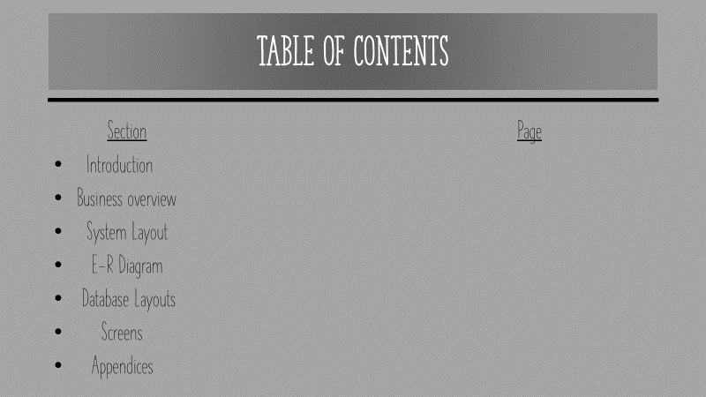

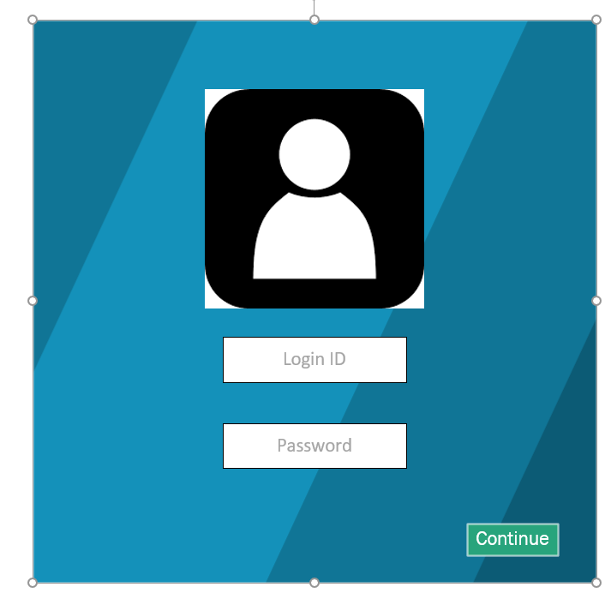

Access to this Screen:

Purpose of this Screen: To Show How to edit a member of staff

Table Processing involved:

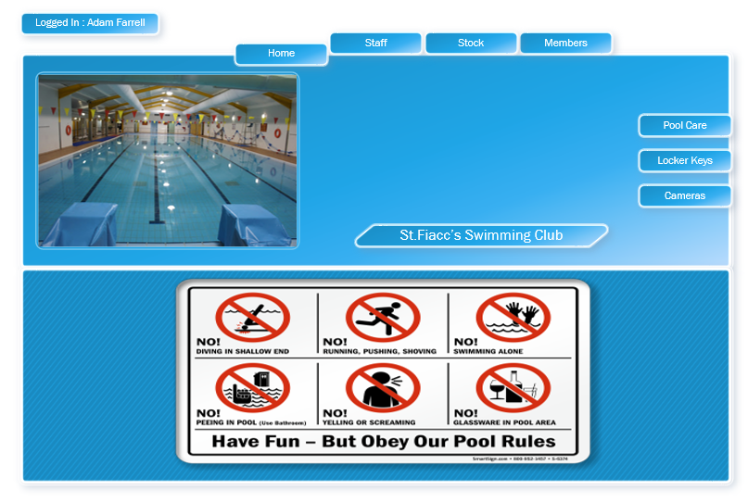

Access to this Screen:

Purpose of this Screen: To Show How to edit a member of staff

Table Processing involved: Access to this Screen:

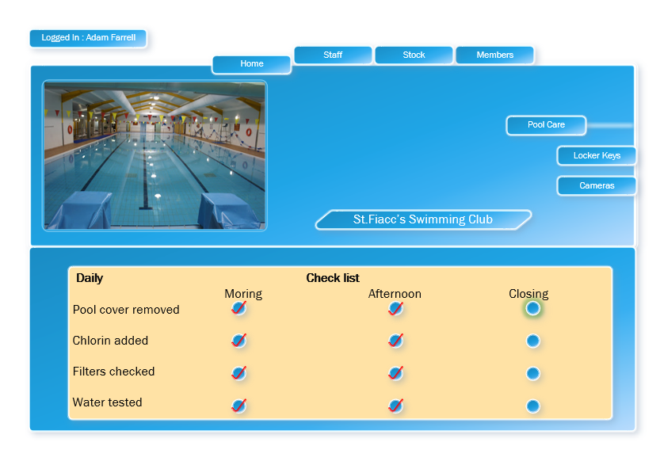

Access to this Screen:

Purpose of this Screen: To Show How to edit a member of staff

Table Processing involved: Access to this Screen:

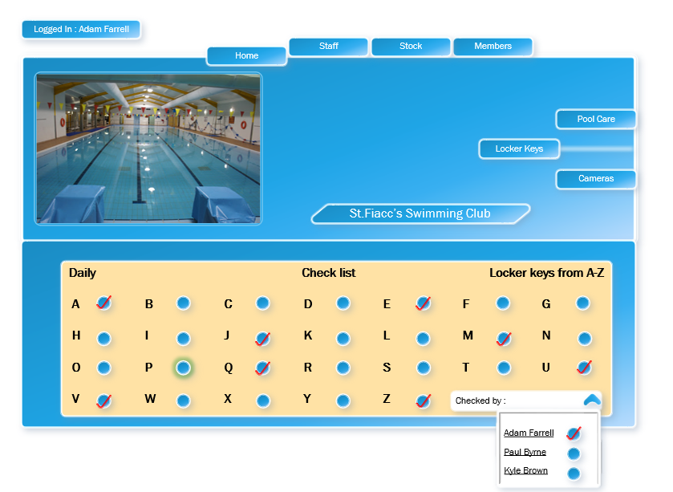

Access to this Screen:

Purpose of this Screen: To Show How to edit a member of staff

Table Processing involved: Access to this Screen:

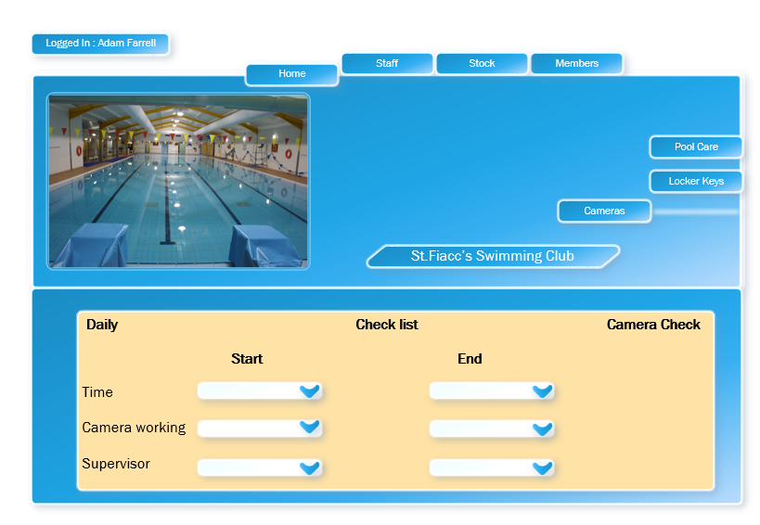

Access to this Screen:

Purpose of this Screen: To Show How to edit a member of staff

Table Processing involved: Access to this Screen:

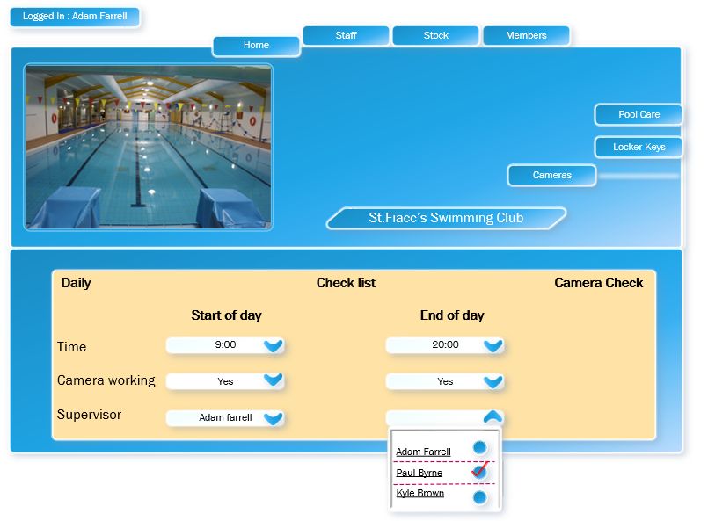

Access to this Screen:

Purpose of this Screen: To Show How to edit a member of staff

Table Processing involved: Access to this Screen:

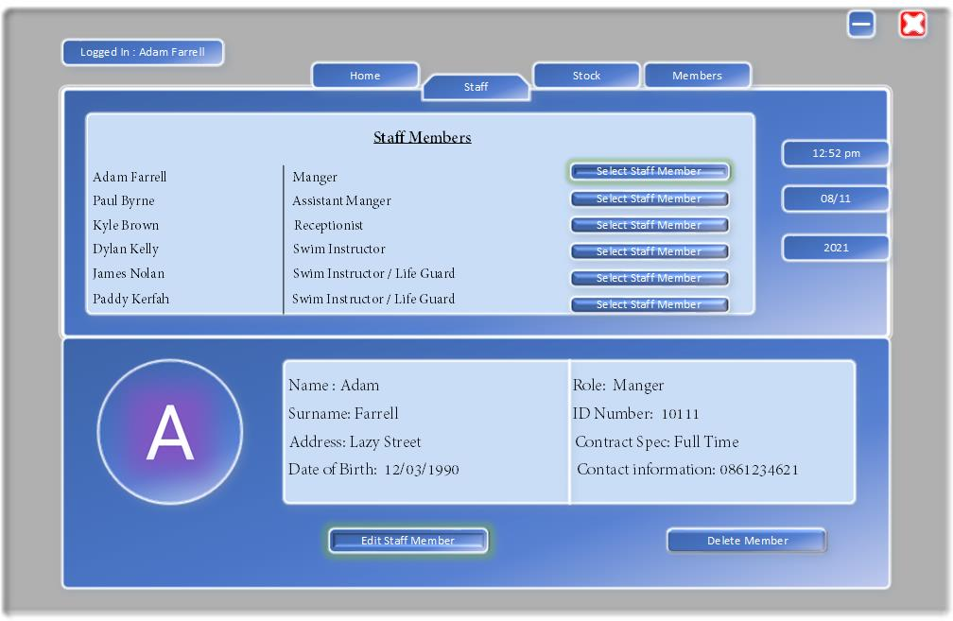

Access to this Screen:

Purpose of this Screen: To Show How to edit a member of staff

Table Processing involved: Access to this Screen:

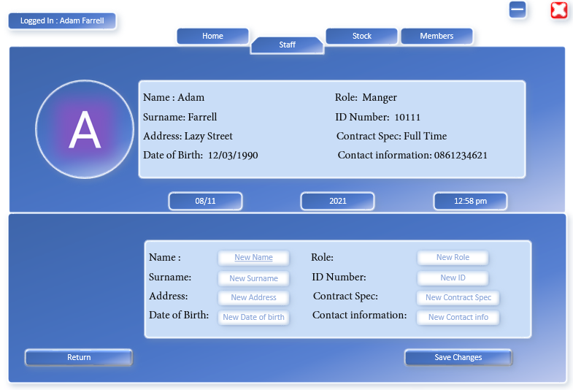

Access to this Screen:

Purpose of this Screen: To Show How to edit a member of staff

Table Processing involved: Access to this Screen: