Apple Crisp iiiiiiServes 4
I've always liked baked apples, but it's only in the past year or so that it's become a staple of mine. I started experimenting with different permutations. There was that time when I took four varieties of apples, baked one of each with honey and one more of each with maple syrup; the best turned out to be pink jazz apples with honey. I hope you'll exploit the literal fruits of my trial and error.

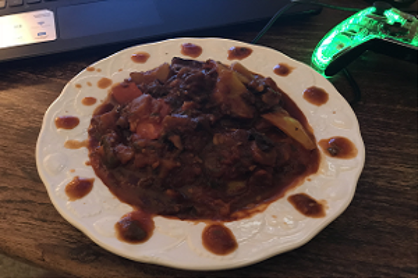
Funny thing about ratatouille (and a lot of dishes with tomatoes, actually) is that
it gets better when it's been sitting in the fridge for a while.

Ingredients
4 pink jazz apples* ½ cup honey
¾ cup pecans ¾ cup walnuts
¾ cup raisins ¾ cup dried cranberries
¾ cup brown sugar 1 tsp vanilla
1 tbsp cinnamon 1 tsp nutmeg
sweet cream or coffee creamer (optional)

* This is flexible. You can use honeycrisp or granny smith apples just as easily.

Let's cook

Step 1
Preheat the oven to 350 degrees F. Take a small baking dish barely big enough to accommodate your apples and put a splash of water in the bottom.

Step 2
Core and quarter your apples, and arrange them in the baking dish.

Step 3
Chop the pecans and walnuts very coarsely – little more than halving them. Fill in the spaces around the apples with the pecans and walnuts, and then do the same with the raisins and dried cranberries.

Step 4
Heat the honey without caramelizing it. Stir the vanilla into the honey, then drizzle that mixture over the whole crisp in the baking dish.

Step 5
Bake in the preheated oven for 1 hour. Check for doneness with a fork. This is really a case of personal preference, but the textbook baked apple is cooked enough that a fork will meet very little resistance, but isn't cooked past the point where the apple's flesh begins to visibly break down.

Step 6
When you serve up your apple crisp, you might add a splash of sweet cream or coffee creamer. Don't overdo it – just a splash. You don't want to overwhelm the flavor of the crisp.

