Traditional Ratatouille iServes 10
Originally from the south of France, ratatouille is a blue collar dish that gained a lot of popularity over time, kind of like pizza. But unlike pizza, ratatouille is very good for you – high in vitamins, low in calories, almost exclusively vegetables and fresh herbs. It's a flexible vegan dish that can be served with steak or fish; cabernet or chardonnay. Ratatouille is delicious, nutritious, and dirt cheap, especially if you make it when the vegetables are in season. You can't go wrong with ratatouille.

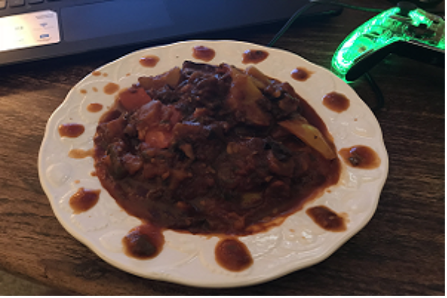
Funny thing about ratatouille (and a lot of dishes with tomatoes, actually) is that
it gets better when it's been sitting in the fridge for a while.

Variations
Like a lot of celebrated basics, there are a lot of ways to come at this. Some people put 3:1 basil to parsley, others put 3:1 parsley to basil. Some add bay leaf, or rosemary, or oregano, or tarragon. If you've seen the Pixar film Ratatouille, you've seen Remy the rat make a variation of ratatouille called confit byaldi. No matter what someone swears by, there's no one right way to do it; you can make this dish however you like. As this is meant to be a traditional representation of the recipe – a template from which you can establish your own preferences – I'll stick to the basics. But if you want to modify the recipe, here are some suggestions to get you started.

If you want to... Then...
Make it sweeter Add some cherry tomatoes
Make it spicy Add some red pepper flakes OR a scotch bonnet*
Make it saltier Add some chicken bouillon
Make it more tomato-y Add some tomato paste
Make it more Italian Add some oregano

* BE CAREFUL: For heaven's sake, DO NOT handle this pepper with your bare hands. Add it to the dish in a cheese cloth so you can remove it after cooking. Scotch bonnets are dozens of times stronger than jalapeños – so hot that they can blister bare skin.

Ingredients
2 lbs yellow squash 2 lbs zucchini
2 lbs eggplant 2.5 lbs tomatoes
1 onion 3 bell peppers
1 head of garlic 1 cup basil
1 cup flatleaf parsley 3 tbsp olive oil
1/3 cup white wine 1 tbsp black pepper
1 tbsp salt

NOTE: There's a rumor going around that there are male and female bell peppers, that they taste different and are better for different kinds of dishes. Malarkey. Disregard this misinformation completely.

Let's cook
An important observation up front: the vegetables' flavors and textures should be distinct from one another; ratatouille is a stew, not a soup. To that end, you should 1) cut them into large pieces, roughly a cubic inch, and 2) simmer the vegetables instead of boiling them. If you can fit two pieces of vegetables into the same bite without unhinging your jaw like a snake, you're cutting them too finely. This goes doubly for the eggplant because disgorgement exaggerates the shrinkage from cooking.

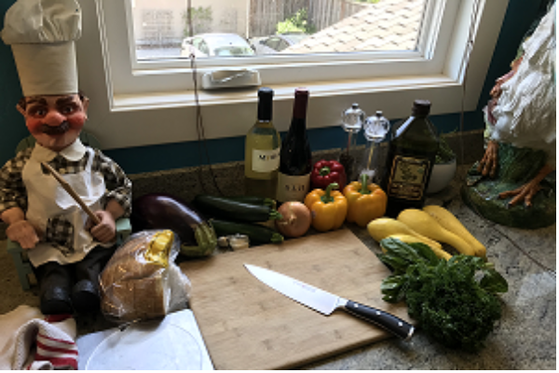
This recipe goes a lot faster with two people,which is why I'll be assisting Sir Robert here.

Step 1
Cut your eggplant, squash, and zucchini into ~1 cubic inch chunks. I know they look huge, but they're going to cook down a lot, especially the eggplant. Some people say peel your eggplant, some say don't. My opinion is that unless you're cooking for a party and trying to make it pretty, you should peel it. The skin is tough and isn't hard to get off.

Step 2
Spread your eggplant chunks out on a cookie sheet with paper towels and salt the dickens out of it. This is called disgorgement and draws the water out of the eggplant over about 20 minutes. Eggplant tends to be slimy if you don't do this, so take the time to do it.

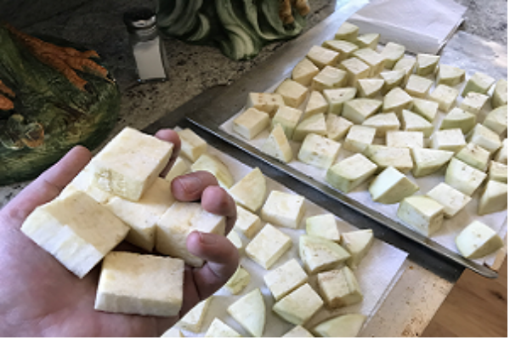
You want your chunks about this big. If you have to make a chunk too big or too small, make it too big.

Step 3
It's time to peel the tomatoes. Prepare an ice bath and get some water boiling. While the water's heating, cut the stem base out of the tops of the tomatoes and cut a small “x” into the bottom. When the water's boiling, drop your tomatoes in there for 30 seconds, then spoon the tomatoes out and drop them in the ice bath for 5 minutes. You shouldn't have any trouble getting the skin off, just take care not to squeeze the tomatoes while you peel them.

Step 4
Add your tomatoes and black pepper to a very large pot and start cooking it on medium heat. Go for a broad pot over a tall one; it'll cook more evenly and it's easier to stir.

Step 5
Chop up your garlic, basil, and parsley and add that to the tomatoes.

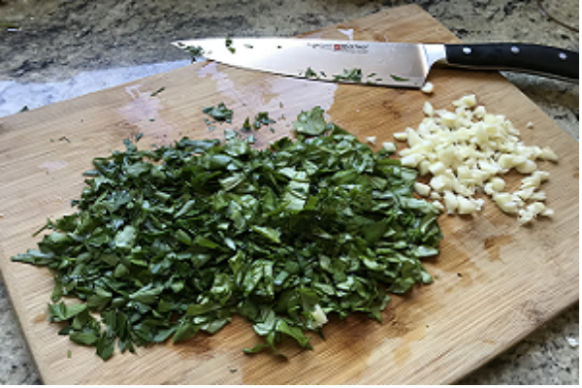
There's no advantage to mincing the herbs; a quick, coarse cut works just as well.

Step 6
Chop up your onion and bell peppers. Add your onion and olive oil to a big skillet and cook it on medium-high heat, stirring to keep it all from burning. When the onion is lightly browned, add your bell pepper to the onions and continue to stir. You want the bell peppers to end up lightly browned and the onions to caramelize.

Step 7
Add your onion and bell peppers to the tomato mixture. Pat your eggplant dry and add that as well. Reduce the heat on the pot to medium-low. Put a lid on it and set the timer for 45 minutes. While it's cooking, get in there a couple of times and stir it to make sure it gets evenly cooked. Take particular care to turn over the stuff on the bottom to the top. And make sure you're simmering the stew and not boiling it; boiling it will ruin the consistency.

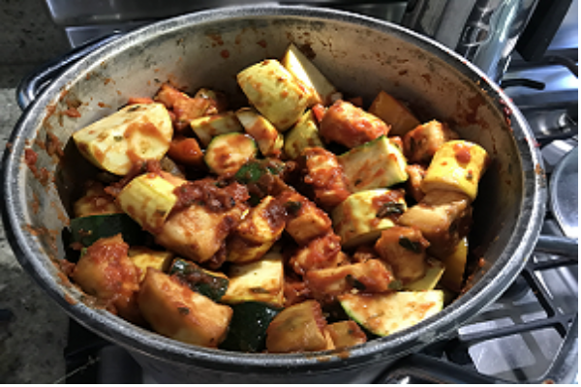
It looks coarse now, but it's going to reduce to a much smoother, more easily stirred consistency in about 15 minutes.

Step 8
Add the wine and salt. Stir it in well, then put the lid back on and let it cook for another five minutes. That's it! You're all set.

