**Analysis**

The new feature allows users to add planets with random features on click and add planets with more detailed features on long click. This is useful because it implements a way for the user to interact with the program outside of the source code or console. It should seamlessly integrate with the overall design of the program so far using the same custom styles as everything else.

**Design**

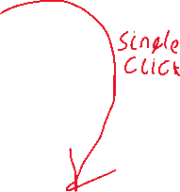

Create planet with constrained random characteristics

Aspects to be constrained

* Position (determined by mouse click)
* Mass
* Velocity
* Colour (pre-sets?)

On long click opens dialogue box (div) on right of screen and pauses game so that planet info can be filled in

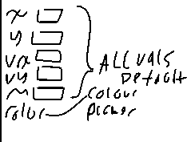

**Testing**

|  |  |  |
| --- | --- | --- |
| Function | Test Type | Works? |
|  |  |  |
|  |  |  |
|  |  |  |

**Docs**

**Evaluation**