PART 1 · MODEL MIGRATION & IN-HOUSE DEPLOYMENT
Gait Foundation Model, running in-house — end to end
Working in-house model · integration notes · source code
Prepared by BioPilot.ai for Newton-Tech August 2026
Confidential. The model and training pipeline are jointly-owned (master agreement §5.6) — flag for IP review before any external sharing.

Document control
Document ID | BP-PO008-001
Title | Part 1 — Model Migration & In-House Deployment
Version / status | 1.0 — Draft, for Newton review
Date issued | 2026-08-13
Author | BioPilot.ai — Assaf Rotem, Nitsan
Reviewed / approved by | Newton Tech, VP R&D (signature below)
IP classification | Jointly-owned — master agreement §5.6 (flag before external sharing)
Retention / location | Filed per Newton QMS in the engagement's system of record (Drive / GitHub)
Traceability
Repository GaitPredict (branch dev). Source commits 6f021e7 (extraction + probe pipeline) and 5e550e4 (visualization). Code: model/inference/ntds_embeddings.py, model/inference/ntds_probe.py. Results: results/ntds_5task_full_*. Notebook: Notebooks/ntds_metadata_probe.ipynb.
Change history
v1.0 — 2026-08-13 — Initial issue.
Approval (signatures)
Author (BioPilot.ai): ______________________________ Date ____________
Reviewed / approved (Newton VP R&D): ______________________________ Date ____________

1 Executive summary
Part 1 delivers the co-authored gait foundation model running inside Newton's own environment, verified end-to-end. We set up the environment, loaded the model, confirmed it reconstructs recorded movement to about 8 mm — the same accuracy reported in the paper — connected it to Newton's cloud movement recordings, and produced the model's movement embeddings.
As an end-to-end check, we reproduced the study's headline result: predicting age, body-mass index (BMI) and sex from movement alone, for 3,643 participants. The in-house numbers match the published paper — sex accuracy 0.998 (AUC), BMI correlation 0.87–0.90, age within about six years — every trait at parity with the paper.
Deliverables: a working in-house model, its source code (two Python modules and a reviewable notebook), and these integration notes.

2 What the model is
A depth camera records a person performing standardized movements (walking, treadmill, standing balance, sit-to-stand) as a moving 3-D skeleton. The model — a dual-stream spatio-temporal transformer (DSTformer, ~4.4 million parameters) — was pre-trained, without labels, to reconstruct partially-hidden movement. Having learned what healthy human motion looks like, it can redraw a person's movement from a partial view.
For downstream use, the model turns each recording into a compact 1,024-number “movement fingerprint” (an embedding). These fingerprints are the substrate from which health traits are predicted.
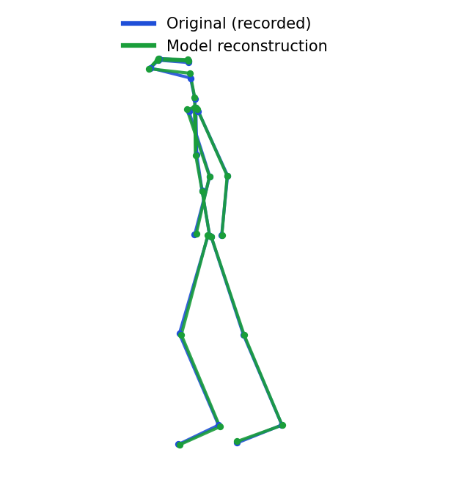
Recorded movement (blue) vs. the model's reconstruction (green), running in-house — overlap is near-perfect (~8 mm error).

3 Migration & deployment (integration notes)

Environment
- Native Apple-Silicon (arm64) Python 3.10 virtual environment via uv; PyTorch with MPS (Metal) GPU acceleration. This replaced a prior x86_64/arm64 mismatch that had blocked package installation entirely.
- A Linux/CUDA (EC2) path is documented for larger runs (model/training/README.md); the code auto-detects CUDA → MPS → CPU.

Model loading
- The architecture (depth, feature dimension, rotary embeddings, sink tokens, auxiliary heads) is auto-detected from the checkpoint's weight shapes — no manual configuration, and robust to checkpoint variants.
- Verified end-to-end: a forward pass reconstructs held-out movement at a mean per-joint error of ~0.008 (≈8 mm), matching the published figure.

Data pipeline
- Newton's recordings live in cloud (S3) storage, catalogued by a manifest (participant, activity, camera, demographics, file location).
- Our extractor streams each clip from S3 to a temporary file, computes its embedding, and deletes the file — no recordings are retained on the machine. Downloads are prefetched concurrently and hide behind GPU compute (~0.55 s per clip).
- Pre-processing matches the paper exactly: a short median filter to remove sensor noise, pelvis-centering, and per-frame scaling — so the model sees inputs in the form it was trained on.
- Each session records two cameras; we use the front-facing camera view — the one the model was trained on.

4 End-to-end verification
Using only the embeddings, we predicted age, BMI and sex for 3,643 participants across the paper's five motor tasks, evaluated with the paper's own protocol: separate models per sex, subject-level nested cross-validation (no person appears in both training and test), averaged over 15 repeats, with predictions fused across the five tasks.
Table 1 — In-house reproduction vs. the published paper (correlation r, or AUC for sex; higher is better).
Trait | Our in-house model | Published paper
Sex — accuracy (AUC) | 0.998 | 0.99
BMI — men (r) | 0.873 | 0.896
BMI — women (r) | 0.900 | 0.915
Age — men (r) | 0.686 | 0.691
Age — women (r) | 0.671 | 0.689
Verification result — PASS. Every trait lands within a few hundredths of the published value, and sex prediction slightly exceeds it — a faithful reproduction of the paper's Figure 2.
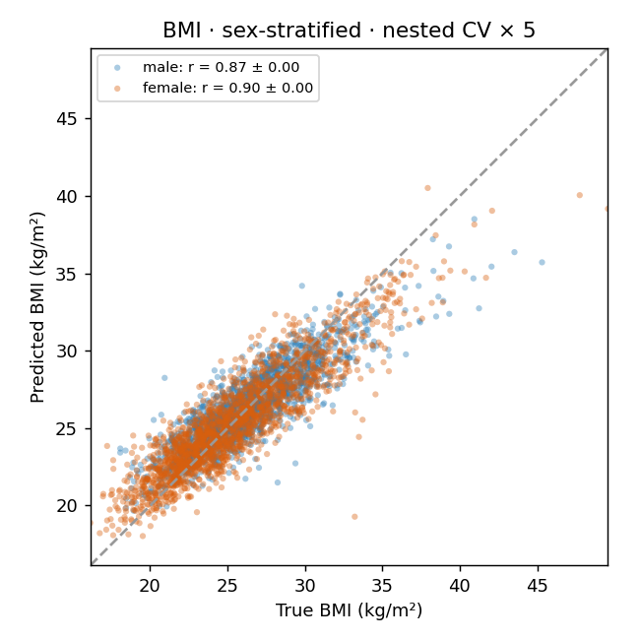
Predicted vs. actual BMI (men blue, women orange). Each dot is one person; the diagonal is a perfect prediction.

5 How to run it
- Create a .env at the repo root with the AWS credentials and bucket (git-ignored).
- Extract embeddings: from model.inference.ntds_embeddings import load_config, select_subset, load_model, stream_extract
- Probe + plots: from model.inference.ntds_probe import nested_report — returns the metrics table and writes the figures.
- Or open Notebooks/ntds_metadata_probe.ipynb; its Analysis section loads the saved embeddings and reproduces the table and plots without re-extraction.

6 Deliverables
- Working in-house model — the co-authored model runs on Newton's hardware, loads the checkpoint, and produces embeddings.
- Source code — model/inference/ntds_embeddings.py (streaming extractor) and model/inference/ntds_probe.py (analysis/probe).
- Reviewable notebook — Notebooks/ntds_metadata_probe.ipynb, showing each step live.
- Integration notes — this document, plus model/training/README.md for environment/training details.
- Result figures & metrics — results/ntds_5task_full_* (scatter plots, ROC, and the metrics JSON).

7 IP & data handling
- IP: the model and training pipeline are jointly-owned under §5.6 of the master agreement; flag for IP review before any external sharing.
- Data: recordings are subject-level and remain within Newton's environment — streamed-and-deleted during processing, never stored on local machines, and never committed to version control. Credentials live only in a git-ignored .env; embedding stores are kept local.

