A Human Synovial Tendon-on-a-Chip Models Early Features of Peritendinous Adhesion Formation and Enables Anti-Fibrotic Drug Testing

Isabelle Linares^{1,2}, Anabelle Creveling¹, Abdikadir Osman¹, Nathan Grandwetter¹, Benjamin L. Miller^{1,2,3,4}, James L. McGrath^{1,2}, Hani A. Awad^{1,2,*}

- Department of Biomedical Engineering, University of Rochester, Rochester, NY, USA.
- Department of Orthopaedics and Rehabilitation, The Center for Musculoskeletal Research, University of Rochester Medical Center, Rochester, NY, USA.
- Department of Dermatology, University of Rochester Medical Center, Rochester, NY, USA.
- Institute of Optics, University of Rochester, Rochester, NY, USA.

* Corresponding Author
Hani Awad, PhD, FAIMBE, FIOR, FORS
Donald and Mary Clark Distinguished Professor of Orthopaedics
University of Rochester Medical Center
601 Elmwood Avenu – Box 665
Rochester, NY 14642
E-mail: Hani_Awad@URMC.Rochester.edu

Funding: NIH UG3TR003281, NIH UH3TR003281, and NIH U2CAG088071
Keywords: organ-on-a-chip, tissue engineering, fibrosis, peritendinous adhesions, synovial fibroblasts, new approach methodology

Abstract
Peritendinous adhesions are a debilitating complication of tendon injury characterized by excessive matrix deposition and inflammatory signaling. Due to limitations of current preclinical models, the early multicellular events that initiate adhesion pathogenesis remain poorly defined, and there are no approved drugs to prevent or resolve adhesions. Here, we develop a human synovial tendon-on-a-chip (synToC) that integrates synovial fibroblasts, tendon-resident fibroblasts, immune cells, and an endothelial barrier within spatially separated synovial and tendon compartments. Over a five-day observation window, synovial fibroblast activation promoted tendon contraction and inflammatory cytokine secretion dominated by IL-6, leading to monocyte infiltration and formation of fibronectin- and collagen III-rich matrix bridges resembling nascent peritendinous adhesions. These phenotypes emerged without exogenous TGF-β1 supplementation, indicating that synovial fibroblast-mediated crosstalk can initiate early adhesion-associated responses to endogenous active TGF-β1. Pharmacological inhibition of the IL-6/JAK/STAT pathway suppressed synovial activation, blunted inflammatory cytokine signaling, and attenuated fibrotic matrix deposition and fibronectin-defined interfacial contacts. These findings support the synToC as a human-relevant new approach methodology (NAM) for interrogating early multicellular drivers of tendon adhesions and for mechanism-informed anti-fibrotic drug testing.

1. Introduction
Adhesions are pathological scar-like extracellular matrix (ECM) that form between neighboring tissues and organs following surgery, injury, or inflammation, and occur across multiple anatomical sites, including musculoskeletal, gynecological, cardiovascular, and abdominal tissues[1]. Among these, zone II injuries of the flexor tendon, historically termed “no man’s land”, are particularly challenging, where rates of post-surgical adhesions exceed 40%, and 5% to 15% of patients require secondary surgeries[2, 3]. Current therapeutic strategies, including drugs, physical barrier materials, and physical therapy, often fail to prevent or resolve adhesions and many patients continue to experience impairments in digital range of motion, grip strength, and dexterity[4-6].

Persistent inflammation and unchecked fibroblast activation have been shown to drive adhesion formation[7]. Activated fibroblasts proliferate and migrate in damaged or healing tissues, promote immune cell recruitment and activation, and secrete cytokines and chemokines that precipitate chronic inflammation and fibrosis[8]. These cells respond to fibrotic signals, including TGF-β1, by activating a myofibroblast phenotype, and deposit excessive ECM including collagen and fibronectin, forming scar tissue that ultimately compromises the regeneration of native tendon structure and normal function. Despite decades of investigation, the cellular origins of the fibroblasts responsible for adhesions remain a source of debate[9]. Evidence from animal models supports the hypothesis that tendon adhesions arise from an imbalance between the intrinsic (tendon-derived) and extrinsic (synovial sheath and surrounding tissue-derived) healing responses[10]. Although both intrinsic tendon cells and synovial sheath cells upregulate TGF-β1 pathways early after injury[11], sheath cells show greater reactivity, migratory capacity, and matrix synthesis in response to TGF-β1[9, 12-14]. Fibroblast-like synoviocytes (FLS), which constitute the major cellular population of the tendon sheath, therefore represent strong candidates as key effector cells linking extrinsic healing to pathological tendon fibrosis and adhesions.

While the role of FLS in peritendinous adhesions remains poorly defined, their contribution to synovial inflammation and fibrosis is well established in other musculoskeletal pathologies. In rheumatoid arthritis (RA), FLS sustain synovial inflammation through direct cell-cell interactions and secretion of soluble mediators[15]. FLS have also been implicated in synovial fibrosis in osteoarthritis (OA), exhibiting increased proliferation and secretion of pro-inflammatory mediators, including IL-6 and IL-8[16], and upregulating TGF-β1-associated genes linked to FLS activation (ACTA2, CDH11) and matrix synthesis (COL1A1, COL3A1, THBS1, FN1), supporting their direct involvement in synovial fibrosis[16, 17]. Furthermore, the crosstalk between FLS and other synovial cells is critical. Recent evidence from refractory RA synovial biopsies identified a complex synovial microenvironment in which inflamed vascular endothelial cells drive FLS activation by creating a spatial gradient of fibrogenic TGF-β1 signaling in the synovium, which contributes to treatment resistance[18]. Interestingly, while tendons are mostly avascular, the scar tissue constituting peritendinous adhesions is highly vascularized. Consequently, a similar crosstalk between inflamed endothelial cells, leukocytes, and fibroblasts likely facilitates immune cell trafficking and orchestrates myofibroblast microenvironment (MME) activation in peritendinous adhesions[19]. We posit that multicellular signaling within the inflammatory MME could be key to identifying therapeutic targets for the resolution of adhesions.

While animal models are widely used to study intrasynovial flexor tendon healing, fundamental limitations restrict their utility to elucidate the multicellular mechanisms that drive adhesion formation. Rodent models provide powerful genetic tools and are well suited for tracing specific cell populations.[20] However, the immune systems and tendon architecture differ between humans and rodents, creating a mismatch in response to drug treatments.[21] Large animal models improve replication of surgical and clinical factors but are costly, low-throughput, and poorly suited for systematic manipulation or longitudinal analysis of specific cell-cell signaling pathways. As emphasized by recent consensus efforts, no existing animal model fully captures the spatial, temporal, and cellular complexity of tendon adhesion pathogenesis[22]. Current in vitro systems likewise rarely combine spatially separated synovial and tendon tissues with an endothelial barrier, immune-cell trafficking, and a directly imaged interfacial matrix-contact endpoint[23]. Organ-on-chip formats can provide this spatial control even when operated statically; a quantitative meta-analysis found that the effects of perfusion were biomarker- and tissue-dependent rather than uniformly beneficial[86]. The defining need for the present study was therefore a human multicompartment system that permits independent assembly of extrinsic synovial and intrinsic tendon tissues and direct quantification of matrix continuity between them.
We previously engineered a human tendon-on-a-chip (hToC) featuring a 3D tendon construct interfaced with a perfused endothelial channel across an ultrathin nanomembrane with dual (micro/nano) porosity, enabling controlled immune-cell trafficking and recapitulation of inflammatory and fibrotic features of tendon pathology driven by TGF-β1[19, 24]. This work established a human-relevant model of intrinsic tendon fibrosis arising from endothelial-immune-fibroblast crosstalk within the MME. However, the hToC does not include an extrinsic synovial tissue compartment and therefore cannot resolve the contribution of synovial fibroblasts to intercompartmental matrix bridging. The present study deliberately reuses this validated hardware and a conventional collagen matrix; its advance is biological and analytical rather than the invention of a new chip architecture or biomaterial.

Here, we adapt the hToC into a human synovial tendon-on-a-chip (synToC) by adding a three-dimensional FLS-containing synovial compartment beneath an endothelial monolayer. The architecture preserves spatially distinct synovial and tendon tissues while enabling transendothelial monocyte trafficking and direct visualization of matrix continuity between the two compartments. The key advance over the prior hToC and single-compartment fibrosis models is the ability to distinguish extrinsic synovial from intrinsic tendon responses and to quantify de novo interfacial matrix bridging. We investigated whether the FLS-seeded synovial lining amplifies early inflammatory signaling, immune-cell recruitment, tendon remodeling, and fibrotic matrix deposition. Without exogenous TGF-β1 supplementation, but in the presence of endogenous active TGF-β1, FLS increased monocyte transmigration, synovial cell expansion, tendon contraction, and deposition of fibronectin- and collagen III-rich bridging ECM. Mechanistically, cytokine analysis identified prominent IL-6/JAK/STAT signaling, which guided testing of tocilizumab and tofacitinib. Drug effects were assessed using molecular and structural readouts, including fibronectin-defined interfacial contact length. This contact-length endpoint measures matrix continuity and is not a direct test of tendon gliding or mechanical adhesion strength. Accordingly, the synToC is presented as a human-relevant NAM for studying early multicellular and interfacial events in adhesion pathogenesis and for mechanism-informed therapeutic testing.

2. Results

2.1 Incorporating an endothelialized synovial lining to model the intrasynovial tendon microenvironment in the synToC
As with the hToC[19, 24], a key feature of the synToC platform is its modular design, which enables independent culture of the tendon and endothelial-synovial compartments prior to integration (Figure 1a). To recapitulate the intrasynovial tendon microenvironment in the bottom compartment, primary human tendon fibroblasts and monocytes were encapsulated in a type I collagen hydrogel and cultured with macrophage colony-stimulating factor (M-CSF) for 6 days (Day -6 to Day 0) to promote monocyte-to-macrophage differentiation and reconstitute an early post-injury tendon inflammatory niche. For the endothelial-synovial compartment, a type I collagen hydrogel embedded with or without primary fibroblast-like synoviocytes (±FLS) was polymerized on the basal surface of the porous nanomembrane. Twenty-four hours later, ECs were seeded on the opposite apical side of the nanomembrane and cultured for an additional 24 hours to establish an endothelial-synovial interface. At Day 0, the endothelial-synovial and tendon components were assembled into the complete synToC, monocytes were introduced to the apical endothelial compartment, and serum-free media with or without 10 ng ml⁻¹ TGF-β1 was added to the bottom (tendon) compartment. CellTracker labeling demonstrated localization of FLS and tendon fibroblasts within their respective regions and transendothelial migration of monocytes to the synovial hydrogel and underlying tendon tissue (Figure 1b).
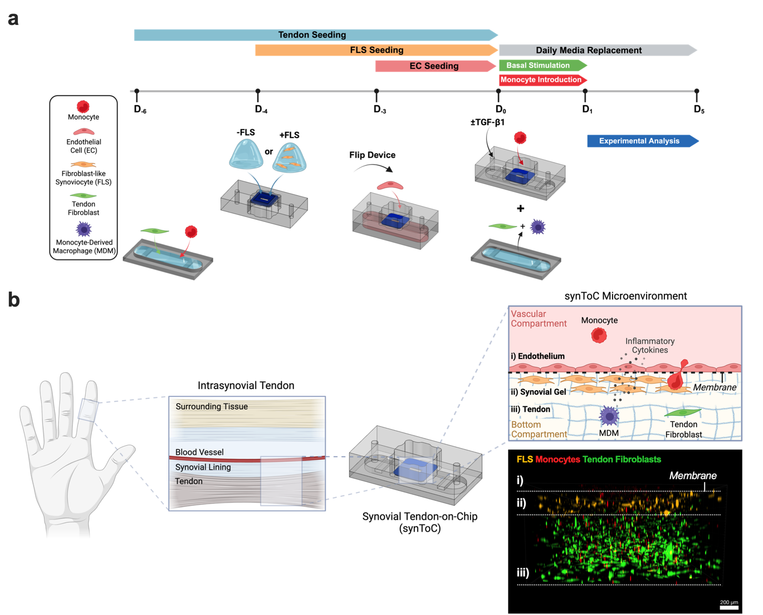
Figure 1. Reconstitution of the intrasynovial tendon microenvironment in the synToC platform. a, Culture timeline outlining the steps to incorporate a synovial layer. A tendon construct containing primary tendon fibroblasts and macrophages was matured in parallel in the bottom chamber. FLS are encapsulated in a type I collagen hydrogel and added to the basal side of the porous nanomembrane (acellular collagen for -FLS), followed by seeding endothelial cells on the apical side to form the endothelialized synovial compartment. At Day 0, the endothelial-synovial compartment is joined with the bottom tendon compartment. Freshly isolated monocytes are added to the apical compartment with or without TGF-β1 in the bottom compartment. Experimental analyses are performed from Day 1 to Day 5. b, Schematic detailing the intrasynovial tendon tissue interface modeled in the synToC. The confocal immunofluorescence image corresponds to a cross-sectional view of representative cell types within the device: i) endothelium, ii) synovial gel, and iii) tendon; it demonstrates the spatial localization of FLS (orange), monocytes (red), and tendon fibroblasts (green) at Day 1 of culture. ECs and tendon-resident monocyte-derived macrophages (MDM) are present but not labeled.

To model an endothelial-synovial interface within the synToC, we established a spatially organized fibroblast-like synoviocyte (FLS)-endothelial cell (EC) co-culture, in which ECs form a monolayer on the apical nanomembrane surface and an FLS-seeded collagen hydrogel is polymerized on the basal side. We compared four culture-media conditions. Among those tested, a 1:1 mix of synoviocyte growth medium and endothelial growth medium was selected as the best-performing compromise because it preserved endothelial junction integrity (VE-cadherin) while maintaining the synovial fibroblast marker cadherin-11 when the cell types were cultured separately in monolayer (Supplementary Figure S1). This selection is limited to the four evaluated conditions and is not presented as a global optimum.
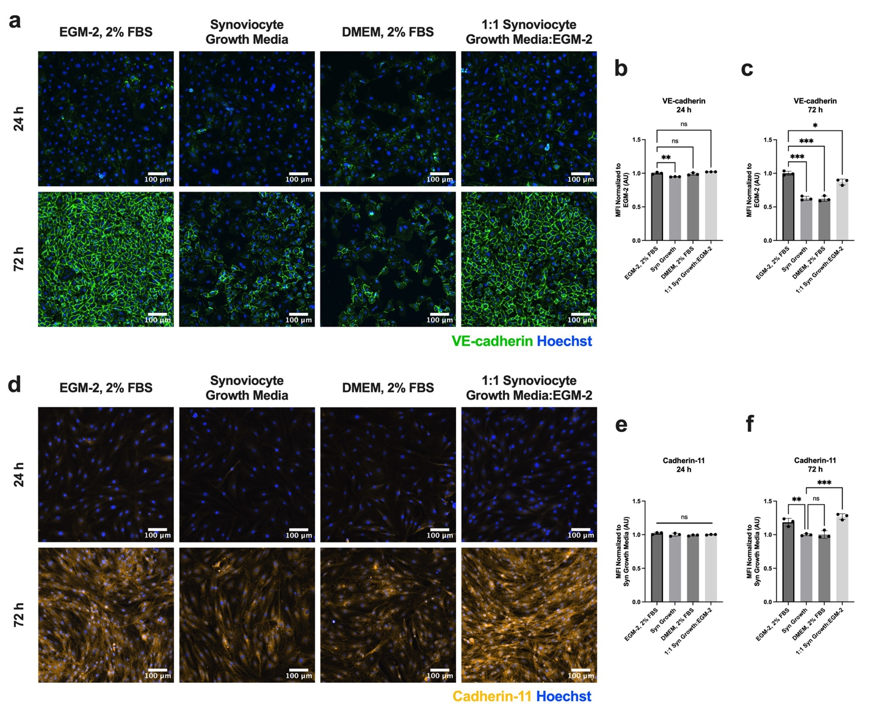
Supplemental Figure S1. Comparative selection of FLS-EC co-culture medium. Among four tested conditions, a 1:1 ratio of Synoviocyte Growth Medium:EGM-2 preserved endothelial VE-cadherin junctions and synoviocyte cadherin-11 expression in 2D culture. a, Immunofluorescence images of HUVEC cultured in monolayer and stained for VE-cadherin (green) and Hoechst (blue) compare four media conditions at 24 h and 72 h of culture. b, Mean fluorescence intensity (MFI) of VE-cadherin expression at b, 24 h and c, 72 h, normalized to the MFI of EGM-2 images. Synoviocyte Growth Medium had significantly less VE-cadherin expression at 24 h compared with EGM-2. VE-cadherin MFI for 1:1 Synoviocyte Growth Medium:EGM-2 most closely matched that of EGM-2 conditions. d, Immunofluorescence images of FLS cultured in monolayer, stained for cadherin-11 (yellow) and Hoechst (blue), compare the four media conditions at 24 h and 72 h of culture. e, MFI quantification of cadherin-11 expression, normalized to the MFI of Synoviocyte Growth Medium, demonstrated no significant differences among culture conditions at 24 h. f, At 72 h, EGM-2 and 1:1 Synoviocyte Growth Medium:EGM-2 had significantly higher cadherin-11 expression compared with Synoviocyte Growth Medium, while DMEM had comparable levels. One-way ANOVA with Tukey’s post-hoc test: n=3 wells per condition, *p<0.05, **p<0.01, ***p<0.001.

To model the endothelial-synovial interface associated with the intrasynovial tendon sheath[28, 29], we encapsulated FLS within a three-dimensional type I collagen hydrogel. The hydrogel was polymerized on the basal side of the porous nanomembrane and cultured for 24 h before the device was flipped and ECs were seeded on the apical side (Figure 2a). Immunofluorescence staining verified VE-cadherin junctions across the endothelial monolayer and maintenance of FLS cadherin-11 expression (Figure 2b), with discernable compartmentalization across the membrane. We also confirmed PRG4 expression, a marker of synovial cells that line tendon sheaths and provide lubrication and cytoprotection[30], in the FLS-laden synovial hydrogel near the endothelial barrier (Figure 2c). To assess the co-culture response to a profibrotic positive control, TGF-β1 (10 ng ml⁻¹) was introduced to the basal compartment at Day 3. This dose matched the prior hToC protocol[19] and conditions commonly used in in vitro flexor-tendon fibrosis studies[58-60]. Collagen III expression remained stable between Day 3 and Day 6 without TGF-β1 supplementation but significantly increased at Day 6 with TGF-β1 treatment (Figure 2d). Ki67 immunostaining also demonstrated a significant increase in proliferative FLS at Day 6 with and without exogenous TGF-β1 (Figure 2e). Total FLS cell density increased by Day 6 regardless of TGF-β1 supplementation (Figure 2f).
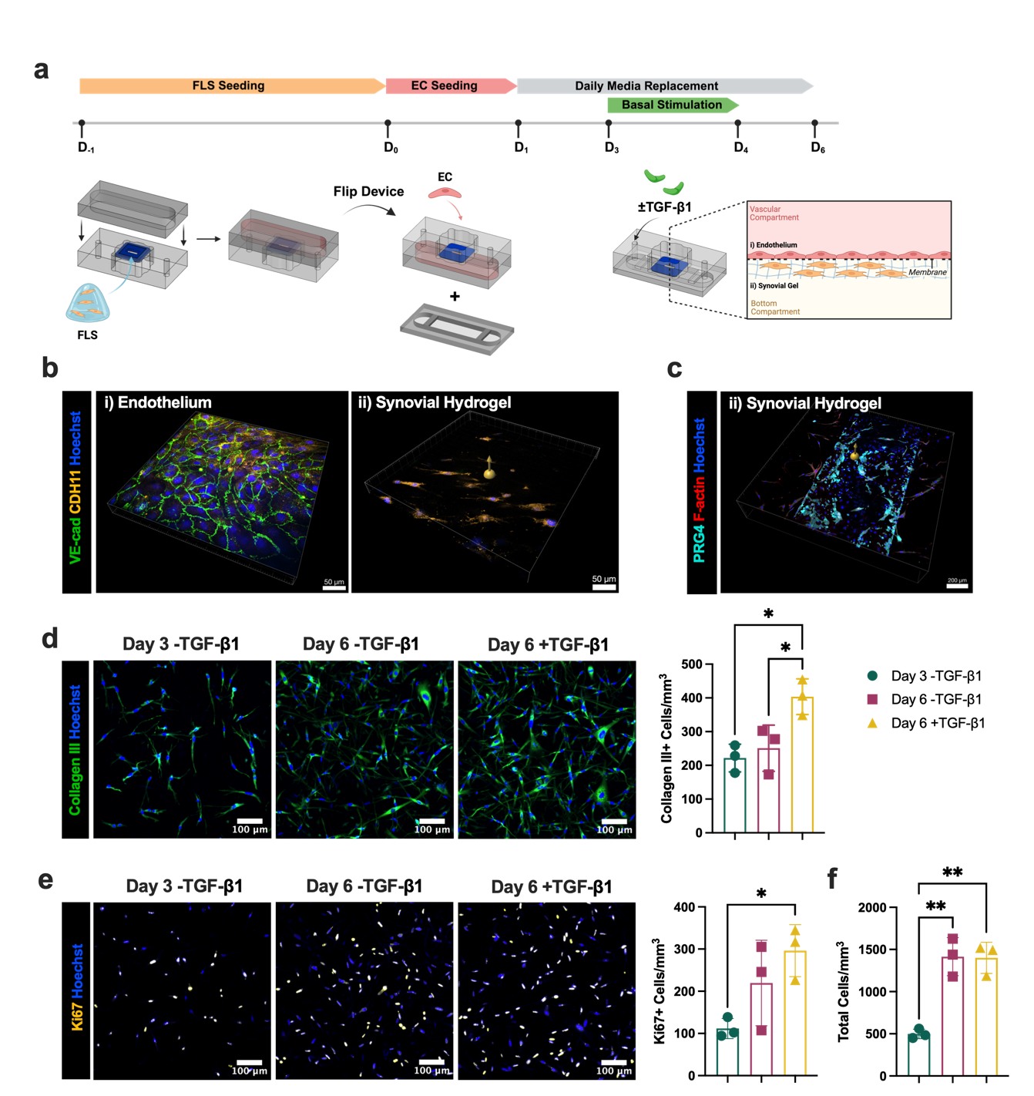
Figure 2. Establishing and validating an endothelialized synovial co-culture in the synToC. a, Overview of the culture timeline used to establish an FLS-EC co-culture. FLS are encapsulated in a type I collagen hydrogel and added to the basal side of the nanomembrane. After 24 h, ECs are added to the apical compartment and form an endothelial barrier over 24 h. Media is replaced daily until Day 3 (D₃), when the profibrotic positive control (10 ng ml⁻¹ TGF-β1) is added to the basal compartment. b, FLS-EC co-culture at Day 3 stained for VE-cadherin (green), cadherin-11 (yellow), and Hoechst (blue). Maximum intensity projection taken at 10x (left). i) z-slice focusing on the endothelial monolayer. ii) z-slice focusing near the bottom of the FLS gel, demonstrating VE-cadherin junctions in the ECs above the FLS gel and compartmentalization of cadherin-11 expression in the FLS gel. c, Synovial hydrogel stained for PRG4 (cyan) and F-actin (red), showing a z-slice in the FLS gel immediately below the endothelial layer on the nanomembrane and demonstrating PRG4 secretion from FLS closest to the endothelial barrier. d, Immunofluorescence images of collagen III (green) expression in the synovial gel, with Hoechst (blue) as nuclear counterstain. Density of collagen III+ cells upon stimulation with TGF-β1 on Day 6. e, Immunofluorescence images of nuclear Ki67 (yellow) expression in the synovial gel, with Hoechst (blue) as nuclear counterstain. The number of Ki67+ cells mm⁻³ significantly increased at Day 6 with TGF-β1 stimulation. f, Quantification of total cell density in the synovial gel, showing comparable increases in cell counts at Day 6 regardless of TGF-β1 stimulation. One-way ANOVA with Tukey’s post-hoc test: n=3 devices per condition, *p<0.05, **p<0.01.

2.2. Synovial FLS promote early intrinsic tendon fibrotic phenotypes without exogenous TGF-β1 supplementation
We next investigated whether incorporating an acellular or FLS-laden synovial hydrogel, with or without supplementation with TGF-β1, modulates fibrotic remodeling within the tendon hydrogel. TGF-β1 is an important growth factor that contributes to pathological fibrosis and tendon adhesions[11]. Macrophages, fibroblasts, and endothelial cells secrete TGF-β1 at the site of injury, which promotes fibroblast to myofibroblast differentiation and proliferation[31]. α-SMA⁺ myofibroblasts are an established marker for fibrosis in injured tendons[31-33]. In the absence of TGF-β1 supplementation, tendon hydrogel contraction was significantly increased in devices with FLS-laden synovial gels (+FLS) compared to acellular synovial gels (-FLS) as early as Day 3, with increased differences by Day 5 (Figure 3a). Upon supplementation with TGF-β1, +FLS and -FLS devices exhibited comparable bulk tissue contraction throughout the duration of culture (Figure 3b). Notably, +FLS devices exhibited significantly greater maximum contraction at Day 5 in the absence of TGF-β1 (Figure 3c). Maximum tendon contraction at Day 5 in +FLS devices under -TGF-β1 conditions was consistent with increased collagen packing density, as evidenced by significant increases in second harmonic generation (SHG) signal intensity in the tendon construct relative to -FLS devices (Supplementary Figure S2).
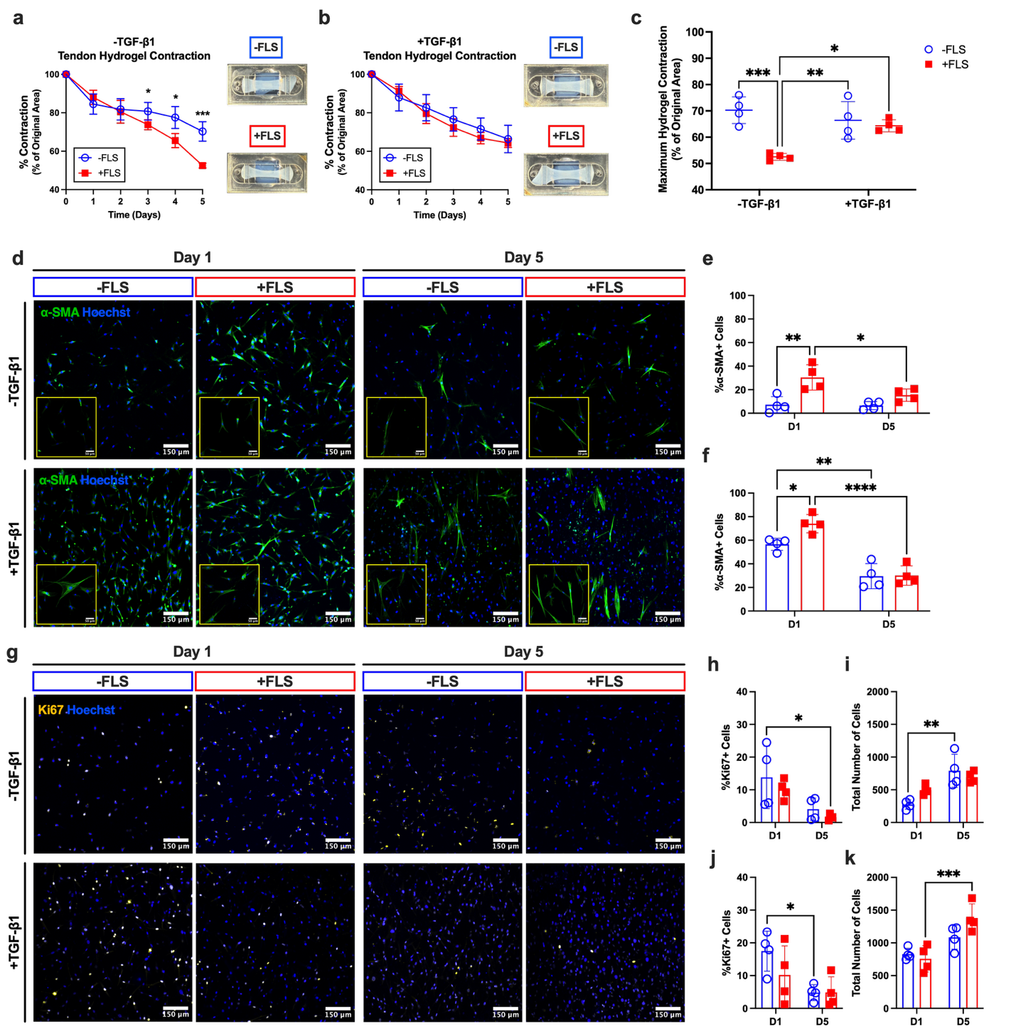
Figure 3. Incorporating FLS in a synovial lining promotes tendon hydrogel contraction and increases α-SMA in the tendon hydrogel without exogenous TGF-β1 supplementation. Tendon hydrogel contraction plotted as the percent of the original hydrogel area in devices a, without exogenous TGF-β1 and b, with TGF-β1 stimulation. Representative images of tendon hydrogels in a and b are shown at Day 5. Data are mean ± s.d. (n=4 devices per condition); Bonferroni-corrected t-tests at each time point: n=4 devices, *p<0.05, ***p<0.001. c, Quantification of maximum hydrogel contraction. Two-way ANOVA with Tukey’s post-hoc test; *p<0.05, **p<0.01, ***p<0.001. d, α-SMA (green) immunofluorescence in the tendon hydrogel comparing devices ±FLS, with or without exogenous TGF-β1. Quantification of α-SMA expression in devices e, without exogenous TGF-β1 and f, with TGF-β1 stimulation, reported as the percentage of positive cells. g, Nuclear Ki67 (yellow) immunofluorescence in the tendon hydrogel comparing devices ±FLS with or without exogenous TGF-β1. Quantification of Ki67 expression in devices h, without exogenous TGF-β1 and j, with exogenous TGF-β1. i, k, Quantification of the total number of cells per field of view in the tendon hydrogel. Data are mean ± s.d. (n=4 devices per condition); two-way ANOVA with Tukey’s post-hoc test; *p<0.05, **p<0.01, ***p<0.001, ****p<0.0001.

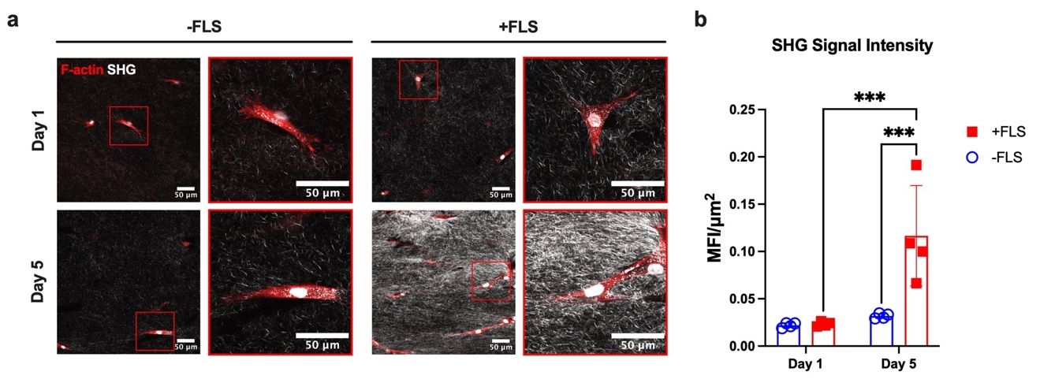
Supplemental Figure S2. FLS induce significant increases in tendon hydrogel collagen density by Day 5. a, Second harmonic generation (SHG) images of tendon hydrogels under basal conditions (-TGF-β1) at D₁ and D₅. Tendon fibroblasts are stained with F-actin (red). Red-boxed insets show a zoomed field of view around individual cells. b, SHG signal intensity quantification shows significantly heightened SHG signal at D₅ in +FLS devices. Two-way ANOVA with Tukey’s post-hoc test: n=4 devices per condition, ***p<0.001.

Analysis of α-SMA immunofluorescence in the tendon construct demonstrated that, without exogenous TGF-β1 supplementation, +FLS devices exhibited a significantly higher proportion of α-SMA⁺ cells at Day 1 compared with -FLS controls (Figure 3d), consistent with early myofibroblast differentiation in the tendon hydrogel. TGF-β1 supplementation produced additive increases in α-SMA expression at Day 1 in both -FLS and +FLS devices (Figure 3e,f), with 74.1±7.8% α-SMA⁺ tendon cells in +FLS,+TGF-β1 devices compared with 30.41±10.7% in +FLS,-TGF-β1 devices. Despite an overall decrease in α-SMA⁺ cells over time across all conditions, high-magnification images depict organized stress fibers at Day 5 compared with diffuse α-SMA expression in tendon fibroblasts at Day 1 (Figure 3d). The percentage of α-SMA+ cells was significantly elevated at Day 1 in +FLS devices compared with -FLS devices, regardless of TGF-β1 treatment (Figure 3e,f). There were no significant FLS- or TGF-β1-dependent differences in Ki67, a nuclear marker of cellular proliferation observed in highly proliferative cells in adhesive peritendinous tissues[34, 35] (Figure 3g). Although the percentage of Ki67⁺ cells tended to decrease over time in all conditions (Figure 3h,j), cell counts were elevated at Day 5 (Figure 3i,k), suggesting that the increased contraction and early myofibroblast differentiation were preceded by proliferative phenotypes at Day 1.

2.3. FLS promote synovial cell expansion and monocyte infiltration
To further investigate the FLS-laden synovial gel inflammatory response in the absence of exogenous TGF-β1, we evaluated proliferative activity, reparative fibroblast markers, inflammatory synovial markers, and immune cell recruitment over time. Immunofluorescence staining of nuclear Ki67 as a proliferation index demonstrated elevated levels of cellular proliferation within the synovial gel at Day 1. Although Ki67⁺ cell density declined by Day 5, the total synovial density, as quantified from nuclei counts, increased significantly over time (Day 1: 1182±121.7 cells mm⁻³; Day 5: 1680±301.8 cells mm⁻³), indicating net cellular expansion despite the decline in proliferative index between days 1 and 5 (Figure 4a).
We next assessed CD90, a cell surface glycoprotein that regulates fibrosis and has also been established as a marker of reparative fibroblasts[36, 37]. We observed robust expression of CD90 in the FLS-laden synovial hydrogel at both Day 1 and Day 5 (Figure 4b), consistent with enrichment of a fibroblast subset linked to adhesions[1]. We also observed a significant increase in podoplanin (PDPN) expression within the synovial gel from Day 1 to Day 5 (Figure 4c). PDPN is a marker of inflammation in stromal fibroblasts in tendinopathy[38], tenosynovitis[39], and tendon adhesions[40]. At Day 1, PDPN expression was detected in a sparse subset of synovial cells, whereas by Day 5 PDPN signal intensity was broadly distributed throughout the synovial gel, along with increased FLS density and morphological elongation.

In contrast, the acellular synovial hydrogel contained a sparse population of fibroblast-like cells that seem to have migrated outward from the tendon hydrogel rather than expansion of a resident synovial population observed in the +FLS synovial gels. CD90 expression within the -FLS synovial compartment remained comparatively low at Day 1 and showed only modest change by Day 5, indicating limited enrichment of reparative fibroblasts. Similarly, Ki67⁺ cell density was maintained at similar levels from Day 1 to Day 5 and was significantly lower than in +FLS synovial gels at Day 1. Thus, the observed synovial expansion, as indicated by increased total synovial cell density, is primarily driven by migration from the tendon hydrogel (Supplementary Figure S3).

To determine whether synovial activation influences immune cells recruitment, we next examined the transendothelial migration of CellTracker-labeled monocytes into the synovial and tendon hydrogels using live confocal imaging at Days 1, 3, and 5 (Figure 4d), which demonstrated that the inclusion of FLS in the synovial hydrogel increased monocytes transmigration from the vascular compartment to the tendon compartment. Quantitative analysis of the confocal images confirmed a significant increase in monocyte infiltration for +FLS devices at Days 3 and 5 compared to -FLS devices and revealed a time-dependent increase in infiltrating monocytes, which was not observed in -FLS devices.
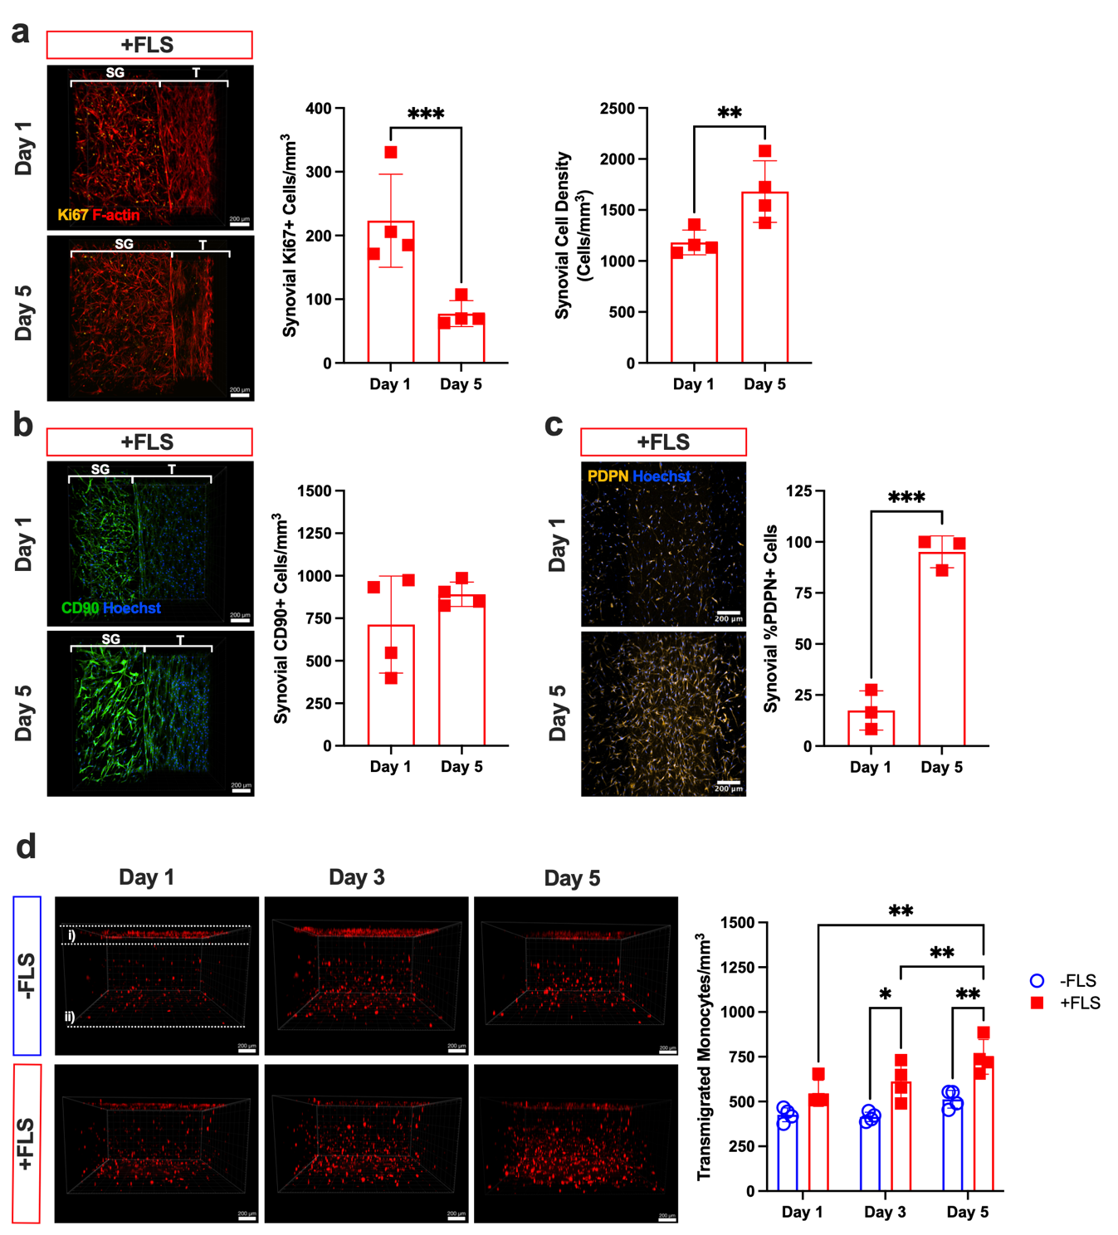
Figure 4. FLS promote synovial cell expansion, inflammatory activation, and monocyte infiltration without exogenous TGF-β1 supplementation. a, Immunofluorescent confocal images of Ki67 (yellow) in the synovial gel (SG) adjacent to the tendon gel (T) at Days 1 and 5. Quantification of Ki67+ cells and total synovial cell density demonstrates elevated proliferation at Day 1 and increased overall cell density in the synovial gel by Day 5. b, Immunofluorescent confocal images and quantification of CD90 (green) expression with Hoechst (blue) as nuclear counterstain at Days 1 and 5 demonstrate enrichment of reparative CD90+ cells in the synovial gel. c, Immunofluorescent confocal images and quantification of podoplanin (PDPN, yellow) expression within the synovial gel, demonstrating significant upregulation from Day 1 to Day 5. d, Three-dimensional confocal imaging of live CellTracker-labeled monocytes (red) at Days 1, 3, and 5 showing transendothelial migration into the i) synovial and ii) tendon compartments (±FLS). Quantification of monocyte infiltration, reported as the number of transmigrated monocytes mm⁻³, shows a time-dependent increase in +FLS compared with -FLS devices at Days 3 and 5. Data are mean ± s.d. (n=4 devices per condition); two-way ANOVA with Tukey’s post-hoc test; *p<0.05, ***p<0.001.

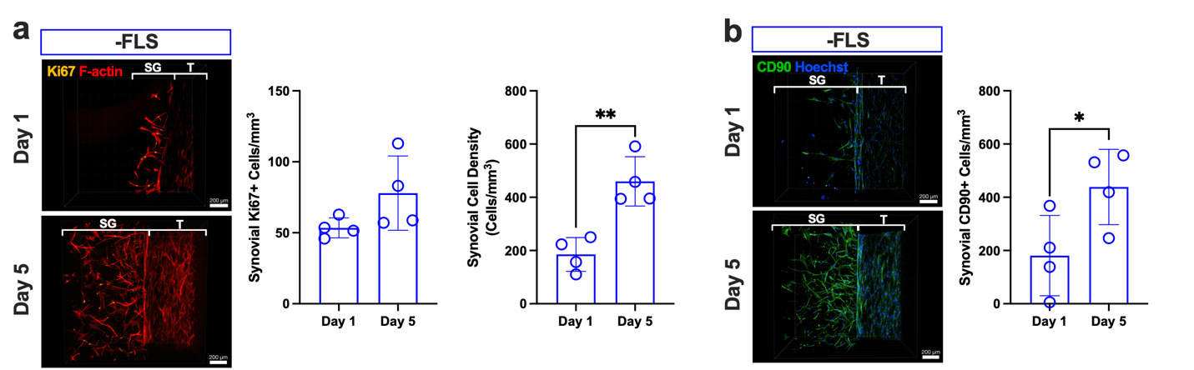
Supplemental Figure S3. Synovial proliferation and CD90 expression -FLS devices under basal conditions. a, Representative confocal images of Ki67 (yellow) and F-actin (red) in the synovial gel (SG) adjacent to the tendon construct (T) at Days 1 and 5 in -FLS devices without exogenous TGF-β1. Quantification of Ki67+ cells within the synovial gel and total synovial cell density, reported as cells mm⁻³. b, Representative confocal images of CD90 (green) and Hoechst (blue) in the synovial gel at Days 1 and 5 (-FLS). Quantification of CD90⁺ cells within the synovial gel, demonstrating increased CD90⁺ fibroblast density at Day 5. Data are mean ± s.d. (n = 4 devices per condition); unpaired t-test; *p<0.05, **p<0.01.

2.4. Synovial FLS promote early adhesion-like matrix deposition without exogenous TGF-β1 supplementation
Having observed FLS-associated synovial cell expansion and inflammation, we next examined extracellular-matrix deposition at the synovial-tendon interface. Macroscopic images of contracted tendon hydrogels revealed visible matrix contacts between the synovial hydrogel below the endothelial barrier and the tendon construct. Without exogenous TGF-β1 supplementation, these contacts occurred predominantly in +FLS devices. To characterize their composition, we acquired confocal images of devices immunostained for collagen III and fibronectin at Day 5.
Without exogenous TGF-β1 supplementation, we observed fibroblast migration into the initially acellular synovial gel in -FLS devices (Figure 5a). Although cells at the edge of the synovial gel expressed fibronectin, their matrix rarely connected with the boundary of the tendon construct (Figure 5b), and collagen III expression was minimal in both gels. In contrast, +FLS devices showed collagen III- and fibronectin-rich networks spanning the tendon and synovial gels, forming early adhesion-like matrix bridges between the two compartments (Figure 5c,d).

Upon TGF-β1 stimulation, fibronectin-rich ECM networks connecting the synovial and tendon gels formed in both ±FLS devices (Figure 5e-h), indicating that a strong profibrotic stimulus can induce this matrix-bridging phenotype. The networks were denser and collagen III expression was more abundant at the synovial-tendon interface of +FLS devices (Figure 5g,h), consistent with reports that FLS contribute to collagen deposition in fibrotic pathologies[16]. Quantification demonstrated that FLS increased collagen III expression in the synovial gel regardless of exogenous TGF-β1 stimulation (Figure 5i). In the tendon gels, collagen III expression was low in -TGF-β1 devices regardless of FLS addition but significantly increased with TGF-β1 stimulation (Figure 5i). We quantified structural interfacial matrix contact using the prespecified adhesion-contact-length metric: the total distance of fibronectin signal contacting both the synovial and tendon gels, consistent with histological contact metrics[41]. FLS significantly increased this contact length without exogenous TGF-β1 supplementation (Figure 5j), whereas exogenous TGF-β1 did not increase it further. This imaging-derived metric describes matrix continuity and does not directly measure tendon gliding, sliding resistance, or mechanical adhesion strength.
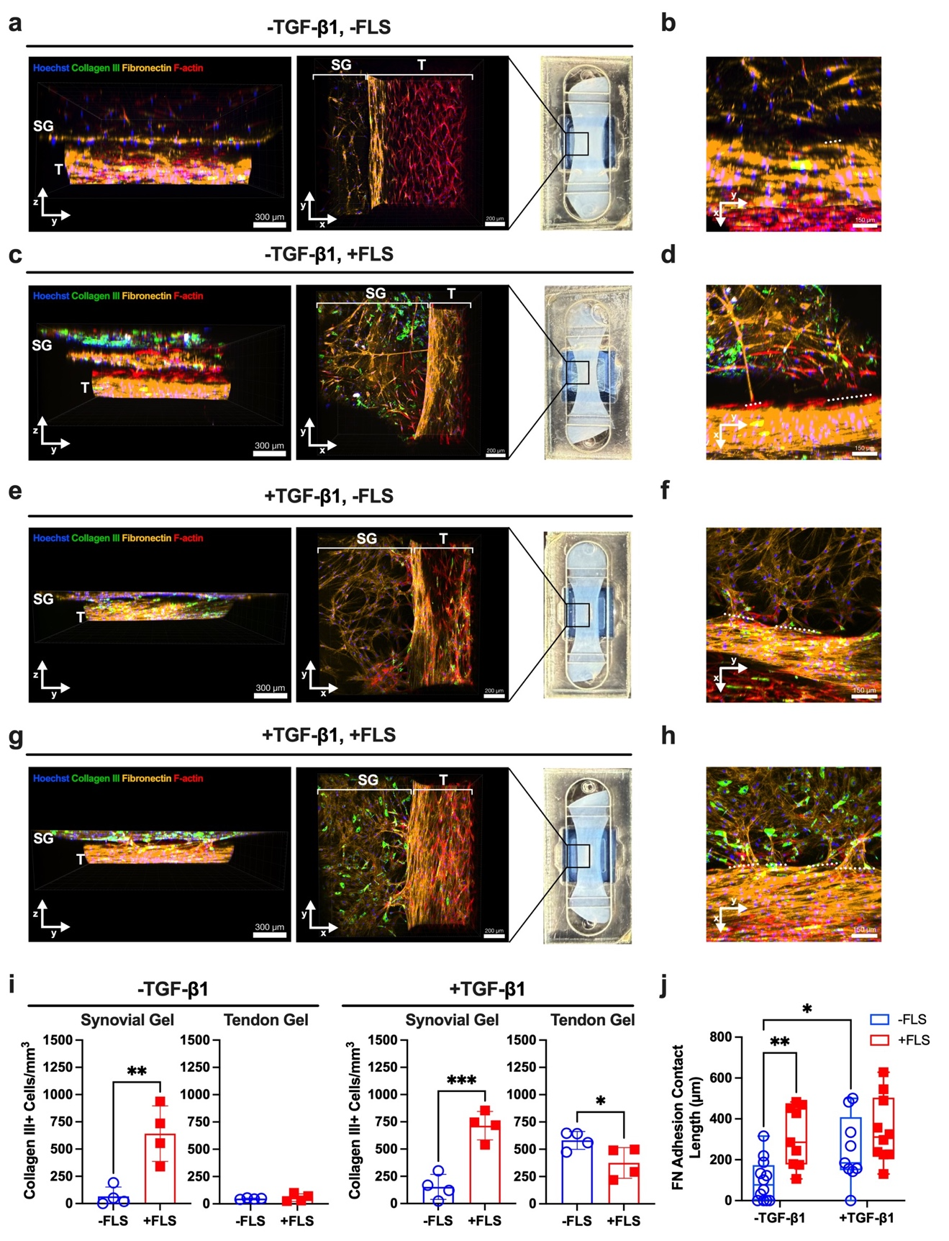
Figure 5. Synovial FLS promote fibronectin- and collagen III-rich matrix bridging at the synovial-tendon interface. a-d, Confocal reconstructions of synToC devices cultured without exogenous TGF-β1 showing side (left) and top (right) views (SG = synovial gel, T = tendon gel). Devices were stained for collagen III (green) and fibronectin (yellow), with Hoechst (blue) and F-actin (red) as counterstains. The macroscopic device image specifies the location of the confocal image field of view at the synovial-tendon interface. a,b, In -FLS devices, fibroblast migration into the synovial gel is observed, but fibronectin networks remain largely compartmentalized with minimal matrix continuity between the synovial and tendon gels. c,d, In +FLS devices, dense fibronectin- and collagen III-rich networks bridge the synovial and tendon compartments, forming direct matrix extensions characteristic of early adhesion-like contacts. Insets highlight synovial-tendon interface regions with a white dashed line. e-h, Confocal images of +TGF-β1 devices at Day 5. Fibronectin-rich interfacial contacts develop in both -FLS and +FLS conditions; however, collagen III deposition within the synovial gel is enriched in +FLS constructs. i, Quantification of collagen III immunofluorescence expression in the synovial and tendon gels, reported as the number of collagen III+ cells mm⁻³. Data are mean ± s.d. (n = 4 devices per condition); unpaired t-test; *p<0.05, **p<0.01, ***p<0.001. j, Quantification of the structural adhesion-contact-length metric, measured as the length of fibronectin signal contacting both the synovial and tendon gels parallel to the tendon long axis. Data are mean ± s.d. (n = 4 devices per condition); two-way ANOVA with Tukey’s post-hoc test; *p<0.05, ****p<0.0001.

2.5. FLS and TGF-β1 amplify pro-inflammatory cytokine secretion
To characterize secreted factors in the synovial tendon-on-a-chip under ±FLS and ±TGF-β1 conditions, we analyzed device supernatants at Day 1 and Day 5 using multiplex cytokine profiling. Heatmaps display relative levels of pro-inflammatory cytokines and reveal that IL-6 and IL-8 were the most abundant cytokines at both time points (Figure 6). Hierarchical clustering also indicated similar response patterns for IL-6 and IL-8 (Figure 6a), suggesting coordinated regulation in adhesion-relevant synovial cell expansion, proliferation, and leukocyte migration[42, 43]. At Day 1, GM-CSF, TGF-β1, and TGF-β2 were the next most prevalent factors. At Day 5, GM-CSF and TGF-β2 demonstrated a similar response pattern and increased overall compared with Day 1, whereas cytokines linked to T-cell differentiation and adaptive immune activation, including IL-2, IL-4, IL-5, IL-12p70, and IFN-γ[44-46], remained low, consistent with the absence of lymphocytes in this model.
We next plotted the concentration of each cytokine to interpret FLS- and exogenous TGF-β1-dependent differences between conditions (Figure 6b and Supplementary Figure S4). Secreted active TGF-β1 was detected in all four conditions at Day 1. At Day 5, active TGF-β1 was significantly higher in +FLS devices (303.1±110.7 pg ml⁻¹) than in -FLS devices (196.1±37.3 pg ml⁻¹), but only under TGF-β1-supplemented conditions. The measured concentrations are consistent with values reported from human samples during initial and early stages of peritendinous adhesion formation[1]. These measurements establish that the -TGF-β1 groups lacked exogenous supplementation but were not biologically independent of endogenous TGF-β1. At Day 1, exogenous TGF-β1 significantly elevated IL-6, IL-8, and IL-10 in both ±FLS devices. In unsupplemented conditions, IL-6 (-FLS: 30-fold, +FLS: 100-fold) and IL-8 (±FLS: 6-fold) accumulated from Day 1 to Day 5. In supplemented conditions, IL-6 and IL-8 remained high from Day 1 to Day 5, indicating that strong profibrotic signaling produced a sustained inflammatory state over the observation window. IL-10 was significantly elevated by TGF-β1 supplementation at both time points. At Day 5 without exogenous TGF-β1, FLS significantly increased IL-6 compared with -FLS devices. Given the roles of IL-6 in tendon-fibroblast activation[47] and leukocyte recruitment[48, 49], these data nominated IL-6/JAK/STAT as a candidate pathway for the drug-testing study.
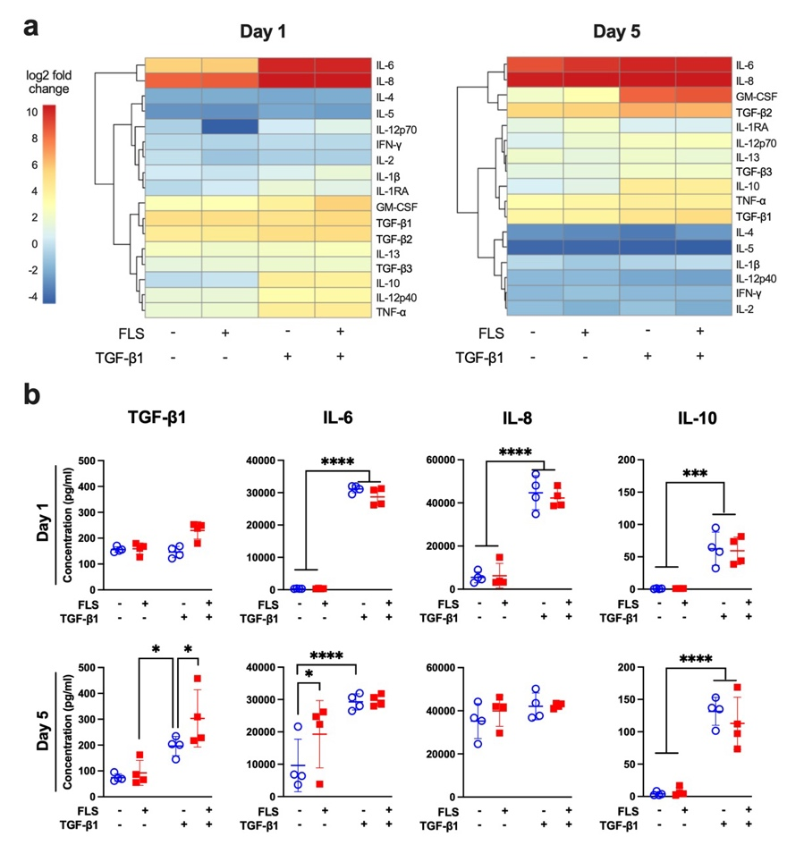

Figure 6. Presence of FLS and TGF-β1 signaling modulate cytokine secretion profiles. a, Heatmaps showing cytokine profiles at Days 1 and 5 comparing ±FLS devices cultured with or without TGF-β1. Results are presented as log2 fold change from the -TGF-β1, -FLS baseline condition. Rows are clustered by similar protein expression patterns. At both time points, IL-6 and IL-8 are significantly elevated. b, Plots detailing the concentrations of secreted active TGF-β1, IL-6, IL-8, and IL-10 from device supernatants. Data are mean ± s.d. (n = 4 devices per condition); Two-way ANOVA with Tukey’s post-hoc test; *p<0.05, ****p<0.0001.

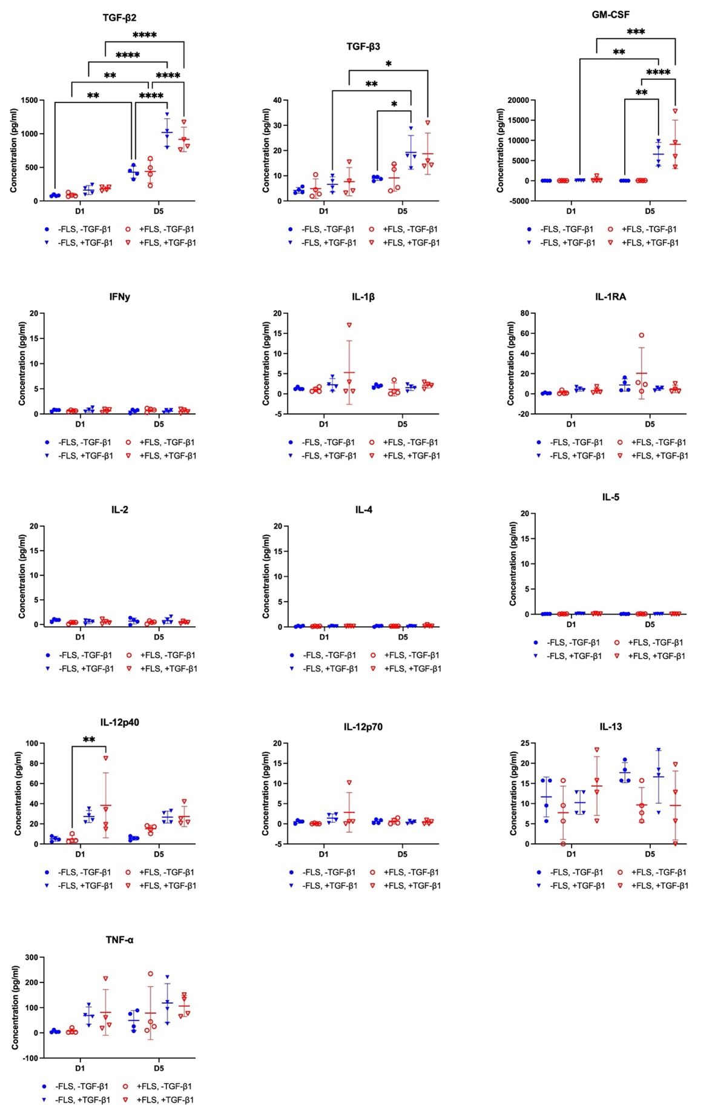
Supplementary Figure S4. Detailed cytokine expression profiles from sampled supernatants assayed via multiplex analysis. Each plot contains data from devices cultured ±FLS and ±TGF-β1 at Days 1 and 5. All device conditions had significantly elevated TGF-β2 levels from Day 1 to Day 5. TGF-β1-stimulated devices had significantly higher levels of TGF-β2 at Day 5 compared to non-stimulated devices. For +FLS devices, TGF-β3 levels were significantly elevated from Day 1 to Day 5, regardless of TGF-β1 stimulation. GM-CSF levels remained low across all conditions at Day 1 and for -TGF- β1 devices at Day 5. TGF-β1-stimulated devices had significantly elevated GM-CSF levels at Day 5. IFNγ, IL-1β, IL-1RA, IL-2, IL-4, IL-5, and IL-12p70 overall had levels <5 pg ml⁻¹ across all conditions. In +FLS devices, IL-12p40 increased with TGF-β1 stimulation at Day 1. IL-13 and TNF-α demonstrated no distinct trends among conditions.

2.6. Pharmacological IL-6/JAK/STAT inhibition suppresses inflammatory synovial activation and adhesion-associated matrix contacts
Given the roles of IL-6 in tendon-fibroblast activation[47] and leukocyte recruitment[48, 49], we tested whether pharmacologic inhibition of the IL-6/JAK/STAT axis could mitigate early adhesion-associated phenotypes without exogenous TGF-β1 supplementation. FLS-laden synToC devices were treated with two FDA-approved drugs targeting the IL-6/JAK/STAT signaling axis. Tocilizumab (TCZ) is a recombinant monoclonal antibody directed against soluble and membrane-bound interleukin-6 receptors (IL-6R)[50], and tofacitinib (TOFA) is a small-molecule inhibitor of JAK1, JAK2, and JAK3[51, 52] (Figure 7a). From the tested concentration ranges, we selected 10 µg ml⁻¹ TCZ and 100 ng ml⁻¹ TOFA because they attenuated nuclear pSTAT3 in FLS monocultures without adversely affecting EC or FLS viability (Supplementary Figure S5). pSTAT3 is the activated form of the STAT3 transcription factor and regulates cell growth, survival, differentiation, and inflammation[53]. These concentrations are consistent with reported steady-state serum concentrations[54, 55].

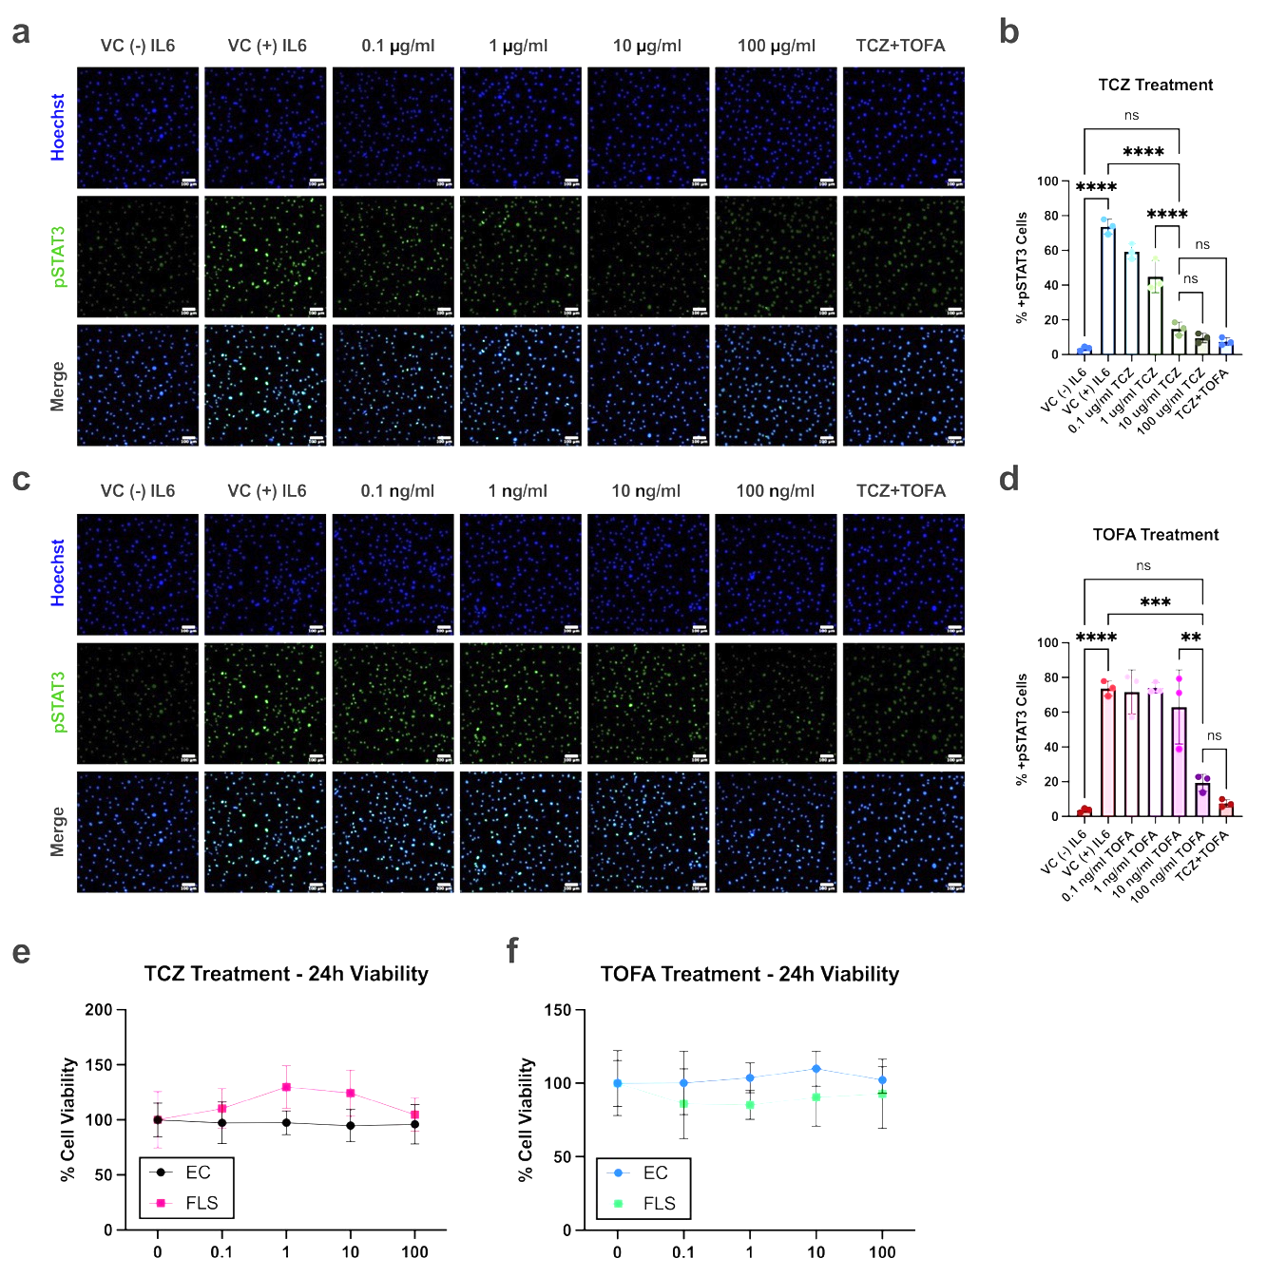
Supplementary Figure S5. Tocilizumab dose-dependently inhibits IL-6-induced STAT3 activation in FLS while preserving FLS and endothelial viability across clinically relevant concentrations. a, Immunofluorescence images of FLS cultured in a monolayer showing nuclear pSTAT3 expression (green), with Hoechst (blue) as nuclear counterstain. FLS were stimulated with IL-6 and treated with a range of tocilizumab (TCZ) concentrations (0.1 μg ml⁻¹-100 μg ml⁻¹). pSTAT3 expression was compared to a negative vehicle control (VC) without IL-6 stimulation as well as a positive VC with IL-6 stimulation. A 10 μg ml⁻¹ TCZ + 10 ng ml⁻¹ tofacitinib (TOFA) treatment was also introduced, based on common dose concentrations found in the literature. b, Image quantification of panel a, reported as the percent pSTAT3+ cells. Nuclear pSTAT3 demonstrated a dose response to TCZ treatment. The most significant drop in pSTAT3 expression occurred from 1 μg ml⁻¹ to 10 μg ml⁻¹ TCZ, while there are no significant differences between 10 μg ml⁻¹ and 100 μg ml⁻¹ or 10 μg ml⁻¹ and combination treatment. c, Nuclear pSTAT3 expression in FLS stimulated with IL-6 and treated with 0.1 ng ml⁻¹-100 ng ml⁻¹ TOFA. d, TOFA had no impact on pSTAT3 levels until the highest dose of 100 ng ml⁻¹. Combination treatment was not significantly different than 100 ng ml⁻¹ TOFA. One-way ANOVA with Tukey’s post-hoc test: n=3 wells per condition, **p<0.01, ***p<0.001, ****p<0.0001. e, FLS and EC cell viability determined by CCK8 assay after 24 h of TCZ treatments. f, FLS and EC cell viability determined by CCK8 assay after 24 h of TOFA treatments. No significant differences in cell viability between untreated controls and TCZ or TOFA doses.

FLS-laden devices were treated with either 10 µg ml⁻¹ TCZ or 100 ng ml⁻¹ TOFA starting at Day 0, following full assembly of the vascular-synovial and tendon compartments (Figure 7a). Drug treatment media was replaced in the vascular compartment daily from Day 0 to Day 5. Immunofluorescence staining demonstrated reduced pSTAT3 expression within the synovial gel following TCZ or TOFA treatment (Figure 7b,c), although pJAK2 expression was not affected (Supplementary Figure S6).

TOFA, but not TCZ, significantly reduced tendon hydrogel contraction over time, demonstrating attenuation of intrinsic matrix-driven tissue remodeling (Figure 7d). Analysis of soluble mediators at Day 5 demonstrated a two-fold reduction in MCP-1 in both apical and basal compartments with TCZ and TOFA treatment (Figure 7f), along with significant suppression of IL-8 in both compartments. IL-6 concentrations remained detectable and were not significantly altered, consistent with receptor or downstream-pathway inhibition rather than cytokine depletion. Consistent with reduced chemokine concentrations, monocyte infiltration was significantly attenuated at Day 2 with TCZ treatment (Figure 7e). At the cellular level, TCZ significantly reduced collagen III deposition within the synovial gel (Figure 7g,h), and both TCZ and TOFA suppressed collagen III accumulation within the tendon compartment (Figure 7g,i). Although fibronectin expression within the TCZ-treated synovial gel appeared elevated (Figure 7j), both TCZ and TOFA significantly reduced fibronectin-defined interfacial contacts between the synovial and tendon gels (Figure 7k). Synovial cell density was also reduced in TCZ- and TOFA-treated chips, indicating that both treatments attenuated synovial cell expansion (Figure 7l).
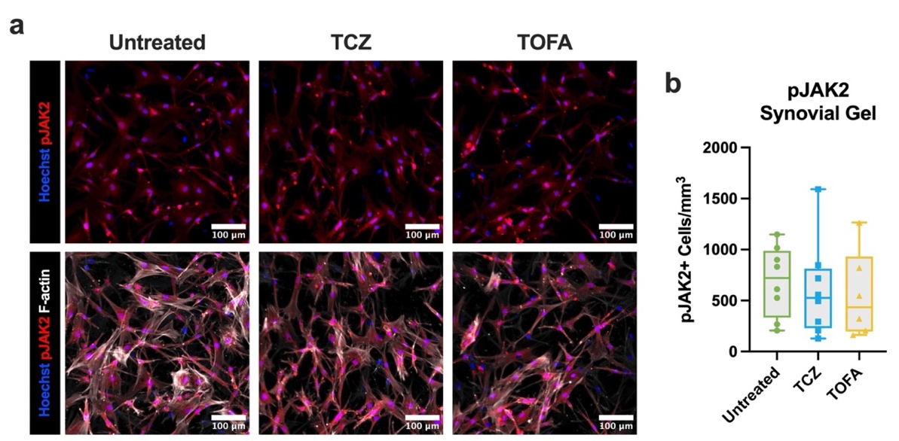
Supplementary Figure S6. Tocilizumab and tofacitinib treatment do not alter synovial JAK2 phosphorylation in +FLS devices at Day 5. a, Day 5 immunofluorescence images of the synovial gels of -TGF- β1, +FLS devices treated with either 10 μg ml⁻¹ TCZ or 100 ng ml⁻¹ TOFA compared to untreated controls. Devices were stained pJAK2 (red), Hoechst (blue), and F-actin (white). b, Quantification of cytoplasmic pJAK2 expression, plotted as the number of pJAK2+ cells mm⁻³. pJAK2 expression was consistent among all treatment conditions.
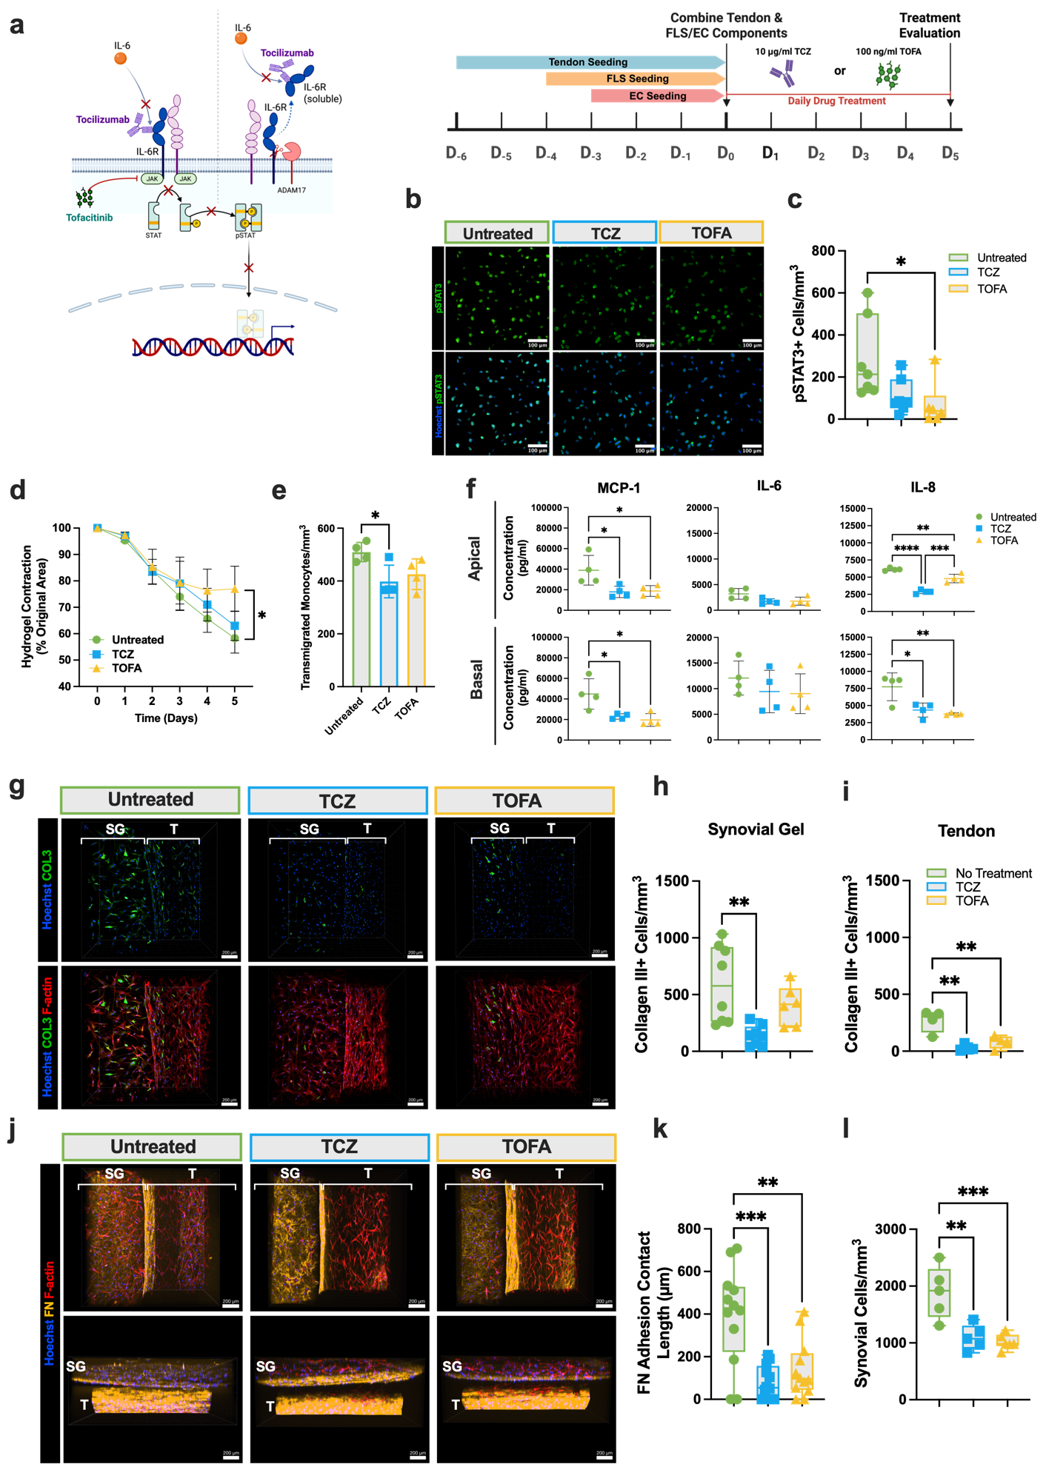
Figure 7. Tocilizumab and tofacitinib attenuate synovial JAK/STAT activation, collagen III deposition, and fibronectin-defined synovial-tendon matrix contacts. a, Drug-treatment strategy and experimental timeline for the synToC drug-testing scheme, outlining the mechanisms and timing of tocilizumab (TCZ) and tofacitinib (TOFA) dosing. b, Nuclear pSTAT3 expression in the synovial gel, with c, quantification demonstrating a significant reduction in pSTAT3 immunofluorescence with TOFA treatment. d, Quantification and representative images of tendon hydrogel contraction from Days 0-5, plotted as the percentage of original hydrogel area. t-test at each time point: n=4 devices, *p<0.05. e, Monocyte transmigration at Day 2, reported as the number of monocytes transmigrated per unit volume. f, Secreted cytokine levels measured in Day 5 supernatants sampled from the apical (endothelial) and basal (tendon) compartments. One-way ANOVA with Tukey’s post-hoc test: n=4 devices per condition, *p<0.05, **p<0.01, ***p<0.001. g, Immunofluorescent confocal images at Day 5 of synToC culture, with collagen III (green), Hoechst (blue), and F-actin (red). Images compare untreated control, TCZ, and TOFA groups. Quantification of collagen III+ cells in the h, synovial gel (SG) and i, tendon (T). TCZ significantly attenuated collagen III expression in the synovial gel, while both treatments significantly decreased collagen III expression in the tendon. One-way ANOVA with Tukey’s post-hoc test: n=8 devices per condition, **p<0.01. j, Confocal image reconstructions of Day 5 synToC devices showing a top-down view (top row) and a side view (bottom row). Devices were stained for fibronectin (yellow), Hoechst (blue), and F-actin (red) to compare fibronectin-defined interfacial contacts between untreated and treated devices at Day 5. k, Quantification of the structural adhesion-contact-length metric. Both TCZ and TOFA significantly reduced fibronectin contacts between the synovial and tendon gels. One-way ANOVA with Tukey’s post-hoc test: n=12 devices per condition, **p<0.01, ***p<0.001. l, Total cell density in the synovial gel, reported as cells mm-3. Untreated synToC devices had significantly greater synovial cell density than drug-treated devices. One-way ANOVA with Tukey’s post-hoc test: n=5 devices per condition, **p<0.01, ***p<0.001.

3. Discussion

We first established an endothelial-synovial interface to model the native tendon-sheath microenvironment[28, 56]. Consistent with prior endothelial-synovial chip models[57], FLS retained characteristic synovial phenotypes, including cadherin-11 and PRG4 expression, while endothelial cells formed continuous VE-cadherin junctions. By seeding FLS within a collagen gel rather than as a monolayer, the co-culture reproduced a three-dimensional synovial ECM compartment and exhibited FLS proliferation and increased collagen III deposition. This response is consistent with in vivo observations of post-injury scar tissue and synovial fibrosis[17, 58]. TGF-β1 supplementation enhanced collagen III expression, whereas FLS proliferation also occurred without exogenous TGF-β1. Because active TGF-β1 was measurable in all conditions, this result is interpreted as independence from exogenous supplementation, not independence from TGF-β signaling.
The scientific and technological advance of the synToC is therefore not a new chip material or flow circuit, but a new use of the validated modular architecture to model an interfacial pathology. Unlike the prior hToC and single-compartment fibroblast cultures, the synovial and tendon constructs begin as physically distinct tissues, allowing de novo ECM bridges to be visualized and quantified while extrinsic and intrinsic cellular contributions remain experimentally separable.

Synovial fibroblasts regulated early tendon-matrix remodeling in the synToC, likely through paracrine signaling within the synovial-tendon microenvironment. With exogenous TGF-β1, tendon contraction was comparable with or without FLS, consistent with TGF-β1 acting as a dominant profibrotic stimulus[1, 19, 59, 60]. Without exogenous TGF-β1, the FLS-containing condition increased tendon contraction relative to acellular synovial controls. Active TGF-β1 was nevertheless detected in device supernatants across conditions; accordingly, the data do not demonstrate TGF-β1-independent fibrosis. Instead, they show that addition of exogenous TGF-β1 was not required for FLS-associated early contraction, α-SMA expression, and matrix bridging within this system. Endogenous TGF-β1 may participate through autocrine or paracrine feedback, potentially together with IL-6 signaling. FLS-driven contraction could also alter matrix sequestration and local activation of TGF-β1[61], although tissue-level TGF-β1 activity was not measured. The decline in α-SMA+ cells between Days 1 and 5, together with more organized stress fibers at Day 5, is interpreted as remodeling over the early observation window and not as evidence of mature scar formation.
The experiments were intentionally conducted under static conditions to isolate the synovial contribution and permit direct comparison with prior static hToC phenotypes[19]. Static operation does not remove the platform’s organ-on-chip attributes: the ultrathin porous membrane, modular independent assembly, optical access to a three-dimensional tissue interface, and transendothelial cell trafficking distinguish the synToC from a standard Transwell. A quantitative meta-analysis of 146 perfused organ-on-chip studies found that most biomarkers were unaffected by flow and that benefits were specific to particular cell types and biomarkers[86]. No claim is made that the present configuration reproduces hemodynamic shear or mechanical loading; the conclusions are limited to early multicellular and interfacial responses under the defined static condition.

Beyond early tendon-matrix remodeling, synovial fibroblast crosstalk promoted deposition of adhesion-like matrix at the tendon-synovial interface. Peritendinous adhesions after tendon injury involve both intrinsic tendon fibroblasts and extrinsic cells from surrounding tissues, including synovium and the circulation[64]. Fibroblast adhesion and chemotaxis shortly after injury are also linked to fibronectin and type III collagen secretion[11, 65]. Correspondingly, FLS-containing synToC devices exhibited greater fibroblast proliferation, migration, and interfacial matrix deposition without exogenous TGF-β1 supplementation. CD90, a surface marker associated with activated fibroblasts in fibrosis[66, 67], was enriched in the FLS-containing synovial compartment. Tendon-resident fibroblasts migrated externally and deposited fibronectin in -FLS controls, but CD90 expression and interfacial contacts were less pronounced, consistent with reports of reduced CD90 expression in inflammation-stimulated tendon-resident cells[68]. The spatially separated compartments therefore resolve extrinsic synovial and intrinsic tendon contributions that cannot be distinguished in a single mixed culture. The adhesion-contact-length endpoint quantifies structural fibronectin continuity between compartments; it does not establish impaired tendon gliding or mechanical adhesion strength.

Early adhesion-associated matrix bridging was accompanied by elevated inflammatory cytokines and enhanced monocyte transmigration, consistent with the coupling of fibrosis and immune-cell recruitment[69, 70]. These observations support non-canonical roles for stromal cells as immune sentinels that produce chemokines and guide immune-cell recruitment and activation[71]. In this defined in vitro system, the FLS-containing synovial compartment increased monocyte transmigration and enabled direct assessment of stromal-immune crosstalk. Among the measured signals, IL-6 emerged as a plausible mediator of adhesion-associated responses without exogenous TGF-β1 supplementation. IL-6 is upregulated in peritendinous adhesion tissue[72-74] and can promote cell proliferation, matrix secretion, and angiogenic signaling through JAK/STAT pathways[75, 76]. Because CD90+ fibroblasts have been identified as sources of IL-6[77], the results support a model in which synovial fibroblasts amplify IL-6 signaling and nominate IL-6/JAK/STAT as a candidate therapeutic pathway rather than establishing TGF-β1 independence.

Although TGF-β1 is a well-established driver of adhesions[1], its pleiotropic role in tendon repair complicates direct therapeutic inhibition[59, 60]. The IL-6/JAK/STAT pathway therefore represents an alternative candidate pathway, consistent with animal studies using experimental IL-6 or JAK/STAT inhibitors[78-80]. In the synToC, tocilizumab and tofacitinib attenuated several early adhesion-associated readouts, including collagen III deposition, synovial cell expansion, inflammatory mediators, and fibronectin-defined interfacial contacts. IL-6 levels remained detectable[81], whereas MCP-1 and IL-8 decreased, consistent with reduced inflammatory recruitment signals. These findings provide human in vitro evidence that IL-6/JAK/STAT inhibition modulates early molecular and structural adhesion-associated phenotypes; they do not by themselves establish clinical efficacy or prevention of functional adhesions.

This study has several limitations that define the scope of its conclusions. The FLS and tendon fibroblasts each came from a single donor, and replicate devices were generated from those same stromal-cell sources. The device replicates therefore demonstrate reproducibility within a defined donor background but do not constitute donor-level biological replication or support generalization across donor variability. FLS were obtained from normal joint synovium rather than flexor tendon-sheath synovium, and tendon fibroblasts were isolated from tenolysis tissue and may retain epigenetic or transcriptional memory of prior fibrosis. These sources make the model relevant to a defined pathological context but do not represent healthy tendon-sheath biology. The type I collagen hydrogel was used as a conventional, constant permissive matrix, and no claim of biomaterial innovation or optimization is made. The model was operated under static conditions without mechanical loading; conclusions therefore do not extend to flow- or load-dependent responses. Finally, the five-day window captures initiation of inflammatory, cellular, and interfacial matrix responses, not chronic inflammation, mature collagen remodeling, persistent myofibroblast behavior, mechanical adhesion strength, or impaired tendon gliding.

Peritendinous adhesions remain a significant clinical challenge, with no approved therapies that prevent or reverse adhesion formation[6, 84]. The synToC addresses an experimental gap by placing a three-dimensional FLS-containing synovial compartment, an endothelial barrier, immune cells, and a tendon construct within a modular tissue interface. Its principal advance is the ability to distinguish extrinsic synovial from intrinsic tendon responses and to visualize and quantify de novo fibronectin- and collagen III-rich matrix continuity between previously separated compartments. Over the five-day observation window, FLS increased tendon contraction, synovial cell expansion, IL-6 and IL-8 secretion, monocyte transmigration, and early adhesion-like matrix bridging without exogenous TGF-β1 supplementation. Because endogenous active TGF-β1 was detected, these findings do not establish TGF-β1 independence. Tocilizumab and tofacitinib reduced several molecular and structural readouts, supporting use of the platform for mechanism-informed drug testing. The interfacial contact metric remains a structural imaging endpoint rather than a functional measurement of tendon gliding. Within these boundaries, the synToC provides a human-relevant NAM for studying early multicellular events in peritendinous adhesion pathogenesis.

4. Conclusions
We establish the synToC as a human multicompartment model of early adhesion-associated events at the synovial-tendon interface. By adding a three-dimensional FLS-containing synovial compartment to a previously validated tendon-on-chip architecture, the model separates extrinsic synovial and intrinsic tendon responses while retaining an endothelial barrier and immune-cell trafficking. FLS promoted synovial cell expansion, inflammatory signaling, tendon remodeling, and fibronectin- and collagen III-rich matrix bridging without exogenous TGF-β1 supplementation, although endogenous active TGF-β1 remained present. IL-6/JAK/STAT inhibition attenuated several molecular and structural phenotypes, supporting mechanism-informed therapeutic testing. The model does not reproduce chronic adhesion maturation or directly measure tendon gliding or mechanical adhesion strength; its validated scope is the initiation and quantification of early interfacial matrix-contact formation under defined static conditions.

5. Methods

5.1. Cell culture details
Primary human fibroblast-like synoviocytes (FLS) were obtained from Cell Applications (San Diego, CA). The FLS donor was a 63-year-old Caucasian male, and the cells were isolated from normal joint synovial tissue. FLS were expanded in T-75 flasks in Synoviocyte Growth Medium (Cell Applications, 415K-500). Tendon fibroblasts were isolated from tenolysis tissue under an approved University of Rochester Institutional Review Board protocol (STUDY00004840). The tendon-cell donor was an 80-year-old Caucasian male, and cells were isolated from the left ring digital flexor tendon. Tendon fibroblasts were expanded in T-175 flasks in MEM Alpha medium (Gibco, 12571063) supplemented with 10% FBS and 1% penicillin-streptomycin and verified for scleraxis expression using immunofluorescence. Experiments used this single FLS donor and single tendon-fibroblast donor; replicate devices therefore do not constitute independent stromal-donor replication. Cryopreserved pooled human umbilical vein endothelial cells (HUVECs) were purchased from Vec Technologies Inc. and expanded in T-25 flasks (Corning Inc., 430639). HUVECs were cultured in EGM-2 Endothelial Cell Growth Medium (Lonza, CC-3162). All cells were maintained under standard culture conditions (37ºC, 5% CO₂, 95% humidity) and used between passages 2 and 6.

5.2. Peripheral blood mononuclear cell (PBMC) isolation and CD14 + monocyte sorting
PBMCs were isolated fresh before each experiment from healthy donors with informed consent according to an approved protocol by the University of Rochester Institutional Review Board (STUDY0004777). All methods were performed in accordance with relevant guidelines and regulations. First, PBMCs were isolated from whole blood samples using SepMate™ according to the manufacturer instructions (Stem Cell Technologies, 85460). The enriched PBMCs were washed with 1X DPBS + 2% FBS twice by centrifuging at 300 x g for 8 minutes at room temperature. After removing the supernatant, the cell pellet was resuspended in isolation buffer consisting of 1X DPBS (Gibco, 14190250), 2 mM EDTA (Gibco, 15575020), and 1 mg ml⁻¹ BSA. The cell suspension was filtered through a 70 µm cell strainer, spun down at 300 x g for 3 min, and suspended in 80 µl of isolation buffer. To sort for CD14+ monocytes, CD14 microbeads (Milltenyi Biotec, 130-050-201) were added to the cell suspension and incubated at 4°C for 15 min. The cell suspension was again centrifuged at 300 x g for 3 min and the cells were suspended in 500 µl of isolation buffer. A QuadroMACS™ separator was assembled with an LS column (Milltenyi Biotec, 130-042-401) and the 500 µl cell suspension was added to the column. The column was washed 3 times with 3 ml of isolation per wash. CD14+ monocytes were then flushed out of the column and used in experiments within 3 h of blood collection.

5.3. synToC device components and nanomembranes
The microfluidic synToC device consists of two acrylic components as well as an accessory reservoir component (18 cm length x 9 cm width) manufactured by ALine Inc. (Signal Hill, CA) separated by a 3-µm dual-scale nanomembrane. Silicon nitride nanomembranes manufactured by SiMPore, Inc. (Henrietta, NY) and serve as biocompatible substrates for cell culture. 3 µm dual-scale membranes (~100 nm thick, ~60 nm diameter nanopores, 3 µm diameter micropores, ~15% nanoporosity, ~0.7% microporosity) were used in this study. We have previously validated that 3 µm dual-scale membranes permit monocyte transmigration[24]. Components were assembled in sterile conditions in a biological safety cabinet, as previously described[19, 85]. Briefly, a membrane chip was placed on a custom assembly jig in a non-inverted orientation using notched chip tweezers. This results in a trench-up chip configuration for the final assembled device. The protective layers surrounding the top component were removed to expose a pressure-sensitive adhesive (PSA). The top component was placed over the nanomembrane and pressed firmly with the jig to activate the PSA. The outer protective layers were removed from the bottom component, while keeping the final masking layer intact to keep the PSA covered. The bottom component and reservoir were placed in a petri dish alongside the assembled top component and membrane. All components were sterilized under UV for 20 minutes.

5.4. synToC culture timeline
The integrated synToC was prepared as outlined in Figure 1a. Tendon fibroblasts were lifted from flasks by rinsing with 1X DPBS and applying 0.25% trypsin-EDTA for 3 min. Tendon fibroblasts and freshly isolated monocytes were encapsulated in a type I collagen hydrogel (Advanced BioMatrix, 5026) at a 7:1 ratio of tendon fibroblasts to monocytes (tendon fibroblast density: 400,000 cells ml⁻¹). The same conventional collagen formulation was used across all groups as a permissive three-dimensional matrix and was not varied as an experimental biomaterial. A 100 µl hydrogel cell suspension was added to the bottom component and allowed to crosslink in the incubator for 20 min. The protective layer was then removed from the reservoir component, and the reservoir was attached to the bottom component. The hydrogels were scored along the long edges between anchors to enable contraction throughout culture. X-VIVO 10 medium (200 µl; Lonza, 04-380Q) supplemented with 20 ng ml⁻¹ M-CSF (PeproTech, 300-25) was added to each reservoir. Hydrogels were cultured for 6 days (D₋₆ to D₀), with daily half-medium replacements. At D₋₄, top components were rinsed with 100 µl 1X DPBS. The apical side of the nanomembrane was coated with fibronectin at 5 µg cm-2 for 1 h at room temperature. The coating solution was removed and replaced with 50 µl Synoviocyte Growth Medium. FLS were lifted from flasks by rinsing with HBSS (Gibco, 14175095) and applying 0.25% trypsin-EDTA for 3 min. FLS were encapsulated in type I collagen hydrogel (Advanced BioMatrix, 5026) at 100,000 cells ml⁻¹. A 15 µl FLS gel was added to the basal side of the nanomembrane; -FLS devices received 15 µl hydrogel without FLS. Devices remained inverted while the hydrogels crosslinked for 15 min. Reservoir components were adhered to a separate petri dish and filled with 200 µl Synoviocyte Growth Medium. Top components with crosslinked hydrogels were flipped onto the media reservoirs with the open well facing upward. After 24 h, HUVECs were lifted by rinsing with 1X DPBS and applying 0.25% trypsin-EDTA for 3 min. Reservoir medium was replaced with a 1:1 ratio of Synoviocyte Growth Medium:EGM-2, and HUVECs were seeded on the apical membrane surface at 130,000 cells ml⁻¹. At D₋₂ and D₋₁, reservoir and top-well medium was replaced with a 1:1 ratio of X-VIVO 10:FLS-EC co-culture medium. At D₀, the upper endothelial-synovial component and lower tendon component were combined after removal of the bottom reservoir. Freshly isolated monocytes were added to the apical well at 100,000 cells ml⁻¹ (10,000 monocytes/device). X-VIVO 10 medium with or without 10 ng ml⁻¹ TGF-β1 was added to the bottom channel. The 10 ng ml-1 dose served as a profibrotic positive control that matched our prior hToC protocol and conditions used in flexor-tendon fibrosis studies[58-60]; it was not intended to reproduce a measured in vivo concentration. Analyses at Days 1, 3, and 5 were selected to capture early cellular activation, monocyte trafficking, and initiation of matrix bridging; Day 5 was the prespecified terminal point for this early-phase model and was not interpreted as mature or chronic adhesion. While prior work demonstrated flow-sensitive endothelial-monocyte responses[24], devices here were maintained in static culture to isolate synovial contributions and benchmark the prior static hToC condition[19]. Static operation retained modular tissue assembly, ultrathin membrane separation, imaging access, and transendothelial cell trafficking but did not model hemodynamic shear or mechanical loading. This scope is consistent with a quantitative meta-analysis showing that perfusion effects across organ-on-chip studies are biomarker- and tissue-dependent and that micrometer-scale cell positioning does not require continuous flow[86].

5.5. Drug treatments
For therapeutic drug-treatment experiments, tocilizumab (Selleck Chemicals, A2012) and tofacitinib citrate (Selleck Chemicals, S5001) were prepared by serial dilution in X-VIVO 10 medium. A preliminary efficacy study identified concentrations that reduced nuclear pSTAT3 expression relative to the untreated vehicle control while preserving cell viability. The vehicle control for tocilizumab was 0.75% DPBS, and the vehicle control for tofacitinib was 0.01% DMSO. Tocilizumab concentrations were 0.1, 1, 10, and 100 μg ml⁻¹, and tofacitinib concentrations were 0.1, 1, 10, and 100 ng ml⁻¹. A combination of 10 μg ml⁻¹ tocilizumab + 10 ng ml⁻¹ tofacitinib was also tested. FLS were cultured in monolayer in a 96-well plate at 70,000 cells ml⁻¹ in serum-free X-VIVO 10 medium. All conditions except the negative vehicle control were incubated with 10 ng ml⁻¹ IL-6 (R&D Systems, 206-IL-010) and the respective drug treatment for 30 min. Cells were then fixed with 4% paraformaldehyde and labeled for pSTAT3 by immunofluorescence. For synToC drug-treatment experiments, 10 μg ml⁻¹ tocilizumab or 100 ng ml⁻¹ tofacitinib was added to the apical compartment at D₀. Daily half-replacements were performed until D₅ by removing 50 μl medium from the apical compartment and adding 50 μl fresh drug-containing medium.

5.6. Cell viability assays
To compare FLS cell viability in different media conditions, a LIVE/DEAD™ Viability/Cytotoxicity Kit (Invitrogen, L3224) was used according to the manufacturer’s protocol. FLS were encapsulated in a type I collagen hydrogel at a density of 100,000 cells ml⁻¹ and cultured in a 96 well-plate, with 30 µl of hydrogel per well. X-VIVO 10, Synoviocyte Growth Medium, FLS-EC co-culture media, or a 1:1 ratio of X-VIVO 10 media:FLS-EC co-culture media was applied, and cell viability was determined after 1, 3, and 6 days of culture. A Cell Counting Kit-8 assay (Tocris Biosciences, 7368) was used to determine cell viability of FLS and HUVECs cultured in their respective medias supplemented with tocilizumab (0.1-100 µg ml⁻¹) or tofacitinib (0.1-100 ng ml⁻¹) treatment. Percent cell viability was calculated as the experimental absorbance divided by the vehicle control absorbance.

5.7. Live cell tracking and monocyte infiltration quantification
CellTracker Green CMFDA (Thermo Fisher, C2925), CellTracker Orange CMTMR (Thermo Fisher, C2927), and CellTracker Deep Red (Thermo Fisher, C34565) were used to visualize the spatial localization of tendon fibroblasts, FLS, and monocytes, respectively, within the synToC device. To capture monocyte infiltration from the vascular side to the tendon compartment, monocytes were labeled with CellTracker Deep Red and imaged at Days 1, 3, and 5. Confocal z-stack images were acquired with an Andor spinning disk confocal microscope (Andor Technology, United Kingdom) on Fusion software with a 10x objective and a 4 µm step size. Devies were placed on an incubation stage at standard conditions for the entire imaging session to prevent cell death during imaging. Images were processed in Imaris (Oxford Instruments, United Kingdom).
Confocal images collected on experimental Days 1, 3, and 5 were imported into Imaris for three-dimensional visualization and quantitative analysis of transmigrated monocytes. Images were centered and oriented to ensure uniformity across the images, with the membrane positioned as the upper layer of the stack. Devices were divided into two regions of interest: the membrane and the tissue compartment. Monocyte quantification was performed using the Imaris Spots detection tool. Automatic spot detection was applied, followed by adjustment of the minimum and maximum quality thresholds as needed to accurately identify individual cells. The final quality threshold value used for each image was kept consistent across all images. The total number of transmigrated monocytes mm⁻³ was calculated by dividing the number of transmigrated monocytes by the volume of the tissue compartment. Quantification was recorded for 4 devices per condition and plotted in Graphpad Prism.

5.8. Immunofluorescence microscopy quantification
To prepare devices for immunofluorescence staining, devices were first washed with DPBS. The top and bottom channels were fixed with 4% paraformaldehyde (Invitrogen, I28800) for 10 min. Top and bottom channels were washed three times with DPBS, and then blocked for 1 h at room temperature with DBPS containing 3% BSA + 0.3% Triton X-100. Following another wash step in DPBS, primary antibodies were diluted in DBPS containing 3% BSA. Primary antibodies were added to the top and bottom channels and incubated overnight at 4ºC. Devices were then washed with DPBS 3 times as follows: 200 µl was flushed through bottom channel 2 times, then 50 µl fresh DPBS was added to the top and bottom channel for 20 min. A second blocking step was carried out with 10% goat serum for 30 min at room temperature. Secondary antibodies were diluted in 5% goat serum and incubated in devices for 2 h at room temperature. Devices were then washed with DPBS 4 times in the same manner as the primary antibody washes. Hoechst nuclear stain was added for 5 min, followed by 2 more DPBS washes of the top and bottom channels. Detailed primary and secondary antibody information is included in Supplementary Table S1. Images were acquired with an Andor spinning disk confocal microscope on Fusion software with a 10x objective and a 4 µm step size. Images were processed in Imaris and the same brightness and contrast settings were kept consistent across all images of the same marker.
The Spots object detection tool in Imaris was used to identify nuclei based on Hoechst staining intensity. The number of synovial cells in two fields of view in 4 devices was quantified, and synovial cell density was calculated by dividing the cell count by the synovial gel volume.
Immunofluorescence images of α-SMA and Ki67 in the tenon hydrogel were analyzed in Imaris. The Surfaces object detection tool was used to generate a 3D render of the cell bodies based on F-actin labeling. The F-actin surface served as a mask for intensity classification for proteins of interest. A positive classification threshold was determined for both α-SMA and Ki67 and kept consistent throughout analysis. The percent positive expressing cells was calculated by dividing the number of positive cells by the total number of cells.
Immunofluorescence images of collagen III, Ki67, and CD90 were analyzed in Imaris. F-actin surfaces were generated for collagen III and CD90 analysis, while Hoechst (nuclear) surfaces were generated for Ki67 and pSTAT3 analysis. A positive classification threshold was determined for each protein and kept consistent throughout analysis. Positive cell density was calculated by dividing the number of positive cells by the total volume of the synovial gel or tendon gel.
Mean values for immunofluorescence quantification were determined per image based on two fields of view in 4 device replicates and plotted in GraphPad Prism.

5.9. Second harmonic generation (SHG) microscopy
To visualize collagen fibers within the tendon hydrogels, multiphoton images were acquired using an Olympus FVMPE-RS multi-photon microscope with a 25X (NA 1.5) objective (Olympus Scientific, Waltham, MA). Devices were illuminated with 800-nm light generated by a Mai Tai HP Deep See Ti:Sa laser (Spectra-Physics, Santa Clara, CA) and collagen was visualized using second harmonic generation. Bandpass filters of 370-410 nm (collagen, SHG) or 575-630 nm (AF567-phalloidin) were applied. Images were acquired beginning 50 µm below the surface of the hydrogel with a 1.25x zoom and a 5 µm z-step size. SHG signal intensity was measured in FIJI from 3 fields of view in 4 replicate devices per condition at the same z-height. Mean intensity per condition was plotted using GraphPad Prism.
5.10. Structural interfacial matrix contact length
A surface was generated from fibronectin immunofluorescence signal in Imaris. Using built-in measuring tools, we measured the length of fibronectin signal that contacted both the synovial and tendon gels in four independent devices per condition and plotted the values in GraphPad Prism. This imaging-derived structural metric, termed adhesion contact length in the figures, quantifies matrix continuity between compartments and is not a measurement of tendon gliding, sliding resistance, or mechanical adhesion strength.

5.11. Cytokine analysis
Secreted cytokine levels were quantified using a multiplex fluorescent bead assays. To compare cytokine levels in devices ±TGF-β1 and ±FLS, 50 µl of media was sampled from the top vascular channel and diluted 1:2 in X-VIVO 10 media. Media supernatants were stored at -80°C until shipment on dry ice to Eve Technologies (Calgary, Alberta, Canada). Supernatants were analyzed with the Human Cytokine Proinflammatory Focused 15-Plex Discovery Assay® Array (HDF15) and the TGFB 3-Plex Discovery Assay® Multi Species Array (TGFβ1-3). For the synToC drug treatment experiment, media was sampled from the top vascular channel (apical) as detailed above. Additionally, media was sampled from the bottom channel (basal) by adding 200 µl X-VIVO 10 media to a pipette tip attached to one port, acting as a reservoir. 200 µl of media, including the ~50 µL bottom channel volume, was collected by reverse pipetting from the opposite port. Apical and basal supernatants were analyzed with a Luminex® Discovery Assay (R&D Systems) which included MCP-1, IL-6, and IL-8.

5.12. Statistical Analysis
Group sizes and experimental units are reported in each figure legend. Device-based measurements used independent devices, whereas preliminary monolayer assays used independent wells. These units do not constitute independent replication of the single FLS and tendon-cell donors described above. Statistical analyses were performed with GraphPad Prism software (GraphPad, La Jolla, CA). An unpaired t-test was used to compare two groups, and an ordinary one-way ANOVA with Tukey’s post-hoc test was used for multiple-group comparisons, with p<0.05 considered statistically significant. Grouped data were analyzed by two-way ANOVA with Tukey’s post-hoc test. Quantitative data are reported as mean ± standard deviation.

Acknowledgements
I.L., A.C., A.O., N.G., B.L.M., H.A.A., and J.L.M were supported by NIH UG3TR003281, UH3TR003281, and U2CAG088071. I.L. was also supported by the National Science Foundation Graduate Research Fellowship. Schematics were created with BioRender.com.

Data Availability Statement
All data related to the current study are available from the corresponding author upon reasonable request.

Author Contributions
Conceptualization: I.L., J.L.M., H.A.A. Experiments and Data Acquisition: I.L., A.C., A.O. Data Analysis and Interpretation: I.L., A.C., A.O., N.G., J.L.M., H.A.A. Writing Original Draft: I.L. Writing Review and Editing of Final Draft: I.L., B.L.M, J.L.M, H.A.A. Funding: B.L.M, J.L.M. H.A.A. All authors have read and approved the final submitted manuscript.

Ethics Approval
Monocytes were obtained from healthy donors with informed consent under an IRB-approved protocol at the University of Rochester (STUDY0004777). Tendon fibroblasts were isolated from tendon tissues obtained during hand surgeries with informed consent under an IRB-approved protocol at the University of Rochester (STUDY00004840). All methods were performed in accordance with relevant guidelines and regulations.

Competing Interests Statement
J.L.M. is a cofounder of SiMPore Inc., the manufacturer of the ultrathin silicon nitride membranes used in this work. H.A.A. , J.L.M., and B.L.M. are cofounders of SiObex Inc., a CRO startup. I.L., A.C., A.O., N.G. declare no conflict of interest.

References
[1] Y. Li, X. Wang, B. Hu, Q. Sun, M. Wan, A. Carr, S. Liu, X. Cao, Neutralization of excessive levels of active TGF-β1 reduces MSC recruitment and differentiation to mitigate peritendinous adhesion, Bone Research 11(1) (2023) 24.
[2] C. Liu, J. Bai, K. Yu, G. Liu, S. Tian, D. Tian, Biological Amnion Prevents Flexor Tendon Adhesion in Zone II: A Controlled, Multicentre Clinical Trial, BioMed Research International 2019(1) (2019) 2354325.
[3] A.J. Demers, T.E. Moran, F.P. Bustos, G.L. Forster, E. Natal, B.R. DeGeorge, Jr., Revision of Flexor Tendon Repair: Factors Associated With Flexor Tenolysis, Hand (N Y) 19(4) (2024) 664-670.
[4] P.R. MANSKE, Flexor Tendon Healing, Journal of Hand Surgery 13(3) (1988) 237-245.
[5] W. Zheng, J. Song, Y. Zhang, S. Chen, H. Ruan, C. Fan, Metformin prevents peritendinous fibrosis by inhibiting transforming growth factor-β signaling, Oncotarget 8(60) (2017) 101784-101794.
[6] S. Wang, P. Sha, X. Zhao, Z. Tao, S. Liu, Peritendinous adhesion: Therapeutic targets and progress of drug therapy, Computational and Structural Biotechnology Journal 23 (2024) 251-263.
[7] P.K. Beredjiklian, Biologic Aspects of Flexor Tendon Laceration and Repair, JBJS 85(3) (2003) 539-550.
[8] S.E. DiIorio, B. Young, J.B. Parker, M.F. Griffin, M.T. Longaker, Understanding Tendon Fibroblast Biology and Heterogeneity, Biomedicines 12(4) (2024) 859.
[9] R.K. Harrison, V. Mudera, A.O. Grobbelaar, M.E. Jones, D.A. McGrouther, Synovial sheath cell migratory response to flexor tendon injury: an experimental study in rats, The Journal of Hand Surgery 28(6) (2003) 987-993.
[10] Q. Zhang, Y. Yang, L. Yildirimer, T. Xu, X. Zhao, Advanced technology-driven therapeutic interventions for prevention of tendon adhesion: Design, intrinsic and extrinsic factor considerations, Acta Biomater 124 (2021) 15-32.
[11] S.C. Juneja, E.M. Schwarz, R.J. O’Keefe, H.A. Awad, Cellular and Molecular Factors in Flexor Tendon Repair and Adhesions: A Histological and Gene Expression Analysis, Connective Tissue Research 54(3) (2013) 218-226.
[12] U. Khan, J. Edwards, D. McGrouther, Patterns of cellular activation after tendon injury, Journal of Hand Surgery 21(6) (1996) 813-820.
[13] U. Khan, N.L. Occleston, P.T. Khaw, D.A. McGrouther, Differences in proliferative rate and collagen lattice contraction between endotenon and synovial fibroblasts, The Journal of hand surgery 23(2) (1998) 266-273.
[14] M.B. Klein, H. Pham, N. Yalamanchi, J. Chang, Flexor tendon wound healing in vitro: The effect of lactate on tendon cell proliferation and collagen production, The Journal of Hand Surgery 26(5) (2001) 847-854.
[15] B. Bartok, G.S. Firestein, Fibroblast-like synoviocytes: key effector cells in rheumatoid arthritis, Immunological Reviews 233(1) (2010) 233-255.
[16] A. Maglaviceanu, B. Wu, M. Kapoor, Fibroblast-like synoviocytes: Role in synovial fibrosis associated with osteoarthritis, Wound Repair and Regeneration 29(4) (2021) 642-649.
[17] S.F. Madsen, S.S. Madsen, A.S. Madrid, M.R. Andersen, A.-C. Bay-Jensen, C.S. Thudium, Fibrotic remodeling in joint diseases: induction and inhibition of fibrosis in fibroblast-like synoviocytes, Translational Medicine Communications 9(1) (2024) 18.
[18] K. Bhamidipati, A.B.R. McIntyre, S. Kazerounian, G. Ce, S.W. Wong, M. Tran, S.A. Prell, R. Lau, V. Khedgikar, C. Altmann, A. Small, R. Madhu, S.R. Presti, K.S. Anufrieva, P.E. Blazar, J.K. Lange, J.A. Seifert, L.T. Donlin, L.T. Donlin, M.H. Smith, R. Thomas, M.J. Zuscik, M.R. Clay, A.D. Clauw, M. Griffith, T. Geohring, P.M. Carry, V.M. Holers, C.L. Ackert-Bicknell, D. Moon, C.A. Hogan, R.M. Frank, M.R. Dayton, F.J. Leversedge, A.J. Seidl, L.W. Moreland, A.P. Croft, M.H. Smith, L.T. Donlin, M.J. Lewis, A.H. Jonsson, C. Pitzalis, R. Thomas, E.M. Gravallese, M.B. Brenner, I. Korsunsky, M.D. Wechalekar, K. Wei, R.A.S.L.E.N. Accelerating Medicines Partnership, A. Accelerating Medicines Partnership, N. Immune-Mediated Diseases, C. Colorado Interdisciplinary Joint Biology Program, Spatial patterning of fibroblast TGFβ signaling underlies treatment resistance in rheumatoid arthritis, Nature Immunology (2026).
[19] R.E. Ajalik, I. Linares, R.G. Alenchery, V.Z. Zhang, T.W. Wright, B.L. Miller, J.L. McGrath, H.A. Awad, Human Tendon-on-a-Chip for Modeling the Myofibroblast Microenvironment in Peritendinous Fibrosis, Advanced Healthcare Materials 14(4) (2025) 2403116.
[20] D.P. Beason, A.F. Kuntz, J.E. Hsu, K.S. Miller, L.J. Soslowsky, Development and evaluation of multiple tendon injury models in the mouse, Journal of biomechanics 45(8) (2012) 1550-1553.
[21] J. Seok, H.S. Warren, A.G. Cuenca, M.N. Mindrinos, H.V. Baker, W. Xu, D.R. Richards, G.P. McDonald-Smith, H. Gao, L. Hennessy, Genomic responses in mouse models poorly mimic human inflammatory diseases, Proceedings of the National Academy of Sciences 110(9) (2013) 3507-3512.
[22] D. Little, P.C. Amadio, H.A. Awad, S.G. Cone, N.A. Dyment, M.B. Fisher, A.H. Huang, D.W. Koch, A.F. Kuntz, R. Madi, K. McGilvray, L.V. Schnabel, S.S. Shetye, S. Thomopoulos, C. Zhao, L.J. Soslowsky, Preclinical tendon and ligament models: Beyond the 3Rs (replacement, reduction, and refinement) to 5W1H (why, who, what, where, when, how), J Orthop Res 41(10) (2023) 2133-2162.
[23] S.-C. Fu, Y.-C. Cheuk, K.-M. Chan, L.-K. Hung, M.W.-N. Wong, Is cultured tendon fibroblast a good model to study tendon healing?, Journal of Orthopaedic Research 26(3) (2008) 374-383.
[24] I. Linares, K. Chen, A. Saffren, M. Mansouri, V.V. Abhyankar, B.L. Miller, S. Begolo, H.A. Awad, J.L. McGrath, Fluid flow impacts endothelial-monocyte interactions in a model of vascular inflammatory fibrosis, Scientific Reports 15(1) (2025) 3227.
[25] M.W. Wang, W.N. Lee, C.C. Hung, J.H. Hsieh, Y.H. Chen, T. Ting-Fang Shih, J.H. Wang, N.H. Yin, H.K. Wang, Validation of the Efficacy of Ultrasound Speckle Tracking in Measuring Tendon Gliding After Finger Flexor Tendon Repair, Ultrasound Med Biol 49(12) (2023) 2548-2556.
[26] J.J. Budovec, G.S. Sudakoff, W.W. Dzwierzynski, H.S. Matloub, J.R. Sanger, Sonographic differentiation of digital tendon rupture from adhesive scarring after primary surgical repair, J Hand Surg Am 31(4) (2006) 524-9.
[27] J.E. Ackerman, V. Studentsova, M. Myers, M.R. Buckley, M.S. Richards, A.E. Loiselle, Non-Invasive Ultrasound Quantification of Scar Tissue Volume Identifies Early Functional Changes During Tendon Healing, J Orthop Res 37(11) (2019) 2476-2485.
[28] M.J. Cohen, L. Kaplan, Histology and ultrastructure of the human flexor tendon sheath, The Journal of Hand Surgery 12(1) (1987) 25-29.
[29] M. Tsuzaki, M. Yamauchi, A.J. Banes, Tendon Collagens: Extracellular Matrix Composition in Shear Stress and Tensile Components of Flexor Tendons, Connective Tissue Research 29(2) (1993) 141-152.
[30] S.G. Rees, J.R. Davies, D. Tudor, C.R. Flannery, C.E. Hughes, C.M. Dent, B. Caterson, Immunolocalisation and expression of proteoglycan 4 (cartilage superficial zone proteoglycan) in tendon, Matrix Biology 21(7) (2002) 593-602.
[31] N. Frangogiannis, Transforming growth factor-β in tissue fibrosis, J Exp Med 217(3) (2020) e20190103.
[32] B. Wu, J. Chen, T.D. Rosa, Q. Yu, A. Wang, J. Xu, M.-H. Zheng, Cellular response and extracellular matrix breakdown in rotator cuff tendon rupture, Archives of Orthopaedic and Trauma Surgery 131(3) (2011) 405-411.
[33] J.E. Ackerman, A.E.C. Nichols, V. Studentsova, K.T. Best, E. Knapp, A.E. Loiselle, Cell non-autonomous functions of S100a4 drive fibrotic tendon healing, eLife 8 (2019) e45342.
[34] W. Zheng, Y. Qian, S. Chen, H. Ruan, C. Fan, Rapamycin Protects Against Peritendinous Fibrosis Through Activation of Autophagy, Front Pharmacol 9 (2018) 402.
[35] A.E.C. Nichols, L. Benoodt, E. Adjei-Sowah, K. Jerreld, A. Kollar, C. Ketonis, A.E. Loiselle, Epitenon-derived progenitors drive fibrosis and regeneration after flexor tendon injury in a spatially-dependent manner, Nature Communications 16(1) (2025) 5448.
[36] Y. Li, T. Wu, S. Liu, Identification and Distinction of Tenocytes and Tendon-Derived Stem Cells, Frontiers in Cell and Developmental Biology Volume 9 - 2021 (2021).
[37] J.D. Ho, H.J. Chung, A. MS Barron, D.A. Ho, D. Sahni, J.L. Browning, J. Bhawan, Extensive CD34-to-CD90 Fibroblast Transition Defines Regions of Cutaneous Reparative, Hypertrophic, and Keloidal Scarring, The American Journal of Dermatopathology 41(1) (2019) 16-28.
[38] S.G. Dakin, C.D. Buckley, M.H. Al-Mossawi, R. Hedley, F.O. Martinez, K. Wheway, B. Watkins, A.J. Carr, Persistent stromal fibroblast activation is present in chronic tendinopathy, Arthritis Res Ther 19(1) (2017) 16.
[39] L. Kong, H. Chen, H. Zhang, X. Zhang, J. Chen, Y. Nie, Z. Su, L. Lin, Mechanistic Study of CD90-Positive Synovial Fibroblasts in the Invasion and Recurrence of Pigmented Villonodular Synovitis, Journal of Inflammation Research 18(null) (2025) 17129-17142.
[40] X. Zhang, Y. Xiao, B. Hu, Y. Li, S. Zhang, J. Tian, S. Wang, Z. Tao, X. Zeng, N.-N. Liu, B. Li, S. Liu, Multi-omics analysis of human tendon adhesion reveals that ACKR1-regulated macrophage migration is involved in regeneration, Bone Research 12(1) (2024) 27.
[41] V. Tan, A. Nourbakhsh, J. Capo, J.A. Cottrell, M. Meyenhofer, J.P. O'Connor, Effects of Nonsteroidal Anti-Inflammatory Drugs on Flexor Tendon Adhesion, The Journal of Hand Surgery 35(6) (2010) 941-947.
[42] I.M. Ellis, L.V. Schnabel, A.K. Berglund, Defining the profile: Characterizing cytokines in tendon injury to improve clinical therapy, Journal of Immunology and Regenerative Medicine 16 (2022) 100059.
[43] N. Bertazzolo, L. Punzi, M.P. Stefani, G. Cesaro, M. Pianon, B. Finco, S. Todesco, Interrelationships between interleukin (IL)-1, IL-6 and IL-8 in synovial fluid of various arthropathies, Agents Actions 41(1-2) (1994) 90-2.
[44] C. Dong, Cytokine Regulation and Function in T Cells, Annual Review of Immunology 39(Volume 39, 2021) (2021) 51-76.
[45] G. Trinchieri, Interleukin-12 and the regulation of innate resistance and adaptive immunity, Nature Reviews Immunology 3(2) (2003) 133-146.
[46] D.H. Kim, W.W. Lee, IL-1 Receptor Dynamics in Immune Cells: Orchestrating Immune Precision and Balance, Immune Netw 24(3) (2024) e21.
[47] T. Stauber, G. Moschini, A.A. Hussien, P.K. Jaeger, K. De Bock, J.G. Snedeker, Il-6 signaling exacerbates hallmarks of chronic tendon disease by stimulating reparative fibroblasts, eLife Sciences Publications, Ltd, 2024.
[48] S.P. Didion, Cellular and Oxidative Mechanisms Associated with Interleukin-6 Signaling in the Vasculature, International Journal of Molecular Sciences 18(12) (2017) 2563.
[49] T. Clahsen, F. Schaper, Interleukin-6 acts in the fashion of a classical chemokine on monocytic cells by inducing integrin activation, cell adhesion, actin polymerization, chemotaxis, and transmigration, Journal of Leukocyte Biology 84(6) (2008) 1521-1529.
[50] M. Sheppard, F. Laskou, P.P. Stapleton, S. Hadavi, B. Dasgupta, Tocilizumab (Actemra), Human Vaccines &amp; Immunotherapeutics 13(9) (2017) 1972-1988.
[51] B.R. Padda IS, Parmar M., Tofacitinib, In: StatPearls (2023).
[52] P.G. Traves, B. Murray, F. Campigotto, R. Galien, A. Meng, J.A. Di Paolo, JAK selectivity and the implications for clinical inhibition of pharmacodynamic cytokine signalling by filgotinib, upadacitinib, tofacitinib and baricitinib, Ann Rheum Dis 80(7) (2021) 865-875.
[53] E.C. Marginean, J. Gotfrit, H. Marginean, D.W. Yokom, J.J. Bateman, M. Daneshmand, S. Sud, A.M. Gown, D. Jonker, T. Asmis, R.A. Goodwin, Phosphorylated transducer and activator of transcription-3 (pSTAT3) immunohistochemical expression in paired primary and metastatic colorectal cancer, Transl Oncol 14(2) (2021) 100996.
[54] Pfizer, https://www.pfizermedicalinformation.com/xeljanz/clinical-pharmacology.
[55] U. Arad, O. Elkayam, Association of Serum Tocilizumab Trough Concentrations with Clinical Disease Activity Index Scores in Adult Patients with Rheumatoid Arthritis, J Rheumatol 46(12) (2019) 1577-1581.
[56] G. Lundborg, R. Myrhage, The Vascularization and Structure of the Human Digital Tendon Sheath as Related to Flexor Tendon Function: An Angiographic and Histological Study, Scandinavian Journal of Plastic and Reconstructive Surgery 11(3) (1977) 195-203.
[57] C.L. Thompson, T. Hopkins, C. Bevan, H.R.C. Screen, K.T. Wright, M.M. Knight, Human vascularised synovium-on-a-chip: a mechanically stimulated, microfluidic model to investigate synovial inflammation and monocyte recruitment, Biomedical Materials 18(6) (2023) 065013.
[58] M.B. Klein, N. Yalamanchi, H. Pham, M.T. Longaker, J. Chan, Flexor tendon healing in vitro: Effects of TGF-β on tendon cell collagen production, The Journal of Hand Surgery 27(4) (2002) 615-620.
[59] E.B. Katzel, M. Wolenski, A.E. Loiselle, P. Basile, L.M. Flick, H.N. Langstein, M.J. Hilton, H.A. Awad, W.C. Hammert, R.J. O'Keefe, Impact of Smad3 loss of function on scarring and adhesion formation during tendon healing, J Orthop Res 29(5) (2011) 684-93.
[60] Y.M. Farhat, A.A. Al-Maliki, A. Easa, R.J. O'Keefe, E.M. Schwarz, H.A. Awad, TGF-β1 Suppresses Plasmin and MMP Activity in Flexor Tendon Cells via PAI-1: Implications for Scarless Flexor Tendon Repair, J Cell Physiol 230(2) (2015) 318-26.
[61] I.B. Robertson, D.B. Rifkin, Regulation of the Bioavailability of TGF-β and TGF-β-Related Proteins, Cold Spring Harb Perspect Biol 8(6) (2016).
[62] F. Ciregia, C. Deroyer, G. Cobraiville, Z. Plener, O. Malaise, P. Gillet, M. Fillet, M. Malaise, D. Seny, Modulation of αVβ6 integrin in osteoarthritis-related synovitis and the interaction with VTN(381–397 a.a.) competing for TGF-β1 activation, Experimental & Molecular Medicine 53 (2021) 1-13.
[63] A.V. Shinde, C. Humeres, N.G. Frangogiannis, The role of α-smooth muscle actin in fibroblast-mediated matrix contraction and remodeling, Biochimica et Biophysica Acta (BBA) - Molecular Basis of Disease 1863(1) (2017) 298-309.
[64] J.K. Wong, Y.H. Lui, Z. Kapacee, K.E. Kadler, M.W. Ferguson, D.A. McGrouther, The cellular biology of flexor tendon adhesion formation: an old problem in a new paradigm, Am J Pathol 175(5) (2009) 1938-51.
[65] R.H. Gelberman, D. Steinberg, D. Amiel, W. Akeson, Fibroblast chemotaxis after tendon repair, The Journal of Hand Surgery 16(4) (1991) 686-693.
[66] Z. Wu, D. Ma, H. Yang, J. Gao, G. Zhang, K. Xu, L. Zhang, Fibroblast-like synoviocytes in rheumatoid arthritis: Surface markers and phenotypes, International Immunopharmacology 93 (2021) 107392.
[67] F. Mizoguchi, K. Slowikowski, K. Wei, J.L. Marshall, D.A. Rao, S.K. Chang, H.N. Nguyen, E.H. Noss, J.D. Turner, B.E. Earp, Functionally distinct disease-associated fibroblast subsets in rheumatoid arthritis, Nature communications 9(1) (2018) 789.
[68] M. Stolk, F. Klatte-Schulz, A. Schmock, S. Minkwitz, B. Wildemann, M. Seifert, New insights into tenocyte-immune cell interplay in an in vitro model of inflammation, Scientific Reports 7(1) (2017) 9801.
[69] B. Wojciak, J. Crossan, The accumulation of inflammatory cells in synovial sheath and epitenon during adhesion formation in healing rat flexor tendons, Clinical & Experimental Immunology 93(1) (1993) 108-114.
[70] J.K.F. Wong, Y.H. Lui, Z. Kapacee, K.E. Kadler, M.W.J. Ferguson, D.A. McGrouther, The Cellular Biology of Flexor Tendon Adhesion Formation: An Old Problem in a New Paradigm, The American Journal of Pathology 175(5) (2009) 1938-1951.
[71] V. Koliaraki, G.-P. Dotto, C.D. Buckley, G. Kollias, Mesenchymal cells in health and disease, Nature Immunology 23(10) (2022) 1395-1398.
[72] M.S.K.I.H. Tsutsui, K.M.M. Jimbo, E.H.J. Fujimoto, Blockade of tumor necrosis factor by etanercept prevents postoperative adhesion formation in mice, Cell Physiol Biochem 54 (2020) 1041-1053.
[73] F. Poutoglidou, C. Pourzitaki, M.E. Manthou, E. Samoladas, A. Saitis, F. Malliou, D. Kouvelas, The inhibitory effect of tocilizumab on systemic bone loss and tendon inflammation in a juvenile Collagen-Induced arthritis rat model, Connective Tissue Research 63(6) (2022) 577-589.
[74] P. Li, H. Zhou, T. Tu, H. Lu, Dynamic exacerbation in inflammation and oxidative stress during the formation of peritendinous adhesion resulted from acute tendon injury, Journal of Orthopaedic Surgery and Research 16(1) (2021) 293.
[75] E. Chisari, L. Rehak, W.S. Khan, N. Maffulli, Tendon healing is adversely affected by low-grade inflammation, Journal of Orthopaedic Surgery and Research 16(1) (2021) 700.
[76] G. Schulze-Tanzil, O. Al-Sadi, E. Wiegand, W. Ertel, C. Busch, B. Kohl, T. Pufe, The role of pro-inflammatory and immunoregulatory cytokines in tendon healing and rupture: new insights, Scandinavian Journal of Medicine & Science in Sports 21(3) (2011) 337-351.
[77] T. Stauber, G. Moschini, A.A. Hussien, P.K. Jaeger, K. De Bock, J.G. Snedeker, Il-6 signaling exacerbates hallmarks of chronic tendon disease by stimulating reparative fibroblasts, eLife 12 (2025) RP87092.
[78] X. Fang, W. Zhang, C. Liu, Y. Liu, W. Tan, Z. Wang, X. Wang, Inhibition of peritendinous adhesion through targeting JAK2-STAT3 signaling pathway: The therapeutic potential of AG490, International Immunopharmacology 143 (2024) 113582.
[79] N. Uyama, H. Tsutsui, S. Wu, K. Yasuda, E. Hatano, X.-Y. Qin, S. Kojima, J. Fujimoto, Anti-interleukin-6 receptor antibody treatment ameliorates postoperative adhesion formation, Scientific Reports 9(1) (2019) 17558.
[80] Z. Pan, Q. Wu, Z. Xie, Q. Wu, X. Tan, X. Wang, Upregulation of HSP72 attenuates tendon adhesion by regulating fibroblast proliferation and collagen production via blockade of the STAT3 signaling pathway, Cellular Signalling 71 (2020) 109606.
[81] X.R. Sheng, X. Gao, C. Schiffman, J. Jiang, T.R. Ramalingam, C.J.F. Lin, D. Khanna, M. Neighbors, Biomarkers of fibrosis, inflammation, and extracellular matrix in the phase 3 trial of tocilizumab in systemic sclerosis, Clinical Immunology 254 (2023) 109695.
[82] N. Kaibara, H. Yamada, T. Shuto, Y. Nakashima, K. Okazaki, H. Miyahara, Y. Esaki, G. Hirata, Y. Iwamoto, Comparative histopathological analysis between tenosynovitis and joint synovitis in rheumatoid arthritis, Histopathology 52(7) (2008) 856-864.
[83] M. Azad-Tirgan, F. Sarrafzadeh-Rezaei, H. Malekinejad, R. Hobbenaghi, B. Heshmatian, Evaluation of tendon healing using fibroblast like synoviocytes in rabbits: a biomechanical study, Veterinary Research Forum, 2016, p. 21.
[84] M. Kadkhodaei, A. Karimi Rouzbahani, B. Amiri, T. Fereydoonnezhad, A. Behzadi, A. Marzban, Anti-adhesive agents in tendon repair: mechanisms, preclinical evidence, clinical challenges, and future perspectives-a narrative review, J Orthop Surg Res 20(1) (2025) 998.
[85] M.C. McCloskey, P. Kasap, S.D. Ahmad, S.-H. Su, K. Chen, M. Mansouri, N. Ramesh, H. Nishihara, Y. Belyaev, V.V. Abhyankar, S. Begolo, B.H. Singer, K.F. Webb, K. Kurabayashi, J. Flax, R.E. Waugh, B. Engelhardt, J.L. McGrath, The Modular µSiM: A Mass Produced, Rapidly Assembled, and Reconfigurable Platform for the Study of Barrier Tissue Models In Vitro, Advanced Healthcare Materials 11(18) (2022) 2200804.
[86] M. Dufva, A quantitative meta-analysis comparing cell models in perfused organ on a chip with static cell cultures, Scientific Reports 13(1) (2023) 8233.

Primary Antibody | Dilution | Manufacturer | Catalog # | Secondary Antibody | Dilution | Manufacturer | Catalog #
VE-cadherin | 1:100 | R&D Systems | MAB8381 | Alexa Fluor 488 | 1:200 | Thermo Fisher | A11001
Cadherin-11 | 1:100 | Thermo Fisher | 71-7600 | Alexa Fluor 568 | 1:200 | Thermo Fisher | A11011
PRG4 | 1:200 | Sigma | MABT401 | Alexa Fluor 488 | 1:200 | Thermo Fisher | A11001
Collagen III | 1:500 | Abcam | ab6310 | Alexa Fluor 488 | 1:400 | Thermo Fisher | A11001
Ki67 | 1:1000 | Abcam | ab15580 | Alexa Fluor 568 | 1:400 | Thermo Fisher | A11011
PDPN | 1:100 | Abcam | ab128994 | Alexa Fluor 568 | 1:400 | Thermo Fisher | A11011
α-SMA  Alexa Fluor 488 | 1:1000 | Sigma | F3777
Fibronectin | 1:500 | Abcam | ab2413 | Alexa Fluor 568 | 1:400 | Thermo Fisher | A11011
CD90 | 1:200 | Abcam | ab181469 | Alexa Fluor 488 | 1:400 | Thermo Fisher | A11001
pSTAT3 | 1:100 | Cell Signaling | 4113T | Alexa Fluor 488 | 1:400 | Thermo Fisher | A11001
pJAK2  Alexa Fluor 647 | 1:100 | Abcam | ab200340
Phalloidin iFluor 647 | 1:1000 | Abcam | ab176759
Phalloidin iFluor 555 | 1:1000 | Abcam | ab176756
Hoechst 33342 | 1:2000 | Invitrogen | H3570
Primary Antibody | Dilution | Manufacturer | Catalog # | Secondary Antibody | Dilution | Manufacturer | Catalog #
VE-cadherin | 1:100 | R&D Systems | MAB8381 | Alexa Fluor 488 | 1:200 | Thermo Fisher | A11001
Cadherin-11 | 1:100 | Thermo Fisher | 71-7600 | Alexa Fluor 568 | 1:200 | Thermo Fisher | A11011
PRG4 | 1:200 | Sigma | MABT401 | Alexa Fluor 488 | 1:200 | Thermo Fisher | A11001
Collagen III | 1:500 | Abcam | ab6310 | Alexa Fluor 488 | 1:400 | Thermo Fisher | A11001
Ki67 | 1:1000 | Abcam | ab15580 | Alexa Fluor 568 | 1:400 | Thermo Fisher | A11011
PDPN | 1:100 | Abcam | ab128994 | Alexa Fluor 568 | 1:400 | Thermo Fisher | A11011
α-SMA  Alexa Fluor 488 | 1:1000 | Sigma | F3777
Fibronectin | 1:500 | Abcam | ab2413 | Alexa Fluor 568 | 1:400 | Thermo Fisher | A11011
CD90 | 1:200 | Abcam | ab181469 | Alexa Fluor 488 | 1:400 | Thermo Fisher | A11001
pSTAT3 | 1:100 | Cell Signaling | 4113T | Alexa Fluor 488 | 1:400 | Thermo Fisher | A11001
pJAK2  Alexa Fluor 647 | 1:100 | Abcam | ab200340
Phalloidin iFluor 647 | 1:1000 | Abcam | ab176759
Phalloidin iFluor 555 | 1:1000 | Abcam | ab176756
Hoechst 33342 | 1:2000 | Invitrogen | H3570
Table S1. Antibodies for immunofluorescence staining.

