BEGINNER PROTOCOL
Run a checked research study
with Scientist1 in Codex
From first sign-in to a checked practice study
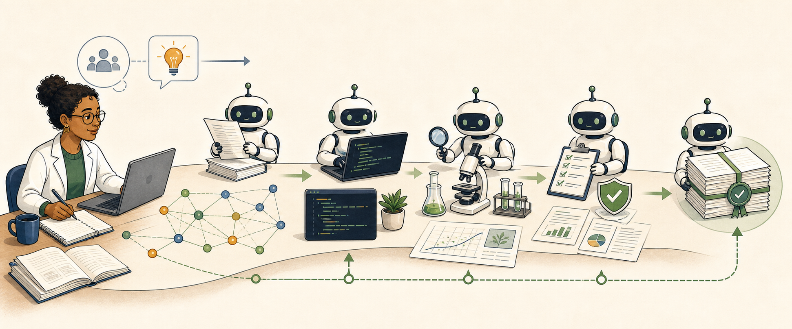

No coding experience is needed. You will review the plan and any decision that reaches you.

Version 1.0 | Checked August 27, 2026

Protocols.io description
Scientist1 helps you plan a study, review the plan, and save the work. You tell it what you want to learn and which files it may use. It can read sources, test methods, compare results, write a paper, and check the paper against the saved evidence. A completed, verified run may include a paper, code, sources, results, and check reports in one folder.
This guide starts at the beginning. It shows you how to get ChatGPT, open Codex, install Scientist1, run a small practice study, and read the result. You do not need to know how to code. You do need to review the study plan and use your own judgment.

Keywords
Scientist1; Codex; AI-assisted research; computational research; research workflow; Chain of Evidence; reproducible research; beginner guide

Time needed
- About 30 to 60 minutes of your time for setup and the guided practice. This does not include the time the AI study takes to run.
- The AI study can take longer. Time depends on the question, files, plan, model, and your account limits.
- A real study may take hours and may pause to ask you a question.

Before you start
You will need:
- A computer that can run the current ChatGPT desktop app. This guide was tested on Mac and Windows.
- An internet connection.
- A ChatGPT account.
- Enough Codex use for the study. Free accounts can try Codex, but a full study may reach the account limit.
- Permission to use every file you give to the study.
- A folder where Scientist1 may save its work.
If you use a school, hospital, company, or lab account, your administrator may control Codex and plugins. Ask that person for access if a button is missing or blocked.

Safety and privacy warning
Do not use this practice with patient records, names, passwords, secret keys, private answer files, or other sensitive data.
For your own studies, follow your lab, school, employer, ethics board, and local law. Remove personal details when you can. Keep private test answers separate. Do not use Scientist1 as the only check for clinical care, dangerous lab work, legal advice, or other high-risk choices.
Scientist1 is designed to make unsupported claims easier to find. This Codex version has not yet been independently tested for research outcomes. It cannot promise that every statement is true. A person with the right subject knowledge must still review the work.
Scientist1 does not send your files to a separate Scientist1 server. Codex still sends your prompts and the content it needs to OpenAI so the AI can do the work. This is not an offline tool.

Files used in this guide
- bean-seedling-growth.csv: a small, made-up dataset with 24 rows. It contains no real people, animals, or experiments.
- The screenshots in this protocol show the current Scientist1 setup page.
The practice file is released as CC0. You may copy and share it.

What Codex is
ChatGPT and Codex both let you talk with an AI. Codex can also work inside a folder on your computer. With your permission, it can read files, make files, write and run code, and check its work.
Think of the folder as the study's workbench. The chat is where you give directions. The files are the lasting record.
Scientist1 adds a research process to Codex. It does not replace your judgment. It helps keep the question, plan, tests, evidence, paper, and checks together.
Scientist1 gives you two places to follow the study. On the left, the main Codex chat is where you talk with the main AI. It guides the run and calls specialist AI agents and AI teams for each stage.
On the right, Codex opens a built-in browser. It first shows seven setup screens. After you approve the plan, that page becomes a live study map. You can select any stage for more detail, ask the main AI a question, or simply watch.
After you answer the seven setup screens and approve the plan, Scientist1 can continue without you watching each step. Keep Codex open. The main AI will pause if it needs a research decision or a permission that only you can give.
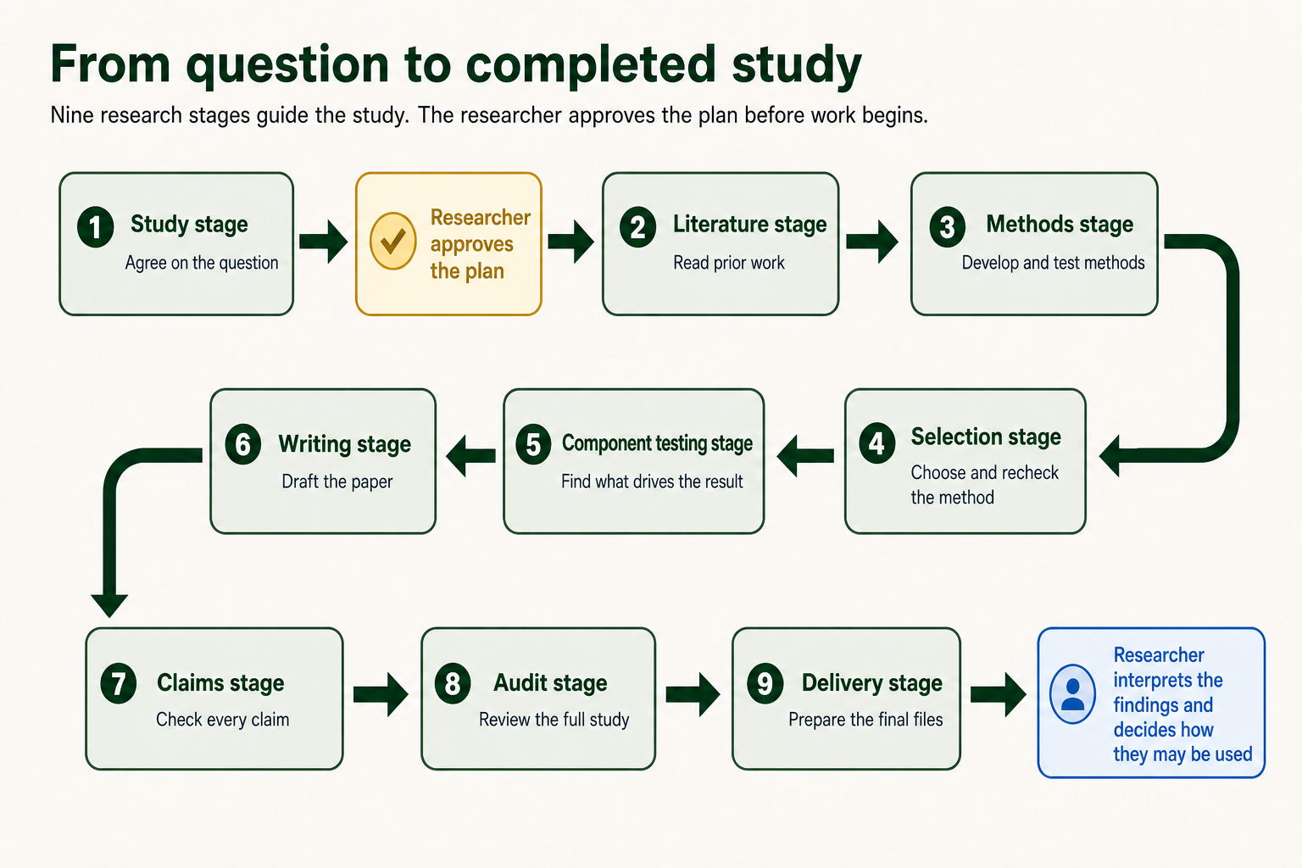
A research question moves through nine checked stages before delivery.

Section 1: Get ChatGPT and open Codex

Step 1. Check your computer
- Make sure your computer can run the current ChatGPT desktop app. This guide was tested on Mac and Windows.
- Save any open work.
- Make sure you can install an app. On a work or school computer, you may need help from technical support.
For a Mac, OpenAI currently requires macOS 14 or newer. Select the Apple menu, then About This Mac, to see your version.
For Windows, OpenAI currently requires Windows 10 version 17763 or newer. Open Settings, select System, then About, and look under Windows specifications.
OpenAI also offers a preview app for some Linux computers. This guide does not cover that preview yet.

Why this matters: Codex is a desktop feature. You cannot start this local Scientist1 study from a phone or the normal ChatGPT web page.

Step 2. Create or open your ChatGPT account
- Go to chatgpt.com.
- Select Log in if you have an account.
- Select Sign up if you do not have an account.
- Use an email address you can reach.
- Finish the sign-in checks shown by OpenAI.
Write down which account you used. You will use the same account in the desktop app.

Step 3. Choose a plan
Codex is included with Plus, Pro, Business, Enterprise, and Edu. OpenAI also gives Free and Go accounts limited access at the time of this guide. The amount you can use is different for each plan.
- Open the current Codex pricing page.
- Read the Codex limits for each plan.
- Choose what fits your work:
- Free can be enough to learn the screens and try a small task. A full study may stop at the use limit.
- Plus is a useful starting paid plan for a person who plans to run full studies.
- Pro is for people who expect to run larger or more frequent work.
- Business, Enterprise, or Edu may be supplied by your school or employer. Ask your administrator what is enabled.
- If you need more use, choose a plan that fits your work.
- If your school or employer may pay, ask before you buy a personal plan.
- Before you pay, check the price, billing period, and renewal terms.
- Return to this guide after your account page shows the plan you chose.
Prices and limits can change. A paid plan does not promise that every full study will finish within its included use. Use the live Codex pricing page, not an old screenshot.

Step 4. Download the desktop app
- Go to chatgpt.com/download.
- Choose the download for your computer.
- Wait for the file to finish downloading.
- Open the downloaded file.
- Follow the steps on the screen to install ChatGPT.
- Open the new ChatGPT app.
If you already used the older Codex app, update it. The current desktop app includes Chat, Work, and Codex.
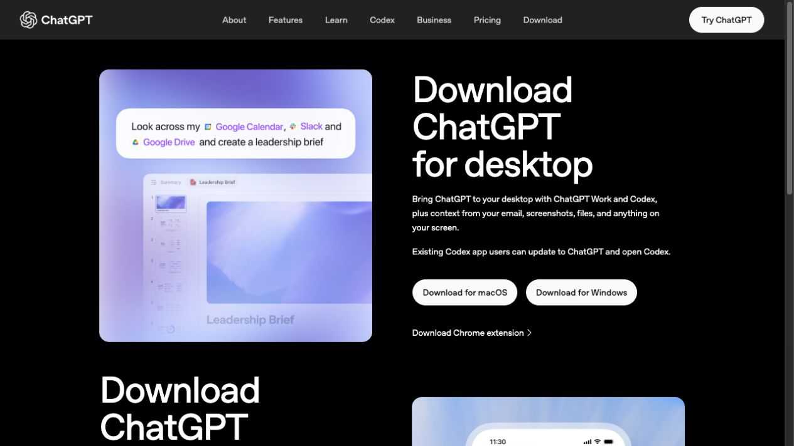
The official ChatGPT download page has separate buttons for macOS and Windows.

Step 5. Sign in to the app
- Select Sign in.
- Use the same ChatGPT account from Step 2.
- Complete any sign-in check in the browser window.
- Return to the desktop app.
If you see more than one workspace, choose the one that is allowed to use your research files.

Step 5A. Check your data controls
Do this before you use real research files.
- Select your profile picture.
- Select Settings.
- Select Data Controls.
- Find Improve the model for everyone.
- If you use a personal account and do not want new tasks used to improve OpenAI's models, turn this setting off.
OpenAI says that Business, Enterprise, and Edu inputs and outputs are not used to train its models by default. Your school or employer may have other rules. Follow those rules even if the app allows the file.
Do not use sensitive or regulated files until the person responsible for privacy at your lab, school, hospital, or employer has approved the use of Codex.

Step 6. Open Codex
- Find the menu near the top-left corner of the app.
- Select Codex.
- Wait for the Codex view to open.
If you cannot find Codex:
- Update the ChatGPT desktop app.
- Close and reopen the app.
- Check that you are signed in to the right account.
- On a managed account, ask your administrator to turn on Codex Local for your role.

Step 7. Make a safe practice folder
On a Mac:
- Open Finder.
- Open Documents.
- Select File, then New Folder.
- Name the folder Scientist1 Practice.
On Windows:
- Open File Explorer.
- Open Documents.
- Select New, then Folder.
- Name the folder Scientist1 Practice.
Do not place private files in this folder. The practice study does not need them.

Step 8. Open the practice folder in Codex
- Return to Codex.
- Select Open folder or Open project.
- Choose the Scientist1 Practice folder.
- Select Open.
- If the app asks for access to this folder, read the request and allow access.

Why this matters: Scientist1 saves the plan, code, sources, results, paper, and checks in the folder you open.

Step 9. Try one simple Codex task
Start a new Codex chat in the practice folder. Enter this message:

Please create a file named hello.txt in this folder. Put one sentence in it that says: Codex can work with files.

Then:
- Read what Codex plans to do.
- If it asks you to decide, check that the file name and change match your request.
- Wait for Codex to finish.
- Open the folder in Finder or File Explorer.
- Check that hello.txt is there.
You have now seen the basic pattern: ask, let Codex review the work, and check the result.

Step 10. Choose the permission mode
Codex may ask before it changes files, uses a software tool, adds a study package, or uses the internet.
For this lesson, choose Approve for me if it is available. OpenAI recommends this mode for most work. Another AI reviews requests for extra access and decides whether each request is safe. Codex still follows its usual safety rules. You see fewer permission prompts, but Codex does not get full access.
Some requests still need your decision. If one reaches you, read it before you choose Allow once. Ask Codex to explain the action in plain words if anything is unclear. Do not use Full access for this lesson.
Before you allow an action, ask:
- Does this action match my study and folder?
- Does it name a tool or website I trust?
- Could it send private data away from my computer?

Section 2: Install Scientist1
Scientist1 comes from its GitHub marketplace. You add the marketplace in the Codex app.

Step 11. Add the Scientist1 marketplace
- Open the ChatGPT desktop app.
- Select Codex from the menu at the top left.
- Select Plugins at the top left of the Codex view.
- Select the plus button at the top right.
- Select Add from Marketplace. Some app versions call this Add a marketplace.
- Paste this exact marketplace source into Source:

AdamHAwad/scientistone-codex-plugin

- Copy and paste the source exactly. Do not type it by hand.
- If you see Git ref, leave it empty.
- Select Add or Add marketplace.
- Wait for the marketplace name to appear in the Plugins list. If it appears, continue.
You only need to add this marketplace once. Scientist1 does not ask you to sign in to a second service.

Step 12. Install and open Scientist1
- Stay on the Plugins page.
- Search for Scientist1.
- Open the Scientist1 result.
- Select Install.
- Wait for the page to show that Scientist1 is installed.
- Select Try now.
- A new Codex task should open with a Scientist1 example prompt in the message box.
- Make sure the open folder is Scientist1 Practice. If it is not, select Open folder and choose it before you send the check.
- Replace the example prompt with this short check:

Scientist1, tell me in two short sentences what you do. Do not start a study yet.

- Send the message.
The answer should say that Scientist1 plans and checks research studies. If Codex says it cannot find Scientist1, go to Troubleshooting at the end of this guide.

Section 3: Run the practice study

Step 13. Download the practice data
- Download bean-seedling-growth.csv from the files attached to this protocol.
- Move the file into your Scientist1 Practice folder.
- Open the file in a spreadsheet app or a plain text app.
- Check that it has 24 plant rows.
- Close the file.
The data are made up for teaching. They are not proof about real plants.
If you cannot find the downloaded file on a Mac, open Finder, then Downloads. On Windows, open File Explorer, then Downloads. Drag the file into Scientist1 Practice.

Step 14. Start a fresh Scientist1 chat
- Return to Codex.
- Make sure the open folder is Scientist1 Practice.
- Start a new chat.
- Type @ and select Scientist1. If your app uses Sources, open Sources, choose Use plugins, and select Scientist1.
- Enter:

Help me run the Scientist1 practice study in this folder.

Scientist1 should open its setup page on the right, in the app's built-in browser. The main Codex chat stays on the left. Keep both open.

Step 15. Enter the research question
On these setup pages, S1 means Scientist1.
On screen 1 of 7, the page asks What should S1 investigate? Enter:

In this teaching dataset, did bean seedlings given 12 hours of light per day grow more over seven days than seedlings given 8 hours?

Select Continue.

Why this is asked: A clear question tells the AI team what it must answer. It also keeps the study focused on that question.


Scientist1 screen 1 asks for one answerable research question.

Step 16. Enter the purpose
On screen 2 of 7, the page asks What should the answer help you decide or understand? Enter:

Learn how Scientist1 plans, runs, checks, and reports a small study.

Select Continue.

Why this is asked: Two studies can use the same data for different reasons. The purpose helps Scientist1 choose a useful plan.

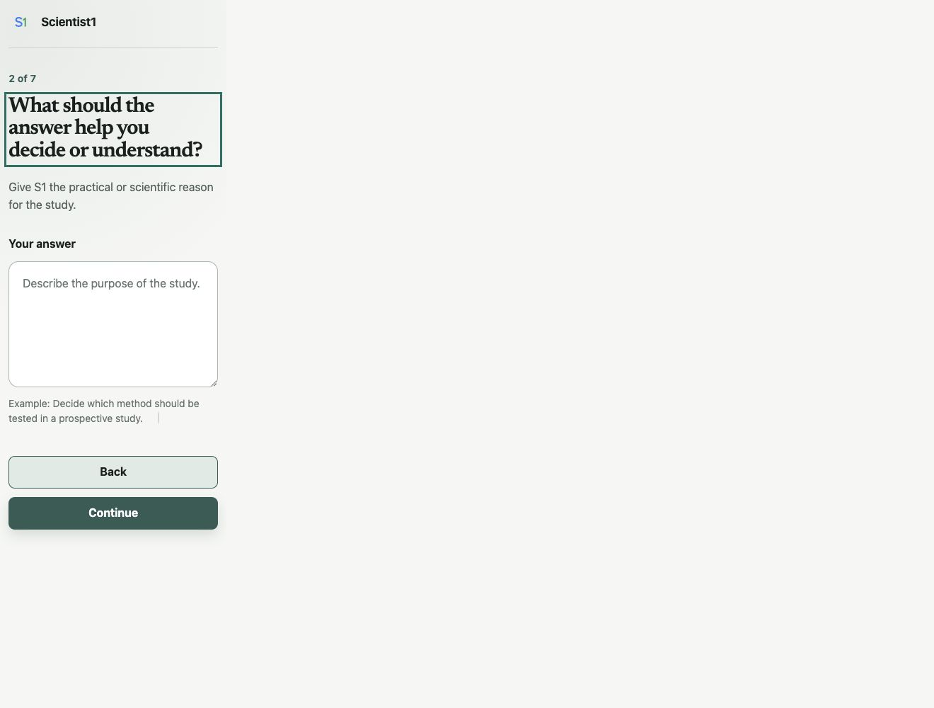
Scientist1 screen 2 asks what the answer should help you understand.

Step 17. Add the data file
On screen 3 of 7, the page asks What files should S1 use?
- In About these files, enter:

Synthetic teaching data. Height is in centimeters. Compare each plant's growth, not final height alone.

- Select the large Add files box.
- Choose bean-seedling-growth.csv from the practice folder.
- Wait until the file name appears on the page.
- Select Continue.

Why this is asked: The note tells the AI team what the columns mean. The file gives the AI team the measurements to study.

The selected file is copied into the open project. Do not add a file that the study should not read.
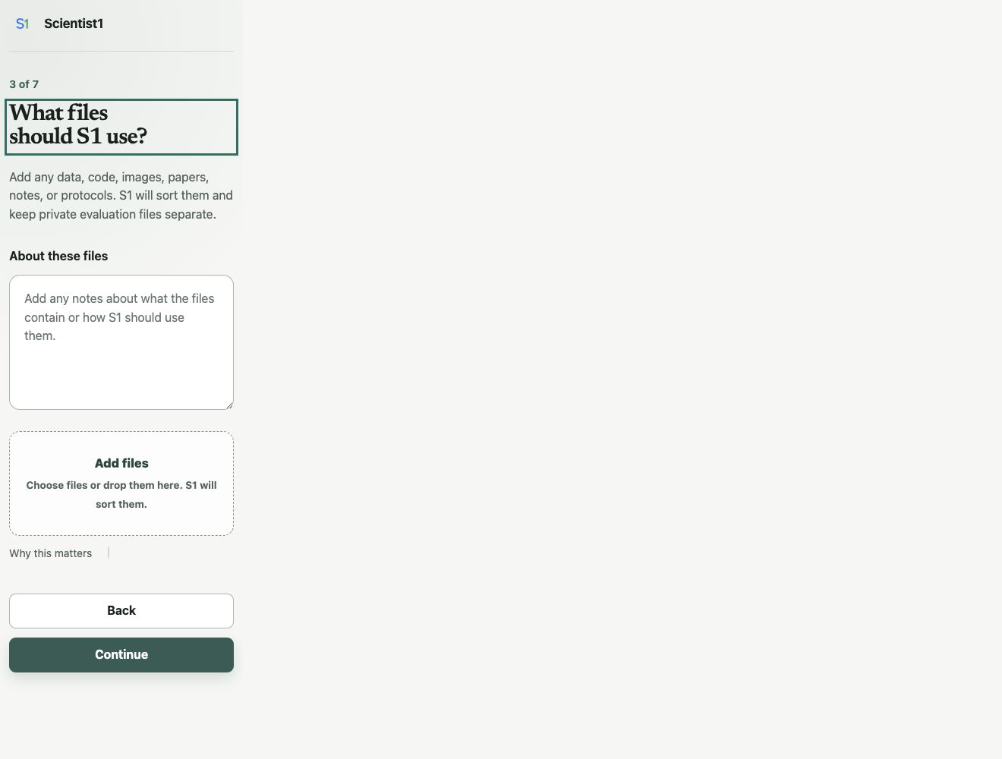
Scientist1 screen 3 includes a large box for adding files.

Step 18. Add prior work
On screen 4 of 7, the page asks Are there papers S1 should read? Leave the box empty. Select Continue.

Why this is asked: In a real study, you can add a paper, DOI, title, or web link that the AI team must read. For this small lesson, no paper is required. Scientist1 may still search public sources. Searching the web uses some of your Codex allowance and may take more time.


Scientist1 screen 4 asks about papers and prior work.

Step 19. State what evidence would answer the question
On screen 5 of 7, the page asks What evidence would answer the question? Enter:

Calculate each plant's seven-day growth. Compare the average growth of the 12-hour group with the 8-hour group. Report the difference as 12-hour minus 8-hour. Show how uncertain the difference is with a two-sided 95% Welch confidence interval. Make a plot. This is a teaching example, not a claim about real plants.

Select Continue.

Why this is asked: This tells the AI team how to judge the answer. It sets the main test before the AI team sees a result.

You do not need to know this test yet. Scientist1 should explain it in the draft plan. Read that explanation before you approve the study.
If you do not know the right test in your own study, leave this box empty. Scientist1 will suggest one for you to review.
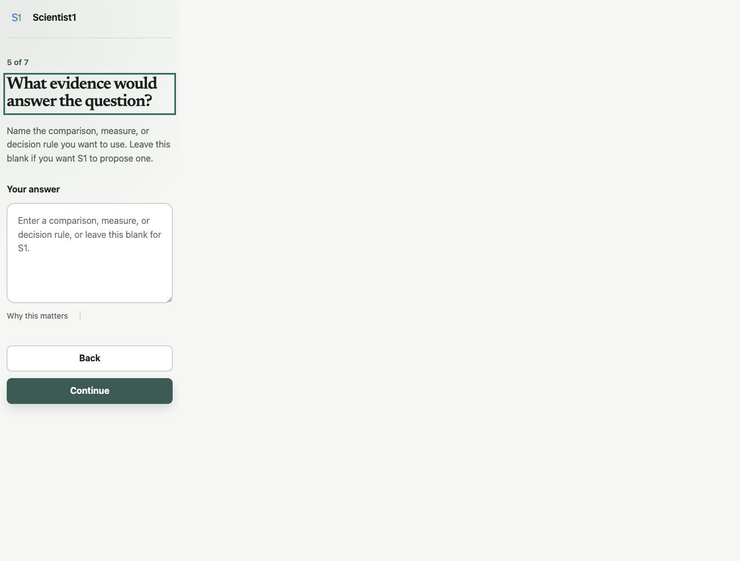
Scientist1 screen 5 asks what evidence would answer the question.

Step 20. State the limits
On screen 6 of 7, the page asks What limits should S1 follow? Enter:

Use the pilot profile. This keeps the practice run small. Use only the uploaded synthetic data and public sources. Do not make claims about real plants, farming, or people. Keep the paper short.

Select Continue.

Why this is asked: Limits tell the AI team what it may use, what it must avoid, and how much work to do.

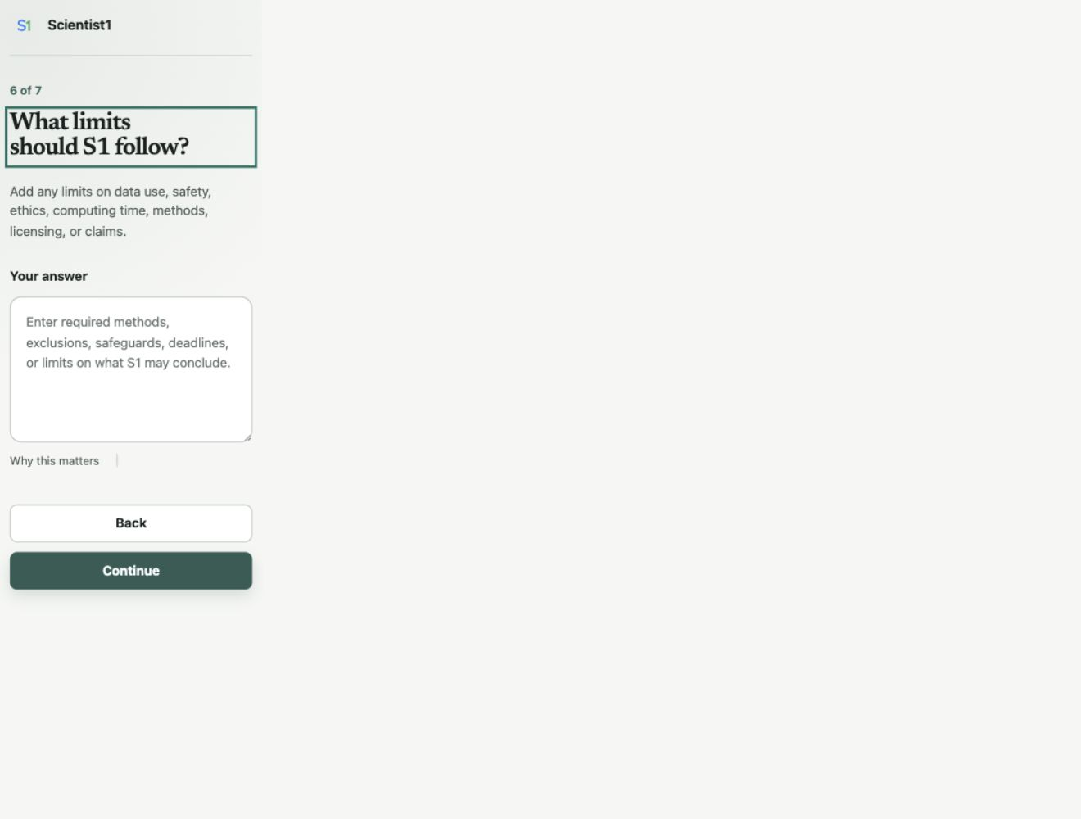
Scientist1 screen 6 asks about limits on data, safety, time, methods, and claims.

Step 21. Review the request
Screen 7 of 7 is called Review your study request. It shows your answers.
- Read every section.
- Check that the question compares 12 hours with 8 hours.
- Check that the file note says to compare growth.
- Check that the uploaded file is bean-seedling-growth.csv.
- Check that the study is called a teaching example.
- Select Back if anything is wrong.
- Select Send to S1 when the request is correct.
Sending the request does not start the study. It asks Scientist1 to draft a plan.

Step 22. Wait for the draft plan
The page will say that S1 is drafting the study plan.
- Keep the page open.
- Return to the Codex chat only if it asks you a question.
- Do not send the setup form again.
- Wait for the review page to appear.

Scientist1 shows a short waiting page while Codex drafts the study plan.

Step 23. Review the study plan
The next page is called Review the study before it begins. This is your main stop point. The study has not started yet.
Read these parts:
- Question: Is it the question you meant to ask?
- Purpose: Will the answer be useful for the reason you gave?
- Materials: Does it name the right files and units?
- Prior work: Does it include any paper that must be read?
- Evidence needed: Is the main comparison clear?
- Requirements and limits: Are the privacy, safety, time, and claim limits correct?
- What the study will produce: Does it save what you need?
- Full study plan: Do the steps answer the approved question?
You can edit a field on the page. If several parts need work, write one clear note in Other changes and select Send changes to S1.
Do not approve a plan that you do not understand. Ask Codex to explain any part in plain language.
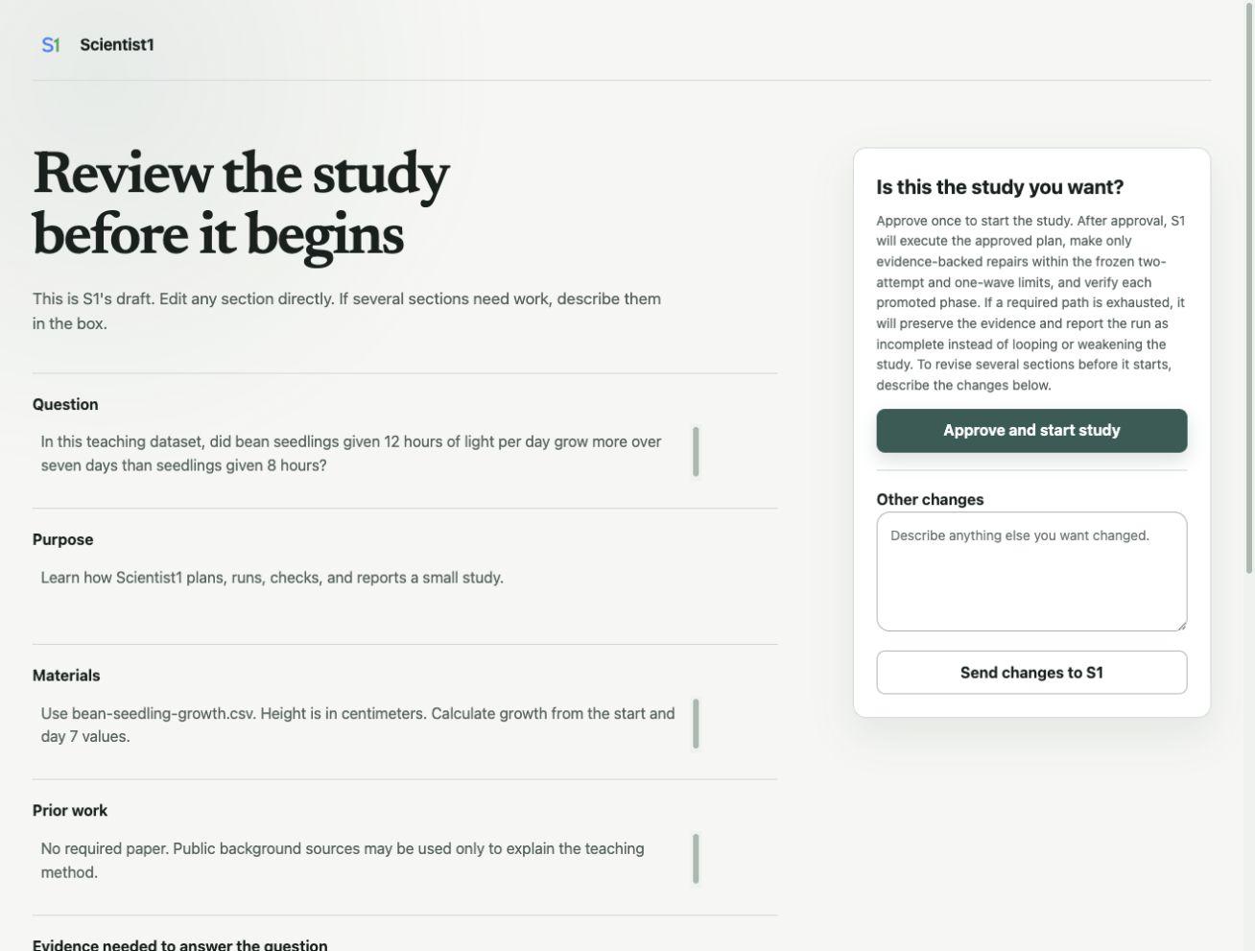
The plan review lets you edit the study before you approve it.

Step 24. Approve and start the study
For this practice study, check that the plan says it will:
- use the one CSV file;
- compute seven-day growth;
- report 12-hour growth minus 8-hour growth;
- use a two-sided 95% Welch confidence interval and make a plot;
- avoid claims about real plants; and
- save code, results, a paper, and checks.
If those points are present, select Approve and start study.
Approval matters. After this point, the question and main test should not change just because the result is surprising.

Step 25. Watch the live study map
After approval, the same page becomes a live study map.
- Look for the current stage.
- Select a stage to see what it does.
- Read the stage label:
- Not started means the stage has not begun.
- Working now means Codex is doing that part of the study.
- Needs your input means the study is waiting for you.
- Checked means the required work for that stage passed its checks.
- Return to the Codex chat if the study asks a question or the permission reviewer needs your decision.
- Keep the app open and the computer awake while local work is running.
The setup page on the right becomes the live map. The main AI tracks the run and calls specialist AI agents and AI teams to do the work shown in each stage. Select a stage to see what it is doing. The study moves through planning, reading, method work, selection, testing, writing, claim checks, audit, and delivery. A small practice may still take time because the checks are part of the lesson.

Step 26. Handle questions and tool requests
Scientist1 handles ordinary research and repair decisions on its own. It may ask only when the approved study lacks information or authority that the system cannot safely supply. The permission reviewer may also send a request to you when it cannot safely decide on its own.
For each request:
- Read what it wants to do.
- Check that it matches the approved plan.
- Check that it uses the practice folder.
- If you are unsure, do not allow the action. Ask for a plain-language reason.
- Choose Allow once only when the request is safe, needed, and within the approved plan.
Do not paste a password, secret key, or patient record into the chat or setup page.

Step 27. Know what a failed check means
A red stage or a needs repair message does not always mean the whole study is lost. It may mean that a number does not match, a claim has no source, a file is missing, or a test needs to be run again.
- Open the failed stage.
- Read the plain-language error and evidence.
- Let Scientist1 make the bounded in-scope repair and re-run the affected checks.
- Do not provide another approval for an ordinary repair. The original study approval already covers it.
- Respond only if Codex needs new information, a new permission, or a change to the approved question or test.

Step 28. Open the completed results
When the study says it is complete, look for the Study record verified badge. If the page says the record needs repair, let Scientist1 continue its bounded repair path. Do not treat the study as complete yet.
After the record is verified:
- Ask in the Codex chat:

Show me the main result, the evidence for it, the limits, and the files I should review first.

- Read the short result in the chat.
- Open the paper.
- Open the main result or measurement file.
- Open the final integrity report.
- Check that the paper's main number matches the saved result.
- Follow at least one evidence link from a paper claim to its source or saved result.
For this dataset, the mean growth is about 3.13 cm in the 8-hour group and 4.43 cm in the 12-hour group. The 12-hour minus 8-hour difference is about 1.29 cm. The two-sided 95% Welch confidence interval is about 1.16 to 1.42 cm. These values only check that the practice analysis used the file correctly.
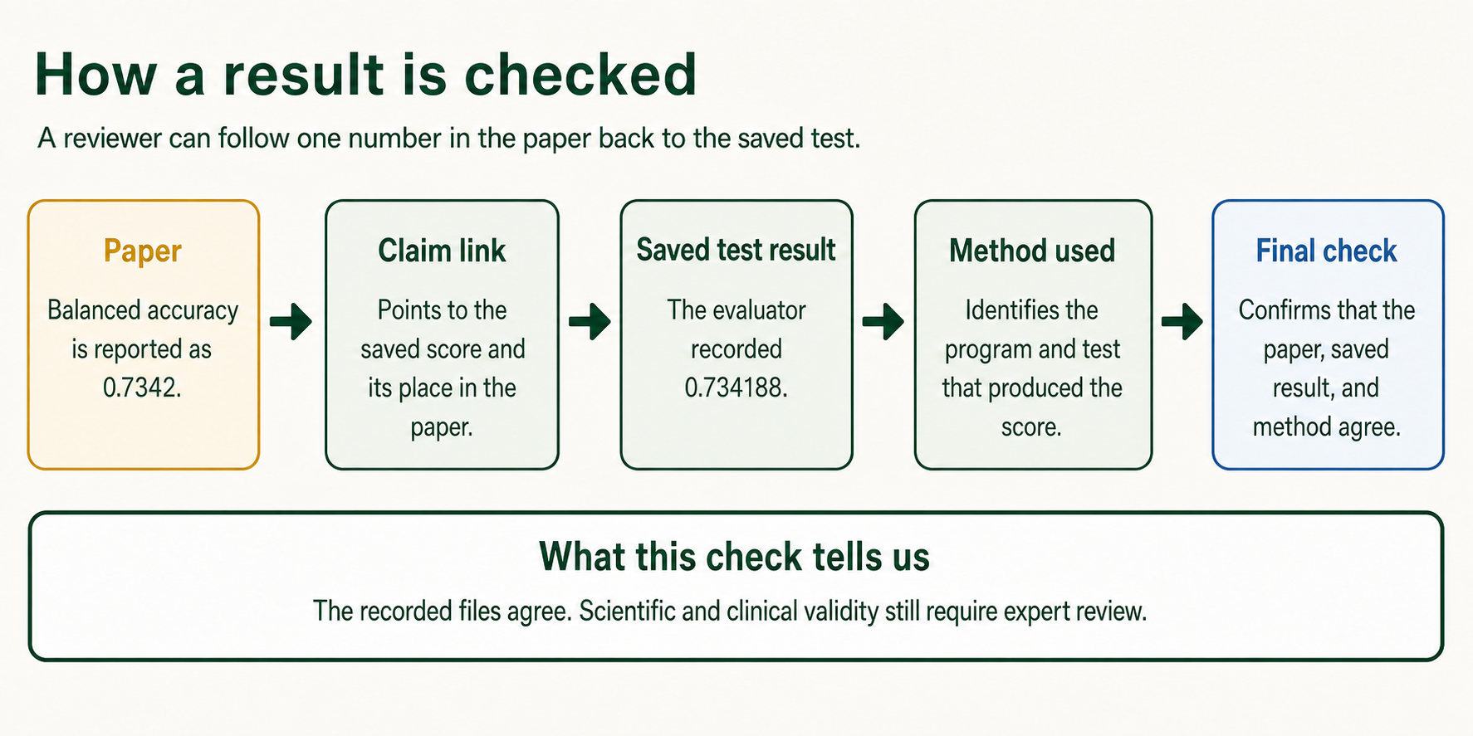
A paper claim can be traced to code, an evaluation, and saved evidence.

Step 29. Find the saved study files
Open the Scientist1 Practice folder in Finder or File Explorer. Open scientist1-runs, then open the newest dated folder.
Open these files first:
- deliverables/paper.pdf, if it exists. If there is no PDF, open deliverables/paper.tex.
- selection/canonical-evaluation.json for the main saved measurement.
- deliverables/audit-report.md for the final checks.
- deliverables/provenance.jsonl for links from claims to evidence.
The exact names may vary by study. A complete run can include:
- the request you sent;
- the plan you approved;
- a list of sources;
- analysis code;
- saved measurements and plots;
- the selected method;
- the paper;
- links from claims to evidence;
- check reports; and
- a guide for running the work again.
Do not judge the study only from the final chat message. The saved files are the record.

Step 30. Finish the practice
You have finished the lesson when you can answer yes to each question:
- Can I open Codex and choose a folder?
- Can I start a new chat with Scientist1?
- Can I explain the six setup questions and the final review screen?
- Can I review and change a plan before approval?
- Can I follow the live study map?
- Can I find the paper, result, source record, and check report?
- Can I explain why a checked study still needs human review?
You may now delete the practice folder if you do not want to keep it. Check the folder first so you do not remove other work. If you may need the lesson later, copy or archive the folder before you delete it.

Section 4: Start your own study

Step 31. Make a new folder for one study
Use one folder for one clear study. Give it a plain name, such as Lake temperature study or Protein model comparison.
Put only needed files in that folder. Keep an untouched copy of the original data somewhere safe.

Step 32. Prepare the question
A useful question says:
- what you are studying;
- what you want to learn;
- which groups, methods, or conditions should be compared; and
- which result matters most.
Bad: Study my data.
Better: In these sensor records, did the new calibration lower the median error compared with the old calibration?
You do not need to name a statistical test if you do not know which test fits. Scientist1 can propose one for you to review.

Step 33. Prepare the files
Before you add a file:
- Make sure you have the right to use it.
- Remove names and other personal details when possible.
- Write down what each column, unit, image, or code file means.
- Mark any file that contains hidden answers or private checks.
- Keep credentials and passwords out of the folder.
- Check that the file opens.
If a file is very large, tell Scientist1 its size and format before you add it.

Step 34. State the evidence before the answer is known
Tell Scientist1 what would count as a useful answer. This can be a score, a comparison, a test using data set aside for checking, a clear way to group interview answers, or another clear rule.
Scientist1 will define and freeze the task-appropriate null interpretation before results are known. A negative result is a valid result, and the system will not change the test to rescue an observed result.

Step 35. State limits in plain words
Useful limits can include:
- data that must not be used;
- claims the paper must not make;
- a time or cost limit;
- required tools or banned tools;
- safety or ethics rules;
- a date range for sources;
- a software license rule; and
- the files that must be produced.

Step 36. Review, approve, then check in
Read the full plan before you approve it. After approval, you do not need to watch every step. Keep Codex open. Check the main chat if the live map says Needs your input. Do not let a repair silently change the question or main test.
At the end, read the limits and audit report before you share the paper.

Keep Codex and Scientist1 up to date
At the start of each day, fully quit and reopen Codex when no study is running. Codex normally updates itself and checks for a new Scientist1 version when it starts. You do not need to install Scientist1 again.
If Scientist1 still looks out of date, open Plugins and select Refresh. Start a new task after the refresh.

Troubleshooting

Scientist1 is not listed after install
- Start a new chat. An old chat may not load a new plugin.
- Open Plugins and check the Installed row.
- Restart the desktop app.
- Select the plus button, then Add from Marketplace or Add a marketplace. Check that AdamHAwad/scientistone-codex-plugin is listed.
- If it is missing, add that marketplace source again and search for Scientist1.
- On a managed account, ask the administrator whether plugins are allowed for your role.

Codex is missing
- Make sure you installed the current ChatGPT desktop app, not only ChatGPT Classic.
- Update and restart the app.
- Use the top-left menu to look for Codex.
- Ask your workspace administrator to enable Codex Local.

The setup page does not open
- Keep the Codex chat open.
- Ask: Scientist1, open the study setup again.
- Make sure the task has permission to use the built-in browser.
- Restart the task in a new chat if the plugin was just installed.
- Do not use a copy of the setup page from an old run.

The file does not appear after you add it
- Wait for the upload message to finish.
- Check that the file is not open in another app.
- Check that it is inside a folder you can read.
- Make a copy named data.csv, then try that copy.
- Ask Codex to explain the error before trying again.

The study reaches an account limit
- Read the limit message.
- Open your usage page in ChatGPT settings.
- Wait for the shown reset time. If you consider credits or another plan, pause and confirm the price, billing period, and renewal terms before you pay.
- Return to the same project and ask Scientist1 to check the saved run before it resumes.
Do not start a second run unless the saved run cannot be resumed.

The computer restarts or the app closes
- Reopen the ChatGPT desktop app.
- Open Codex and the same study folder.
- Start a new chat with Scientist1.
- Ask: Check the saved Scientist1 run in this folder and tell me whether it is safe to resume.
- Review the status before you allow more work.

The result looks wrong
Do not ask the AI team to rewrite the paper first. Ask it to check the evidence:

Trace the result I am worried about to the saved data, code, measurement, and audit. Tell me where the first mismatch appears.

If the approved test was wrong, stop the run and start a new study with a new approved plan. Do not quietly replace the test after seeing the answer.

Expected outcome
After following this protocol, a new user should be able to:
- install and sign in to the ChatGPT desktop app;
- open Codex and a local project folder;
- install and select Scientist1;
- explain each setup question;
- run the small practice study;
- review the plan before work begins;
- follow the live study map; and
- find the paper, code, results, sources, and checks.

Sources and current product guidance
This protocol was checked on August 27, 2026. Product names and buttons can change.
- Download ChatGPT for desktop
- ChatGPT desktop preview for Linux
- Moving to the new ChatGPT desktop app
- Mac system requirements
- Using the ChatGPT Windows app
- ChatGPT Work and Codex
- Using Codex with your ChatGPT plan
- Codex sandboxing and permission modes
- How Approve for me uses an AI reviewer
- How the ChatGPT desktop app updates
- Codex pricing
- ChatGPT Data Controls
- Keep chat history while turning off model training
- Plugins in ChatGPT and Codex
- Protocols.io help
- Add steps, sections, and substeps in Protocols.io
- ScientistOne research paper

Citation note
After Protocols.io creates the public version and DOI, use the citation that Protocols.io generates. Do not use a draft citation without the final DOI and version date.

