Recognizing geometric shapes
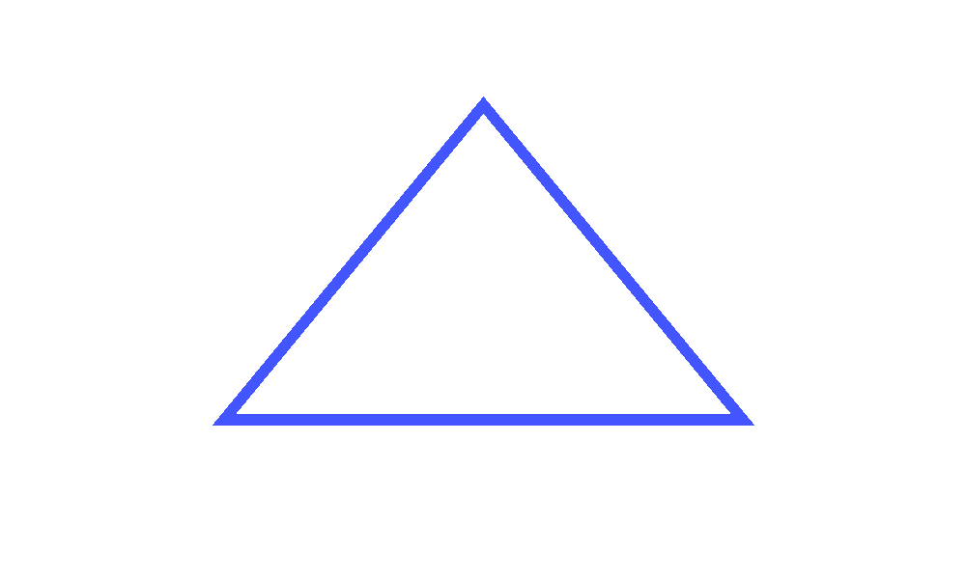
A triangle has three sides and three vertices. A square has four equal sides and four right angles. A circle has no straight sides or vertices. A regular pentagon has five equal sides. The unlabeled diagram above shows a triangle.

