Adam Burnett  
ECEn 620  
Assignment 3  
  
This lab involved using tasks, functions and do-while loops to improve my solution from the chapter 2 homework. To improve my solution, I added checks to verify if both read and write data were asserted at the same time, a test that checks the checker, calculation of even parity in the memory module and a do-while loop. These improvements helped both in functionality and readability of the code.

my_mem code:

`default_nettype none

**module** my_mem**(**clk**,**

write**,**

read**,**

data_in**,**

address**,**

data_out**);**

**input** logic clk**;**

**input** logic write**;**

**input** logic read**;**

**input** logic **[**7**:**0**]** data_in**;**

**input** logic **[**15**:**0**]** address**;**

**output** logic **[**8**:**0**]** data_out**;**

//This function calculates even parity

**function** automatic logic ev_parity**(**logic **[**7**:**0**]** din**);**

return **(^**din**);**

**endfunction**

//Declare a 9-bit associative array using the logic data type

logic **[**8**:**0**]** mem_array**[**shortint**];**

**always** **@(posedge** clk**)** **begin**

**if** **(**write**)**

mem_array**[**address**]** **=** **{**ev_parity**(**data_in**),** data_in**};**

**else** **if** **(**read**)**

data_out **=** mem_array**[**address**];**

**end**

endmodule

testbench code:

`default_nettype none

`timescale 1ns**/**100ps

**module** testbench **();**

logic clk**;**

logic write**;**

logic read**;**

logic **[**7**:**0**]** data_in**;**

logic **[**15**:**0**]** address**;**

logic **[**8**:**0**]** data_out**;**

shortint address_array**[];**

byte data_to_write_array**[];**

bit **[**8**:**0**]** data_read_expect_assoc**[**shortint**];**

int error_counter**;**

bit **[**8**:**0**]** data_read_queue**[**$**];**

//Read Write Checker

**function** automatic logic ReadWriteChecker**(**logic rd**,** logic wr**);**

**if(**rd **==** 1 **&&** wr **==** 1**)** **begin**

$display**(**"Error@%d: Read and Write asserted at the same time\n"**,** $time**);**

error_counter**++;**

**end**

**endfunction**

//Test Read Write Checker

always_comb **begin**

ReadWriteChecker**(**read**,** write**);**

**end**

//Test Bench Code

**initial** **begin**

clk **=** 0**;**

error_counter **=** 0**;**

read **=** 0**;**

address_array **=** new**[**6**];**

data_to_write_array **=** new**[**6**];**

//Test Checker

**@(negedge** clk**);**

read **=** 1**;**

write **=** 1**;**

**@(negedge** clk**);**

read **=** 0**;**

write **=** 0**;**

//Do While Loop

do

**begin**

$display**(**"Waiting..."**);**

**#**10ns**;**

**end**

**while** **(**$time **<** 60 **);**

foreach**(**address_array**[**i**])** **begin**

address_array**[**i**]** **=** $random**;**

data_to_write_array**[**i**]** **=** $random**;**

data_read_expect_assoc**[**address_array**[**i**]]** **=** **{^**data_to_write_array**[**i**],** data_to_write_array**[**i**]};**

**end**

foreach**(**address_array**[**i**])** **begin**

write_to_memory**(**address_array**[**i**],** data_to_write_array**[**i**]);**

**end**

address_array**.**reverse**();**

foreach**(**address_array**[**i**])** **begin**

**@(negedge** clk**)**

read **=** 1**;**

address **=** address_array**[**i**];**

**@(posedge** clk**)**

**#**1

data_read_queue**.**push_back**(**data_out**);**

**if(**data_read_expect_assoc**[**address**]** **!=** data_out**)** **begin**

$display**(**"Found Error: %03X %03X"**,** data_read_expect_assoc**[**address**],** data_out**);**

error_counter **=** error_counter **+** 1**;**

**end**

**end**

$display**(**"Print Read Values"**);**

foreach**(**data_read_queue**[**i**])** **begin**

$display**(**"\t%03X"**,** data_read_queue**[**i**]);**

**end**

$display**(**"Error Count: %d"**,** error_counter**);**

**end**

**task** write_to_memory**(input** shortint addr**,** byte data**);**

write **=** 1**;**

data_in **=** data**;**

address **=** addr**;**

**@(posedge** clk**);**

write **=** 0**;**

**@(negedge** clk**);**

**endtask;**

**always** **begin**

**#**5 clk **=** **~**clk**;**

**end**

my_mem mem**(**clk**,**

write**,**

read**,**

data_in**,**

address**,**

data_out**);**

endmodule

Waveform:

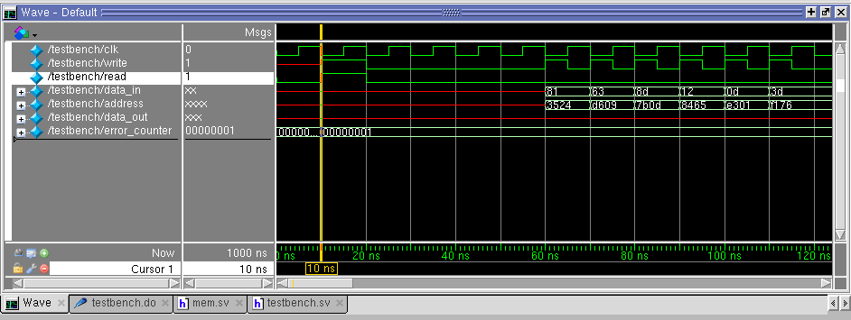

**Transcripts:**

**Error Free:**

# vsim -novopt testbench

# Refreshing /net/fpga1/users/adamrb/ECEn620/Assignments/Assignment3/work.testbench  
# Loading sv_std.std  
# Loading work.testbench  
# Refreshing /net/fpga1/users/adamrb/ECEn620/Assignments/Assignment3/work.my_mem  
# Loading work.my_mem

# Waiting...  
# Waiting...  
# Waiting...  
# Waiting...  
# Waiting...  
# Waiting...

# Print Read Values

# 13d  
# 10d  
# 012  
# 08d  
# 063  
# 081

# Error Count: 0

**Read = 1 Write =1 Error**

# Refreshing /net/fpga1/users/adamrb/ECEn620/Assignments/Assignment3/work.testbench

# Loading sv_std.std  
# Loading work.testbench  
# Refreshing /net/fpga1/users/adamrb/ECEn620/Assignments/Assignment3/work.my_mem  
# Loading work.my_mem  
**# Error@ 10: Read and Write asserted at the same time**#   
# Waiting...  
# Waiting...  
# Waiting...  
# Waiting...

# Print Read Values

# 13d  
# 10d  
# 012  
# 08d  
# 063  
# 081

# Error Count: 1

**Data Read Error**

# vsim -novopt testbench

# Refreshing /net/fpga1/users/adamrb/ECEn620/Assignments/Assignment3/work.testbench

# Loading sv_std.std  
# Loading work.testbench  
# Refreshing /net/fpga1/users/adamrb/ECEn620/Assignments/Assignment3/work.my_mem

# Loading work.my_mem  
# Waiting...  
# Waiting...  
# Waiting...  
# Waiting...  
# Waiting...  
# Waiting...

**# Found Error: 13d 000  
# Found Error: 10d 000  
# Found Error: 012 000  
# Found Error: 08d 000  
# Found Error: 063 000  
# Found Error: 081 000**

# Print Read Values

# 000  
# 000  
# 000  
# 000  
# 000  
# 000

# Error Count: 6