Adam Burnett  
ECEn 620  
Assignment 4.2

Overview

This report details the changes made to the memory module interface and the test bench in order to test out new (to me) functionality of System Verilog. The main changes that have been made are:

1. Added a Clocking Block to the memory interface.
2. Separated my test bench into a program and a top level module.
3. Changed my protocol checker from an interface function to an assertion
4. Changed the clock speed from 100 MHz to 10 MHz

This report contains all of the System Verilog source code used in this project. Additionally, I have included waveforms and console transcripts for both the 0 delay memory model and the 75ns delay memory model.

**Code: Interface**

interface mem_if**(input** bit clk**);**

logic write**;**

logic read**;**

logic **[**7**:**0**]** data_in**;**

logic **[**15**:**0**]** address**;**

logic **[**8**:**0**]** data_out**;**

clocking cb **@(posedge** clk**);**

**output** write**;**

**output** read**;**

**output** address**;**

**input** data_out**;**

**output** data_in**;**

endclocking

modport TEST**(**clocking cb**);**

modport DUT**(input** clk**,** write**,** read**,** address**,** data_in**,** parity**,**

**output** data_out**);**

a1**:** assert property **(@(posedge** clk**)** **!(**cb**.**read**==**1 **&&** cb**.**write**==**1**));**

///////////////////////////

// Even Parity Calc. //

///////////////////////////

**function** logic parity**(**logic **[**7**:**0**]** din**);**

return **(^**din**);**

**endfunction**

endinterface

**Code: Top Module**

//////////////////////

// Top-Level Module //

//////////////////////

**module** top**;**

//Clock Generator

bit clk **=** 0**;**

**always** **#**50ns clk **=** **~**clk**;**

//Memory Interface

mem_if mem_bus**(**clk**);**

//Test Program

test t1**(**mem_bus**);**

//Memory Model

my_mem mem**(**mem_bus**);**

endmodule

**Code: Program Test**

program automatic test**(**mem_if**.**TEST mem_bus**);**

shortint address**;**

byte data**;**

int ErrorCount **=** 0**;**

typedef struct **{**

shortint address**;**

byte data_to_write**;**

bit **[**8**:**0**]** expected_read**;**

bit **[**8**:**0**]** actual_read**;**

**}** ScoreBoardEntry**;**

ScoreBoardEntry ScoreBoard**[];**

**initial** **begin**

//Initialize Score Board

ScoreBoard **=** new**[**6**];**

//Generate Random Writes

foreach**(**ScoreBoard**[**i**])** **begin**

address **=** $random**;**

data **=** $random**;**

ScoreBoard**[**i**].**address **=** address**;**

ScoreBoard**[**i**].**data_to_write **=** data**;**

ScoreBoard**[**i**].**expected_read **=** **{^**data**,** data**};**

**end**

mem_bus**.**cb**.**read **<=** 0**;**

//Test Protocol Error Checker

//This should produce three Errors

mwrite**(**0**,** 0**);**

mread**(**0**);**

**@**mem_bus**.**cb**;**

**@**mem_bus**.**cb

**@**mem_bus**.**cb

mem_bus**.**cb**.**write **<=** 0**;**

mem_bus**.**cb**.**read **<=** 0**;**

//Perform Writes

foreach**(**ScoreBoard**[**i**])** **begin**

write_memory**(**ScoreBoard**[**i**]);**

**end**

**@(**mem_bus**.**cb**);**

mem_bus**.**cb**.**write **<=** 0**;**

//Rearrange Array for Reads

ScoreBoard**.**shuffle**();**

//Perform Reads and Check Results

foreach**(**ScoreBoard**[**i**])** **begin**

read_memory**(**ScoreBoard**[**i**]);**

check**(**ScoreBoard**[**i**]);**

**end**

mem_bus**.**cb**.**read **<=** 0**;**

//Display the Actual Values Read

$display**(**"Print Read Values"**);**

foreach**(**ScoreBoard**[**i**])** **begin**

$display**(**"\t%03X"**,** ScoreBoard**[**i**].**actual_read**);**

**end**

$display**(**"Tests Performed: %d"**,** ScoreBoard**.**size**());**

$display**(**"Incorrect Read Errors: %d"**,** ErrorCount**);**

//$display("3.Read/Write Signal Errors: %d", mem_bus.rdwr_error_count);

**end**

final **begin**

$display**(**"Test Complete."**);**

$stop**();**

**end**

///////////////////////////

// Read Function //

///////////////////////////

//Note: does not return read value

**function** void mread**(**logic **[**15**:**0**]** addr**);**

mem_bus**.**cb**.**read **<=** 1**;**

mem_bus**.**cb**.**address **<=** addr**;**

**endfunction**

///////////////////////////

// Write Function //

///////////////////////////

**function** void mwrite**(**logic **[**15**:**0**]** addr**,** logic **[**7**:**0**]** data**);**

mem_bus**.**cb**.**write **<=** 1**;**

mem_bus**.**cb**.**data_in **<=** data**;**

mem_bus**.**cb**.**address **<=** addr**;**

**endfunction**

**task** automatic write_memory**(**ref ScoreBoardEntry Entry**);**

**@(**mem_bus**.**cb**);**

mwrite**(**Entry**.**address**,** Entry**.**data_to_write**);**

**endtask**

**task** automatic read_memory**(**ref ScoreBoardEntry Entry**);**

**@(**mem_bus**.**cb**);**

mread**(**Entry**.**address**);**

**@(**mem_bus**.**cb**);**

**@(**mem_bus**.**cb**);**

Entry**.**actual_read **=** mem_bus**.**cb**.**data_out**;**

**endtask**

**function** check**(**ScoreBoardEntry Entry**);**

**if(** Entry**.**expected_read **!=** Entry**.**actual_read**)** **begin**

$display**(**"Found Error: %04X %04X"**,** Entry**.**expected_read**,** Entry**.**actual_read**);**

ErrorCount**++;**

**end**

**endfunction**

endprogram

**Program Output for Zero Delay Memory Model:**

**Waveform:**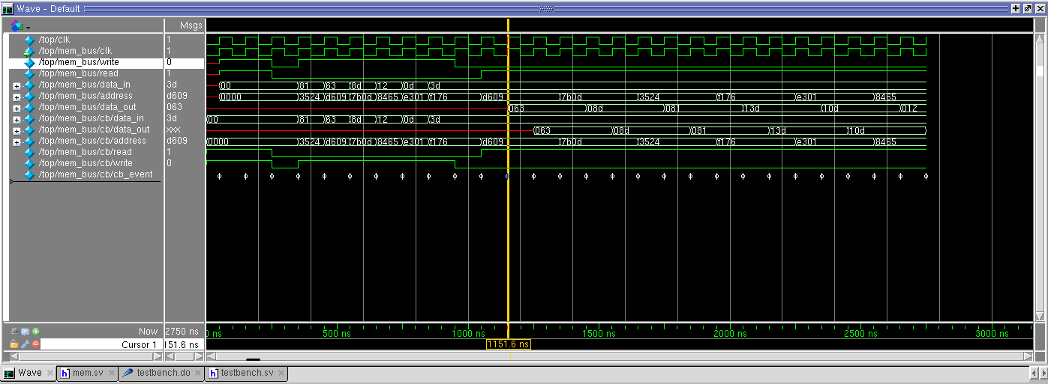

**Transcript with Zero Memory Read Errors:**

# Test Complete.

# vsim -novopt top   
# Refreshing /net/fpga1/users/adamrb/ECEn620/Assignments/Assignment4.2/work.top

# Loading sv_std.std  
# Loading work.top  
# Refreshing /net/fpga1/users/adamrb/ECEn620/Assignments/Assignment4.2/work.mem_if

# Loading work.mem_if  
# Refreshing /net/fpga1/users/adamrb/ECEn620/Assignments/Assignment4.2/work.test  
# Loading work.test  
# Refreshing /net/fpga1/users/adamrb/ECEn620/Assignments/Assignment4.2/work.my_mem# Loading work.my_mem  
# Print Read Values

# 063  
# 08d  
# 081  
# 13d  
# 10d  
# 012

# Tests Performed: 6  
# Incorrect Read Errors: 0

**Transcript with One or More Memory Read Errors:**

# Refreshing /net/fpga1/users/adamrb/ECEn620/Assignments/Assignment4.2/work.top  
# Loading sv_std.std  
# Loading work.top  
# Refreshing /net/fpga1/users/adamrb/ECEn620/Assignments/Assignment4.2/work.mem_if

# Loading work.mem_if  
# Refreshing /net/fpga1/users/adamrb/ECEn620/Assignments/Assignment4.2/work.test  
# Loading work.test  
# Refreshing /net/fpga1/users/adamrb/ECEn620/Assignments/Assignment4.2/work.my_mem  
# Loading work.my_mem

# Found Error: 0063 0000  
# Found Error: 008d 0000  
# Found Error: 0081 0000  
# Found Error: 013d 0000  
# Found Error: 010d 0000  
# Found Error: 0012 0000

# Print Read Values

# 000  
# 000  
# 000  
# 000  
# 000  
# 000

# Tests Performed: 6  
# Incorrect Read Errors: 6

**Transcript with One or More Assertion Errors:**

Test Complete.

# vsim -novopt top   
# Refreshing /net/fpga1/users/adamrb/ECEn620/Assignments/Assignment4.2/work.top  
# Loading sv_std.std  
# Loading work.top  
# Refreshing /net/fpga1/users/adamrb/ECEn620/Assignments/Assignment4.2/work.mem_if  
# Loading work.mem_if  
# Refreshing /net/fpga1/users/adamrb/ECEn620/Assignments/Assignment4.2/work.test  
# Loading work.test  
# Refreshing /net/fpga1/users/adamrb/ECEn620/Assignments/Assignment4.2/work.my_mem  
# Loading work.my_mem

**# ** Error: Assertion error.**# Time: 50 ns Started: 50 ns Scope: top.mem_bus.a1 File: /net/fpga1/users/adamrb/ECEn620/Assignments/Assignment4.2/sverilog/mem.sv Line: 23

**# ** Error: Assertion error.**# Time: 150 ns Started: 150 ns Scope: top.mem_bus.a1 File: /net/fpga1/users/adamrb/ECEn620/Assignments/Assignment4.2/sverilog/mem.sv Line: 23

**# ** Error: Assertion error.**# Time: 250 ns Started: 250 ns Scope: top.mem_bus.a1 File: /net/fpga1/users/adamrb/ECEn620/Assignments/Assignment4.2/sverilog/mem.sv Line: 23

# Print Read Values

# 063  
# 08d  
# 081  
# 13d  
# 10d  
# 012

# Tests Performed: 6  
# Incorrect Read Errors: 0

**Program Output for 75ns Delay Memory Model:**

**Waveform:**

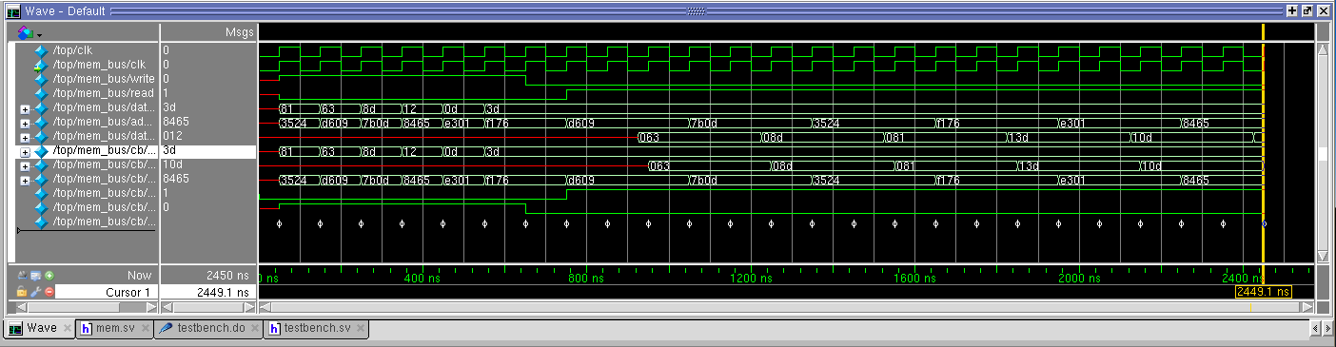

**Transcript with Zero Memory Read Errors:**

Refreshing /net/fpga1/users/adamrb/ECEn620/Assignments/Assignment4.2/work.top

# Loading sv_std.std  
# Loading work.top  
# Refreshing /net/fpga1/users/adamrb/ECEn620/Assignments/Assignment4.2/work.mem_if  
# Loading work.mem_if  
# Refreshing /net/fpga1/users/adamrb/ECEn620/Assignments/Assignment4.2/work.test  
# Loading work.test

# Refreshing /net/fpga1/users/adamrb/ECEn620/Assignments/Assignment4.2/work.my_mem  
# Loading work.my_mem

# Print Read Values

# 063  
# 08d  
# 081  
# 13d  
# 10d  
# 012

# Tests Performed: 6  
# Incorrect Read Errors: 0

**Transcript with One or More Memory Read Errors:**

# Test Complete.

# vsim -novopt top   
# Refreshing /net/fpga1/users/adamrb/ECEn620/Assignments/Assignment4.2/work.top  
# Loading sv_std.std  
# Loading work.top  
# Refreshing /net/fpga1/users/adamrb/ECEn620/Assignments/Assignment4.2/work.mem_if  
# Loading work.mem_if  
# Refreshing /net/fpga1/users/adamrb/ECEn620/Assignments/Assignment4.2/work.test  
# Loading work.test  
# Refreshing /net/fpga1/users/adamrb/ECEn620/Assignments/Assignment4.2/work.my_mem

# Loading work.my_mem

# Found Error: 0063 0000  
# Found Error: 008d 0000  
# Found Error: 0081 0000  
# Found Error: 013d 0000  
# Found Error: 010d 0000  
# Found Error: 0012 0000

# Print Read Values

# 000  
# 000  
# 000  
# 000  
# 000  
# 000

# Tests Performed: 6  
# Incorrect Read Errors: 6

**Transcript with One or More Assertion Errors:**

# Test Complete.

# vsim -novopt top   
# Refreshing /net/fpga1/users/adamrb/ECEn620/Assignments/Assignment4.2/work.top

# Loading sv_std.std  
# Loading work.top  
# Refreshing /net/fpga1/users/adamrb/ECEn620/Assignments/Assignment4.2/work.mem_if  
# Loading work.mem_if  
# Refreshing /net/fpga1/users/adamrb/ECEn620/Assignments/Assignment4.2/work.test  
# Loading work.test  
# Refreshing /net/fpga1/users/adamrb/ECEn620/Assignments/Assignment4.2/work.my_mem  
# Loading work.my_mem

**# ** Error: Assertion error.**# Time: 50 ns Started: 50 ns Scope: top.mem_bus.a1 File: /net/fpga1/users/adamrb/ECEn620/Assignments/Assignment4.2/sverilog/mem.sv Line: 23 **# ** Error: Assertion error.**# Time: 150 ns Started: 150 ns Scope: top.mem_bus.a1 File: /net/fpga1/users/adamrb/ECEn620/Assignments/Assignment4.2/sverilog/mem.sv Line: 23 **# ** Error: Assertion error.**# Time: 250 ns Started: 250 ns Scope: top.mem_bus.a1 File: /net/fpga1/users/adamrb/ECEn620/Assignments/Assignment4.2/sverilog/mem.sv Line: 23

# Print Read Values

# 063  
# 08d  
# 081  
# 13d  
# 10d  
# 012

# Tests Performed: 6  
# Incorrect Read Errors: 0