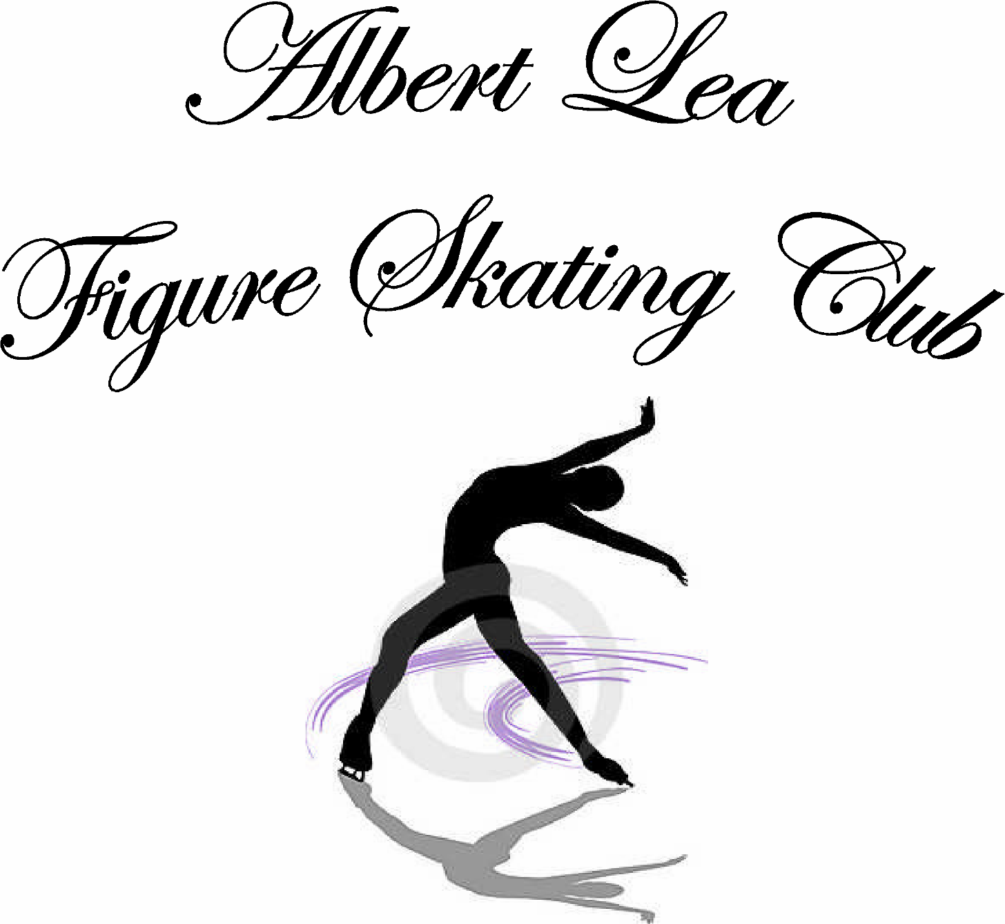

Albert Lea Figure Skating Club

Parents/Guardians and Skaters:
The Albert Lea Figure Skating Club (ALFSC) is a non-profit, educational organization. It is our goal to provide a skating environment that fosters both recreational and competitive skating. Our club has a broad membership and we strive to meet the needs of each skater.

The ALFSC Membership Handbook has been written for the current skating session to help familiarize you with the sport of figure skating and make your skating experiences more pleasurable. We hope to answer some of the more commonly asked questions and pass on some of the knowledge we have gathered.

Please keep this manual handy for quick reference.
If you ever have a question, please call a member of the Board of Directors or your coach. It is our goal that each of you will become as informed and enthusiastic about skating as we are. With that in mind, please
take time to read this handbook with your skater
so that they are informed as well.

Thank you,
The Albert Lea Figure Skating Club
Board of Directors

BOARD OF DIRECTORS
The Albert Lea Figure Skating Club is governed by a Board of Directors elected by the membership. The board meets monthly. Watch the bulletin board for dates and times of board meetings if you are interested in attending. They are currently being held on the 2nd Monday of each month at 6:30 at the City Arena. During the summer months, time and locations vary. You are invited to attend the meetings, which are open unless the board is discussing personnel issues or past due accounts, which require a closed session. Questions, concerns, and comments from members are welcomed and will be addresses during the first 10-15 minutes. Some of the annual events include the fall orientation/registration and the spring banquet, at which time we hold elections for new board members. Fundraisers are discussed at the fall orientation meeting.

The ALFSC is sanctioned by the USFSA
(United States Figure Skating Association)

Our Skating Professionals

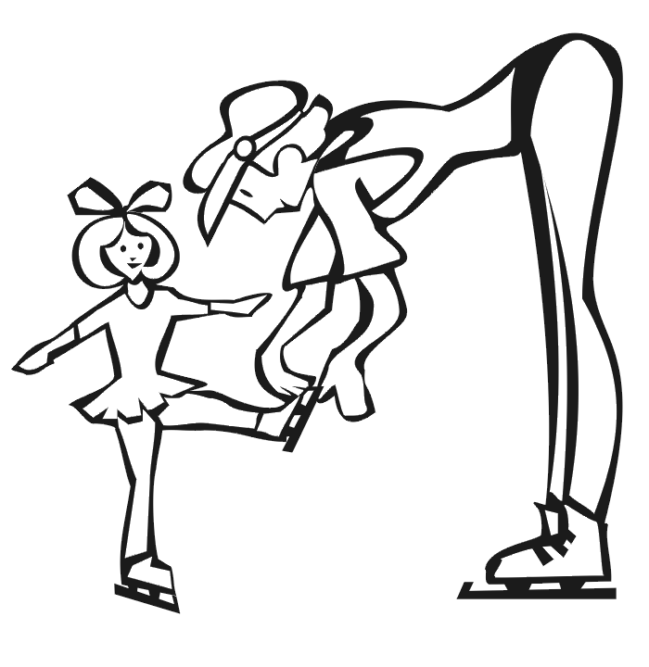
Suzanne Olson
Home (507) 526-2611
figure8prk@bevcomm.net

Anne Sternhagen
Cell 507-383-1932
sternhagen23@yahoo.com

Sarah Anderson
Cell-507-696-4905
SMAnderson008@yahoo.com
Brittni Lair
Cell 507-351-0102
brittni.n.lair@gmail.com

Our ALFSC Board of Directors
President: Nikki Austinson 507-402-2336
Vice President: Travis Olson- 507-383-1179
Secretary: Beth Isaacson 507-383-9907
Treasurer: Amy Klimmek 507-383-5556
Testing Chair: Carol Linde
Publicity/ Scheduling: Nikki Austinson 507-402-2336
Director: Jill Nelson 507-383-5109
Director: Erica Samp 507-383-9812
Director: Leah Schmidt 651-353-7113
Director: Travis Olson 507-383-1179
Director: Natalie Loock 507-391-3369

You will find registration forms, bylaws, handbook, show information, skater pictures, and much more information on our club website: www.alfsc.org

PLEASE READ THE RULES OF THE ICE LISTED BELOW

- During freestyle and MIF (moves in the field), skaters should be working. If it is necessary to talk with other skaters, please leave the ice.

- All skaters fall, but for your own safety and for the safety of others, get up immediately, NEVER lay or sit on the ice!

- Kicking holes in the ice is inappropriate behavior and is detrimental to the ice.

- PROS (coaches) and skaters should be aware if another student and/or pro are working in a particular area and not move into that area to practice.

- If two skaters are moving toward each other and are on a collision course, as a general rule, pass each other on the right. That way neither skater is trying to guess which way the other will go.

- A skater in a spin cannot move to avoid a collision. It is the responsibility of the skater who is moving towards the spinner to change direction to avoid a collision. If a skater is doing their program, try to avoid doing a spin where the program skater may be doing a jump.

- Look first before doing backward spirals toward crowded ice. Look both ways when leaving a talk with a pro during lessons, or when leaving the side of the boards.

- Do not skate in the path of a jumper.

- Skaters in lessons have priority on the ice. It is the responsibility of other skaters to move out of the way. Make an effort to familiarize yourself with the other skaters' music so you can anticipate when you should move. Coaches have the right to dismiss you from the ice for the night.

- When stretching, don’t kick your foot up on the boards. Place it on the board so you do not hit someone. Never kick behind you - it is a poor way to stretch and it is very dangerous to other skaters who may be stroking around the rink.

- Hanging around the boards is a waste of your time and money and the club's ice.

- Place your CD in line when you get on the ice and wait for your turn to play it. A skater in a lesson has priority for the CD player.

- Leave the ice promptly when your session is over. You will be billed if you stay on the ice for another session. No skater should be on the ice at the same time as the resurfacing machine.

- Do not get on the ice before your session starts. You will be billed for an extra
session.

- Do not get on the ice before your session starts. You will be billed for an extra
session.

- Foul language and inappropriate behavior on or off the ice will not be tolerated and will be grounds for removal from the ice during that lesson and/or future lessons. Inappropriate behavior reported after a lesson has finished will be dealt with when it is brought to the attention of the club. As it is important to resolve these issues in a timely manner, please bring any behavior issues to the coach and/or club as soon as possible. Any behavior issues will be dealt with at the discretion of the board on a case by case basis.

- Be encouraging and supportive of each other and be respectful of our coaches.

- Parents, if it is necessary to talk with your skater, please have them leave the ice.

- Parents, if you need to talk to a coach, please find a time other than lesson times
to do so. Please do not interrupt the coaches during lessons, especially if it is not
your child’s lesson time.

21. All skaters must watch the safety video before they are allowed on the ice

22. No headphones or cell phones are allowed on the ice.

23. No food, gum, or pop on the ice or boards.
Parents, it is your responsibility to go over the
above rules with your skater!
The Board of Directors strongly encourages
parents of skaters under the age of 12 to
stay and watch your child’s lesson.

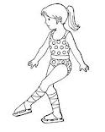

TYPES OF FIGURE SKATING
BASIC SKILLS
A skater usually begins lessons in group classes working on BASIC SKILLS. Basic Skills are a series of badges numbered 1-8 that teach the very basics of figure skating. As a new member, each skater will be given a Basic Skills Handbook that will explain what is necessary to learn and master in order to "test out of” or "pass" a particular badge level before moving on to the next badge in the sequence. The coaches will test basic skills skaters periodically throughout the year. At the spring banquet in April, the club will hand out badges to the students for each level they have passed during that season. It is very important to bring your books with you on testing dates, so that your coach can sign and date it as each level is passed. Please leave your book in your folder at the arena. If you lose your book, please contact the Basic Skills coordinator to make arrangements for getting a new one.

After the mastery of Basic Skills the ALFSC offers the following types of figure skating:

MOVES IN THE FIELD
MIF is a program developed by the USFSA in which patterns are skated across the whole surface of the ice. The emphasis is on stroking, footwork, and use of edges with power and speed.

FREESTYLE
Freestyle skating begins with stroking, good footwork, and the introduction of jumps and spins. Freestyle or free skating is the familiar part of the sport performed to music with jumps, spins, and artistry.

SYNCHRO LINE
The ALFSC may at some point during the season offer the opportunity to skate in a synchro line to any freestyle skater age 12 and above. (Younger freestyle skaters may participate, but more than 50% of the skaters on the line must be at least 12 years of age). There must be a minimum of eight skaters for synchro classes to take place. Contact your coach for more information if you are interested in this opportunity.

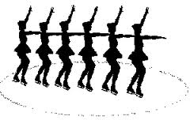

LESSON TIMES
Private and Semi-Private and Group lessons are currently available on Monday and Wednesday
evenings. It is advisable for skaters to skate more than once a week to see
continued improvement. A minimum of two times per week is desirable for skaters
of all levels. Lesson times are scheduled on a first come, first served basis. Those
who have their registration forms turned in first are given preference of lesson times
and coaches.

ALFSC ANNUAL ICE SHOW
Tryouts for the show will take place in the fall as determined by the Board of Directors. Watch the bulletin board and newsletter for dates and information. Tryouts are held for freestyle numbers (solos, features, duets, trios and quartets and possibly Jr. & Sr. lines). Skaters will be allowed to try out for a freestyle number in the show season if they have passed out of their basic skills prior to July 1st of the current skating season.
Based on their abilities, Basic Skills Skaters will be assigned to a group by the coaches with whom they will skate their numbers in the show.
Any skater who is not planning on participating in the annual show must give written notice to the club's president prior to November 1st. Once costumes have been ordered, the skater/family is responsible to pay for the costume whether or not they are in the show.

Free-Style Tryouts

Skaters must be registered as a USFSA Freestyle Member (not Basic Skills member) in order to try out for the show. Tryouts are held in late October or early November.
Tryouts for the show are considered mandatory for freestyle skaters. If a freestyle
skater is unable to attend the scheduled show tryouts, special permission may be requested from the board to make other arrangements. The board may or may not consult the coaches
on this matter. The board may or may not grant the request. The board decision in this matter shall be considered final. Each case presented shall be considered on an individual basis.

Tryout Requirements:
No Required Elements- A skater is judged on the same scale as every skater performing the most difficult elements that they can properly complete.

Judging is based on 10-point scale divided into 3 categories: Jumps, Spins, and Artistic.

Coaches may help skaters with their tryout program. Coaches bill independently for cutting music and choreography. Talk to your coach about rates. Length of tryout music must adhere to the following guidelines:
Freestyle skaters up to Pre-Juvenile Level: 1 minute, 30 seconds
Freestyle skaters who have passed Pre-Juvenile Level: 2.0 minutes
Freestyle skaters who have passed Juvenile Level: 2 minutes, 15 seconds

There may be practice ice available prior to tryouts. Watch the bulletin board for these dates and times.

Exemption from tryouts for senior skaters: Any 12th grade senior skater who wishes may skate a solo in the ice show. To qualify, they must have been an ALFSC member for a minimum of five consecutive years prior to their senior year.

Qualifications for a senior solo of any skater transferring to this club must meet the above requirements from the last club and also have been a member of ALFSC for two years prior to their senior year.

In the event that there is more than one graduating senior, the skaters will skate a short program together for their senior showcase number.

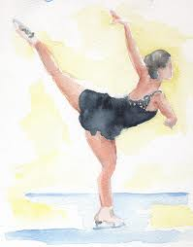

Remember: Skating is fun! It provides a child with good friends, great exercise, self-discipline, poise, and self-confidence. We hope that it is an enjoyable experience for both you and your child. If you have any suggestions or questions, please contact any board member.



Bad Weather Cancellations:
Please listen to KATE radio (AM 1450) , also Facebook and check your email for cancellation of skating events. You will not be called. It is your responsibility to check on cancellations. If the Albert Lea Area Schools and/or their evening events are closed/cancelled or close early due to weather conditions, skating will be cancelled for that evening. No billing for lessons. If your school and/or evening events are closed/cancelled or closes your absence is excused, but you will be billed for your lessons
ALFSC Policies
- USFSA MEMBERSHIP: All skaters and board members and coaches must have a current USFSA membership. The membership year runs from July 1st to June 30th for all skaters, therefore, it is important to pre-register in the spring. The registration fee is paid at this time or whenever a new member registers. Registration cannot be completed unless all the paperwork is turned in and the registration fee is paid.
- FUNDRAISING: ALL SKATERS must raise $150 PROFIT for the club, regardless of how many skaters there are in one family. The first season fundraising information is handed out at the fall registration meeting. For later fundraisers, information will be posted on the bulletin board closer to the selling period. If the skater raises more than the required amount, the excess profit will be applied to the individual skater's account. If a skater leaves the club prior to the completion of the year, all profit shall be forfeited and will remain with the club. The excess profits are considered income, and members should claim that information on their taxes.
- ICE ASSIGNMENTS: All ice assignments are made by the scheduling coordinator. The ALFSC Board has the right to re-assign levels if there are safety concerns. All efforts are made to accommodate religious conflicts for skaters (confirmation, first communion etc.). These requests should be made before the registration deadline! Skaters may request two lessons on one day, but requests are not guaranteed and may or may not be honored. The scheduling coordinator will try to accommodate requests as space allows. All requests will be honored by the date they were received. Turn your forms in early.
- LESSON CHANGES: Changes or adding of lessons may be made at any time during the skating season and are subject to coaching and ice availability. If a skater wishes to drop lessons they must do so by the 15th of the month prior to the month that they are wishing to drop lessons in. Example: you know that your skater will no longer skate on Saturday morning beginning in December. You must notify the club’s scheduling coordinator by the 15th of November. Please call the scheduling coordinator for availability.
** Due to the short duration of spring session and August session, skaters will be responsible for the entire session once they register.**
5. COACHING CHANGES: Should a skater wish to change coaches before the start of the skating season, the procedures outlined below should be followed:
Parents:
1) Contact your current coach, the scheduling coordinator, and the club president to express your reasons for wanting to switch to another coach. There may be a way to change the current situation and the need to switch coaches could be resolved.
2) Discuss the change with your skater and be sure they are comfortable with it.

Prospective Coach:
1) First verify that the parent has contacted their skater’s former head coach.
2) If this contact has been made, the prospective coach should contact the former coach to discuss the situation and make sure that no resolutions could be made.
3) Support the former coach and respect what the coach has done for the skater.
If the skater’s concerns cannot be met by the current coach and if the requested coach has openings in their schedule after all of that coach’s current skaters have had lessons scheduled, then the coaching change can be made.
Coaching changes, with few exceptions, shall not be made mid-season or during show session.
Consult the following PSA guidelines with any questions concerning changing coaches:
http//www.skatepas.com/Proper-Procedures-for-Changin-%20Coaches.htm
http//www.skatepsa.com/Ethical-Issues-When-Changing-Coaches.htm.

- SELLING LESSONS: If you take private lessons and are unable to skate a lesson, you may sell your lesson and ice time to another skater. It is the responsibility of the skater scheduled to pay the club for the lesson and receive payment from the person to whom they sold the lesson. You can contact the Scheduling Coordinator and she will send out an email to the club and try to sell your lesson.

- BILLING: All ice and professional fees are billed a month in advance and are due on the 15th of the month. A $20.00 late fee will be assessed if not paid by the end of the month the bill is due. If your payment and late fees have not

been received by the 15th of the following month, your skater will not be allowed to skate until your bill is current. The following will apply while you are not skating:
  - You will be responsible for lessons you have scheduled from the 15th until the end of the month.
  - If someone buys your lesson(s) during that time they will pay the club and you will be credited for those lessons between the 15th and the end of the month.
  - If no one buys your lessons you must still pay for them.
  - Selling/filling of these lessons is YOUR responsibility.
If by the end of the month that your skater was removed from the ice and you still haven’t paid your bill plus the late fee then the following can happen
- Another skater may fill your lessons on a permanent basis.
- If your lessons aren't filled on a permanent basis and your skater resumes skating, you may be asked to pay your bill one month in advance for the remainder of the season.
If you are late two times with your bill, necessitating a monthly reminder, you will be asked to begin paying your bill one month in advance. If you have extenuating circumstances and notify the board prior to your bill being due, every effort will be made to work with you.

- ILLNESS or INJURY: If a skater is injured or becomes ill during the season and will be off of the ice for more than two weeks, it is the skater's responsibility to continue to pay for lessons for the first two weeks of the illness or injury (from the date that the president of the club is provided with the doctor's written excuse.) After those two weeks, the club will waive the ice and lesson fee for that skater until they are able to return to the ice. During this time the club will attempt to fill the skater's lesson with another skater or adjust the schedule appropriately. It is your responsibility to inform us of the anticipated date that the skater will be back on the ice so that we know how long to adjust the schedule. The exception to this is during show session, during which there will be no credit for illness or injury.

- PRACTICE ICE: Practice ice may be available if the number of skaters and/or the skill level of skaters on the ice do not exceed safety limits.

- EARLY ON THE ICE: No skater is allowed on the ice early for any reason. Skaters may not enter the ice or box area until their scheduled time.

This is a safety issue and is distracting to those already taking lessons. Any skater entering the ice early, even for stretching, will be asked to leave the ice. Those who continue to do so will be billed for practice ice time.

- RETURNING TO THE CLUB FOR SHOW SESSION: If a skater did not skate in the fall session and has decided they wanted to skate in an optional number in the show, the following rules would apply.

The Skater:
- Must have been in the club in the previous year and have been a freestyle skater.
- Must register with the club and take one freestyle lesson during show session.
- Would only be allowed to skate in optional numbers since they didn't try out
- Must meet all requirements for the number (example: age, skill level, etc.)
- Must adhere to the attendance policy.
- May only exercise this option once in their skating career.

12. SHOW PRACTICE ATTENDANCE POLICY:
- Attendance at the show practices is mandatory for all skaters.
If a skater misses any portion of more than 2 practices (2 Mondays or 2 Wednesdays) they will not be allowed to skate in the show. Remember, you must skate in ALL of the numbers in which you have been placed. ALFSC's injury and illness policy will be in affect for those skaters who have injuries or illnesses that prevent them from skating. Skaters with injuries must still attend practices and watch from the boards. If this is done, the session will not be counted as an absence. If a skater is disqualified from skating in one number, they will not skate in any of their numbers.
- Tardiness will count for ½ an absence for every 10 minutes for a maximum of 1 absence per session if the skater is late for rehearsal.
- Skaters must participate in all show numbers they are places in. They will not be allowed to pick and choose.
- Parents will be notified after the 2nd absence with a phone call. If there is a 3rd absence, the skater will not be allowed to perform.

13. COSTUME AND MUSIC SELECTION FOR THE SHOW:
- Group music will be selected by the coaches.
- Group costumes will be chosen by the board and approved by the coaches.
- All Freestyle and artistic numbers’ (quartets, trios, duets) music will be chosen by the coaches.
- Solo and feature costumes will be chosen by the skaters with a board member assisting and approved by the coaches. All other freestyle costumes will be picked by the board and approved by the coaches, with the exception of the artistic and line numbers which will be picked by the coaches.
- Feature music will be selected by the coaches to match the music for the group they are featured with.
- Feature costumes will be chosen by the skater with a board member and approved by the coaches.
- Soloists will choose their own music and costumes before all other skaters.
- All music (with the exception of senior showcase and senior’s solo) will be selected from a list provided by the board that fits the show theme.
14. CONFLICT RESOLUTION POLICY:
The first step of conflict resolution is communication. We request that you attempt to resolve your conflict by discussing it directly with the appropriate person. If no resolution can be made at that time, you may then put your conflict in writing and provide a copy to the person involved as well as to the president of the club. At that point, the president will discuss the issue with all parties (together or individually) and attempt to resolve the complaint. If the complaint is not resolved at that time, the issue will go to a board appointed committee. The committee will meet with all parties and a resolution will be reached.

If the conflict is directly related to a policy, bylaws, etc. and does not involve other people, the person must put their conflict in writing and provide it to the board. The president of the board will then contact the person to discuss the
issue. If no resolution is made at that time, the conflict will be reviewed in a board meeting with all parties present for potential resolution. If there is no resolution, the issue will go to a board appointed committee. The committee will meet all parties and a resolution will be reached.

The board appointed committee may ask for other information from any parties (in person or in writing) while they are attempting to resolve conflicts.

If the conflict is with the current president of the club, the immediate past president will replace the current president for the resolution process.

Home Club Policy
The Skater must be in good standing with ALFSC
The skater must represent ALFSC in competitions, testing, and exhibitions
The skater must take a private or group lesson with an ALFSC coach during
2 sessions of ice time, one of which must be the fall session.
The other sessions of choice will either be show, spring or summer
The skater must participate in the fundraising requirements of the club.

Member in Good Standing Policy

The skater’s bill must not be delinquent
The skater must not have any disciplinary action against them. That
Does include warnings that have caused the skater to be removed from the ice which excluded verbal or written warnings

USE OF SOCIAL MEDIA:
The use of social media such as Facebook, Twitter, You Tube, Pinterest, etc. is popular among many organizations. The ALFSC has a Facebook page which the board makes every effort to keep updated with notifications, photos taken at various ALFSC events, and other miscellaneous information. Facebook is a method for the distribution of information to club members.

While the ALFSC cannot control the use of social media by its members, all skaters are strongly encouraged to use these resources in a positive manner in regard to the club and other skaters. We ask that parents discuss the proper use of social media with their children/skaters. Though figure skating is not by definition a “team” sport, the board hopes that all members will support each other in their mutual passion for skating. Please keep in mind that one skater’s success and accomplishments do not conflict with or detract from those of another skater. The USFSA does have a policy in place for social media.



USFSA Testing

Progress in figure skating is measured by a series of tests, which are governed by USFSA Rules. Individual skaters are tested in FREESKATING and MOVES IN THE FIELD (MIF). Judges for test sessions are trained USFSA judges. Within the USFSA testing structure, there are a total of eight free skate and eight MIF tests. The MIF and free skate test levels are as follows:
Pre-Preliminary (Pre-Pre)
Preliminary (Pre)
Pre-Juvenile (Pre-Juv)
Juvenile (Juv)
Intermediate
Novice
Junior
Senior

The MIF test must be passed before a free skate test can be taken at the same level. Your professional will tell you when you are ready to test. Even if you are ready to pass a test, your pro may have you wait so that you can compete at the appropriate level.
The testing chairperson makes all the arrangements for the test sessions. This includes setting the date and time, arranging for the ice, calling the judges, setting the testing schedule, and reporting all test results to the USFSA.
On all tests except the pre-preliminary and preliminary, there is a minimum of three judges with one acting as "judge-in-charge." This is the judge a skater would ask questions of during the test. A panel may consist of more than three judges if a trial judge is judging. A trail judge is a "judge-in-training". Pre-pre and pre tests require only one judge.
Judges have spent many years in training and they volunteer their time because they care about the sport of figure skating. A thank you at the end of your test is appropriate. Appropriate test etiquette should be discussed with your pro prior to the test session.
USFSA rules state that any skater wishing to retry a failed test must wait for at least 27 days between attempts.
Volunteer Opportunities

Food Committee:
· Banquet – Plan the annual banquet; notify members, set date/place/time, door prizes, award, etc.
· Food Sales – Fundraising project Monday/Wednesday/Friday during show week. Organize the different foods to serve each night, pick up/delivery of food. Everyone working brings a pan of bars to serve.
Fundraising: To raise money, order product, arranging delivery of product, etc. We will have a variety of fundraising opportunities this year. Greater Midwest Gourmet Foods, Wreaths and Garlands, Butter Braids, Herberger’s Community Days coupon books, a Burger Basket night, Kwik Trip cards, and scratch off tickets.
Pool Concession Stand: Running the concession stand at the City Pool
Publicity: Send photos to the newspaper, social media to promote the club and the annual show.
· Show Program
· National Skating Month – Planning some skating opportunities/community outreach.
· Contact and secure show sponsors
Learn to Skate Program: Helping to organize and run the LTS Program.
· Registration meetings
· Type up a LTS roster and give it to the Membership Chair so she can register the skaters.
Creating Props: Set - set construction, painting, assembling during lesson times on Monday and Wednesday nights.
Picture Day: Create a schedule for picture day. Make sure this day is not on a LTS skating day. Write down the skaters’ names in the groups; get the skaters lined up to keep the day flowing smoothly.
Costumes: Measuring skaters, placing order, sorting order and passing out costumes to the skaters.
Show week Coordinator: Besides ordering the two items highlighted, it mostly just making sure everyone that is sign up is called and reminded that they need to work and finding more people if needed.
· Prop Set Up – Always involves Friday during the day of show week.
· Prop Tear Down – Tear down set after Sunday’s show.
· Flower Sales – order flowers and sell before the show and during intermissions. Also need flowers for the senior parents, coaches and jr. coaches.
· Ticket and Program Sales - order tickets and stand at the door to sell programs/tickets
· Room Parents – help skaters change into costumes, keep Basic Skill skater groups together.
· Back Stage Coordinator – Line up groups backstage during the show.
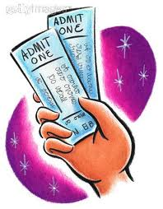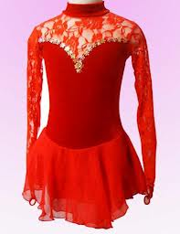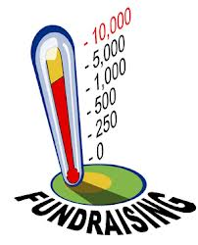

The more volunteers we have for our committees, the less work there is for everyone involved. Please give your time to help all of our skaters. Thank you in advance.

ALFSC Concession Stand at the City Pool

All families will be required to work shifts (app. 1:15 pm —5:45 pm) in the pool concession stand during the summer. This is our major fundraiser for the year. It takes everyone to make it successful. If your skater is an ALFSC member for the 2015-2016 season, these shifts would take place in the summer of 2016. If you are unable to or choose not to work, you are responsible to obtain a replacement to work on your behalf. This could be a spouse, relative, neighbor, teenager, or friend over the age of 14. There is a buyout option available through the club if you choose not to work your shifts. The cost for each shift that you choose to buy out is $50.00. If you have one skater, you must work 2 shifts, if you have two skaters, you must work 3 shifts, and if you have more than 2 skaters, you must work 4 shifts.

The Albert Lea Figure Skating Club
is a member of the United States Figure Skating Association.

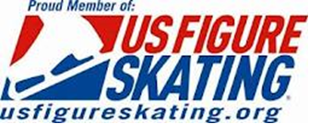
Shopping for New Skates

"Buyer Beware" are the watch words when it comes to purchasing new skates. Please
keep in mind that when you go to sporting goods shop, they have clerks who, for the
most part, have very little knowledge about fitting skates. The more you know, the
better. The following are some tips to remember when purchasing skates:
- Don’t buy skates that are too big with the thought that you are leaving room for feet to grow. A skate should fit firmly around the ankles and you should be able to wiggle your toes a little. Be sure to purchase a skate with leather upper and check to see that the blades are mounted straight on the bottom.
- Wear thin socks or tights with skates. Wear what you plan to skate in when fitting new skates.
- A skate that fits properly is usually one half to one size smaller than street shoes.
- Purchase from a reputable dealer. Be sure to stand in the skates to assure a comfortable fit and have adequate ankle support- no wobbling.
- Many new skates have not been sharpened. Check to see if they have been sharpened properly when you purchase them and if not, have it done before beginning to use the skates.
- New skates may hurt the first few times you wear them, but don’t give up: they just need to be broken in.

Take care of those new skates, wear guards, and wipe your blades dry after every use. Have skates sharpened often, especially if you skate outside in the winter. Don’t ever walk on concrete without your guards.

Getting started
Ice skating is a great way to have fun while doing something that is good for you. Skating is a great sport for everyone-age is not a factor and it is never too late to learn. Skating is good exercise: it helps build muscles, stimulate you heart, and improves coordination and balance. In addition to the healthy aspect of the sport, skating is just plain fun! Come on, round up your friends and family, and head for the rink!
What will I need?
Whether skating indoors or outdoors, dress for warmth by layering your clothing. Remember to bring mittens and a hat. Comfort and ability to move freely are also very important. Sweatpants or warm up pants are ideal. Your feet will feel best if you wear one pair of lightweight socks or tights. Bulky or thick socks may limit the support provided by the boot and may also create "lumps and bumps" inside your boots. Make sure that you have enough room to move your toes once your foot is properly laced into the boot. Safety helmets are becoming more popular for beginning skaters.
What about skates?
The boot should provide a snug fit. It should be made of a firm material, preferably top grain leather, to support the ankle. Make sure the hooks and eyelets are firmly anchored and that the boot is fully lined. If the boot is too big, it will not provide the necessary support. If the book is too small, OUCH! Proper fit is essential to success in skating!
The blades should be stainless steel so that they hold an edge. They should be properly mounted on the boot with screws.

New, used, or rentals?
It is not always necessary to buy new skates. Used skates can be a great bargain if you know what to look for. Look for clean, firm leather boots that are fully lined. Check the blades for deep nicks and scratches and make sure they still have enough life for future sharpening’s. If you are unsure as to the condition of the pair of skates, ask your skating instructor for tips.
If you decide to buy new skates, ask you instructor for the names of skate manufacturers and for locations where they can be purchased. Some skate shops or sporting goods stores carry beginning skates, or they can order them directly from the manufacturer. Most manufacturers produce a beginner’s boot that comes with a beginner’s blade. As you become more advanced, you may wish to check out specialty blades that can be mounted on specialty boots. But when you are just beginning, this is not necessary.
Also remember that rental skates will work fine. When renting skates, ask for a pair with firm boots and sharp blades.
Proper Lacing
Loosen the laces, pull the tongue forward, and insert your foot into the boot. Center the boot tongue and pull it up. Then tighten the laces through the eyelets so that they are snug (no slack) but not too tight. To insure proper support for the ankles, the tightest point of lacing should be at the instep. Follow by criss-crossing the laces snugly around each hook. When you reach the top hook, tie a secure bow. If the ends are too long, wrap the laces through the hooks again and then tie a bow in front. Do not let the ends drag on the ice. A good fit will allow you to insert a finger in the back of your boot.
Let's go Skating!
Testing and Competitions

According to the USFSA Official Rulebook, there is appropriate attire required for testing and competitions. (SSR 19.00)
The clothing of the competitors in all disciplines of figure skating must be modest, dignified, not garish or theatrical in design, and appropriate for athletic competition. Clothing may, however, reflect the character of the music chosen. Clothing not meeting the foregoing requirements must be penalized by the judges by a deduction of 0.1 in the second mark.
Clothing for Men cannot be theatrical in nature. Men must wear full-length trousers. Tights are not permitted. The clothing must have a neckline that does not expose the chest, must not be sleeveless, and must be without excessive decoration such as beads, sequins, and the like.

Clothing for Ladies cannot be theatrical in nature. They must have skirts and pants covering the hips and posterior. A unitard is not acceptable. A bare midriff is not acceptable. Clothing must be without excessive decorations such as beads, sequins, feathers, and the like. Any ornamentation attached to the clothing must be firmly fastened so as to not fall off while skating under normal competitive conditions.
Accessories and props are not permitted, except where stated in the competition rules.

Figure skating blades used during the taking of tests and skating competitions must be standard stock blades of the type manufactured by the recognized figure skating manufacturer and generally available to figure skaters. Blades must be sharpened to produce a flat to concave cross section without change to the width of the blade as measured between the edges. However, a slight tapering or narrowing of the cross section of the blade is permitted.

Checklist for Test Candidates
Prior to Test Day
- Complete Test Application and fill in the requested information, including USFSA number.
- Submit completed application and fees prior to deadline.
- If you are testing with a club other than ALFSC, request that your home club test chair or officer send the necessary permission to the host club.
- Provide proof of having passed the prerequisite test requirement.
- If you have a special need or request, inform the test chair as far in advance as possible.
- If after applying for a test you find you cannot make it, notify the test chair immediately.
- Check with the test chair in advance to determine if the club uses a cassette, CD player, or both.

On Test Day
- Plan to arrive one hour prior to your scheduled warm-up time unless instructed otherwise.
- Bring with you: skates and guards, skating outfit, tape or CD plus a backup, water and snacks, test permission form (if not already mailed), extra laces, extra tights, something to do quietly until test time (book, I-Pod, etc...).
- Make sure skates are polished and have new or clean laces.
- Dress properly for the test.
- Upon arriving at the rink, check in with the test chair or assistant and determine if there have been any schedule changes.
- Turn in your tape or CD. Make sure tape is rewound and that tape or CD is clearly marked with your name. Again, have a backup just in case something happens to your original.
- Keep your voices low so as not to interrupt another tester's concentration.
- Have skates on and be ready to get on the ice when called.
- Be aware of which end of the ice you will be starting your test.

During Test
- Prior to starting your test, introduce yourself to the judging panel.
- Wait for a signal from the judge-in-charge or other official prior to starting test and each move.
- During MIF test you may speak BRIEFLY to you coach between moves but NOT between changes in direction. However, skaters should be ready to start when signaled to do so.
- At the conclusion or your test, do not leave the ice until dismissed by your judging panel.
- If judges request a re-skate of an element, let the judges know whether you plan to warm up or just do it. You may also speak briefly with your coach.

After Test
- Test papers will be given to you so that you can see the results and read the judges’ comments.
- Return the original test papers to the test chair before leaving the rink. However, you may be able to obtain copies from the test chair or rink management.
- Be mindful of other skaters’ feelings.
- Retrieve your tape or CD.
- Thank the judges and those in charge of the test session.
- Make sure you have all of your belongings before departing the rink.

The Competitive Skater

Competitions and performances in shows and exhibitions are an incentive for figure skaters to train, develop, and improve their proficiency in the sport. Choosing to compete is a choice that the skater, parent, and coach must arrive at together. Competing is not for every skater. If you have specific questions beyond what is covered in this manual, please contact your coach or a board member. We may not be able to answer your questions, but we will put you in touch with another parent who has experience with competitions and can be helpful to you.
Local clubs run non-qualifying competitions. Usually compulsory and technical freeskating, Moves in the Field, and sometimes artistic events are offered. They are one-time competitions and do not serve as a preliminary round for a later competition. These USFSA competitions are run by members of amateur clubs and are judged by qualified amateur judges. Skaters register according to test level and age. In non-qualifying competitions, skaters may compete at one level higher than their highest test level. Remember ALFSC code of conduct is strictly enforced….Please display good sportsmanship at all times.

Listed below are several different events that you can enter in a competition:
- Freestyle (or freeskating) a program that is skated to music.
- Compulsory competitions require that specific jumps, spins, and footwork are performed without music through the Juvenile level. Intermediate through Senior level skaters perform a short program to music that includes required moves.
- Artistic events are skated to music with emphasis on artistic feeling and presentation rather than technical difficulty.
- Moves in the Field require specific moves to be skated.
Your coach usually travels to the competitions with you or will request that another of our club's coaches assist the skater. The coaches charge for their time and expenses; please discuss this with them well before the competition. You do not want any surprises!
Remember that it is nice to have your coach attend competitions with you and your skater but it is not mandatory. Please be sure to thank them for their hard work and encouragement.
When competing, it is important to carefully read the application. Required elements vary from competition to competition. Competition forms are available on the club websites. They have a postmark deadline date approximately four to six weeks prior to the competition. The forms need to be signed by the skater, their coach, and a club officer. In order for the club to sign your entrance form, you must be a member in good standing (payments must be current). Entrance fees for competitions generally run from $75 and up depending on the competition and the number of events entered. Mail the form, entrance fee, and a self-addressed stamped envelope before the due date.

