Code

**import** javax.swing.JOptionPane;

/**

* **@author**: adam_j_schachte

* 1st and 2nd Period

* **@date**: 10/28/11

* **@purpose**: Make a Java program that uses do while loops

* to add the users' numbers together.

*/

**public** **class** SumOfTheNumbers {

**public** **static** **void** addition1(){

**double** Number=0;

**double** Entry=0;

String Message1="Enter Zero to end the Program.";

String Message2="\nThis program adds numbers.";

**do** {

Entry=Double.*valueOf*((JOptionPane.*showInputDialog*(**null**,

Message1+Message2, "Reverser",

JOptionPane.*INFORMATION_MESSAGE*)));

Number=Number+Entry;

Message2="\n"+Number;

}**while** (Entry!=0);

}//end of method.

**public** **static** **void** main(String[] args) {

*addition1*();

}//end of main.

}//end of class

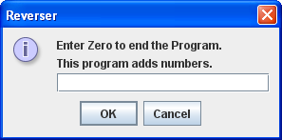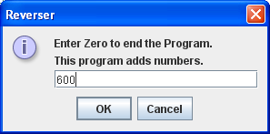

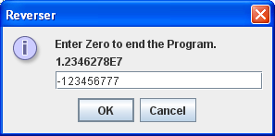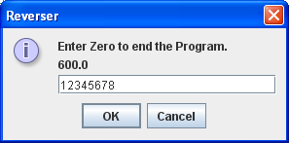

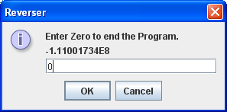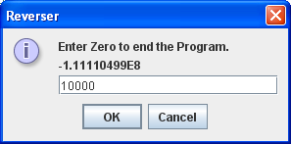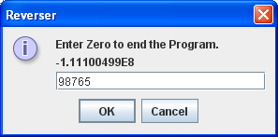

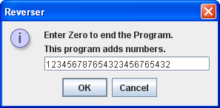

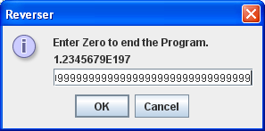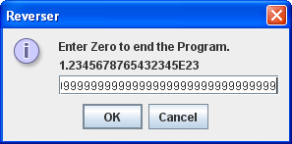

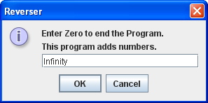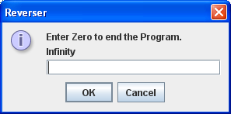

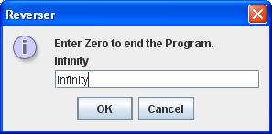

Exception in thread "main" java.lang.NumberFormatException: For input string: "infinity"

at sun.misc.FloatingDecimal.readJavaFormatString(Unknown Source)

at java.lang.Double.valueOf(Unknown Source)

at SumOfTheNumbers.addition1(SumOfTheNumbers.java:16)

at SumOfTheNumbers.main(SumOfTheNumbers.java:24)

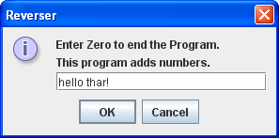

Exception in thread "main" java.lang.NumberFormatException: For input string: "hello thar!"

at sun.misc.FloatingDecimal.readJavaFormatString(Unknown Source)

at java.lang.Double.valueOf(Unknown Source)

at SumOfTheNumbers.addition1(SumOfTheNumbers.java:16)

at SumOfTheNumbers.main(SumOfTheNumbers.java:24)