STANDARD SIMULATION TEST REPORT

Test date:
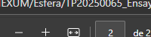

Graph:
