To-Do List app

Project Document

Introduction
The purpose of this project is to build a simple, easy to use interface for planning out your day/week/month. As someone who uses to-do lists daily, this would greatly increase my productivity.
Must have a somewhat aesthetic design, simple functionality for understandability and notifications for reminders.

The Problem
In today’s society people are constantly busy with different tasks and obligations. To-do lists help by taking the memory part of this. A study from Forbes showed 47% of people have a lengthy to-do list on most days.
In current apps, there is often quite an expensive pay wall, or the interface may be too complex and overbearing, pushing users away.
I want to create an app that is free and extremely easy to understand and use. However, along the road a paid version could be created with exclusive features and benefits.

Target Users
- Students
- Project leaders
- Business owners
- Workers
- Casual users
Essentially, anyone that may have multiple future tasks to do, which is everyone.

Other implementations

Example One – ‘Todoist’
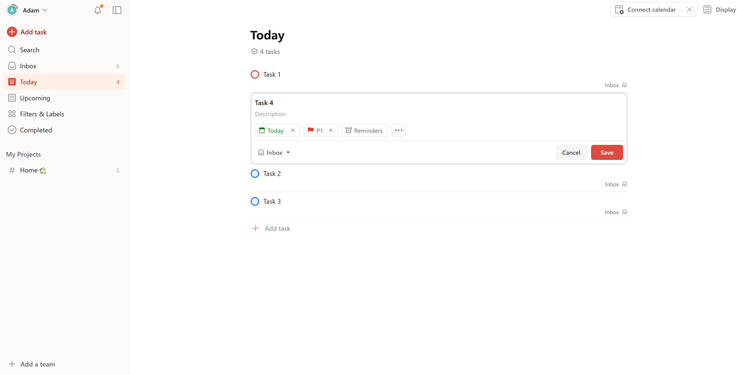
From this example, they utilise priorities, setting dates and reminders, which are some key elements I have to consider. I also really like the user interface, I think it is quite simple yet aesthetic. However, completed tasks go into a ‘Completed’ section, which I am not a fan of.

Feature Requirements

Technical Research

Design Inspiration

Next Steps

