A Pre-Hospital Early Warning System for Ischemic Stroke Risk Based on Multi-Wavelength PPG and an XGBoost Algorithm
Adam Kandias¹, Kadek Savita Dyutianaya², Kalyana Daeva Ali³, Ni Komang Diah Pratiwi⁴, Jonzeven La Royba⁵, Agrippina Waya Rahmaning Gusti^{3*}
¹[Undergraduate Student — gelar akademik mohon diisi], Computer Engineering Study Program, Department of Informatics and Computer Engineering, Politeknik Elektronika Negeri Surabaya, Surabaya, Indonesia
²[Undergraduate Student — gelar akademik mohon diisi], Applied Data Science Study Program, Department of Informatics and Computer Engineering, Politeknik Elektronika Negeri Surabaya, Surabaya, Indonesia
³[Undergraduate Student — gelar akademik mohon diisi], Electronics Engineering Study Program, Department of Electrical Engineering, Politeknik Elektronika Negeri Surabaya, Surabaya, Indonesia
⁴[Undergraduate Student — gelar akademik mohon diisi], Internet Engineering Technology Study Program, Department of Electrical Engineering, Politeknik Elektronika Negeri Surabaya, Surabaya, Indonesia
⁵[Undergraduate Student — gelar akademik mohon diisi], Creative Multimedia Technology Study Program, Department of Creative Multimedia Technology, Politeknik Elektronika Negeri Surabaya, Surabaya, Indonesia
*Email: agrippina@pens.ac.id
Abstract:
Ischemic stroke outcomes depend on how quickly families recognize warning signs, yet risk-stratification tools are applied only after hospital arrival, and consumer wearables are not designed to combine hemodynamic and metabolic risk factors into a single screening pathway. This study aims to develop and evaluate a pre-hospital early-warning system for family-assisted ischemic stroke risk screening. The system integrates a three-channel photoplethysmography (PPG) wristband (green 525 nm, red 660 nm, infrared 880 nm) with cloud-side signal processing, five physiological estimators, and a class-weighted eXtreme Gradient Boosting (XGBoost) stroke-risk classifier that triggers an Age, Blood pressure, Clinical features, Duration, Diabetes (ABCD2) self-assessment for the family caregiver. The system was evaluated on 11 volunteers against reference devices using leave-one-subject-out (LOSO) cross-validation, and on a public dataset of 5,110 records (4.9% positive) under a stratified 70/30 split. Streamed heart rate agreed with a finger oximeter at a mean absolute error of 1.2 beats per minute, and the LOSO accuracy of the five physiological estimators ranged from 76.2% to 91.4% against reference devices. On the public dataset, the classifier reached an Area Under the Curve (AUC) of 0.823 and a recall of 0.973 at a screening threshold of 0.042, detecting 73 of 75 stroke cases. Propagating the observed estimation errors into the classifier changed at most 3.8% of the risk tiers, indicating that the alert output is stable. These findings support the proposed system's use as a family-facing pre-hospital screening aid that prompts medical evaluation, rather than as a diagnostic tool.
Keywords:
class imbalance, ischemic stroke, multi-wavelength photoplethysmography, pre-hospital monitoring, XGBoost
1. Introduction
Ischemic stroke is one of the leading causes of long-term neurological disability and death worldwide. According to the Global Stroke Fact Sheet 2025, approximately 7.25 million deaths occur each year due to stroke [1]. Of these total cases, ischemic strokes account for approximately 65% globally and can reach as high as 87% in certain populations, such as in the United States [1, 2]. This clinical condition is highly time-sensitive; consequently, the greatest obstacle to effective treatment (based on the “time is brain” principle) often occurs during the prehospital phase. This delay is generally caused by families’ lack of awareness in recognizing the urgency of intermittent symptoms such as a Transient Ischemic Attack (TIA) [3, 4]. Although clinical risk stratification methods such as the ABCD2 score have been proven valid for evaluating the level of urgency following a TIA [5], these tools are generally only applied by medical personnel after the patient arrives at a healthcare facility.
Currently, existing pre-hospital monitoring relies heavily on consumer smartwatches and fitness trackers. While these devices are effective for tracking basic cardiovascular metrics such as resting heart rate or single-lead electrocardiograms (ECG), they present significant limitations for comprehensive stroke prevention. Conventional wearables generally lack the capability to continuously monitor and integrate multiple metabolic and hemodynamic risk factors such as blood pressure, glucose, and cholesterol levels without invasive procedures. Furthermore, they do not employ specialized predictive models tailored to handle highly imbalanced clinical data for acute risk stratification.
Therefore, there is a need for a continuous pre-hospital monitoring system capable of detecting early risk indicators and triggering automatic alerts, thereby accelerating the family’s decision to seek immediate care at a healthcare facility.
Existing pre-hospital monitoring solutions primarily use consumer wearables to provide basic physiological measurements, such as heart rate, physical activity, and, in some devices, single-lead electrocardiography [6, 7]. However, these devices are mainly designed for fitness, general health monitoring, or specific cardiovascular applications, and their use for comprehensive clinical risk assessment remains subject to limitations in measurement accuracy and clinical applicability [6, 8]. A systematic review of wearable technologies for cardiometabolic health reported that heart rate, blood glucose, and electrocardiography were among the commonly monitored parameters, while blood pressure and cholesterol were not monitored in the included studies [7]. In addition, wearable technologies for stroke-related applications still face challenges in measurement accuracy and the integration of physiological measurements into comprehensive stroke-risk assessment [6]. These limitations indicate that the integration of multiple physiological risk factors and stroke-specific risk classification into a single family-facing pre-hospital screening system remains limited. To address this gap, this study proposes a multi-wavelength PPG-based wristband integrated with cloud-side signal processing, physiological estimation models, and a class-weighted XGBoost classifier, with the resulting risk information delivered through a mobile application for family-assisted pre-hospital screening.
Wearable devices that incorporate photoplethysmography (PPG) technology open up opportunities for non-invasive monitoring of physiological parameters [9]. Compared to single-optical sensors, signal acquisition using a multi-wavelength PPG platform takes advantage of the varying light penetration depths in skin tissue, resulting in more comprehensive and stable hemodynamic monitoring [10]. However, when predicting stroke risk based on health data, machine learning models generally face the challenge of extreme class imbalance in medical datasets [11, 12]. A literature review demonstrates that implementing a class-balanced loss function and data balancing techniques in the eXtreme Gradient Boosting (XGBoost) algorithm can significantly boost model performance in detecting the minority class (at-risk patients) [13-17].
Based on this literature review, the objective of this study is to design a distributed early-warning system architecture that integrates multi-wavelength PPG signal acquisition with artificial intelligence based on the XGBoost algorithm. This classification model is specifically optimized using class weighting parameters to detect the risk of ischemic stroke in highly imbalanced data. The primary benefit expected from this study is a wearable screening device with high sensitivity that is integrated with a mobile application, so that a family caregiver is alerted before the patient reaches a healthcare facility. The contributions of this work are threefold: (i) a distributed architecture that connects three-wavelength PPG acquisition, server-side signal processing, and stroke-risk classification; (ii) a leave-one-subject-out (LOSO) evaluation of PPG-based estimation of five physiological parameters in an initial cohort of 11 volunteers, with an independent laboratory comparison in one volunteer; and (iii) a class-weighted XGBoost classifier with two decision thresholds, together with a sensitivity analysis that propagates the observed estimation errors into the final risk tier.
2. Method
This study proposes a distributed early-warning system architecture for detecting the risk of ischemic stroke in the prehospital phase. The methodology applied in the development of this system is divided into three main stages: designing the hardware architecture for multi-wavelength PPG signal acquisition, the signal preprocessing stage along with the estimation of physiological parameters, and risk level classification modeling using the XGBoost algorithm.
2-1- Multi-Wavelength Signal Acquisition Architecture
The early warning system prototype is designed to continuously acquire the user’s hemodynamic data using photoplethysmography (PPG) technology. To overcome the diagnostic limitations of a single sensor, the system integrates two optical sensors with different wavelengths (multi-wavelength). The SON1303 sensor is used on the green channel (525 nm) to detect changes in superficial capillary blood volume, while the MAX30102 sensor is used on the red (660 nm) and infrared (880 nm) channels to achieve deeper tissue penetration [9, 10]. The combination of these multiple light spectra aims to produce a more informative signal that is resistant to motion artifacts during monitoring. The entire process, including data acquisition, three-channel PPG data sampling, and batch data organization, is controlled locally using an ESP32-S3 microcontroller. The MAX30102 channels are sampled at 400 Hz, while the green channel is sampled at 200 Hz. The acquired PPG signals are organized into one-second batches, after which the ESP32-S3 computes a Signal Quality Index (SQI) before transmitting the raw PPG samples and SQI metadata through Wi-Fi to the server. This hardware configuration enables local signal acquisition and quality assessment while limiting computational processing on the wearable device.
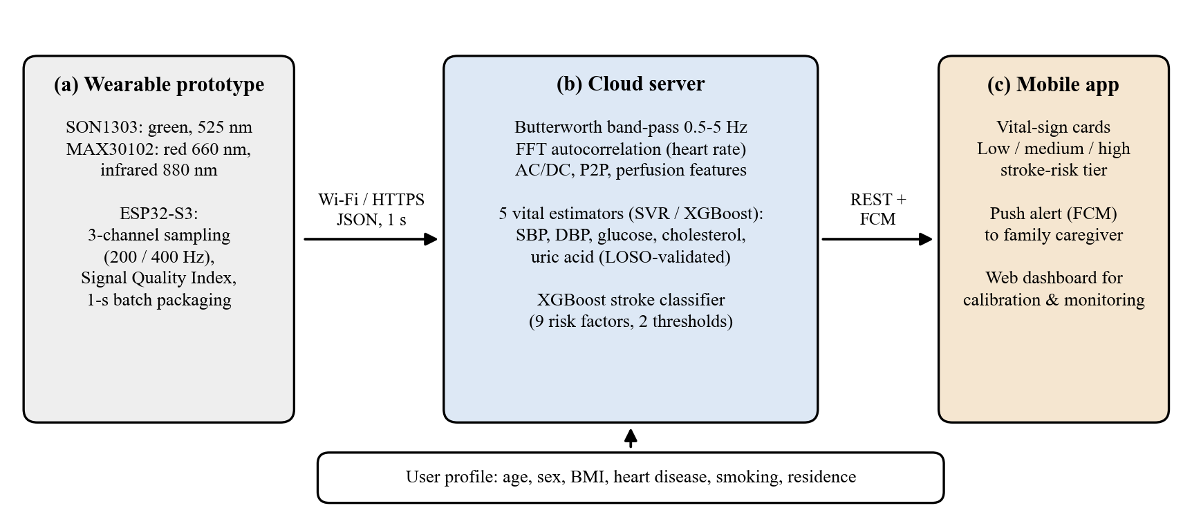
Fig. 1. Architecture of the proposed system: (a) three-wavelength wearable prototype, (b) cloud server for signal processing, physiological estimation, and stroke-risk classification, and (c) mobile application delivering vital-sign cards and risk alerts to the family caregiver.
Fig. 1 summarizes the data flow. The wristband streams one-second batches of raw samples over Wi-Fi to the server, which returns vital-sign estimates and a three-level risk tier to the mobile application. Keeping the computation on the server keeps the microcontroller light and allows the models to be retrained as calibration data accumulate, without reflashing the firmware.
2-2- Signal Preprocessing and Physiological Estimation
To minimize the computational load on the microcontroller, the system employs a distributed processing architecture between the prototype and the server. The ESP32-S3 computes a Signal Quality Index (SQI) for every one-second batch and transmits it as metadata together with the raw samples; the decision to accept or discard a batch is made on the server, where all sub-metrics are available and the thresholds can be changed without reflashing the device.
On the server, each channel is filtered with a fourth-order Butterworth band-pass filter (0.5–5 Hz) applied forward and backward to obtain zero phase distortion [18]. The lower edge removes the direct-current baseline and respiratory modulation (about 0.15–0.3 Hz), and the upper edge retains the first four harmonics of a 75 bpm pulse. The pulsatile component of each channel is characterized by its mean level D (DC) and the peak-to-peak amplitude A (AC) of the last second.
Heart rate is obtained from the autocorrelation of the band-passed infrared signal y[n], computed through the fast Fourier transform,
$$R[k]=\frac{ℱ^{-1}\left({\left(ℱ(y)\right)}^{2}\right)}{N}$$ (1)
where ℱ denotes the discrete Fourier transform and N the number of samples. The dominant lag k̂ is the highest local maximum of R[k] inside the physiological range of 40–180 bpm, refined by parabolic interpolation, and the heart rate is
$$HR=\frac{60f_{s}}{k̂}$$ (2)
where fs is the sampling rate (400 Hz for the MAX30102 channels). The periodicity confidence c = R[k̂]/R[0] lies in [0, 1], and readings with c < 0.30 are rejected. Because a window that contains alternating pulse amplitudes can lock onto twice the beat period (an octave error that halves the rate), the raw estimate is passed through a temporal stabilizer. A reading that deviates by more than 20% from the last accepted value is corrected by a factor of two when it matches half or double the previous value, otherwise it is held; the output is the median of the last five accepted values,
$${HR}_{t}=\operatorname{median}{{HR′}_{t-4}, …, {HR′}_{t}}$$ (3)
where HR′ denotes the accepted (octave-corrected) readings. The estimator is evaluated on a window that grows every second up to 10 s (minimum 4 s), which reproduces the streaming behavior of the deployed system.
The cleaned optical signals are then used to estimate five physiological parameters (systolic blood pressure, diastolic blood pressure, blood glucose, cholesterol, and uric acid). For each parameter, the input is a seven-element vector: the DC level and AC amplitude of the infrared and red channels, the heart rate, age, and sex, standardized with the mean and standard deviation of the training subjects only. A separate regression model is selected automatically for each parameter from 12 candidates (three model configurations × 4 feature subsets: all seven features, heart rate with age and sex, the two DC levels with age, and age only). The model configurations are support vector regression (SVR) with a linear kernel and with an RBF kernel [19], and XGBoost [20]; a multilayer perceptron was compared in preliminary experiments and gave lower accuracy than SVR and XGBoost, so it was not retained. Hyperparameters are fixed in advance rather than tuned after seeing the scores. The winning candidate m* is the one with the highest leave-one-subject-out validation score S on the training subjects,
$$m^{*}=\underset{m}{argmax}S_{LOSO}\left(m\right)$$ (4)
To ensure that the trained regression models do not experience data leakage between users, model performance is evaluated with leave-one-subject-out (LOSO) cross-validation [21]. Because the winner in (4) is itself chosen by a leave-one-subject-out score, reporting that same score would be optimistic. We therefore repeat the entire selection procedure inside every LOSO fold (nested LOSO): for each held-out subject, the model is selected and fitted using only the other N − 1 subjects, and then predicts the held-out subject. The results of these physiological estimates are then integrated with user profiles to generate nine risk factors that serve as inputs for the final stroke risk classification model.
2-3- Risk Level Classification Modeling Using XGBoost Algorithm
The classifier takes nine risk factors: age, sex, body-mass index (BMI), hypertension, heart disease, average glucose level, smoking status, residence type, and working status. In deployment, the average glucose level comes from the glucose estimator, and the hypertension flag is derived from the estimated blood pressure,
$$HTN=I{SBP≥140 ∨ DBP≥90}$$ (5)
where I(·) is 1 when the condition holds and 0 otherwise.
The model is trained on a public stroke dataset [22] with 5,110 records (249 positive, 4.87%), from which a stratified 70/30 split gives 3,577 training and 1,533 test records (75 test positives). BMI is missing in 201 records and is handled natively by XGBoost. The dataset contains no blood pressure, so hypertension is a diagnosis flag at training time.
XGBoost builds an additive ensemble of regression trees and minimizes a regularized logistic loss [20]. To address the extreme class imbalance, the positive class is up-weighted in that loss,
$$ℓ_{ρ}\left(y,p\right)=−ρy log p − (1−y) log(1−p)$$ (6)
where y ∈ {0, 1} is the label, p the predicted probability, and ρ = N−/N+ the ratio of negative to positive training records, which gives ρ = 19.56 on the training split. Hyperparameters were searched by randomized search (40 candidates, stratified five-fold cross-validation, average precision as the score); the selected configuration is 100 trees, maximum depth 4, learning rate 0.03, minimum child weight 5, subsample 1.0, and L2 regularization λ = 1.0. HistGradientBoosting was evaluated as a challenger under the same protocol, and XGBoost was retained on cross-validated average precision.
This is a screening tool, so missing a person at risk is costlier than a false alert. Two thresholds with different roles are derived from out-of-fold (OOF) predictions on the training set only (never from the test set) [23]. With precision P = TP/(TP + FP), recall R = TP/(TP + FN) and F1 = 2PR/(P + R), the detection threshold is the highest threshold that still reaches a target recall,
$$τ_{det}=\max_{τ}\left\{τ:R_{OOF}\left(τ\right)≥0.98\right\}$$ (7)
and the high-risk threshold is the F₁-optimal point,
$$τ_{high}=\underset{τ}{argmax}F_{1,OOF}\left(τ\right)$$ (8)
The risk tier shown to the user is low when the predicted probability p < τdet, medium when τdet ≤ p < τhigh, and high when p ≥ τhigh. A target recall of 0.98 rather than 1.0 is used because perfect recall is reached only when nearly the whole population is flagged, at which point the output carries no discriminative information. The two thresholds are kept separate; deriving the medium tier as a fraction of τdet would collapse the low tier once τdet is lowered for recall. Because average precision is more informative than ROC analysis for imbalanced data [24], it is used for model selection, and the area under the ROC curve is reported alongside it.
Following a stroke-risk alert, the mobile application provides an ABCD2 self-assessment as a follow-up screening questionnaire. The ABCD2 score consists of five clinical components: Age, Blood pressure, Clinical features, Duration of symptoms, and Diabetes mellitus [5]. In this study, the questionnaire is provided to support family caregivers in assessing additional stroke risk information following an alert and to encourage timely medical evaluation. It is used as a screening support tool and not as a diagnostic assessment.
2-4- Participants, Reference Measurements, and Evaluation Metric
Eleven volunteers (5 men, 6 women; age 20–80 years) were recorded once each. The study was approved by the Health Research Ethics Committee of the Faculty of Public Health, Universitas Airlangga (Ethical Approval No. 235/EA/KEPK/2026). After 5–10 minutes of seated rest, the wristband was worn on the wrist with the arm supported at heart level, and the server stored the last 10 s of the PPG buffer. Reference values were taken within about two minutes of the recording: blood pressure with a Yuwell digital sphygmomanometer on the contralateral arm, capillary glucose with an Elvasense 3in1 EMS10, cholesterol and uric acid with an Elvasense 3in1 EMS10, and heart rate with a Yuwell pulse oximeter. All samples were non-fasting (random). For one volunteer (S010), venous blood was additionally analyzed at a commercial clinical laboratory (Klinik Parahita, Surabaya) on the same day, providing an independent laboratory comparison.
For each parameter, with reference yi and estimate ŷi over N subjects, we report the mean absolute error,
$$MAE=\frac{1}{N}\sum_{i=1}^{N}{\left|y_{i}−{\hat{y}}_{i}\right|}$$ (9)
and the mean absolute percentage error:
$$MAPE=\frac{100}{N}\sum_{i=1}^{N}{e_{i}}$$ (10)
where the relative error of volunteer i is defined as:
$$e_{i}=\frac{\left|y_{i}−{\hat{y}}_{i}\right|}{\left|y_{i}\right|}$$ (11)
The percentage accuracy commonly quoted in non-invasive sensing studies is Acc = 100 − MAPE. Heart-rate agreement is summarized by the bias and the 95% limits of agreement (bias ± 1.96 SD) of the Bland-Altman analysis. Classifier discrimination is reported as AUC and average precision with 95% bootstrap confidence intervals (1,000 resamples of the test set).
3. Result and Discussion
3-1- Signal Acquisition and Heart-Rate Estimation
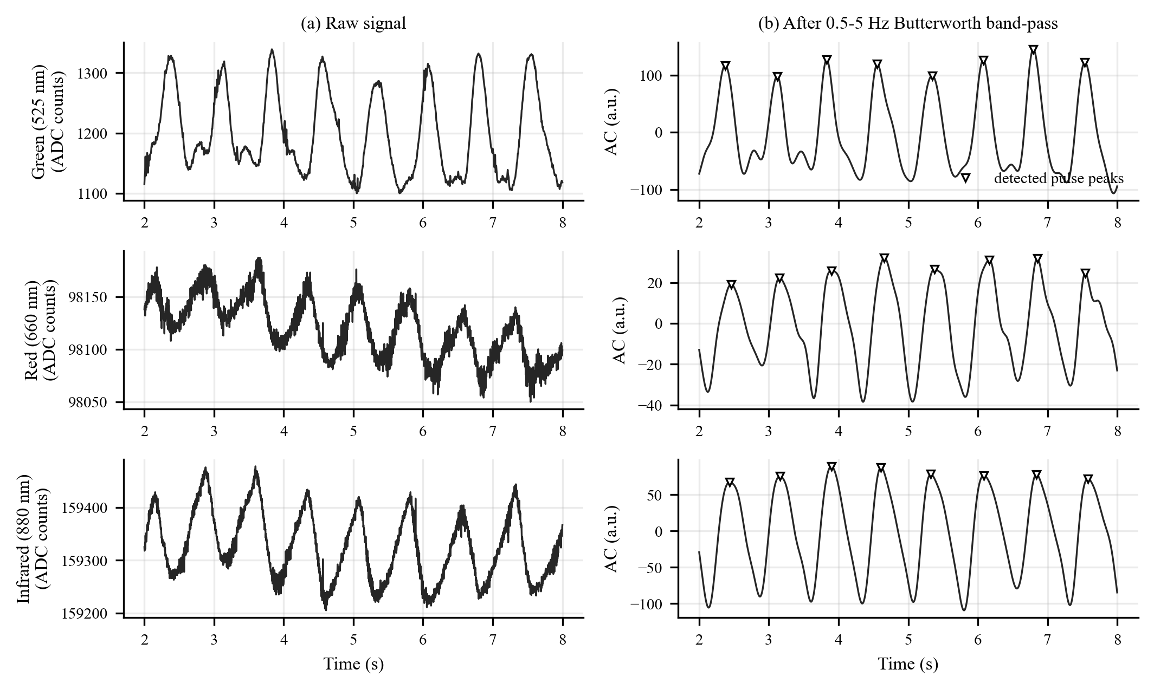
Fig. 2. Three-channel PPG example (subject S011, 6-s window). (a) Raw signals. (b) Signals after the 0.5–5 Hz zero-phase Butterworth band-pass filter; the red and infrared channels are inverted for display because systole appears as a trough in reflective mode. Triangles mark detected pulse peaks.
Fig. 2 shows that all three channels carry a clear pulsatile component. The raw traces sit on very different direct-current levels (about 1.2 × 10³ counts for green, 9.8 × 10⁴ for red, and 1.6 × 10⁵ for infrared) with slow baseline drift. The peak-to-peak swing over the 10-s recording, which includes that drift, is 23% of the mean for green but only 0.17% for red and 0.26% for infrared, so the green channel has a far larger relative pulsatile amplitude. The band-pass filter removes the drift and high-frequency noise; a secondary (diastolic) shoulder is visible in several green beats. This agrees with the report that green light gives a higher AC/DC ratio and better motion resilience than red or infrared light [25], which supports using green as the primary pulse-waveform channel and infrared as the deeper reference. Note that the deployed heart-rate estimator in (2) uses the infrared channel (with red as fallback) because it is sampled at 400 Hz, whereas the green channel is sampled at 200 Hz.
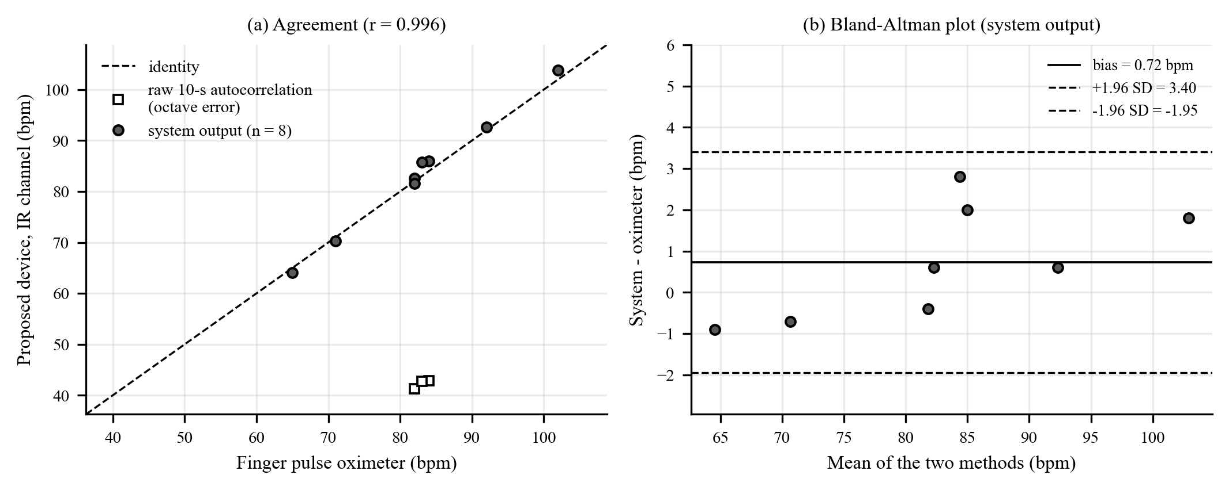
Fig. 3. Heart-rate agreement with a finger pulse oximeter (n = 8 recordings with an output). (a) Scatter plot; filled circles are the system output, open squares are the raw 10-s autocorrelation estimates that suffered octave errors. (b) Bland-Altman plot of the system output.
Fig. 3 shows that the heart-rate estimator of (2) and (3) was evaluated on the recordings as a growing window, as in the deployed system. The raw ten-second autocorrelation alone occasionally locked onto twice the beat period: three of the eight recordings with a valid confidence (S003, S006, and S010) returned almost exactly half of the oximeter rate (42.9 vs 84, 41.3 vs 82, and 42.7 vs 83 bpm), which is the octave error that the temporal stabilizer of (3) is designed to remove. With the stabilizer, the estimates agreed with the oximeter with a bias of +0.7 bpm, limits of agreement of −1.95 to +3.40 bpm, a mean absolute error of 1.2 bpm (1.5%), and a correlation of 0.996 (Fig. 3). The stabilizer works because the octave error appears only in some windows, so the accepted history steers the correction of the halved readings. Eight of the eleven recordings produced a heart-rate output. The other three were too short or too weakly periodic for the acceptance criteria (S007: 7 s long, confidence 0.18; S008: 2 s long, below the 4 s minimum; S009: confidence just below the 0.30 gate), which shows that the recording should last at least about ten seconds.
3-2- Cohort and Physiological Estimation
Table 1. Characteristics of the study cohort (N = 11)
Characteristic | Reference device | Value, mean ± SD (range)
Age (years) | - | 65.0 ± 16.7 (20.0 − 80.0)
Sex, male / female | - | 5/6
Sampling condition | - | Random (non-fasting)
Heart rate (bpm) | Yuwell pulse oximeter | 80.3 ± 13.0 (54.0 − 102.0)
Systolic blood pressure (SBP) (mmHg) | Yuwell sphygmomanometer | 147 ± 16 (121 − 173)
Diastolic blood pressure (DBP) (mmHg) | Yuwell sphygmomanometer | 83 ± 12 (56 − 102)
Glucose (mg/dL) | Elvasense 3in1 EMS10 | 141 ± 35 (94 − 183)
Cholesterol (mg/dL) | Elvasense 3in1 EMS10 | 232 ± 37 (151 − 269)
Uric acid (mg/dL) | Elvasense 3in1 EMS10 | 5.3 ± 1.0 (3.7 − 7.2)

The cohort consists of 11 volunteers, mostly elderly (mean age 65 years, range 20-80), which matches the intended user group of the system; two volunteers had a personal history of stroke. Each reference value spans a clinically relevant range, from normal to elevated levels: SBP 121-173 mmHg, DBP 56-102 mmHg, random glucose 94-183 mg/dL, total cholesterol 151-269 mg/dL, and uric acid 3.7-7.2 mg/dL. Nine of the eleven volunteers met the hypertension criterion in (5) by their reference readings, so both hypertensive and non-hypertensive profiles are represented.
Table 2. LOSO estimation performance of the five physiological estimators (N = 11)
Parameter | Model selected on all 11 | MAE | RMSE | Accuracy (%)
SBP (mmHg) | SVR (linear) | 13.18 | 16.06 | 91.0
DBP (mmHg) | SVR (linear) | 6.09 | 9.61 | 91.4
Glucose (mg/dL) | XGBoost | 29.36 | 35.57 | 76.2
Cholesterol (mg/dL) | SVR (linear) | 30.44 | 37.39 | 85.1
Uric acid (mg/dL) | SVR (RBF) | 0.75 | 0.96 | 86.2

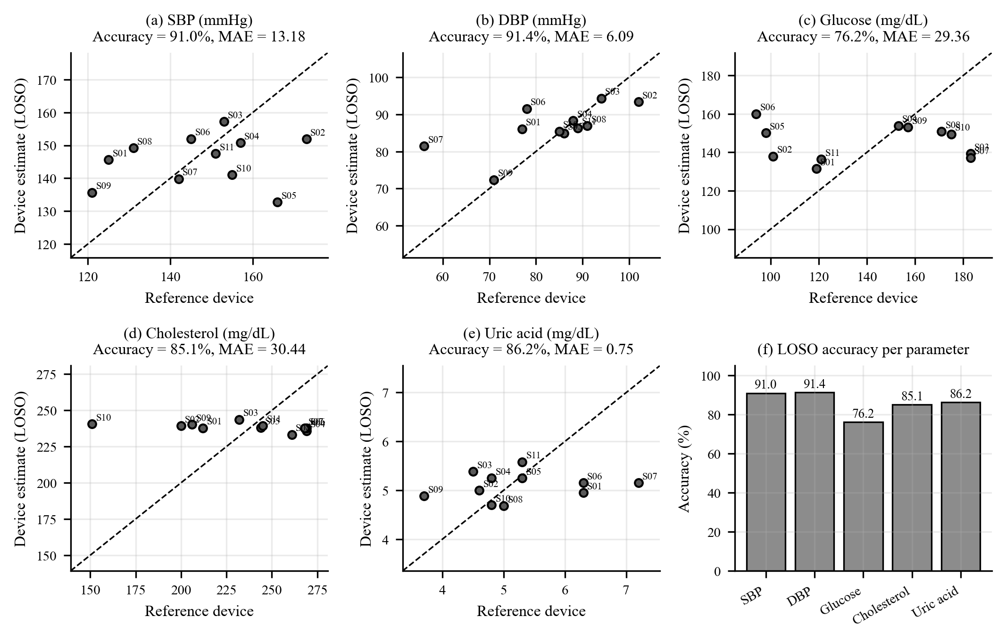
Fig. 4. Leave-one-subject-out estimates against reference-device values for (a) SBP, (b) DBP, (c) glucose, (d) cholesterol, and (e) uric acid; the dashed line is identity and labels are volunteer codes. (f) LOSO accuracy per parameter.
Table 2 and Fig. 4 summarize the estimates. With only ten training volunteers per fold, accuracy reached 91.0% for SBP and 91.4% for DBP, and it was above 85% for cholesterol (85.1%) and uric acid (86.2%); glucose, which has the widest relative range in the cohort (coefficient of variation 25%), reached 76.2%. The median absolute percentage error was 3.0% for DBP, 9.0-11.7% for SBP, uric acid, and cholesterol, and 14.6% for glucose; ten of eleven SBP, DBP, and cholesterol estimates were within 20% of the reference. In physical units, the mean absolute errors were 13.2 mmHg (SBP), 6.1 mmHg (DBP), 29.4 mg/dL (glucose), 30.4 mg/dL (cholesterol), and 0.75 mg/dL (uric acid). The DBP estimates follow the identity line closely across the 56-102 mmHg range (Fig. 4b). These results show that the complete pipeline, from the wristband signal to the vital-sign card in the mobile application, delivers an estimate of all five parameters for volunteers who were not used to train the model.
The automatic selection chose SVR for four parameters and XGBoost for glucose, with a different feature subset for each, which is expected when the relationship between the optical signal and each analyte differs. Because the candidates were compared on the same 11 volunteers and the reference ranges are still narrow, the accuracies in Table 2 are preliminary. They are meant to show that the approach is feasible, and the planned enlargement of the cohort to at least 30 volunteers, with a separate test set, will provide the independent evidence needed to confirm them.
3-3- Comparison With a Clinical Laboratory Reference
Table 3. Case S010: estimates against a clinical laboratory (sample taken 7 September 2026, non-fasting)
Parameter | Laboratory | Proposed Device | Acc. vs lab (%)
SBP (mmHg) | 150 | 141.0 | 94.0
DBP (mmHg) | 80 | 85.4 | 93.2
Glucose (mg/dL) | 178 | 149.4 | 84.0
Cholesterol (mg/dL) | 154 | 240.5 | 43.9
Uric acid (mg/dL) | 4.6 | 4.7 | 97.8

S010 was excluded from training for its own estimate under the leave-one-subject-out (LOSO) procedure. Blood pressure was measured at the clinic and is therefore reported as a clinical measurement rather than a laboratory assay.
For case S010, the proposed device produced estimates that showed different levels of agreement with the clinical laboratory results. SBP was estimated at 141.0 mmHg compared with the laboratory value of 150 mmHg (94.0% agreement), and DBP was estimated at 85.4 mmHg compared with 80 mmHg (93.2% agreement). Glucose was estimated at 149.4 mg/dL compared with 178 mg/dL (84.0% agreement), and uric acid was estimated at 4.7 mg/dL compared with 4.6 mg/dL (97.8% agreement). Cholesterol was the least accurate estimate for this volunteer: it was estimated at 240.5 mg/dL compared with the laboratory value of 154 mg/dL, corresponding to only 43.9% agreement. The laboratory cholesterol value of 154 mg/dL was lower than the values observed in the other ten volunteers, which ranged from 200 to 269 mg/dL based on the reference-device measurements used during data collection. This indicates that lower cholesterol values were less represented in the training data, so an estimate obtained without this volunteer's own data moves toward the rest of the cohort rather than toward the true low value.
This comparison is limited to a single volunteer and therefore cannot be used to determine the overall accuracy of the proposed device. However, the result provides a direct comparison between the device estimates and laboratory measurements and identifies the limited coverage of lower cholesterol values as an area for further data collection.
3-4- Stroke-Risk Classification
Table 4. Discrimination and performance at the default threshold of 0.5 (test set, n = 1,533; 75 stroke cases)
Model | AUC | AP | Recall at 0.5 | Precision at 0.5
Unweighted XGBoost | 0.838 | 0.271 | 0.013 | 1.000
Class-weighted XGBoost (proposed) | 0.823 | 0.250 | 0.760 | 0.123
Balanced logistic regression | 0.838 | 0.218 | 0.773 | 0.128

Bootstrap 95% CI of the proposed model: AUC 0.823 (0.780-0.865), AP 0.256 (0.177-0.349). Prevalence in the test set is 0.049.
Table 5. Performance at the recall-targeted threshold (τ from out-of-fold recall ≥ 0.98)
Model | Threshold | Recall | Precision | FN | Alert rate (%)
Unweighted XGBoost | 0.010 | 0.933 | 0.082 | 5 | 55.8
Class-weighted XGBoost (proposed) | 0.042 | 0.973 | 0.075 | 2 | 63.8
Balanced logistic regression | 0.164 | 0.933 | 0.082 | 5 | 55.8

FN = missed stroke cases out of 75; alert rate = share of the 1,533 test records flagged (false alerts: 786, 905, and 785, respectively). Bootstrap 95% CI of the proposed model: recall 0.973 (0.930-1.000), precision 0.075 (0.058-0.091).
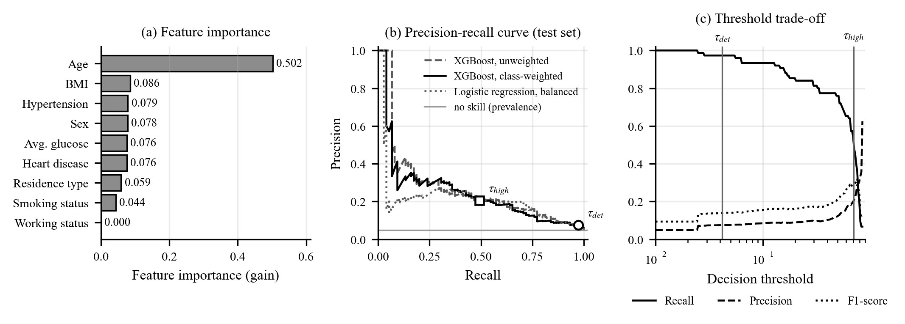
Fig. 5. Stroke-risk classifier. (a) Feature importance (gain) of the deployed XGBoost model. (b) Precision-recall curves on the test set with the two operating points τdet and τhigh. (c) Recall, precision, and F1 against the decision threshold.
Age dominates the model with a gain of 0.502, followed by BMI (0.086), hypertension (0.079), sex (0.078), average glucose (0.076), and heart disease (0.076); working status receives exactly zero (Fig. 5a). The dominance of age is consistent with the clinical epidemiology of stroke, where incidence roughly doubles every decade after 55 years [26], and hypertension is the strongest modifiable risk factor, with an odds ratio near 3 and about half of the population-attributable risk in a 32-country case-control study [27]. On the test set the classifier reaches an AUC of 0.823 and an average precision of 0.250 against a prevalence of 0.049, that is, about five times better than chance (Table 4 and Fig. 5b). At the detection threshold τdet = 0.042 it finds 73 of 75 stroke cases (recall 0.973, Table 5), which fulfils the screening goal of minimizing missed cases; this comes with 905 false alerts (precision 0.075), a trade-off that is intentional for a tool whose alerts lead to a low-cost follow-up (the ABCD2 self-assessment) rather than to treatment. At τhigh = 0.705 the precision rises to 0.206 with recall 0.493, and at the default threshold of 0.5 the recall is 0.760 (Fig. 5c). The three tiers are ordered as intended: the observed stroke rate is 0.4% in the low tier (555 people, 2 events), 4.5% in the medium tier (798 people, 36 events), and 20.6% in the high tier (180 people, 37 events).
Class weighting mainly makes the default operating point usable. Without weighting, the model predicts almost no positives at the threshold of 0.5 (recall 0.013), whereas the class-weighted model detects 57 of the 75 cases (recall 0.760; Table 4). The ranking metrics are comparable across the three models: the AUC of the weighted model (0.823) is within 0.015 of that of the unweighted and balanced logistic-regression models (0.838 for both), and the paired bootstrap 95% confidence intervals of these differences include zero (−0.032 to +0.001 and −0.040 to +0.010). For average precision, the weighted model is 0.032 higher than balanced logistic regression (95% CI −0.048 to +0.107). With a threshold tuned for the target recall (Table 5), the weighted model detects 73 of the 75 cases against 70 for the other two models. Class weighting therefore delivers high sensitivity without resampling of medical records, in line with the benefit reported for other imbalanced medical data [13-17].
3-5- End-to-End Sensitivity to Estimation Error
Table 6. Effect of PPG estimation error on the risk output (100 simulations; mean ± SD; τ = τdet)
Scenario | AUC | AP | Recall | Precision | Tier changed (%)
Clean inputs | 0.823 | 0.250 | 0.973 | 0.075 | 0.0
Glucose error only (σ = 35.6 mg/dL) | 0.820 ± 0.005 | 0.241 ± 0.010 | 0.973 | 0.074 | 2.9 ± 0.3
Hypertension-flag error only (27.3% flips) | 0.821 ± 0.002 | 0.242 ± 0.010 | 0.973 | 0.075 | 1.2 ± 0.2
Both errors | 0.818 ± 0.005 | 0.235 ± 0.012 | 0.973 | 0.074 | 3.8 ± 0.4

Two of the classifier's nine inputs come from PPG estimates in deployment, the average glucose level and the hypertension flag, so the observed estimation errors were propagated into the classifier. The public dataset has no blood pressure, so blood-pressure error is represented through the hypertension flag: the flag derived from the estimated blood pressure agreed with the flag from the reference readings in 8 of 11 volunteers (7 of the 9 hypertensive volunteers were flagged), and this disagreement rate was applied as a symmetric flip probability, which is an approximation. With the full LOSO glucose error (σ = 35.6 mg/dL) and the flag error together, the AUC changed from 0.823 to 0.818, the recall at τdet remained 0.973, and only 3.8% of the risk tiers changed (Table 6). The alert output is therefore stable against the estimation errors observed in this study. This stability also reflects the structure of the model: age, which comes from the user profile, carries half of the importance, so the tier is anchored by profile data, while the PPG-derived inputs act as complementary modifiers that can be refreshed at every measurement. A classifier trained on data that include PPG-derived measurements from the target population is a natural next step.
4. Conclusion
This study presented a pre-hospital early-warning system that links a three-wavelength PPG wristband, server-side signal processing, five physiological estimators, and a class-weighted XGBoost stroke-risk classifier, and that delivers the results to a family caregiver through a mobile application. Streamed heart-rate estimation agreed with a finger oximeter with a mean absolute error of 1.2 bpm, and the leave-one-subject-out accuracy of the five estimators against reference devices was 91.0% for systolic and 91.4% for diastolic blood pressure, 76.2% for glucose, 85.1% for cholesterol, and 86.2% for uric acid in the 11 volunteers. The stroke-risk classifier reached an AUC of 0.823 (95% CI 0.780-0.865) with a recall of 0.973 at its screening threshold, its three risk tiers separated observed stroke rates of 0.4%, 4.5%, and 20.6%, and the tier changed for only 3.8% of the people when the observed estimation errors were propagated into it. The proposed system is intended as pre-hospital screening support that prompts a medical evaluation, not as a diagnostic device. The main limitations are the small cohort (n = 11, one ten-second recording each, two volunteers with a history of stroke), the use of the same volunteers to select and evaluate the estimation models, a classifier trained on a public dataset without PPG-derived inputs, and an alert rate of 63.8% at the screening threshold. Future work should recruit at least 30 volunteers with repeated sessions and a separate test set, add a second measurement site for pulse-transit-time features, recalibrate the thresholds for a lower alert burden, and train and validate the classifier prospectively on data collected with the device.
Acknowledgment
The authors thank the volunteers who took part in the data collection, Klinik Parahita for the laboratory analysis, the Health Research Ethics Committee of the Faculty of Public Health, Universitas Airlangga, for the ethical review (Ethical Approval No. 235/EA/KEPK/2026), the neurologist who reviewed the clinical risk parameters used in this study, and their academic supervisor for guidance throughout the work.
References
[1] V. L. Feigin, et al., World Stroke Organization: Global Stroke Fact Sheet 2025, International Journal of Stroke, 20(2) (2025) 132–144.
[2] C. Capirossi, A. Laiso, L. Renieri, F. Capasso, N. Limbucci, Epidemiology, organization, diagnosis and treatment of acute ischemic stroke, Eur. J. Radiol. Open, 11 (2023) 100527.
[3] W. Potisopha, K. M. Vuckovic, H. A. DeVon, C. G. Park, N. Phutthikhamin, P. E. Hershberger, Decision Delay Is a Significant Contributor to Prehospital Delay for Stroke Symptoms, West. J. Nurs. Res., 45(1) (2023) 55–66.
[4] F. Khan, et al., Long-Term Risk of Stroke After Transient Ischemic Attack or Minor Stroke, JAMA, 333(17) (2025) 1508.
[5] M. D. Spampinato, et al., ABCD2, ABCD2-I, and OTTAWA scores for stroke risk assessment: a direct retrospective comparison, Intern. Emerg. Med., 17(8) (2022) 2391–2401.
[6] Y.-H. Chen, M. Sawan, Trends and Challenges of Wearable Multimodal Technologies for Stroke Risk Prediction, Sensors, 21(2) (2021) 460.
[7] M. A. Lee, M. Song, H. Bessette, M. Roberts Davis, T. E. Tyner, A. Reid, Use of wearables for monitoring cardiometabolic health: A systematic review, Int. J. Med. Inform., 179 (2023) 105218.
[8] H. Ben Pazi, et al., Pre-hospital stroke monitoring past, present, and future: a perspective, Front. Neurol., 15 (2024).
[9] K. B. Kim, H. J. Baek, Photoplethysmography in Wearable Devices: A Comprehensive Review of Technological Advances, Current Challenges, and Future Directions, Electronics (Basel)., 12(13) (2023) 2923.
[10] S. Karolcik, D. K. Ming, S. Yacoub, A. H. Holmes, P. Georgiou, A Multi-Site, Multi-Wavelength PPG Platform for Continuous Non-Invasive Health Monitoring in Hospital Settings, IEEE Trans. Biomed. Circuits Syst., 17(2) (2023) 349–361.
[11] M. Sutcu, D. Jouda, B. Yildiz, J. Katrib, K. M. Almustafa, Predicting Stroke Risk Using Machine Learning: A Data‑Driven Approach to Early Detection and Prevention, Stroke Res. Treat., 2025(1) (2025).
[12] N. Melnykova, Y. Patereha, S. Skopivskyi, M. Farion, S. Fedushko, K. Drohomyretska, Machine learning for stroke prediction using imbalanced data, Sci. Rep., 15(1) (2025) 33773.
[13] J. Luo, Y. Yuan, S. Xu, Improving GBDT performance on imbalanced datasets: An empirical study of class-balanced loss functions, Neurocomputing, 634 (2025) 129896.
[14] A. M. A. Rahim, et al., Stroke prediction using data balancing method and extreme gradient boosting, IAES International Journal of Artificial Intelligence (IJ-AI), 15(1) (2026) 655.
[15] I. Araf, A. Idri, I. Chairi, Cost-sensitive learning for imbalanced medical data: a review, Artif. Intell. Rev., 57(4) (2024) 80.
[16] M. Hassan, H. Nasiri, M. Esmaeili, M. Dorrigiv, Stroke prediction using synthetic minority over-sampling technique and extreme gradient boosting, Comput. Methods Biomech. Biomed. Engin., (2025) 1–12.
[17] Gullam Almuzadid, Egia Rosi Subhiyakto, Stroke Risk Classification Using the Ensemble Learning Method of XGBoost and Random Forest, Journal of Applied Informatics and Computing, 9(3) (2025) 828–837.
[18] J. Park, H. S. Seok, S.-S. Kim, H. Shin, Photoplethysmogram Analysis and Applications: An Integrative Review, Front. Physiol., 12 (2022).
[19] A. J. Smola, B. Schölkopf, A tutorial on support vector regression, Stat. Comput., 14(3) (2004) 199–222.
[20] T. Chen, C. Guestrin, XGBoost: A scalable tree boosting system, in: Proceedings of the 22nd ACM SIGKDD International Conference on Knowledge Discovery and Data Mining, ACM, New York, NY, USA, 2016, pp. 785–794.
[21] S. Mehta, N. Kwatra, M. Jain, D. McDuff, Examining the challenges of blood pressure estimation via photoplethysmogram, Sci. Rep., 14(1) (2024) 18318.
[22] Fedesoriano, Stroke Prediction Dataset, Kaggle, (2021). Available: https://www.kaggle.com/datasets/fedesoriano/stroke-prediction-dataset
[23] Q. Zou, S. Xie, Z. Lin, M. Wu, Y. Ju, Finding the Best Classification Threshold in Imbalanced Classification, Big Data Research, 5 (2016) 2–8.
[24] T. Saito, M. Rehmsmeier, The Precision-Recall Plot Is More Informative than the ROC Plot When Evaluating Binary Classifiers on Imbalanced Datasets, PLoS One, 10(3) (2015) e0118432.
[25] J. Lee, M. Kim, H.-K. Park, I. Y. Kim, Motion Artifact Reduction in Wearable Photoplethysmography Based on Multi-Channel Sensors with Multiple Wavelengths, Sensors, 20(5) (2020) 1493.
[26] M. Yousufuddin, N. Young, Aging and ischemic stroke, Aging, 11(9) (2019) 2542–2544.
[27] M. J. O’Donnell, et al., Global and regional effects of potentially modifiable risk factors associated with acute stroke in 32 countries (INTERSTROKE): a case-control study, The Lancet, 388(10046) (2016) 761–775.

