Adam Kentel

Awk Lab

Awk is a useful very commonly used tool used in Linux. The things we will be covering are introductory level. It is mostly used for searching for and retrieving data someone desires.

awk usage:

awk [options] ‘selection {action}’ filename

(for the list of options use awk --help)

*(This assignment is being done with the AwkLab.data file on centos 8. Date commands were executed 11-7-22)*

**Query 1: Print all the First Names.**

awk ‘{print $1}’ AwkLab.data

In awk the $ is frequently used. It identifies a field in a line by separating lines using a character. Here we use the default “ ”(space) as a separator.

Here we are having the system retrieve the first field in each line of the AwkLab.data file and having it print that first field.

**Query 2: Print phone numbers for Tom and Frodo after their names.**

awk -F ‘/Tom|Frodo/{print $1 “ ” $3}’ AwkLab.data

Here I used the option *-F* for awk. It allows you to change the separator from the default space to a colin. The part with */Tom|Frodo/* allows us to look for Tom or Frodo as criteria. I put *print $1 “ “ $3* to create a space between both fields in the output in order to make it more readable and clear we were getting the information we wanted.

**Query 3: Print Peregrin’s full name and phone number area code only.**

awk ‘/Peregrin/{print $1 $2 }’ Fs=­, AwkLab.data



**Query 4: Print all phone numbers (full number) in the 123 area code along with the names.**

awk ‘/(123)/{print$1 $2 $3 $4}’ FS=- AwkLab.data

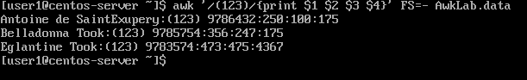

**Query 5: Print all Last names beginning with either a T or D (careful of middle names!).**

awk ‘$2~/(T|D)/{print $2}’ AwkLab.data

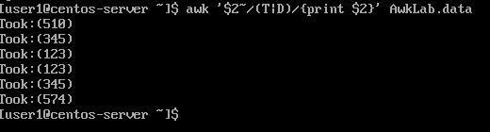

**Query 6: Print all first names containing four or less characters.**

awk ‘{if(length($1)<=4){print $1}}’ AwkLab.data

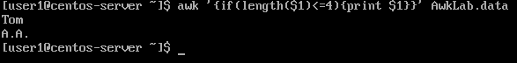

**Query 7: Print the first names and area codes of all those in the 916 area code.**

awk ‘/(916)/{print $1 $2}’ Awklab.data

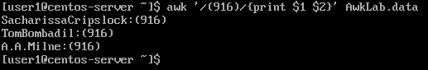

**Query 8: Print Sacharissa’s campaign contributions following her name. Each value should be printed with a leading dollar sign; e.g., $250 $100 $175.**

awk -F: ‘/Sacharissa/{print $1 “$” $3, “$”$4 “$”$5}’ AwkLab.data



**Query 9: Print last names followed by a comma and the phone number. Be careful of the last names’ format.**

awk -F “[ :]” ‘{print $2 “, ” $3 $4}’ AwkLab.data

**Query 10: Print the first and last names of those who contributed more than $110 in the last month. Make sure to include their last month’s contribution amount after the name.**

awk -F ‘[: ] ‘ ’ {if(($7)>+110) {print $1, $2, $7}}’ AwkLab.data

**Query 11: Print the last names, phone numbers, and first month contribution of those who contributed less than $150 in the first month.**

awk -F ‘[: ]’ ‘{if (($5)<=150){print $1, $2, $3,$4, $5}}’ AwkLab.data



**Query 12: Print the first names and contribution of those who contributed between $10 and $200 in the first month.**

awk -F “:” ‘$5<=200 && $5>=10 {print $1, $5}’ AwkLab.data

**Query 13: Print the first name, last names, and total contributions of those who contributed less than $700 over the three-month period.**

awk -F ‘[: ]’ ‘{if(($5+$6+$7)<700) {print $1,$2, ($5+$6+$7)}}’ AwkLab.data

**Query 14: Print the first names and first letter of the last name, and average contribution of those who had an average contribution of more than $300**

awk -F ‘ [: ]’ ‘($5+$6+$7)/3>300{print $1, $5+$6+$7/3}’

**Query 15: Print the last name and area code of those not in the 916 area code.**

awk -F ‘[: ]’ ‘!($3==“(916)” ){print $2, $3 $4}’ AwkLab.data

**Query 16: Print each record preceded by the number of the record.**

awk ‘{ print NR,$0}’ AwkLab.data

**Query 17: Print the name and total contribution of each person.**

awk -F ‘[: ]’ ‘{print $1, $2, $5+$6+$7}’ AwkLab.data

**Query 18: Add $10 to Tiffany Aching’s first contribution and print her full name and first contribution.**

awk -F ‘[: ]’ ‘/^\<Tiffany Aching\>/{$5=$5+10;Print}’ AwkLab.data



**Query 19: Change Samwise Gamgee’s name to Sean Astin**

awk -F ‘[: ]’ ‘$1==”Samwise” && $2==”Gamgee”{$1=“Sean”;$2=“Austin”; print $1, $2, $3}’ AwkLab.data



**Query 20: Write an awk script to meet the requirements (not bash or commands in the command line).**

**(a) Prints first name of the all the Tooks followed by their total campaign contributions.**

**(b) Print the full names and contributions of anyone who contributed between $10 and $200 in the last contribution**

**(c) Prints the full names and average contribution of those who contributed less than $300 on average**

#!/usr/bin/awk -f

BEGIN {FS = ":" ; sort -k $NF}

/Took/ {split($1,n," ") ; print n[1],$3+$4+$5 " (Tooks Total)"}

$5 > 10 && $5 < 200 {print $1,$5}

$3+$4+$5/3<300 {print $1,$3+$4+$5/3, " (Less Than 300)"}

