Python: <https://www.python.org/downloads/windows/>

<http://www.selenium.org.cn/category/python>

1. Open link <https://www.python.org/downloads/windows/>
2. Download the right version base on your device.
3. Double click the .exe file. Click “Install Now”, and choose “Yes” for the pop up window.

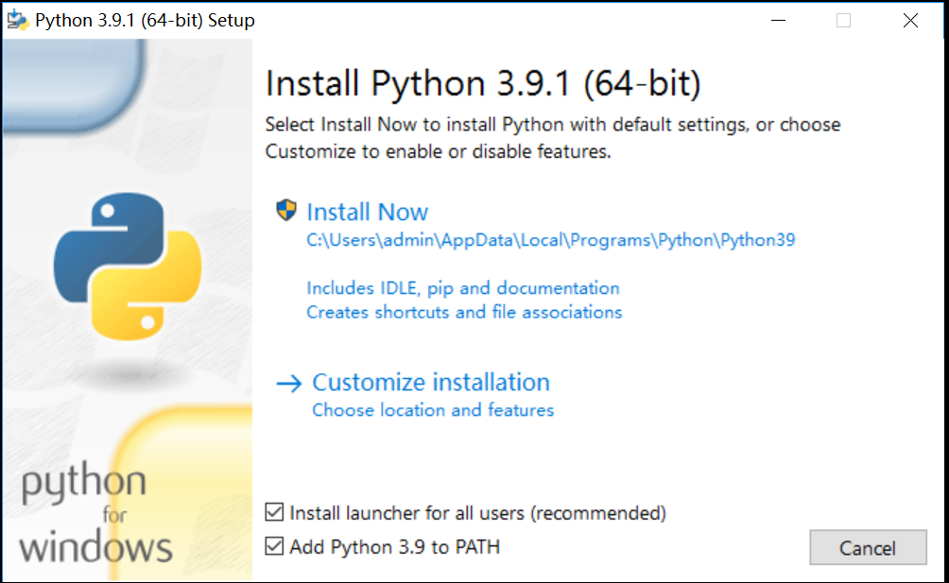

1. Click “Disable path length limit”

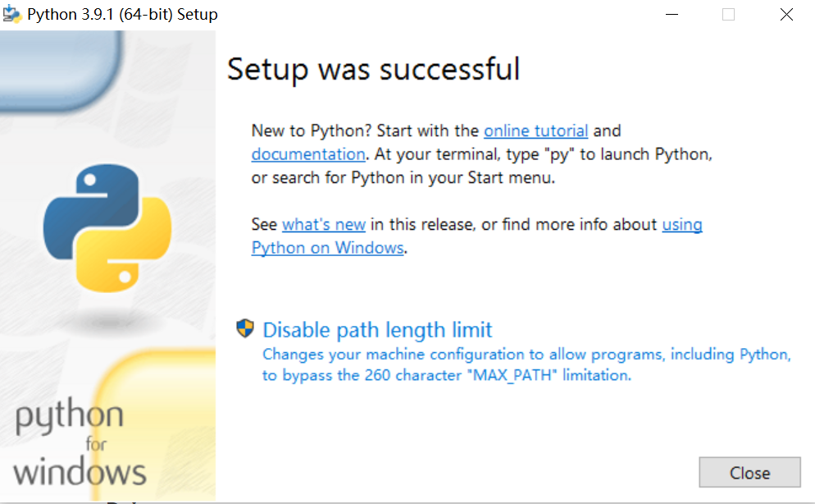

1. Click “Close”
2. Open cmd window
3. Input “python”. If you saw below information, it mean the python is installed successfully.

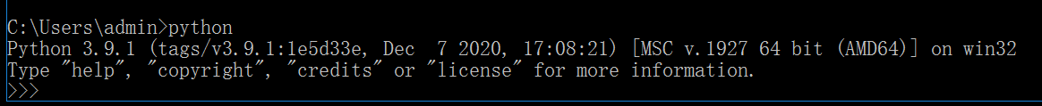

1. Input command “pip install -U selenium”

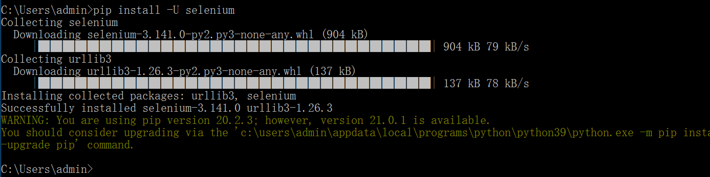

1. Input command “pip install xlwt”

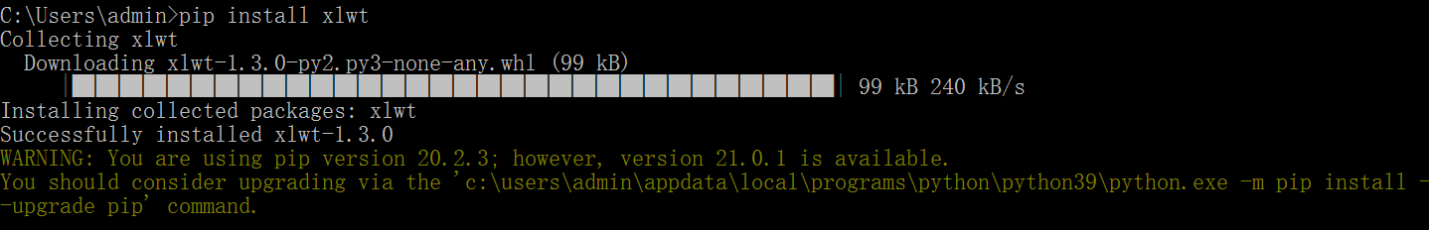

1. Input command “pip install xlutils”

