Snapping objects .
Snap Cases:
1. Snapping Objects to Straight
A . Snapping Straight to Straight
1. Snapping to the 'logical end' of the straight being snap to
a. Snapping from the 'logical end' of the staright beeing snapped
b. Snapping from the 'logical startof the staright beeing snapped
2. Snapping to the 'logical start' of the straight being snap to
a. Snapping from the 'logical end' of the staright beeing snapped
b. Snapping from the 'logical startof the staright beeing snapped
B. Snapping Bend to Straight
1. Snapping to the 'logical end' of the bend being snap to
a. Snapping from the 'logical end' of the staright beeing snapped
b. Snapping from the 'logical startof the staright beeing snapped
2. Snapping to the 'logical start' of the bend being snap to
a. Snapping from the 'logical end' of the staright beeing snapped
b. Snapping from the 'logical startof the staright beeing snapped
C. Snapping Switch to Straight
1. Snapping to the 'logical end' of the switch being snap to
a. Snapping from the 'logical end' of the staright beeing snapped
b. Snapping from the 'logical startof the staright beeing snapped
2. Snapping to the 'logical start' of the switch being snap to
a. Snapping from the 'logical end' of the staright beeing snapped
b. Snapping from the 'logical startof the staright beeing snapped
3. Snapping to the 'logical bend ' of the switch being snap to
a. Snapping from the 'logical end' of the staright beeing snapped
b. Snapping from the 'logical startof the staright beeing snapped
2. Snapping Objects to Bend
3. Snapping Objects to Switch

Basic functions.
1.ComputeExtendedLinePointSwitch
2.ComputeExtendedLinePointBend
3.ComputeExtendedLinePoint
4.ComputeCenterPoint
5.
6.
7.
8.
9.
10.

1.ComputeExtendedLinePointSwitch
CFPoint pt = ComputeExtendedLinePointSwitch( p );
CFPoint ComputeExtendedLinePointSwitch( CRail *p )
{
CFPoint CenterPoint = p->GetPoint(3); // (blue cross)
CFPoint StartPoint = p->GetPoint(0); // (black cross)
CFPoint EndPoint = p->GetPoint(2) ; // (white cross)
return ComputeExtendedLinePoint( CenterPoint , StartPoint ,EndPoint); // red cross (hardwired 100 pixels from white
}

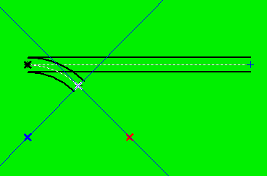

ComputeExtendedLinePointBend
2.ComputeExtendedLinePointBend
CFPoint ComputeExtendedLinePointBend( CRail *p )
CFPoint ComputeExtendedLinePointBend( CRail *p )
{
CFPoint CenterPoint = p->GetPoint(3); // (blue cross)
CFPoint StartPoint = p->GetPoint(0); // (black cross)
CFPoint EndPoint = p->GetPoint(1) ; // (white cross)
return ComputeExtendedLinePoint( CenterPoint , StartPoint ,EndPoint); // red cross (hardwired 100 pixels from white
}

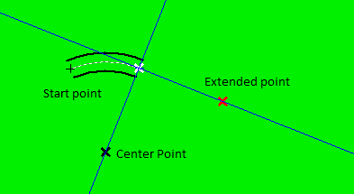

3.ComputeExtendedLinePoint
CFPoint ComputeExtendedLinePoint( CenterPoint , StartPoint ,EndPoint);

4.ComputeCenterPoint
CFPoint ComputeCenterPoint( CFPoint StartPoint ,CFPoint EndPoint ,CFPoint ExtPoint , float iRadius )
Switch parameters
ComputeCenterPoint( p->GetPoint(0),p->GetPoint(1),p->GetPoint(2), p->GetFloat(2))
StartPoint - White cross
EndPoint - Blue cross
ExtPoint - Black cross
float iRadius
return CFPoint - Red cross.
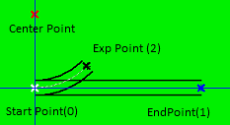

Bend parameters
ComputeCenterPoint( p->GetPoint(0),p->GetPoint(5),p->GetPoint(1),p->GetFloat(2)) ;
StartPoint - White cross (0)
EndPoint - Blue cross (Virtual) (5)
EndPoint - Black cross (1)
float iRadius (100)
return CFPoint - Red cross.
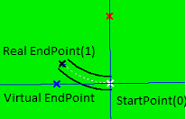

Example:
TurnBend ( p , 90 );
CFPoint new_destination = CFPoint (100,100);
MoveBend ( p , new_destination , 1); // 1 -> enp = new_destination
Right red - initail placement of virtual endpoint point
Left red - after turning by 90degree & moving to endpoint point at coordinate (100,100)
White - start point
Blue center point
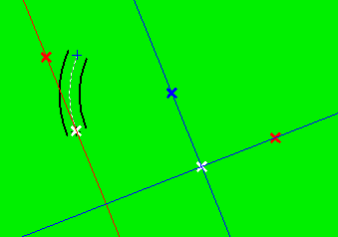

int CList::SnapSwitchToStrightObjects( CRail *p1,CRail *p2,CRect rc)
if ( PointInsideTheRect( stp1 , rc ) )
if ( ( PointInsideTheRect( enp3 , rc ) ) ) // extra switch end point
{
p1->SetRailConnId( 0 , wID2 );
p2->SetRailConnId( 2 , wID1 );
float a1 = ComputeVectorAngle( enp1, stp1 ) ; //reverse vector
CFPoint pt = ComputeExtendedLinePointSwitch( p2 );
float a2 = ComputeVectorAngle( pt , p2->GetPoint(2) ) ;
if ( GetAbsAngleOfTwoVectors( a1 , a2 ) > 60 ) return 1;
// p2->SetDebugPoint(0, enp3 );
// p2->SetDebugPoint(1, pt );
// p2->SetDebugPoint(2, stp1 );
// p2->SetDebugPoint(3, enp1 );
TurnSwitch( p2 , a1-a2 );
UpdatePaintRailSwitchStruct( p2->GetDrawDataStructPtr() , 0 );
MoveSwitch ( p2 , stp1 );
}

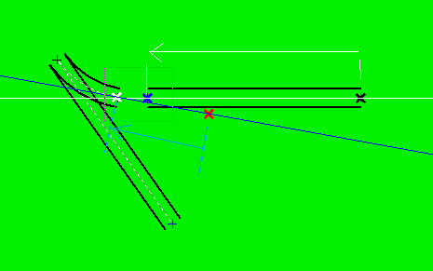
Goes to:
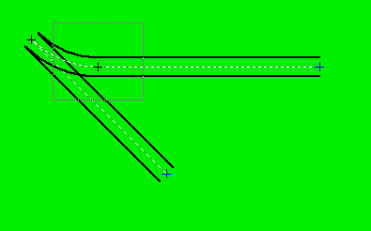

int CList::SnapSwitchToStrightObjects( CRail *p1,CRail *p2,CRect rc)
else ( PointInsideTheRect( stp1 , rc ) )
if ( ( PointInsideTheRect( enp3 , rc ) ) ) // extra switch end point
{
p1->SetRailConnId( 1 , wID2 );
p2->SetRailConnId( 2 , wID1 );
float a1 = ComputeVectorAngle( stp1 , enp1 ) ;
CFPoint pt = ComputeExtendedLinePointSwitch( p2 );
float a2 = ComputeVectorAngle( pt , p2->GetPoint(2) ) ;
// p2->SetDebugPoint(0, enp3 );
// p2->SetDebugPoint(1, pt );
// p2->SetDebugPoint(2, stp1 );
// p2->SetDebugPoint(3, enp1 );
if ( GetAbsAngleOfTwoVectors ( a1, a2 ) > 60 ) return 1;
TurnSwitch ( p2 , a1-a2 );
UpdatePaintRailSwitchStruct( p2->GetDrawDataStructPtr() , 0 );
MoveSwitch ( p2 , enp1 );
}

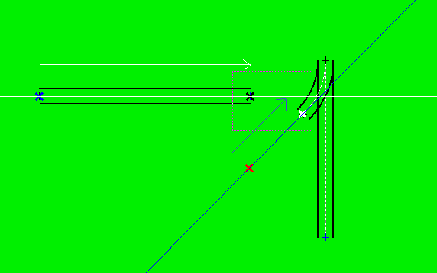

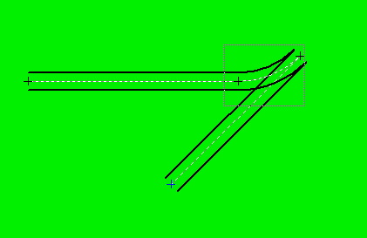

int CList::SnapSwitchToBendObjects( CRail *p1,CRail *p2,CRect rc)
if ( PointInsideTheRect( stp1 , rc ) )
if ( PointInsideTheRect( exp2 , rc ) )
if ( PointInsideTheRect( exp2 , rc ) ) // extra switch end point
{
p1->SetRailConnId( 0 , wID2 );
p2->SetRailConnId( 2 , wID1 );
float a1 = ComputeVectorAngle( p1->GetPoint(5) ,stp1 ) ;
CFPoint pt = ComputeExtendedLinePointSwitch( p2 );
float a2 = ComputeVectorAngle( pt , p2->GetPoint(2) ) ;
// p2->SetDebugPoint(0, p1->GetPoint(5) );
// p2->SetDebugPoint(1, stp1 );
// p2->SetDebugPoint(2, pt );
// p2->SetDebugPoint(3, p2->GetPoint(2) );
if ( GetAbsAngleOfTwoVectors ( a1, a2 ) > 60 ) return 1;
TurnSwitch ( p2 , a1-a2 );
UpdatePaintRailSwitchStruct( p2->GetDrawDataStructPtr() , 0 );
MoveSwitch ( p2 , stp1 );
}
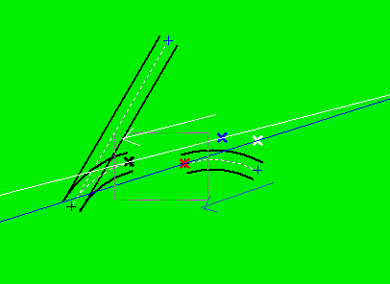

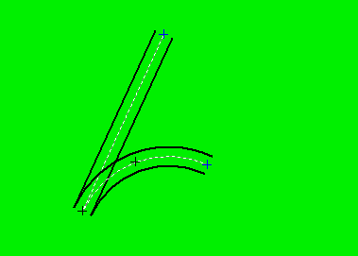

else ( PointInsideTheRect( exp2 , rc ) )
if ( PointInsideTheRect( exp2 , rc ) ) // snapping switch to endpoint need extended line
{
p1->SetRailConnId( 1 , wID2 );
p2->SetRailConnId( 2 , wID1 );
CFPoint pt1 = ComputeExtendedLinePointBend( p1 );
float a1 = ComputeVectorAngle( enp1 , pt1 ) ;
CFPoint pt = ComputeExtendedLinePointSwitch( p2 );
float a2 = ComputeVectorAngle( pt , exp2 ) ;
//p2->SetDebugPoint(0, enp1 );
//p2->SetDebugPoint(1, pt1 );
//p2->SetDebugPoint(2, pt );
//p2->SetDebugPoint(3, exp2 );
if ( GetAbsAngleOfTwoVectors ( a1, a2 ) > 60 ) return 1;
TurnSwitch ( p2 , a1-a2 );
UpdatePaintRailSwitchStruct( p2->GetDrawDataStructPtr() , 0 );
MoveSwitch ( p2 , enp1 );
}

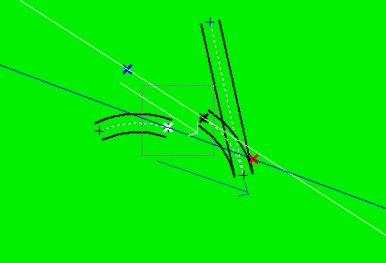

int CList::SnapTwoSwitchObjects( CRail *p1,CRail *p2,CRect rc)
if ( PointInsideTheRect( stp1 , rc ) )
if ( ( PointInsideTheRect( exp2 , rc ) ) ) // extra switch end point
{
p2->SetRailConnId( 2 , wID1 );
float a1 = ComputeVectorAngle( enp1, stp1 ) ; //reverse vector
CFPoint pt = ComputeExtendedLinePointSwitch( p2 );
float a2 = ComputeVectorAngle( pt , exp2 ) ;
p2->SetDebugPoint(0, enp1 );
p2->SetDebugPoint(1, stp1 );
p2->SetDebugPoint(2, pt );
p2->SetDebugPoint(3, exp2 );
if ( GetAbsAngleOfTwoVectors ( a1, a2 ) > 60 ) return 1;
TurnSwitch ( p2 , a1-a2 );
UpdatePaintRailSwitchStruct( p2->GetDrawDataStructPtr() , 0 );
MoveSwitch ( p2 , stp1 );
}

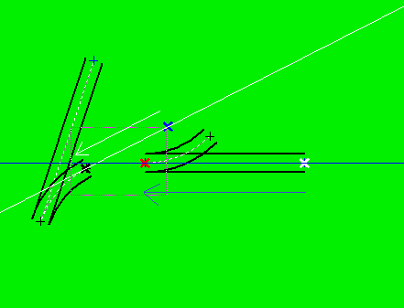

if ( PointInsideTheRect( enp1 , rc ) )
if ( PointInsideTheRect( exp2 , rc ) )
{
p2->SetRailConnId( 2 , wID1 );
float a1 = ComputeVectorAngle( stp1 , enp1 ) ;
CFPoint pt = ComputeExtendedLinePointSwitch( p2 );
float a2 = ComputeVectorAngle( pt , exp2 ) ;
//p2->SetDebugPoint(0, enp1 );
//p2->SetDebugPoint(1, stp1 );
//p2->SetDebugPoint(2, pt );
//p2->SetDebugPoint(3, exp2 );
if ( GetAbsAngleOfTwoVectors ( a1, a2 ) > 60 ) return 1;
TurnSwitch ( p2 , a1-a2 );
UpdatePaintRailSwitchStruct( p2->GetDrawDataStructPtr() , 0 );
MoveSwitch ( p2 , enp1 );
}

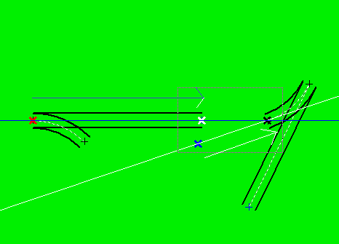

if ( PointInsideTheRect( exp1 , rc ) )
if ( PointInsideTheRect( exp2 , rc ) )
{ // only exp to exp possible
p2->SetRailConnId( 2 , wID1 );
CFPoint pt1 = ComputeExtendedLinePointSwitch( p1 );
float a1 = ComputeVectorAngle( exp1, pt1) ; //reverse vector
CFPoint pt2 = ComputeExtendedLinePointSwitch( p2 );
float a2 = ComputeVectorAngle( pt2 , exp2 ) ;
// p2->SetDebugPoint(0, exp1 );
// p2->SetDebugPoint(1, pt1 );
// p2->SetDebugPoint(2, pt2 );
// p2->SetDebugPoint(3, exp2 );
if ( GetAbsAngleOfTwoVectors ( a1, a2 ) > 60 ) return 1;
TurnSwitch ( p2 , a1-a2 );
UpdatePaintRailSwitchStruct( p2->GetDrawDataStructPtr() , 0 );
MoveSwitch ( p2 , exp1 );
}
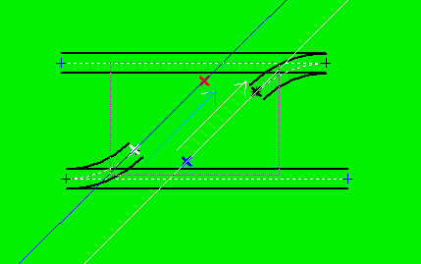

int SnapStrightToBendObjects( CRail *p1,CRail *p2,CRect rc)

case 3
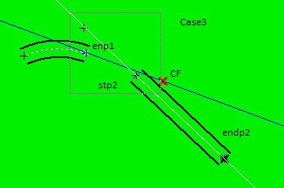

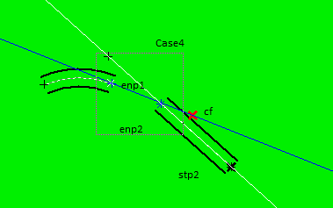

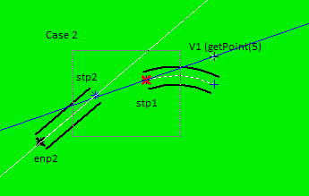

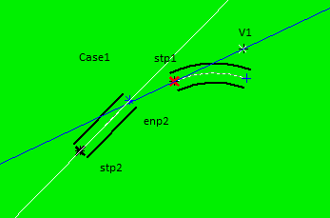

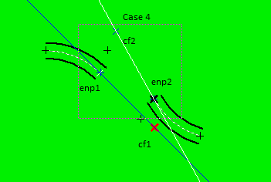

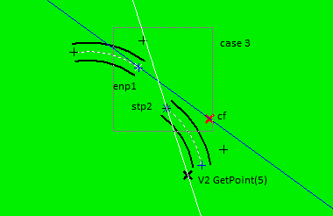

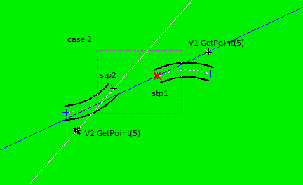

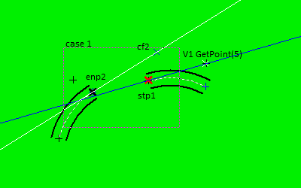

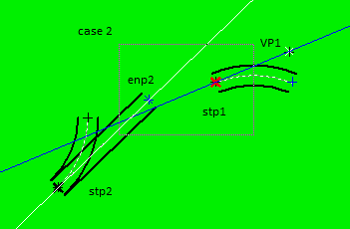

Select by klick – 3 handles to rotate & move

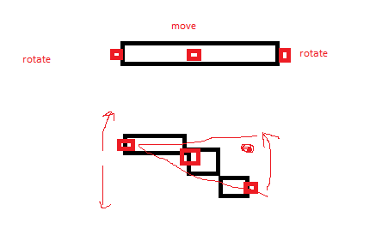

Auto Snap condition – distance < 10 pixels

//----------------------------------------------------------------------------------------
// We are here because :
// two objects are selected - both are fixed to the other objects
// option one - extend straight line to connect-if at least one straight exists and angles < 2
// option two - use bend to connect two object - if at least one straight can be extended / shorten
// option three - if endpoint matches then simply adjust close endpoints
// ---------------------------------------------------------------------------------------
Function int CList::GlueTwoFixedObjects(CRail * p1,CRail *p2,CRect rc)
if (( p1->mtype == ObjStraightRail ) && ( p2->mtype == ObjStraightRail ))

if (( p1->mtype == ObjStraightRail ) && ( p2->mtype == ObjRailSwitch )) - 1

if (( p1->mtype == ObjRailSwitch ) && ( p2->mtype == ObjStraightRail )) - 2

if (( p1->mtype == ObjStraightRail ) && ( p2->mtype == ObjBendRail )) -1

if (( p1->mtype == ObjBendRail ) && ( p2->mtype == ObjStraightRail )) -2

if (( p1->mtype == ObjBendRail ) && ( p2->mtype == ObjBendRail ))

if (( p1->mtype == ObjRailSwitch ) && ( p2->mtype == ObjRailSwitch ))

if (( p1->mtype == ObjRailSwitch ) && ( p2->mtype == ObjBendRail )) -1

if (( p1->mtype == ObjBendRail ) && ( p2->mtype == ObjRailSwitch )) -2

Function int CList::GlueTwoFixedObjectsWithBend(CRail * p1,CRail *p2,CRect rc)

if (( p1->mtype == ObjStraightRail ) && ( p2->mtype == ObjStraightRail ) ) V

if (( p1->mtype == ObjBendRail ) && ( p2->mtype == ObjBendRail ) ) V

if (( p1->mtype == ObjStraightRail ) && ( p2->mtype == ObjBendRail ) ) V

if (( p1->mtype == ObjRailSwitch ) && ( p2->mtype == ObjRailSwitch ) ) V

if (( p1->mtype == ObjRailSwitch ) && ( p2->mtype == ObjBendRail ) ) V

if (( p1->mtype == ObjStraightRail ) && ( p2->mtype == ObjRailSwitch ) ) V

Function int CList::GlueTwoFixedObjectsWithStright(CRail *p1,CRail *p2,CRect rc)

if (( p1->mtype == ObjBendRail ) && ( p2->mtype == ObjBendRail ) ) V

if (( p1->mtype == ObjStraightRail ) && ( p2->mtype == ObjBendRail ) V

if ( p1->mtype == ObjRailSwitch ) && ( p2->mtype == ObjBendRail ) ) V

if (( p1->mtype == ObjRailSwitch ) && ( p2->mtype == ObjRailSwitch ) ) V

if (( p1->mtype == ObjStraightRail ) && ( p2->mtype == ObjRailSwitch ) )

___________if (( p1->mtype == ObjStraightRail ) && ( p2->mtype == ObjStraightRail ) )

