**Part A**

**I**

**A**

**B**

**C**

**D**

**E**

**F**

**G**

**Objective** : Name and decribe each component

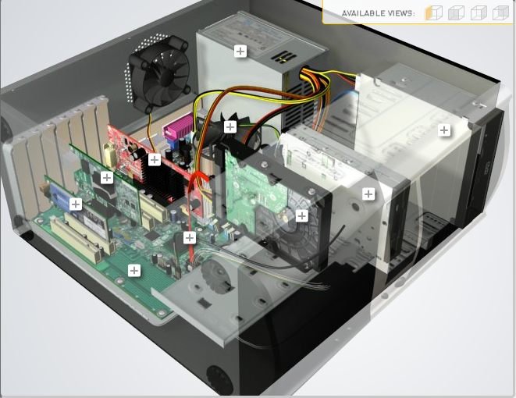

**H**

|  |  |  |
| --- | --- | --- |
| Download [**http://tinyurl.com/CW208-CAG-SIM**](http://tinyurl.com/CW208-CAG-SIM) PC Build Simulator.  Go through steps of building a PC, as you complete the simulation find and describe in detail components A to I. To run simulator first install <http://www.swffileplayer.com/> and open ***RootMovie.swf*** using SWF player. Alternatively install [Macromedia Flashplayer](https://fpdownload.macromedia.com/pub/flashplayer/updaters/32/flashplayer_32_sa.exe) . Ideally use a simulator as listed in class. | | |
| Label | Name each component | Description |
| A | Network Interface Card | Allows the PC to connect to a network |
| B | Graphics Processing Unit | Specialised processor designed for accelerated graphics rendering. Performs fast maths calculations. |
| C | Central Processing Unit Heatsink | Keeps the CPU cool while in use |
| D | Power Supply Unit | Supplies power to the components of the pc. Converts AC to DC for the components. |
| E | ------- |  |
| F | CD Drive | Allows CDs to be run by the PC |
| G | Hard Disk Drive | Stores and retrieves data using magnetic storage. Stores all of the digital content on a PC. |
| H | Serial ATA Cable | Bus interface that connects to the storage medium of the PC. |
| I | Motherboard | Circuit board that contains connections for most other components of the PC. |

**Part B**

**Objective**

Compare a pre-assembled system and the components that could be assembled to build a comparable system. After completing this practical, you should be able to:

1. Identify the components of a pre-assembled system
2. Locate prices for components needed to assemble a comparable system
3. Compare the cost of a pre-assembled system and a self-assembled system.

If you can’t find exact match for components, find the closest possible substitute. Use the Internet and available computer-related publications as your sources for information. Examples of websites for computer parts [www.komplett.ie](http://www.komplett.ie), [www.dell.ie](http://www.dell.ie), [www.custompc.ie](http://www.custompc.ie) [www.amazon.de](http://www.amazon.de)

MAKE SURE TO INCLUDE VALID LINKS TO WEB REFERENCES

|  |  |  |
| --- | --- | --- |
|  | **Pre-Assembled Computer Package** | **Computer Package**  **Components** |
| **CPU** | 11th Gen Intel® Core™ i7 11700F (8-Core, 16MB Cache, 2.5GHz to 4.9GHz w/Intel® Turbo Boost Max) | Intel Core i7-11700F processor 2.5 GHz 16 MB Smart Cache Box  https://tinyurl.com/2h6reuhf |
| **Storage / Memory** | | |
| |  | | --- | |  | | RAM | | Hard Drive | |  | | |  | | --- | |  | | 8GB, 1x8GB, DDR4, 3200MHz, XMP | |  | | No HDD, 512GB M.2 PCIe NVMe SSD | | 32GB Corsair Vengeance LPX DDR4 3200MHz PC4-25600 CL16 Dual Channel Kit (2x 16GB) Black  https://tinyurl.com/2tbew635 Seagate Barracuda Fast SSD, 1 TB, External Solid State Drive Portable - USB-C USB 3.0 for PC Laptop and Mac, and Three-year Rescue Services (STJM1000400) https://tinyurl.com/wy8y2an9 |
| **Input/Output** | | |
| |  | | --- | | Keyboard | | Pointing Device | | Monitor | | Speakers | | Network Adapter | |  | |  | | Multimedia Keyboard-KB216AW - UK (QWERTY)  Optical Mouse MS116AW  Not included  Not included  Not included | Logitech Keyboard Wired USB, Nordic Black https://tinyurl.com/4metbcht  Logitech B100 3 Button Wired Optical Mouse Black  https://tinyurl.com/53bzzk7a  DELL SE2722H Full HD 27" LCD Monitor - Black  https://tinyurl.com/9ybtxfmp  Logitech Z150 PC Speakers, 3 W (RMS)W (RMS)  https://tinyurl.com/u4hfy8c5 Startech 1 Port PCI Network Interface Card, 10/100/1000Mbit/shttps://tinyurl.com/29bp68mt |
| **Bundled Software**  (Including Operating System) | Windows 11 Home, English, Dutch, French, German, Italian | Windows 10 Professional Retail  https://tinyurl.com/3hnakpnx |
| **Total Cost** | € 1649.00  https://tinyurl.com/cz59pmpy | € 1047.49 |

**Part C**

**Objective**

You have been asked by a family friend to assist them with a computer purchase. They’re unfamiliar with technology and the terms used and have presented you with two alternatives machine choices. They would like to be able to write word documents, surf internet and play Minecraft © Mojang and Half-Life © Valve Software. They are considering playing Fortnight but are not sure yet, as it depends on machine cost and if they can extract some money from their Bitcoin wallet.

Compare Personal Computer Option A and B in relation to each of the side headings and recommend a system and any alterations.

|  |  |  |
| --- | --- | --- |
|  | Personal Computer  Option A | Personal Computer  Option B |
| CPU | 2.2 GHz Intel Celeron 450 | 3.2 GHz Intel Core i5 |
| Memory |  |  |
| |  | | --- | | Cache | | RAM | | Hard Drive | | CD-ROM/DVD | | |  | | --- | | 512 KB Cache | | 4 GB RAM | | 320 GB Hard Drive | | DVD+/-RW drive | | |  | | --- | | 4 MB Cache | | 8 GB RAM | | 1 TB Hard Drive | | DVD+/-RW drive | |
| Input/Output |  |  |
| |  | | --- | | Keyboard | | Pointing Device | | Screen | | Speakers | | Network Adapter | | |  | | --- | | USB multifunction keyboard | | USB optical mouse | | 20’’ HD flatscreen monitor | | Multimedia Speaker System | | Integrated 10/100/1000 Ethernet | | |  | | --- | | wireless multifunction keyboard | | wireless optical mouse | | 25’’ HD flatscreen monitor | | Dolby Surround Sound Speakers | | Integrated 10/100/1000 Ethernet | |

|  |
| --- |
| **Recommendations** |
| I would personally recommend option B as, even though it will more than likely come out to a slightly dearer cost, the build will have much more longevity than option A. Not only will option B be able to run the games asked for, it will also be able to run any games my friend decides to play in the future. The larger storage, better CPU and RAM will allow the PC to be used for a larger amount of games than option A, and the improved peripherals are worth it. |

**Your Recommend System**

|  |  |
| --- | --- |
|  | Personal Computer  Recommendation |
| **CPU** |  |
| **Memory** | |
| |  | | --- | |  | | RAM | | Hard Drive | | SSD Drive | | |  | | --- | |  | |  | |  | |  | |
| **Input/Output** | |
| |  | | --- | | Keyboard | | Pointing Device | | Screen | | Speakers | | Network Adapter  GPU | | |  | | --- | |  | |  | |  | |  | |  | |

Hand up this practical report at the end of session and ensure it has been checked

|  |  |  |  |
| --- | --- | --- | --- |
| **Student Name** | Adam Lambert | **Student Number** | C00257510 |
| **Date** | 27/10/2021 | **Checked** |  |
| **Group** | **A** |  |  |