Лабораторна робота №4
API Authentication and Security
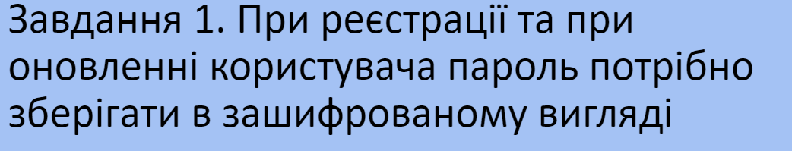
const mongoose = require("mongoose");
const bcrypt = require("bcrypt");
const userSchema = new mongoose.Schema({
name: {
type: String,
required: true,
trim: true
},
age: {
type: Number,
default: 0,
validate(value) {
if (value < 0) {
throw new Error("Age must be a positive number");
}
}
},
email: {
type: String,
required: true,
lowercase: true,
unique: true,
validate: {
validator: function(value) {
const emailRegex = /^[^\s@]+@[^\s@]+\.[^\s@]+$/;
return emailRegex.test(value);
},
message: props => `${props.value} is not a valid email!`
}
},
password: {
type: String,
required: true,
minlength: 7,
trim: true,
validate: {
validator: function(value) {
if (value.toLowerCase().includes("password")) {
throw new Error("Password cannot contain the word 'password'");
}
},
message: props => `Password validation failed`
}
}
});
userSchema.pre('save', async function(next) {
const user = this;
if (user.isModified('password')) {
user.password = await bcrypt.hash(user.password, 8);
}
next();
});
const User = mongoose.model('User', userSchema);
module.exports = User;

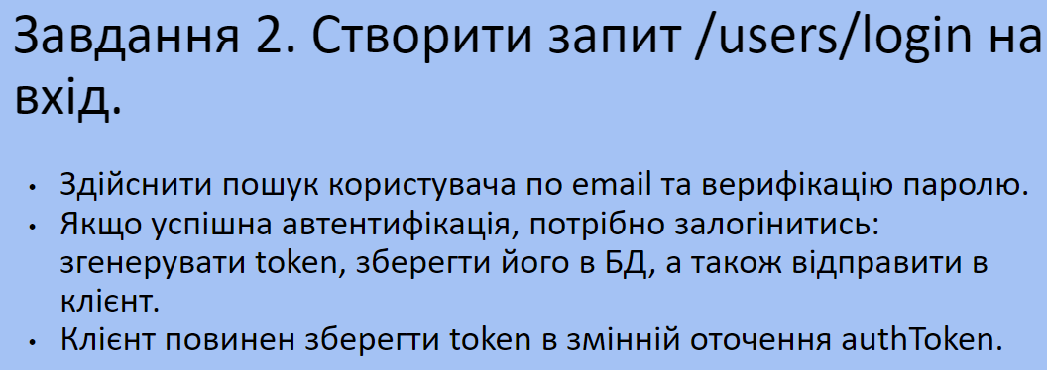

router.post("/login", async (req, res) => {
try {
const { email, password } = req.body;
const user = await User.findOne({ email });
if (!user) {
return res.status(404).send("User not found");
}
const isPasswordMatch = await bcrypt.compare(password, user.password);
if (!isPasswordMatch) {
return res.status(401).send("Invalid email or password");
}
const token = jwt.sign({ id: user._id }, process.env.JWT_SECRET, { expiresIn: "1h" });
user.tokens.push({ token });
await user.save();
res.json({ authToken: token });
} catch (error) {
res.status(500).send(error.message);
}
});

router.post('/logout', auth, async (req, res) => {
try {
req.user.tokens = req.user.tokens.filter(token => token.token !== req.token);
await req.user.save();
res.send('Logged out successfully');
} catch (error) {
res.status(500).send(error.message);
}
});
router.post('/logoutAll', auth, async (req, res) => {
try {
req.user.tokens = [];
await req.user.save();
res.send('Logged out from all devices successfully');
} catch (error) {
res.status(500).send(error.message);
}
});

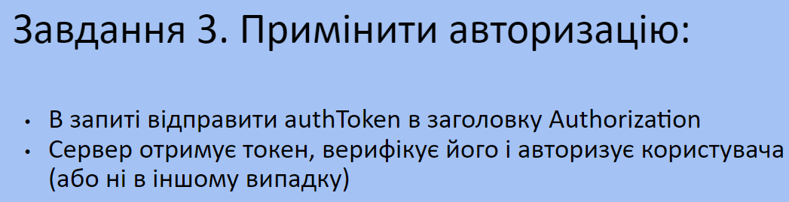
const jwt = require('jsonwebtoken');
function verifyToken(req, res, next) {
const authToken = req.headers.authorization;
if (!authToken) {
return res.status(401).send('Unauthorized: No token provided');
}
const token = authToken.split(' ')[1];
jwt.verify(token, process.env.JWT_SECRET, (err, decoded) => {
if (err) {
return res.status(401).send('Unauthorized: Invalid token');
}
req.userId = decoded.id;
next();
});
}
module.exports = verifyToken;
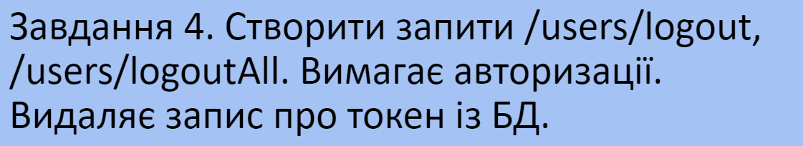

router.post('/logout', auth, async (req, res) => {
try {
req.user.tokens = req.user.tokens.filter(token => token.token !== req.token);
await req.user.save();
res.send('Logged out successfully');
} catch (error) {
res.status(500).send(error.message);
}
});
router.post('/logoutAll', auth, async (req, res) => {
try {
req.user.tokens = [];
await req.user.save();
res.send('Logged out from all devices successfully');
} catch (error) {
res.status(500).send(error.message);
}
});

Висновок: під час виконання даної лабораторної роботи, я вдосконалив свої знання з Node.
GitHub: https://github.com/AdamLahovskyi/NodeJS

