CHRONOS-Rb
Compact High-precision Rubidium Oscillator Network Operating System
Hardware Design & Assembly Guide
Raspberry Pi Pico 2-W NTP/PTP Server
Synchronized to FE-5680A Rubidium Frequency Standard
Version 1.0
Open Source Hardware Project

1. Project Overview
CHRONOS-Rb is a high-precision NTP/PTP time server based on the Raspberry Pi Pico 2-W microcontroller, disciplined by an FE-5680A rubidium atomic frequency standard. This combination provides Stratum-1 quality time distribution over WiFi with sub-microsecond stability.

1.1 Key Features
- Stratum-1 NTP server with rubidium reference (10⁻¹¹ stability)
- IEEE 1588 PTP support for precision timing applications
- WiFi connectivity via Pico 2-W's CYW43439 chip
- Web-based status and configuration interface
- PIO-based precision timing for sub-microsecond accuracy
- Automatic holdover during reference signal loss
- Five interval pulse outputs (0.5s, 1s, 6s, 30s, 60s) synchronized to atomic reference

2. FE-5680A Rubidium Oscillator
The FE-5680A is a compact rubidium atomic frequency standard originally designed for telecommunications. It provides an extremely stable 10MHz output signal locked to the hyperfine transition of rubidium-87 atoms.

2.1 Specifications
Parameter | Value | Notes
Output Frequency | 10 MHz | Sine wave
Output Level | ~1 Vpp | Into 50Ω
Short-term Stability | < 3×10⁻¹¹ | At 1 second
Long-term Stability | < 5×10⁻¹² | At 1 day
1PPS Output | TTL compatible | ~100µs pulse
Supply (+15V) | 15V DC | Physics heater
Supply (+5V) | 5V DC | Electronics
Warmup Current | ~2A @ 15V | First 3-5 min
Operating Current | ~0.7A @ 15V | After warmup
Warmup Time | 3-5 minutes | To lock
Lock Indicator | Active LOW | Open collector

2.2 FE-5680A Pinout
Pin | Signal | Description
1 | +15V | Main power input
2 | GND | Ground
3 | +5V | Logic power
5 | 10MHz OUT | Sine wave (1Vpp)
7 | 1PPS OUT | Pulse per second
9 | LOCK | Lock status (active LOW)

3. Signal Conditioning Circuit
The FE-5680A outputs a 10MHz sine wave at approximately 1Vpp, which must be converted to a 3.3V digital signal for the Pico 2-W. The 1PPS signal also needs level shifting from 5V TTL to 3.3V LVCMOS.

3.1 10MHz Sine to Square Converter
A high-speed comparator converts the 10MHz sine wave to a clean 3.3V square wave. The LT1016 or MAX999 are recommended for their fast propagation delay (<10ns).
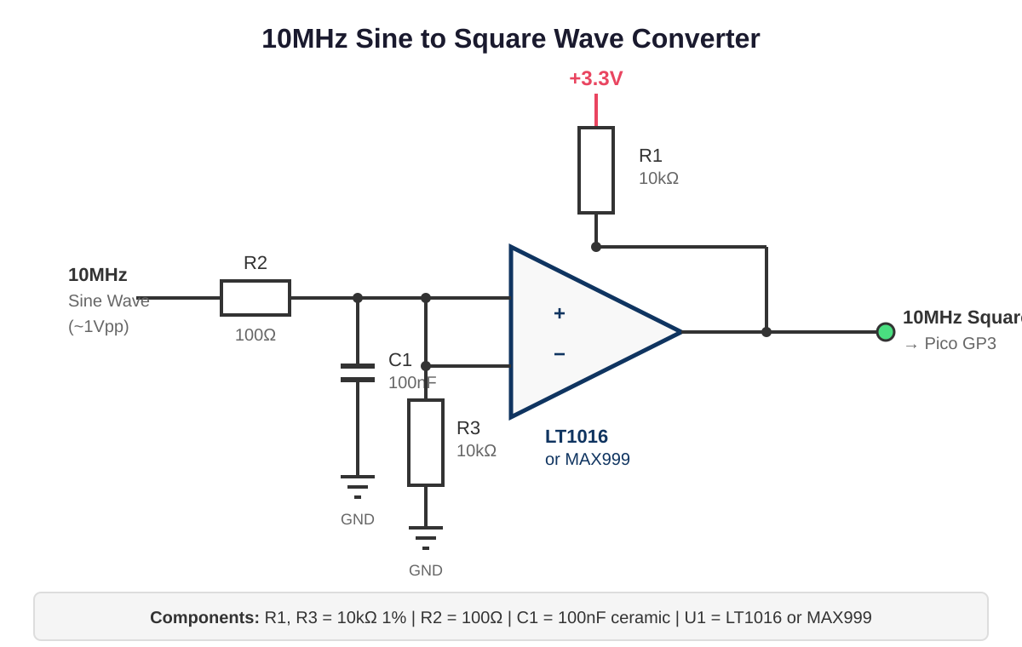
The circuit uses AC coupling (C1) to remove DC offset. R3 sets the threshold at ~1.65V. R1 provides pull-up for the open-drain output.

3.2 1PPS Level Shifter
A simple voltage divider converts the 5V TTL 1PPS signal to 3.3V, with a Schottky diode for ESD protection.
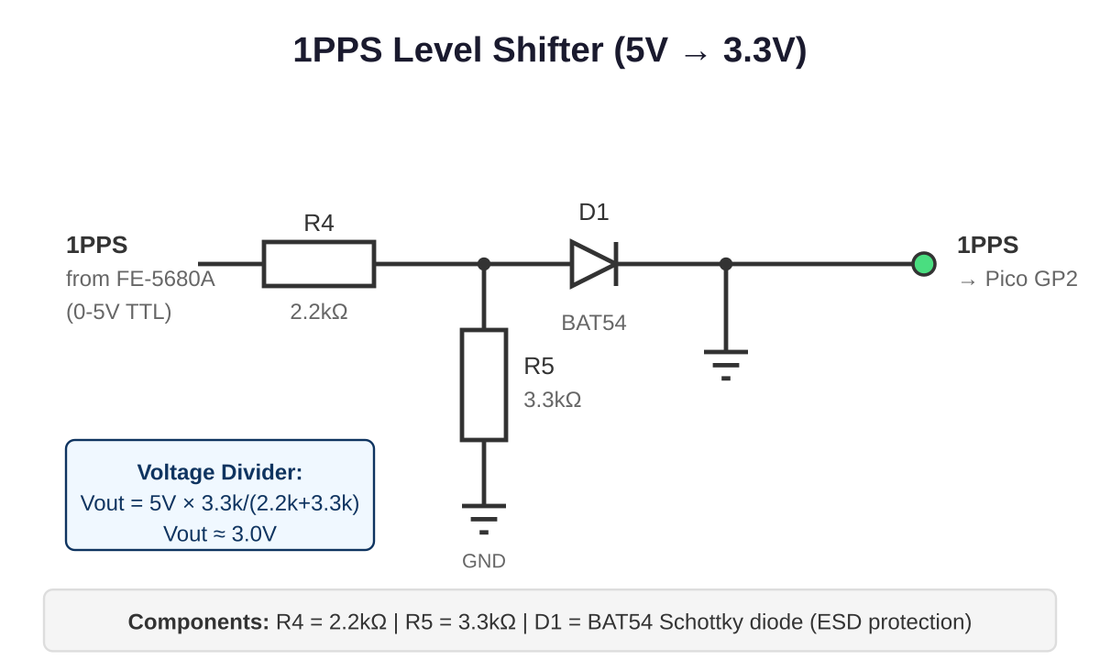

4. Power Supply Design
The FE-5680A requires +15V (physics heater) and +5V (electronics). The Pico needs 3.3V via its onboard regulator from 5V USB or VSYS.

4.1 Power Requirements
Rail | Voltage | Warmup | Running
+15V | 15V DC | 2.0A | 0.7A
+5V | 5V DC | 0.3A | 0.2A
+3.3V | 3.3V DC | 0.3A | 0.15A

4.2 Power Configuration
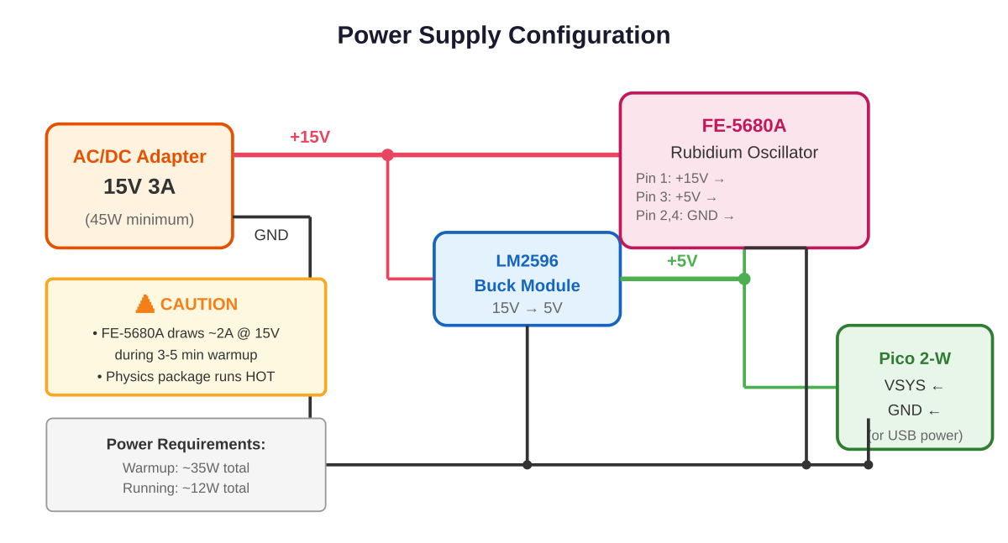

4.3 Safety Notes
- WARNING: FE-5680A physics package runs HOT. Ensure ventilation.
- Add a 3A fuse in series with +15V supply.
- Never connect/disconnect signals while powered.

5. Complete Wiring Guide

5.1 GPIO Assignments
GPIO | Function | Connection
GP2 | 1PPS Input | From level shifter
GP3 | 10MHz Input | From comparator
GP4 | Lock Status | From FE-5680A pin 9
GP6 | LED Sync | Green LED
GP7 | LED Network | Blue LED
GP8 | LED Activity | Yellow LED
GP9 | LED Error | Red LED
GP10 | Debug PPS | Test output
GP12/13 | I2C | Optional OLED
GP14 | Pulse 0.5s | 500ms interval
GP15 | Pulse 1s | 1 second interval
GP16 | Pulse 6s | 6 second interval
GP17 | Pulse 30s | 30 second interval
GP18 | Pulse 60s | 60 second interval

5.2 System Schematic
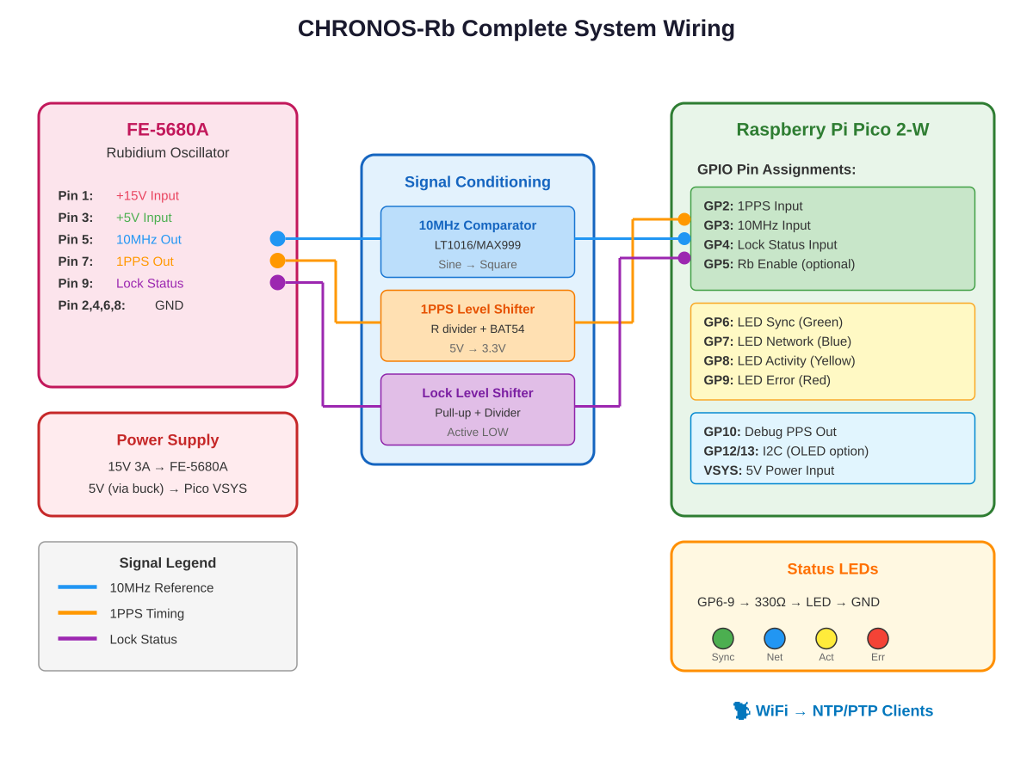

5.3 Status LED Circuit
Four LEDs provide visual feedback. Each is driven through a 330Ω current-limiting resistor.
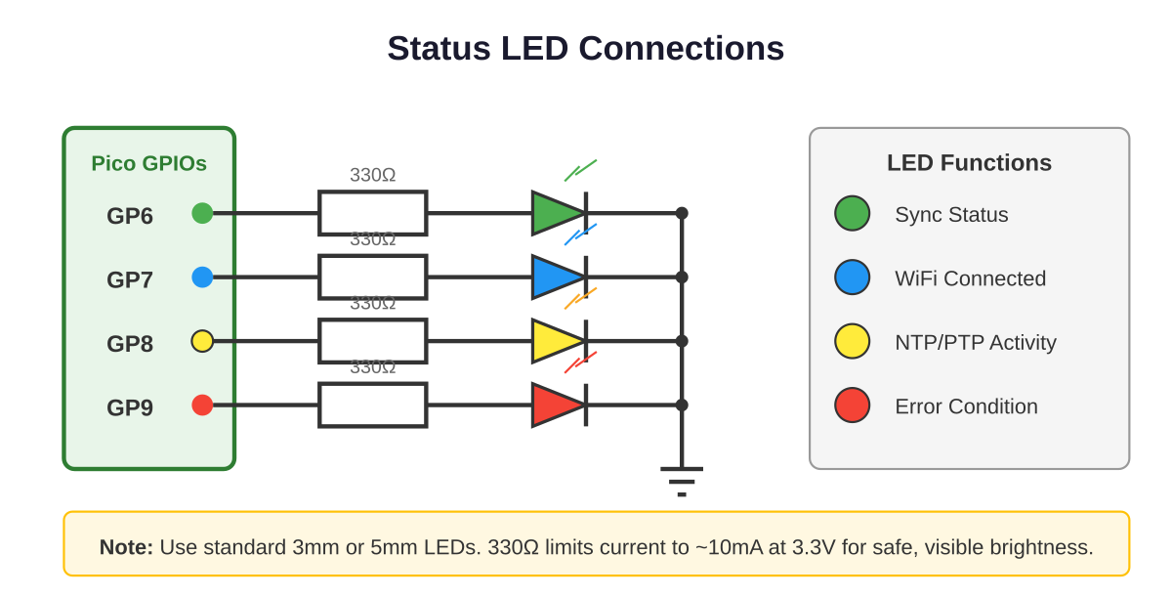

5.4 Interval Pulse Outputs
CHRONOS-Rb provides five interval pulse outputs synchronized to the rubidium 1PPS reference. These outputs generate 10ms active-high pulses at precise intervals, useful for triggering external equipment, calibration, or timing distribution.
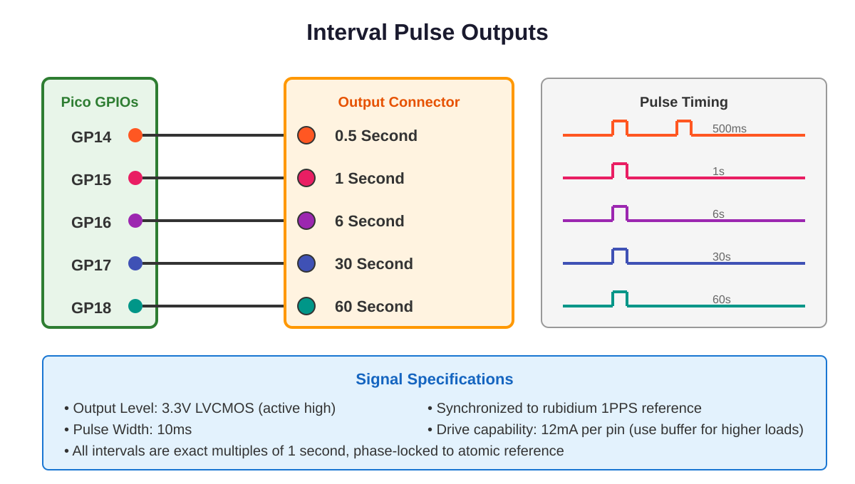
Output | GPIO | Interval | Use Case
500ms | GP14 | 0.5 seconds | High-rate timing, servo sync
1s | GP15 | 1 second | PPS distribution
6s | GP16 | 6 seconds | GPS-compatible timing
30s | GP17 | 30 seconds | Calibration triggers
60s | GP18 | 60 seconds | Minute markers
All outputs are phase-locked to the atomic 1PPS reference and maintain sub-microsecond accuracy. The 0.5s output pulses twice per second (at 0ms and 500ms after each PPS edge). Use external buffers (e.g., 74LVC1G125) if driving cables or loads requiring more than 12mA.

6. Bill of Materials

6.1 Main Components
Qty | Description | Part Number | Notes
1 | Raspberry Pi Pico 2-W | SC1623 | With WiFi
1 | FE-5680A Rubidium | FE-5680A | Surplus/eBay
1 | 15V 3A PSU | - | Min 45W
1 | LT1016/MAX999 | LT1016CN8 | DIP-8

6.2 Signal Conditioning
Qty | Description | Value
2 | Resistor | 10kΩ 1%
1 | Resistor | 100Ω
1 | Resistor | 2.2kΩ
1 | Resistor | 3.3kΩ
4 | Resistor | 330Ω
1 | Capacitor | 100nF ceramic
1 | Diode | BAT54
4 | LEDs | 3mm assorted

7. Assembly Instructions

7.1 Preparation
- Gather all components from the BOM
- Test FE-5680A separately before integration
- Program Pico with CHRONOS-Rb firmware
- Prepare workspace with ESD protection

7.2 Assembly Steps
- Build 10MHz comparator circuit on perfboard
- Add bypass caps near comparator power pins
- Build 1PPS voltage divider
- Test each section before connecting to Pico
- Connect D-sub to FE-5680A
- Apply power and wait for lock (~5 min)
- Verify signals with oscilloscope
- Connect signal conditioning to Pico GPIOs

8. Firmware Overview
Build with Pico SDK 2.0+, CMake 3.13+, ARM GCC. Edit chronos_rb.h for WiFi credentials before building. Flash the UF2 file while holding BOOTSEL.

8.1 Module Overview
Module | File | Function
Main | main.c | Entry, init, loop
PPS | pps_capture.c | 1PPS timing
Freq | freq_counter.c | 10MHz measurement
Sync | rubidium_sync.c | State machine
Discipline | time_discipline.c | PI controller
NTP | ntp_server.c | NTPv4 server
PTP | ptp_server.c | IEEE 1588
WiFi | wifi_manager.c | Connection mgmt
Web | web_interface.c | HTTP interface

9. Using the Time Server

9.1 NTP Client Setup
Linux: Add NTP=<ip> to /etc/systemd/timesyncd.conf
Windows: w32tm /config /manualpeerlist:<ip> /syncfromflags:manual /update
macOS: System Preferences > Date & Time, or: sudo sntp -sS <ip>

9.2 Web Interface
Access http://<device-ip>/ for real-time status. JSON API at /api/status for monitoring integration.

10. Troubleshooting
Symptom | Cause | Solution
No 10MHz | Power issue | Check +15V/+5V
Won't lock | Warmup | Wait 5+ minutes
No 1PPS | Not locked | Wait for lock LED
WiFi fail | Credentials | Check config
High offset | Signal issue | Check circuits
NTP timeout | Firewall | Open UDP 123

Appendix: Project Name
CHRONOS-Rb =
- Compact
- High-precision
- Rubidium
- Oscillator
- Network
- Operating
- System
The "-Rb" suffix denotes rubidium (chemical symbol Rb). Chronos (Χρόνος) is the Greek personification of time.
— End of Document —

