**ACKNOWLEDEGEMENTS**

I would like to extend my sincere appreciation to my project supervisors, Ronald K.Mo and Dr Hafizul Asad for their guidance and support throughout this project. they guide me to solve the problems and have a clear path on how to achieve this project more effectively and efficiency.

**ABSTRACT**

this report describes a blockchain-based software development project to build a blockchain application for fake product identification. The application allows user to view the specific products with their own contact address and transaction records so they can clarify if that is a counterfeit.

The Report beings by defining the background, objectives and deliverables of the project, describing the aim and objectives of the project, current solution and the limitation of the current solutions. And then there is a section on literature review to explain an overview of current knowledge, relevant theories, methods and gaps in the existing topic.

Further on, the report describes the method of approach during the development process. And also, to look at the legal, social, ethical and professional issues of this project development.

The main body of the report discusses the project management of the application. The development was split into distinct stages, approaching each of these stages with an iterative approach which relies on the completion of the previous stage before moving on to the next. Also looks into how issues and challenges were met and overcome. The next section focuses on the testing/demonstration of the application.

The final sections of the report give a review of how the completeness of this project is by evaluating its architecture, design and the technologies used. Moreover, there is an appendices section which contains documents relevant to the project such as a user guide, project management document and sprint reviews.

1. **INTRODUCTION**

Blockchain is one of the most significant technological innovations, and it has grown amazingly in the past few years. A renowned blockchain application is the cryptocurrency – Bitcoin. The Blockchain technology is powerful and effective to confirm the legitimacy of transparent records without relying on a centralized system. However, it’s just a tip of the iceberg for it. It is ensured that the Blockchain technology can bring a lot more advantages to the systems/applications such as tamper-proofing/tamper resistance for the contents of the data.  
  
Using Blockchain one can create a data record system that does not depend on a trusted third party as a transaction intermediary, and that is openly shared and reliable at the same time. The Project is not only focused building an anti-counterfeiting system but also to explore the characteristic of the Blockchain (for example: Security and Privacy, Decentralization, Untraceability, Flexibility & Transparency) and understand how these characteristics make Blockchain becomes a disruptive technology and how it helps the industries.

**2. Background:**

**2.1 what is the current issue**

As found that almost every popular brand has fake manufacturers selling a counterfeit at cheaper rates nowadays. It’s obvious that even the company experts may not be able to recognize between the real or fake electronic products so it makes the customers lack of confidence to purchase the popular brands’ electronic products from the retailers especially when the customers are buying online.

**2.2 What is the ideal solution**  
 In this way, this phenomenon makes me think what if there’s a decentralized Blockchain system with products anti-counterfeiting? in that way manufacturers can use this system to provide genuine electronic products without having to manage direct-operated stores, which can significantly reduce the cost of product quality assurance. And the customers can easily distinguish between fake ones and real ones by using the system and it is beneficial for both the buyers and the sellers as the buyer-seller relationship has been improved as the customers will have the ability to identify if it’s a counterfeit.

To achieve this, what if the system can offer a digital signature or embedded barcode which is tied to a blockchain system? So, both the manufacturers and customers can rely on the embedded barcode or digital to help identify whether the product is fake or not. And it will be more user-friendly if the system can be used on the mobile devices.

* 1. **Objectives**

1. Build a Blockchain Based system to identify the fake product

2. Discover how identification system have benefited from blockchain technology

3. Discover what is the advantages for the data to be stored by using the decentralized blockchain technology.

**2.4 Study Goal**The study goal of this project is to understand what is blockchain, how blockchain works and how it is transforming the software development. For example, understand why blockchain software is highly secure and the key features of blockchain-based system. (Data replication & Transaction Recording etc.)

**3.Literautre Review**

**3.1 Blockchain**

Blockchain – decentralized system, is essentially a distributed database of records or public ledger of all transactions or digital events that have been executed and shared among participating parties. Each transaction in the public ledger is verified by consensus of a majority of the participants in the system **[1]**. and the information is undeletable once it has, details for identification and more important the verification.

For example, from each transaction record you are able to see the below attributes:

|  |  |
| --- | --- |
| Attribute Name | Description |
| Transaction Hash | A unique 66 characters identifier that is generated whenever a transaction is executed |
| Status | The status of the transaction (success, failed etc.) |
| Block | The number of the block in which the transaction was recorded. Block confirmation indicate how many blocks since the transaction is mined. |
| Timestamp | The Date and time at which a transaction is mined. |
| From | The sending party of the transaction (could be from a contract address) |
| To | The receiving party of the transaction (could be a contract address) |
| Value | The value being transacted in Ether and flat value (for example how many Ether has been valued from this transaction and how many US Dollars they are referred to. |
| Transaction Fee | Amount paid to miner for processing the transaction |
| Gas Price | Cost per unit of gas specified for the transaction, in Ether and Gwei. The higher the gas price the higher the chance of getting included in a block. |

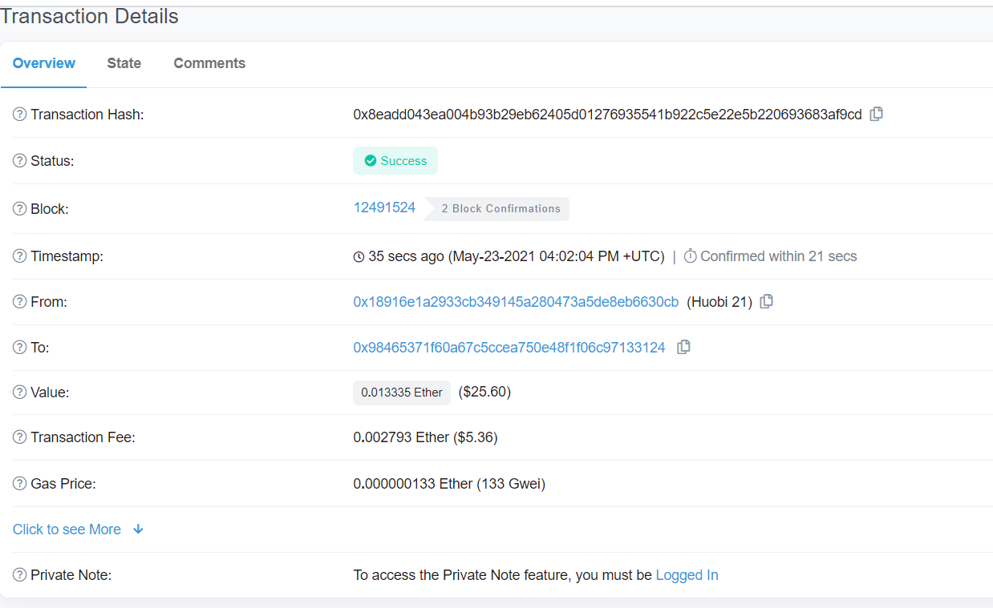

Figure 1. – transaction details on Ethereum Blockchain Explorer

[1]Blockchain Technology Beyond Bitcoin – Michael Crosby, Nachiappan, Oct 2015.