##### GitHub Commit History

[Daniel-Scarfe/COSC2196_A2 - Master Branch](https://github.com/Daniel-Scarfe/COSC2196_A2/commits/master) [Daniel-Scarfe/COSC2196_A2 - Website Branch](https://github.com/Daniel-Scarfe/COSC2196_A2/commits/website)

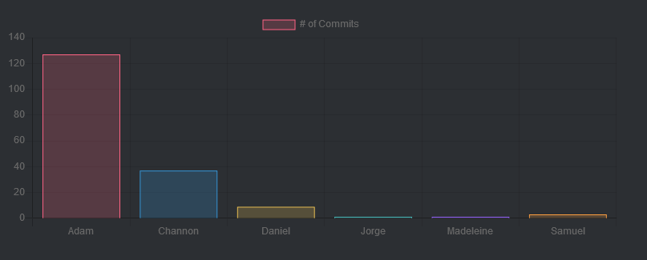

###### Comments:

Our GIT audit trail does not accurately reflect our groups work overall as a lot of deliverables were created in word and submitted to the relevant sub channel on Microsoft Teams, Which were then converted to html to suit the website design. So, in short, the GIT audit trail more accurately reflects the website development and not the overall work completed by the team and its members.

##### Discord Discussion History

[Discord Archive - Text Channels / general](https://dev.techydata.com.au/COSC2196_A2/files/Discord/)

###### Comments:

Discord was used as a "out of band" communications tool for general discussions of minor issues and ideas for the website that were too minor in nature to present at a meeting, general feedback and support amongst team members, and some off-topic discussions.

It is included here for the sake of completeness.