ISYS2095 – Assessment 3 – Task D

Adam Mutimer (S3875753)

# Task D.1

List the total number of vaccines administered in each observation date for Afghanistan

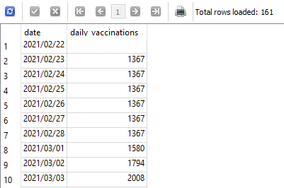

|  |
| --- |
| SELECT date,  daily_vaccinations  FROM CountryVaccinations  WHERE iso_code = (  SELECT iso_code  FROM Locations  WHERE location = "Afghanistan"  ); |

# Task D.2

Produce a dataset containing total number of COVID-19 doses administered by each country

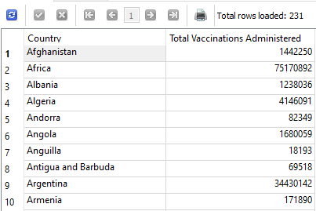

|  |
| --- |
| SELECT (  SELECT location  FROM Locations  WHERE iso_code = CountryVaccinations.iso_code  )  AS Country,  MAX(NULLIF(total_vaccinations, "") ) AS [Total Vaccinations Administered]  FROM CountryVaccinations  WHERE total_vaccinations NOT NULL  GROUP BY Country  ORDER BY Country ASC; |

# Task D.3

Produce a list of all countries with the type of vaccines administered

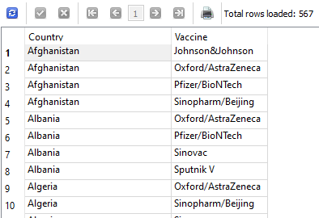

|  |
| --- |
| SELECT (  SELECT location  FROM Locations  WHERE iso_code = LocationVaccines.iso_code  )  AS Country,  (  SELECT name  FROM Vaccines  WHERE vaccine_id = LocationVaccines.vaccine_id  )  AS Vaccine  FROM LocationVaccines  ORDER BY Country ASC; |

# Task D.4

Produce report showing the total number of vaccines administered according to each data source  
NOTE: Combined Duplicates only when the data source website matched

**FOR THIS TASK I WROTE TWO INDEPENDENT QURIES WHICH PERFORM THE SAME TASK HOWEVER ONE USES A JOIN AND THE OTHER DOES NOT**

## Task D.4 – With Join

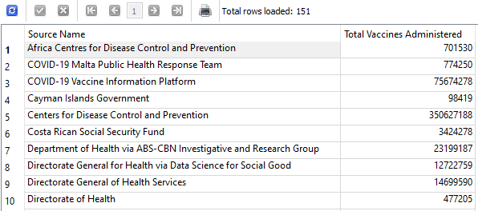

|  |
| --- |
| SELECT SourceName AS [Source Name],  SUM(TOTAL) AS [Total Vaccines Administered]  FROM (  SELECT CountryVaccinations.iso_code,  MAX(NULLIF(CountryVaccinations.total_vaccinations, "") ) AS Total,  IFNULL(DataSource.source_name, "Unknown Source - Data Unavaliable") AS SourceName,  DataSource.source_website AS SourceWebsite  FROM CountryVaccinations  LEFT JOIN  DataSource ON CountryVaccinations.iso_code = DataSource.iso_code  GROUP BY CountryVaccinations.iso_code  )  GROUP BY SourceWebsite  ORDER BY SourceName ASC; |

## Task D.4 – Without Join

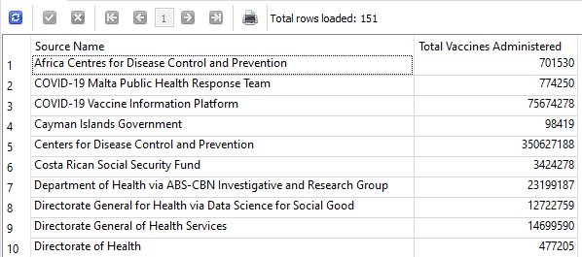

|  |
| --- |
| SELECT SourceName AS [Source Name],  SUM(TOTAL) AS [Total Vaccines Administered]  FROM (  SELECT iso_code,  MAX(NULLIF(total_vaccinations, "") ) AS Total,  IFNULL( (  SELECT source_name  FROM DataSource  WHERE iso_code = CountryVaccinations.iso_code  ), "Unknown Source - Data Unavaliable") AS SourceName,  (  SELECT source_website  FROM DataSource  WHERE iso_code = CountryVaccinations.iso_code  )  AS SourceWebsite  FROM CountryVaccinations  GROUP BY iso_code  )  GROUP BY SourceWebsite  ORDER BY SourceName; |

# Task D.5

Produce a report that lists all the observation dates, and provides total number of fully vaccinated in 4 countries (Australia, United States, France, and Israel)

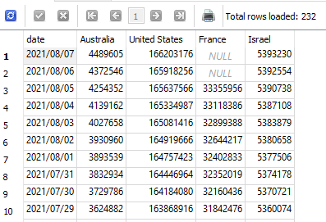

SEE NEXT PAGE FOR QUERY

|  |
| --- |
| SELECT CountryDailyTotals.date,  MAX(CASE WHEN CountryDailyTotals.iso_code = (  SELECT iso_code  FROM Locations  WHERE location = 'Australia'  )  THEN CountryDailyTotals.people_fully_vaccinated END) AS Australia,  MAX(CASE WHEN CountryDailyTotals.iso_code = (  SELECT iso_code  FROM Locations  WHERE location = 'United States'  )  THEN CountryDailyTotals.people_fully_vaccinated END) AS [United States],  MAX(CASE WHEN CountryDailyTotals.iso_code = (  SELECT iso_code  FROM Locations  WHERE location = 'France'  )  THEN CountryDailyTotals.people_fully_vaccinated END) AS France,  MAX(CASE WHEN CountryDailyTotals.iso_code = (  SELECT iso_code  FROM Locations  WHERE location = 'Israel'  )  THEN CountryDailyTotals.people_fully_vaccinated END) AS Israel  FROM CountryDailyTotals  GROUP BY CountryDailyTotals.date  ORDER BY CountryDailyTotals.date DESC; |