My First Kaggle Competition - Football Match Probability Prediction

This blog post will cover the main takeaways from my first kaggle competition. It will be broken down into the following sections:

* A brief overview of the competition, my approach, and my score.
* Things I wished I'd known before starting.
* Importance of understanding the dataset + thoughtful feature engineering.
* The models I used and their performance.
* Places to improve and my next stpes.

**A brief overview of the competition, my approach, and my score**

The aim of [this competition](https://www.kaggle.com/competitions/football-match-probability-prediction/overview) was to predict the match outcome of some 189 games of football using statistics from the team’s last ten games. The predictions were judged using a log-loss score so overconfidence is punished.

My general approach was to extract short, medium, and long term averages of different features included in or engineered from the original data set. I used feature importance from a decision tree forest to see if these signals had good predictive power or not before ensembling a few different kinds of models for a final submission.

The predictions were judged using a log-loss score so overconfidence was punished. I scored a respectable 1.00520. For context, the leader scored 0.98834, and the bookies 0.9730. My real aim for this competition was to get used to the end-to-end process of predictive modelling and to this means it was a success.

Here’s the screengrab which, at the time of writing, put me in 51st out of 288 position:

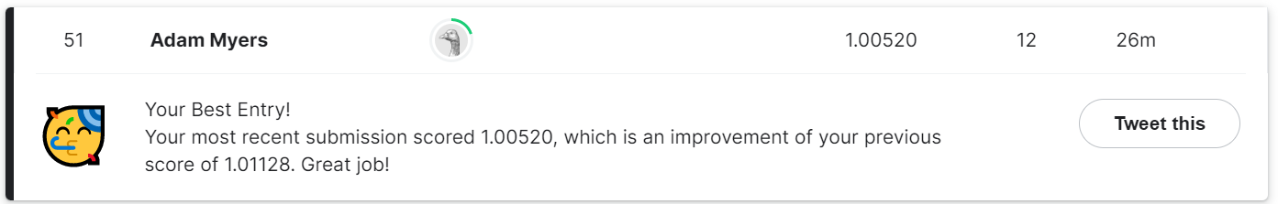

**Things I wished I'd known before starting**

I’ll put these in a list for ease:

1. Once testing is complete, train a final model with the whole data set provided - not just the training split. This hampered my progress quite a lot before I noticed but it was a valuable learning point nonetheless.
2. Don’t be afraid to do some hard coding. By this I mean looping through variable names can be complicated and lead to mistakes. If in doubt just copy and paste a few times to be safe.
3. Use box and whisker plots or histograms after each newly added feature to check things went as planned.

**Importance of understanding the dataset + thoughtful feature engineering**

Most of my gains didn’t come from the actual model I chose - in fact I hardly optimised these at all - they came from deriving useful metrics from the data and getting rid of useless ones.

By looking at how each feature split in a tree improves the model's predictive power, feature importance can be gauged. Here’s a bar chart of my top fifteen features:

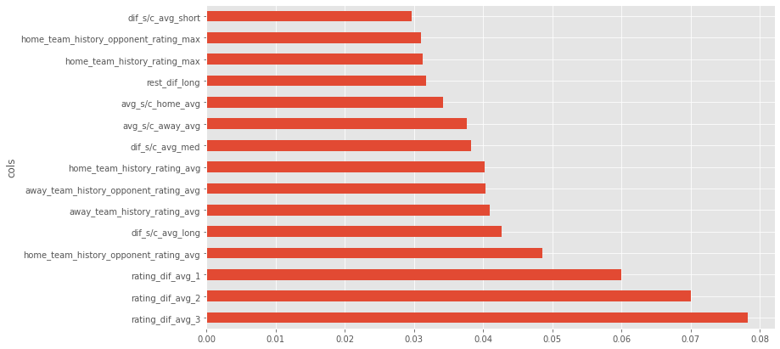

Most of the variables are fairly self explanatory; however, i'll add that ‘dif’ refers to a difference between the home and the away team; ‘1’,’2’,’3’ and ‘long’,’med’,’short’ refer to the respective time average taken; and ‘s/c’ is the difference between scored and conceded goals. 

This shows how explicitly feeding the model differences really helps it categorise games. I was most surprised to see how ‘rest_dif_long’, which is the long term average rest differences between games between the home and away team, is judged as fairly important by the decision trees.

Team ratings were provided by [Ocotosport](https://www.octosport.io/), and again the relative difference between the averages proved most useful.

I didn't apply any explicit time series transforms to this data but I'd be interested to see how decomposing ratings trends into signal components with a fourier transform of some kind may provide extra signal - having said this, extra complexity always comes at a price.

**The models I used and their performance**

My final submission was an ensemble of a logistic regression model; a random forest mode; a light gradient boosted model; and a two layer neural network. Okay this was overkill but it was more for learning the strengths of different models - ensembling was just an easy extra kick up the leaderboard.

Surprisingly simple a logistic model alone would have scored very well. This speaks a lot for simple models and is definitely a good take away: start simple, the rest is limiting returns.

The shallow neural net extrapolated really well out of its training batch. I used fast.ai’s tabular model, which incorporates lots of under the hood tricks to work well on tabular data. Their high level API helped to split categorical and continuous features; make the entity embeddings for categorical features; and find a good learning rate for a learning rate varied fitting cycle.

**Places to improve and my next steps**

The glaring area for further research is running a grid search on my tree based models. To do this I think I'll have to rent a better GPU as the free version on [Paperspace](https://www.paperspace.com/) simply took too long.

Having said this, for a first attempt, I'm happy with my performance as I picked up the main points about making a good model. Optimising little things is the aim of the game of Kaggle competitions but for me it's about learning as much as I can.

My plan now is to learn some more about natural language processing models and do a bit more of a deep dive behind the maths behind.