**TITLE**

**Solving Simple Problems in C**

**LAB # 02**

**SECTION # 8**

**FULL NAME**

**Adam Jennissen**

**SUBMISSION DATE:**

**9/8/2022**

**DATE**

**9/8/2022**

# Problem

The purpose of this lab was to solve multiple different problems. Most of the problems were different types of simple math. They were taking input and finding the area of a rectangle and volume of a cube, fixing a programs output, creating math formulas for area of a circle given circumference, converting feet to meters, and converting Fahrenheit to Celsius. The final problem was creating a program that uses the Pythagorean Theorem.

# Analysis

For the problems I had to find the correct formulas and figure out how to get the program to do the math in the correct order. I needed to convert from circumference back to radius then use radius to find the area. For the Fahrenheit Celsius problem, I had to make sure it did the subtraction first, then the multiplication and division. For the Pythagorean Theorem problem, I had to square two numbers, then add them, then take the square root of them.

# Design

The first problem had two parts, the first part I took in the input of width and height and output the area of a rectangle (2). For the second part, I did the same thing, but I also took in input of the length, and output the area of a cube (3). Problem 3 required fixing code that was not working right (4). Two of the outputs were wrong, because of a wrong type specifier, and the middle output was wrong, because the variable was not put in for the second argument of the print statement. For the fourth problem, there was a list of math operations and some of them do not output correctly (5). C, E, F, and I do not output correctly because there is integer division in it, meaning that it does not take the remainder. For the Pythagorean Theorem problem, I took input for a and b and then created one equation to find c (7).

# Testing

To make sure that my Pythagorean Theorem program worked correctly, I first input, 3 and 4, which output 5. I did this because they are a Pythagorean triple so I knew the output should be 5. I then put in 3.0 and 4.0, and I got 5.0 out. I put these in to make sure that putting in a decimal did not break my program. Finally, I put it the numbers we were told to in the problem, 5 and 9, and I got 10.295630 (7). I checked an online calculator to make sure that was correct.

# Comments

Throughout this lab I made multiple mistakes that I learned from. For example, in my Pythagorean Theorem program when I put in 3.0 and 4.0, it did not work the first time, because of my input statements. To fix this I put a space before the %lf in my second input so that it did not go to a new line when I pressed enter, we learned this in class, but I learned how to actually use it. I also got a better understanding of integer division after figuring out which equations did not give the right answer in the fourth problem.

# Screen Shots

<Number the screenshots and paste here. The point of numbering the screenshots is so that you can refer to them during your discussion in the various parts above. Alternatively, you can include the screenshots in-line with the text above as part of your discussion.>

1.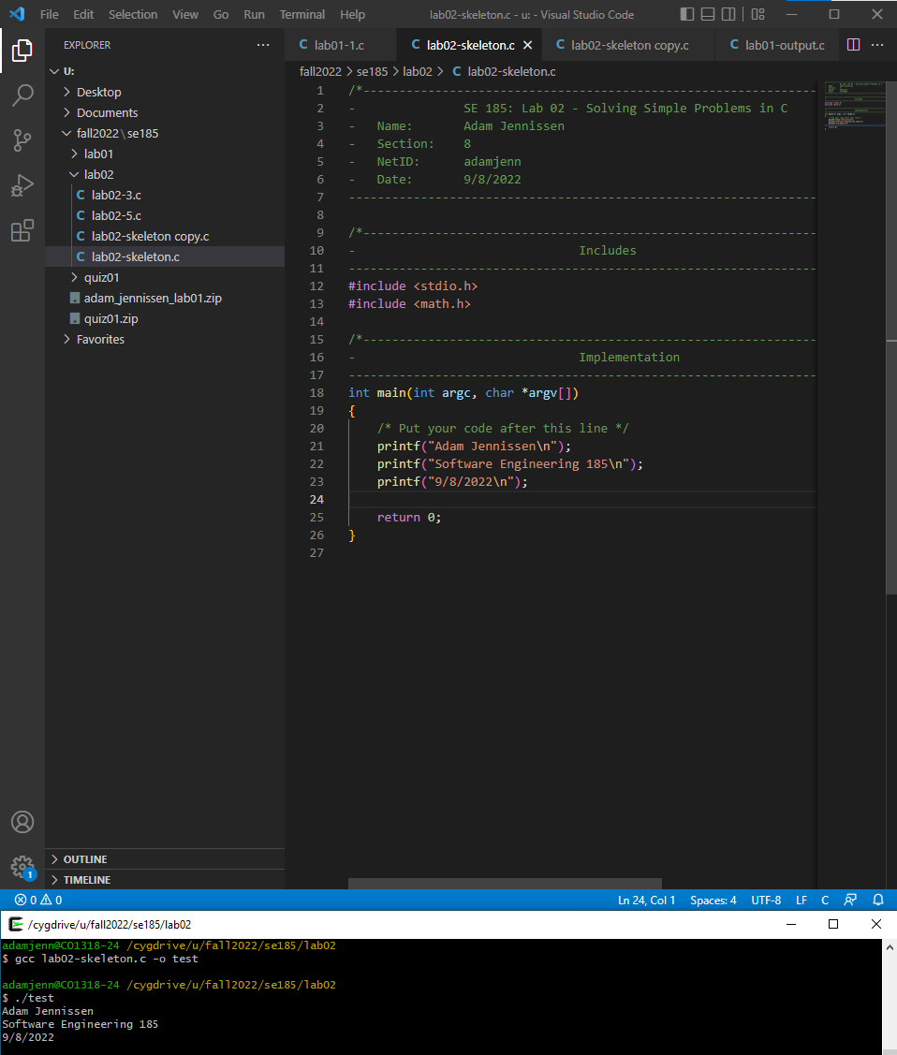

2.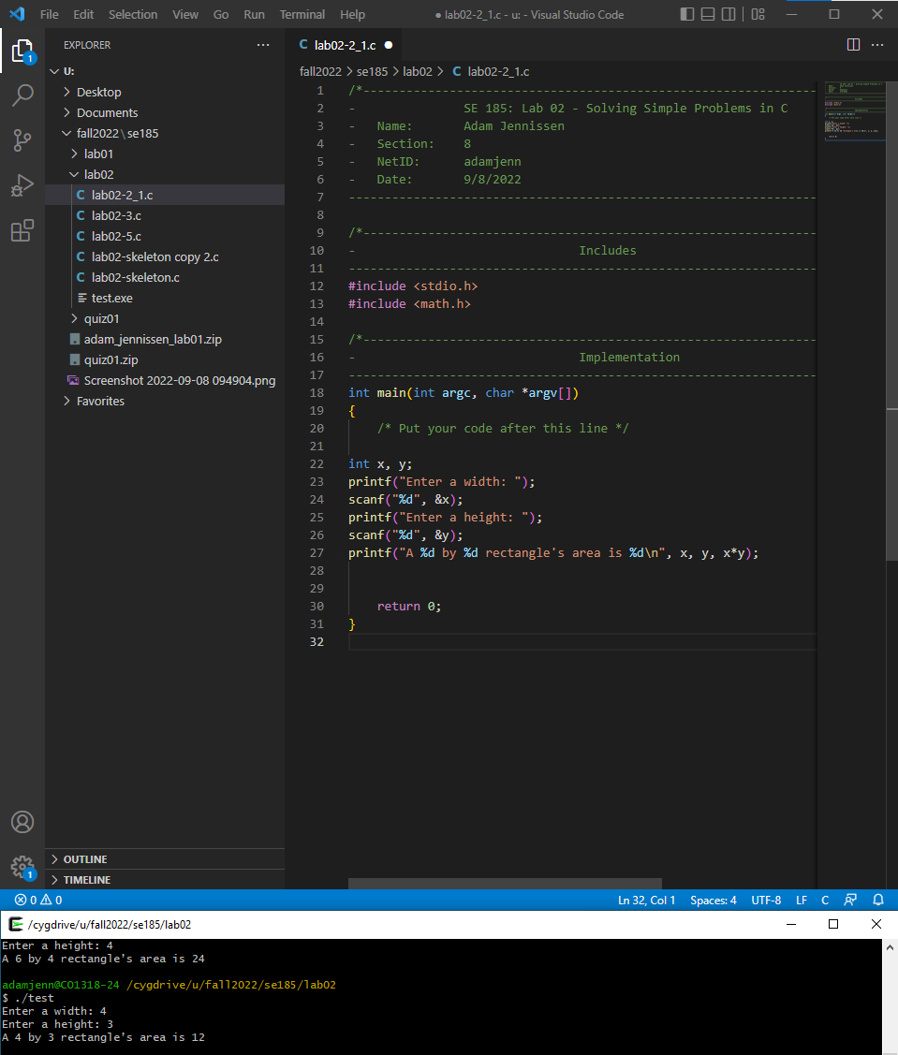

3.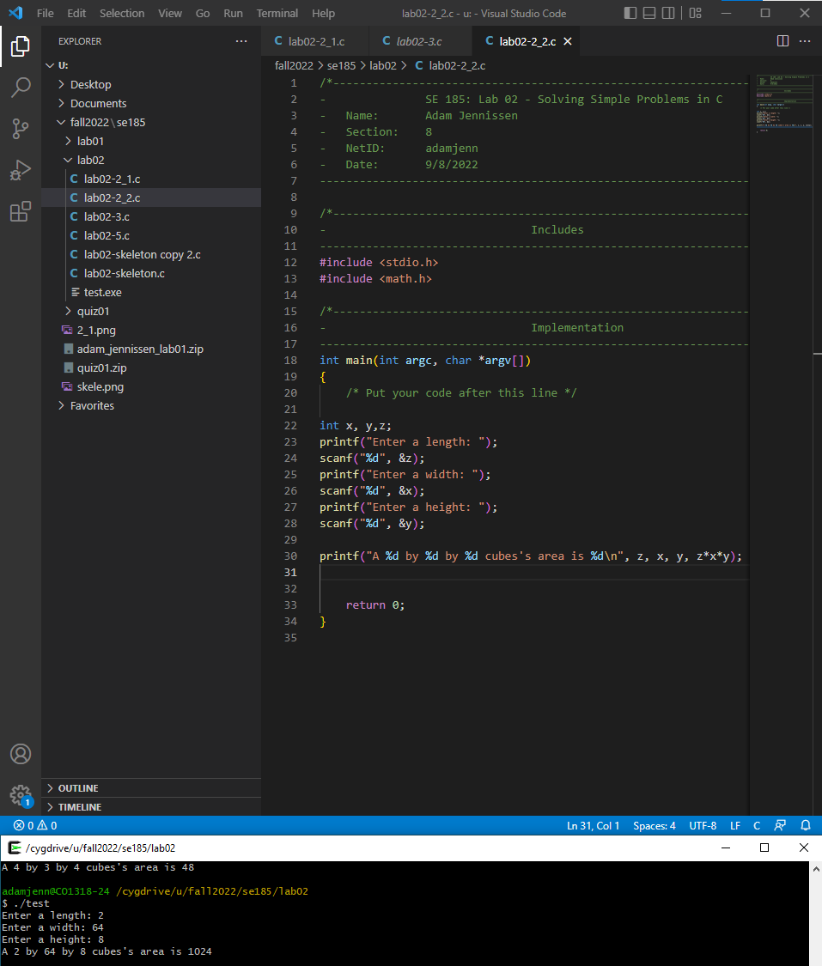

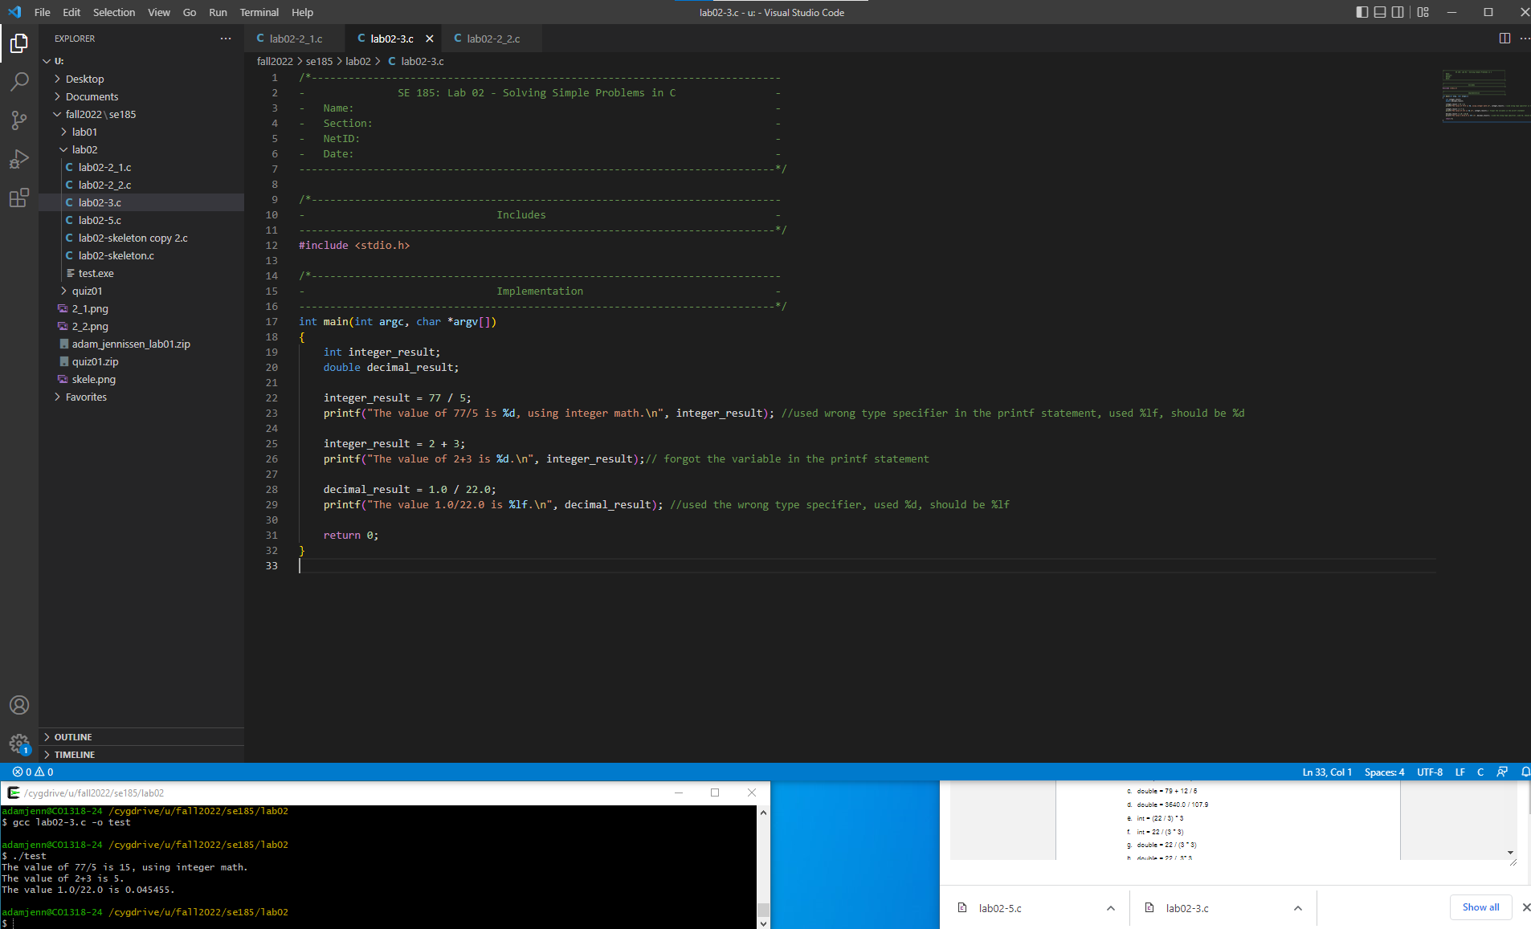4.

5.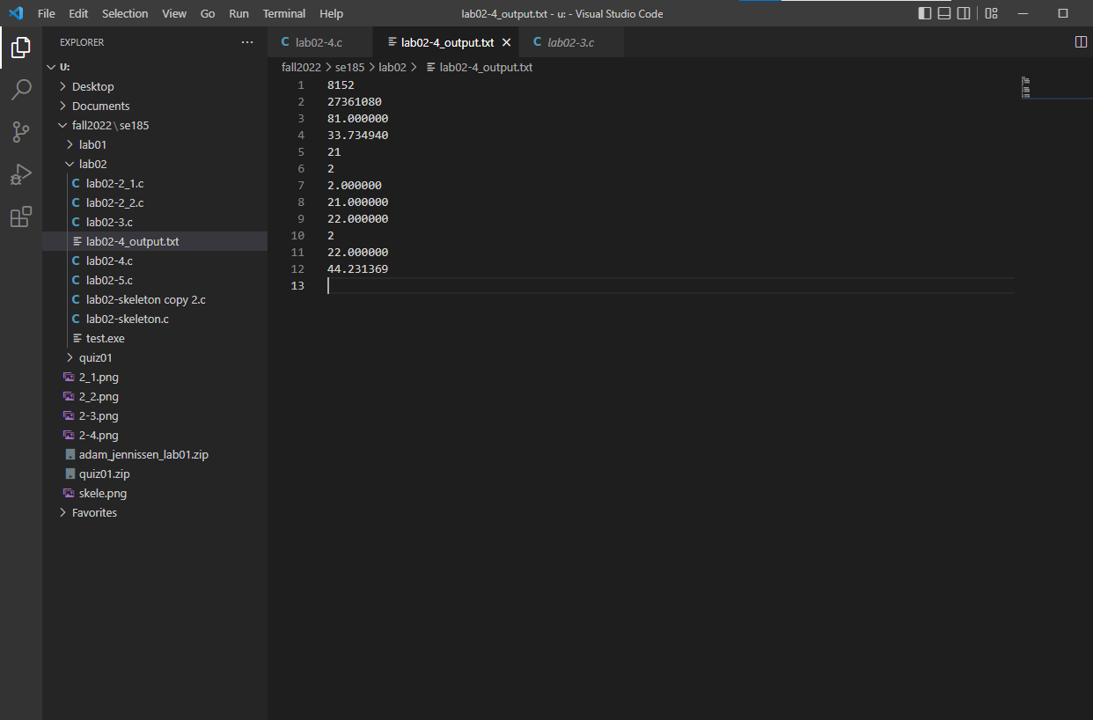

6.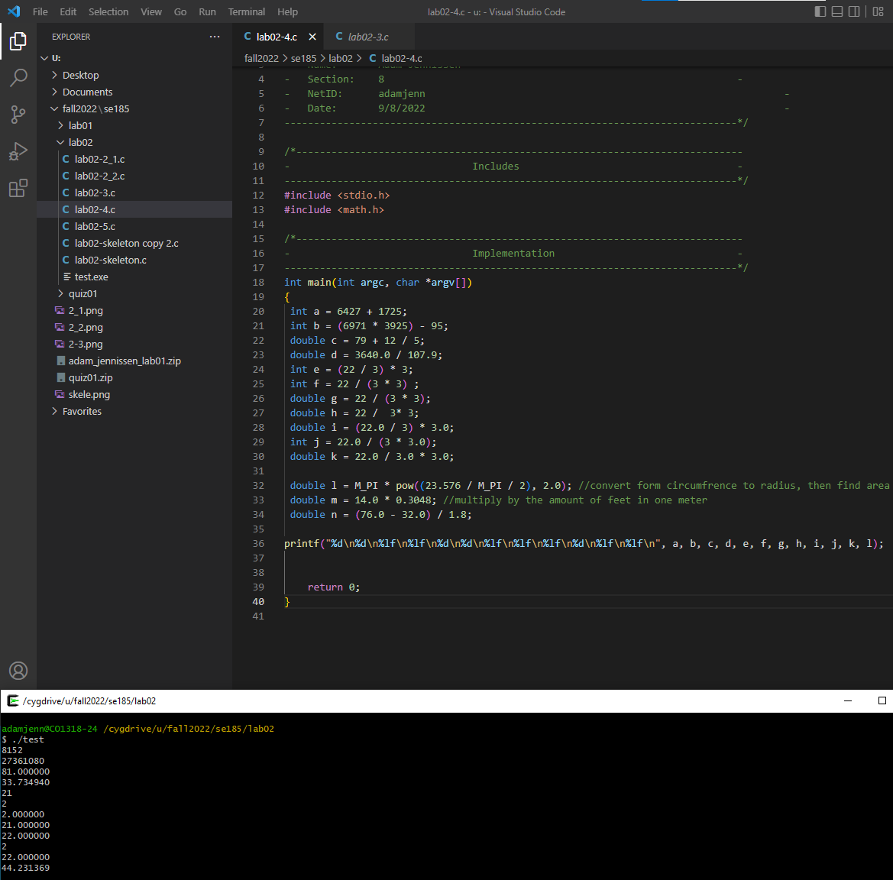7.