**TITLE**

**Introduction the DS4 and Functions**

**LAB # 03**

**SECTION # 8**

**FULL NAME**

**Adam Jennissen**

**SUBMISSION DATE:**

**9/18/2022**

**DATE**

**9/15/2022**

# Problem

The purpose of this lab was to create 2 programs that interacted with a DualShock 4 controller as well as learn how to use the DualShock 4 controllers inside of Cygwin. The first program converted milliseconds into minutes, seconds, and milliseconds. The second program counted the number of buttons pressed on the DualShock 4 controller.

# Analysis

The program had to take input from the ds4 controller and output it to a spreadsheet, as well as convert the time to minutes, seconds, and milliseconds. For this I had to know that there are 60000 milliseconds in a minute, and 1000 milliseconds in a minute. For the second problem I just had to take input from the ds4 controller and perform basic addition.

# Design

For the first program I had to figure out how to convert from milliseconds into minutes, seconds, and milliseconds. I first converted milliseconds to minutes by dividing by 60000 and using integer division to my advantage. In order to find the seconds, I used the remainder of 60000 to find the milliseconds left after converting to minutes, and then divided it by 1000 to get the seconds using integer division. Lastly to get the milliseconds left, I used the remainder of 60000 and the remainder of 1000, to get the millisecond left after finding both minutes and seconds. For the second problem, I had to take the input, which I just looked at the other problem to figure out how to do. I then had to create a program that used that input and then added the number of buttons pressed, which was simple and just involved adding the numbers together.

# Testing

In order to make sure that my programs outputted the correct thing, I had to run them for a while to make sure they worked right. For the first problem, I ran it for about a minute to make sure that all of my math worked correctly. In the screenshot it only ran for about 30 seconds (4). When testing the second problem I tried a combination of all the different buttons, to make sure that it would add any of them together (5).

# Comments

I learned how to find the device ID of a ds4 controller, and then how to use a ds4 controller through Cygwin. I also learned multiple different tags that can be used, depending on what you want to track form the ds4 controller. I got a better understanding of the modulo operator when converting milliseconds to minutes, seconds, and milliseconds. Doing both of the problems also gave me a better understanding of how functions work, and how the program actually runs.

# Screen Shots

1.

2.

3.

4.

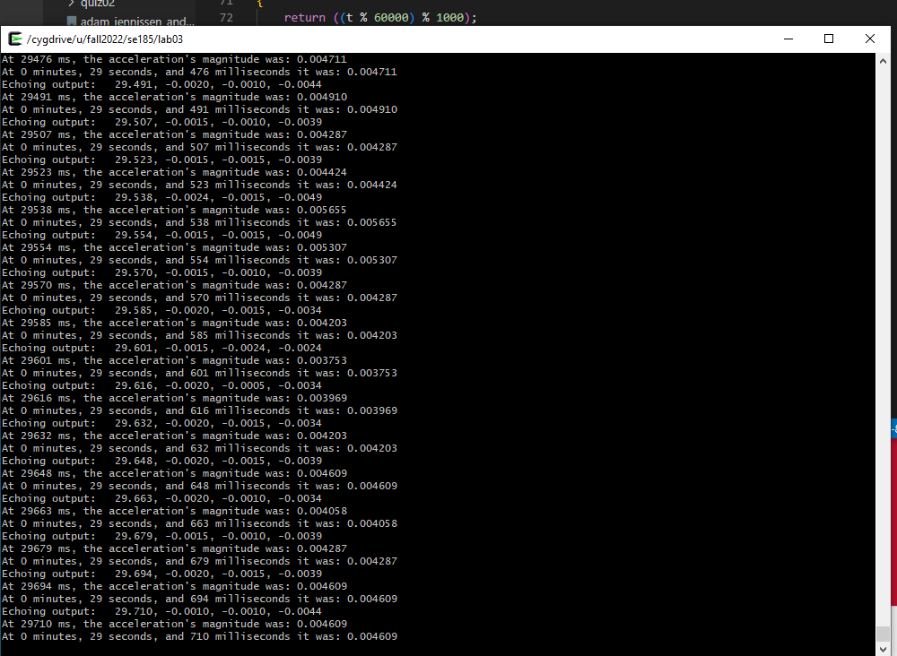

5.