|  |  |
| --- | --- |
| **Iowa State University**  OF SCIENCE AND TECHNOLOGY | Department of Statistics  Snedecor Hall  Iowa State University  Ames, Iowa 50011-1210  201-563-4325  niemi@iastate.edu  http://jarad.me  22 September 2016 |

To the Editors of the Journal of Agricultural, Biological, and Environmental Statistics,

We submit the attached manuscript, “Assessing the impacts of time to detection distribution assumptions on detection probability estimation” to the Journal of Agricultural, Biological, and Environmental Statistics (JABES). Please find the required materials in the online submission.

Our work fits within the context of abundance and occupancy modeling that JABES has a history of publishing including the note by Haines in the most recent issue of JABES. The key quantity to estimate is the detection probability as estimation of this quantity allows estimation of abundance and occupancy. We construct a continuous time model that allows for the introduction of a generic time to detection distribution (TTDD), treat the point count data as interval censored data, and evaluate the impact of the TTDD on the estimation of detection probability.

We feel that this paper is appropriate for your journal and would like to thank you for handling our submission.

Best regards,

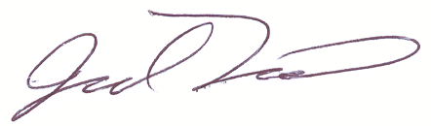

Jarad Niemi