|  |  |
| --- | --- |
| **Iowa State University**  OF SCIENCE AND TECHNOLOGY | Department of Statistics  Snedecor Hall  Iowa State University  Ames, Iowa 50011-1210  201-563-4325  niemi@iastate.edu  http://jarad.me  18 May 2017 |

To the Editors of the Journal of Agricultural, Biological, and Environmental Statistics,

We are resubmitting the attached manuscript, “Assessing the impacts of time to detection distribution assumptions on detection probability estimation” to the Journal of Agricultural, Biological, and Environmental Statistics (JABES) under manuscript #JABE-D-16-00127. Please find the required materials in the online submission.

We thank the reviewers and associate editor for their comments. We believe the manuscript is clearly a better document in consequence. In particular, the reviewers encouraged us to generate more simulations --- in terms of both the number of replicates and the variety in true detection probabilities. In pursuing these recommendations, we improved our simulation code to be more efficient by orders of magnitude for the covariate-free simulations. Our results now more fully describe model performance across a range of true detection probabilities, and the patterns observed are more compelling on account of the greater number of replicates.

Best regards,

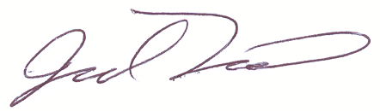

Jarad Niemi