

**Angular 2 Cinema Application**

**Rich Web Applications**

**B.Sc. in Computing in Information Technology**

**BN013**

**Adam McCarthy**

**B00085376**

***Department of Business***

***School of Business & Humanities***

***Institute of Technology, Blanchardstown***

***Dublin 15***

**Rich Web Applications**

**BSc in Computing in IT**

**16/07/2018**

Contents

Introduction 3

Design of the Application 3

Movie Class 3

Movielist Component 4

Cinema Class 5

List & App Component 5

CSS & Index Page 7

What I Have Learnt 8

# Introduction

For this assignment I was tasked with creating a web application that displays a list of cinemas in Ireland that when clicked show a list of movies that they are screening. The movies must also detail their start time, director, actors, a review and an option to view a trailer of the movie. The application must incorporate a component based design using Angular and include data binding, dependency injection and other Angular features. It was also advised to use JSON file where ever possible. The user was to be able to select which county they are in and the website would update to only show the cinemas in that county but being a single page web application, the website would not change to another page but instead just update the area of the web page where the cinemas are displayed.

# Design of the Application

The first thing I decided when I started this assignment was to use Atom as my editor as it recognised TypeScript files which made it easier for working with Angular 2. Originally, I just made a class called Config to display the main heading of the index page.

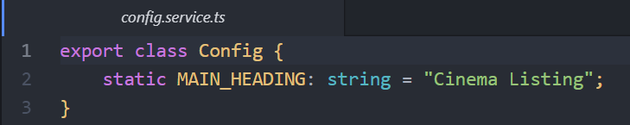

## Movie Class

After that I began designing the index page with some basic components that I then expanded upon later in the project. I originally began with a web page that just displayed movies, with their title, rating, description and ID number. I eventually expanded on the movies component to include actors, directors, a review, show times and a link to a trailer for the film.

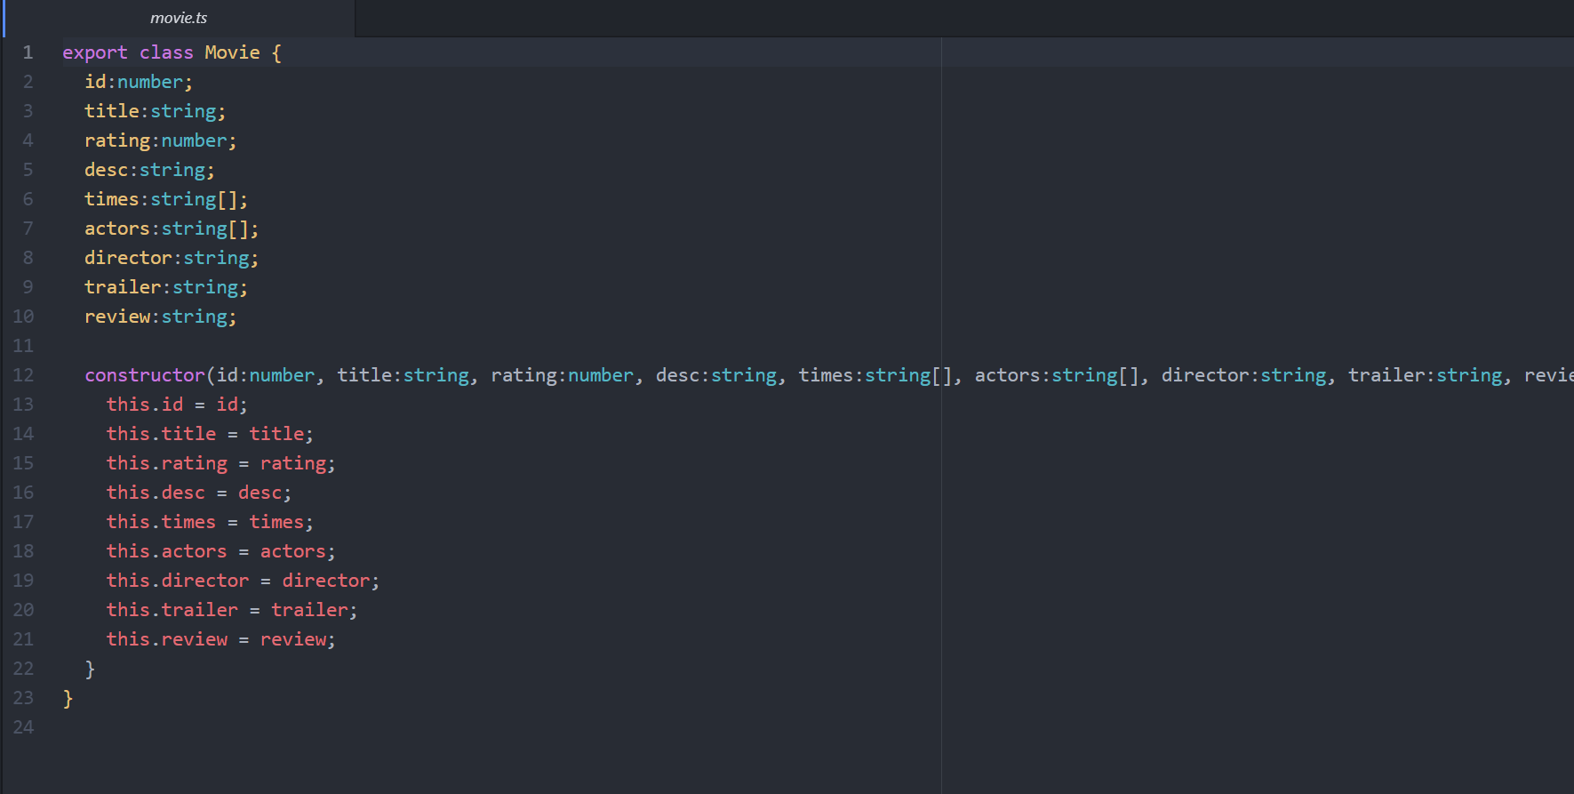

One other thing I decided to do was to separate the TypeScript files and the JavaScript that they were converted to, this was to reduce any confusion as to which files I would edit and work on.

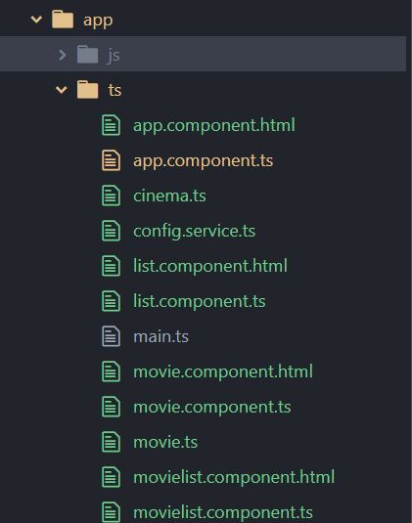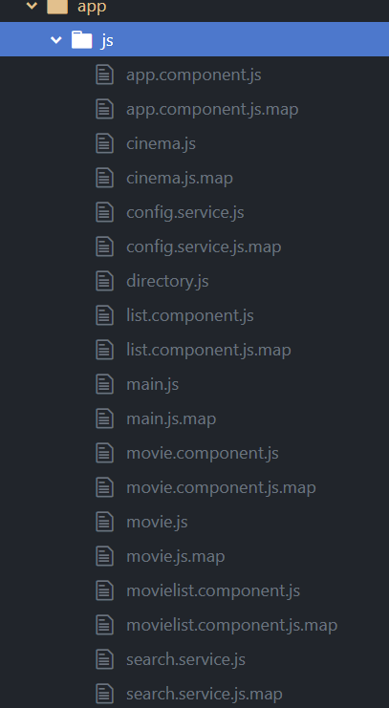

## Movielist Component

I then created a movielist component to display all the movies on the actual web page. This included both a html file and a TypeScript file, I also created a movie component html and TypeScript file. These files all worked together to create the movie list and to display them to the web page. Additionally, the movielist html and TypeScript files made it so that when the movie is clicked it would notify the console, this was originally intended to just be a method of testing whether clicking the movie was functional or not but unfortunately, I was never able to make anything more than that. 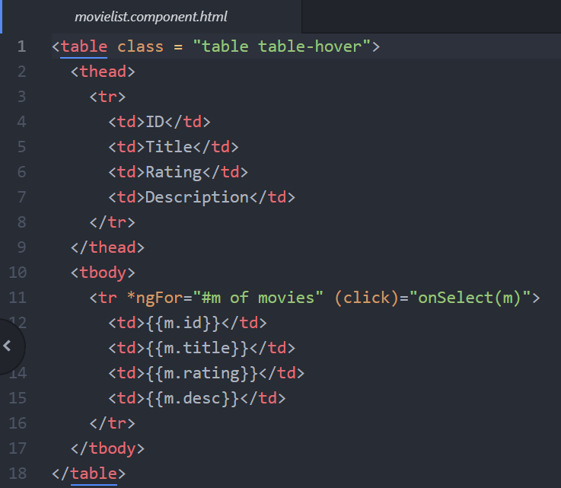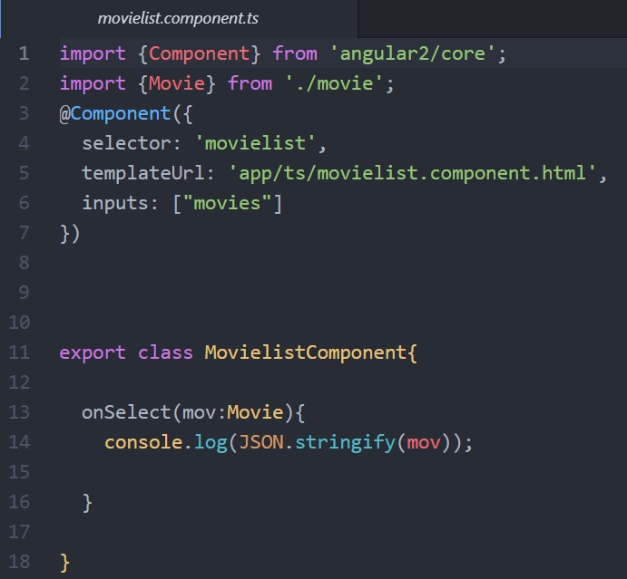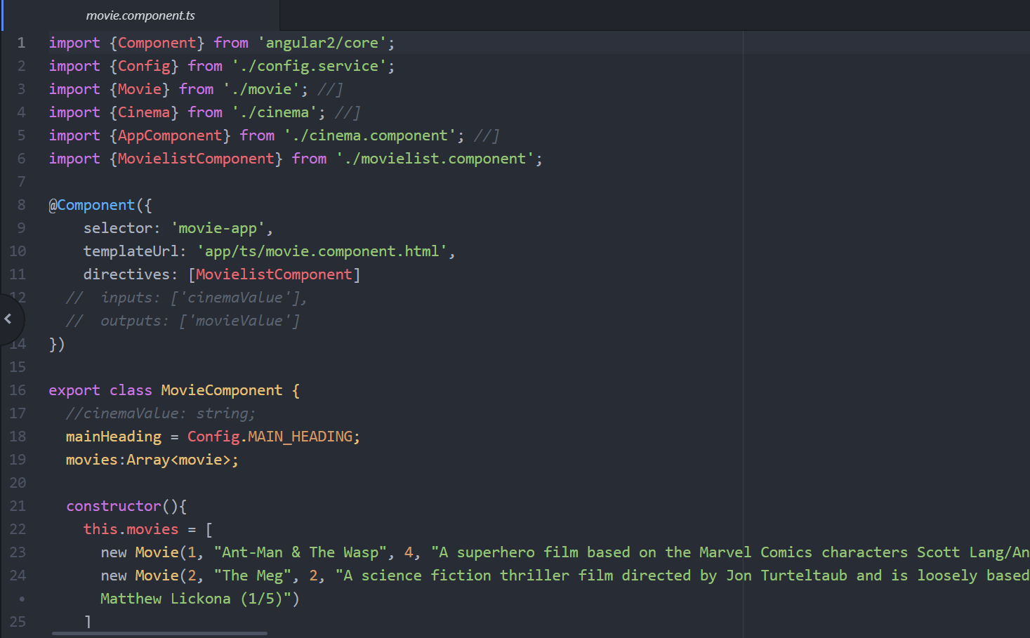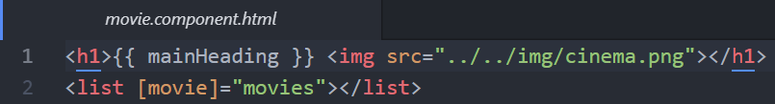

## Cinema Class

After that I decided to create a class for the cinemas. I only created it with a name, ID number and county. I intended on adding the movie component as an attribute, however, I found it difficult to accomplish this. I attempted using either inputs or outputs to link the two classes, but this did not seem to work in the way that I thought it would. The cinema class ended up with just the three attributes in the end.

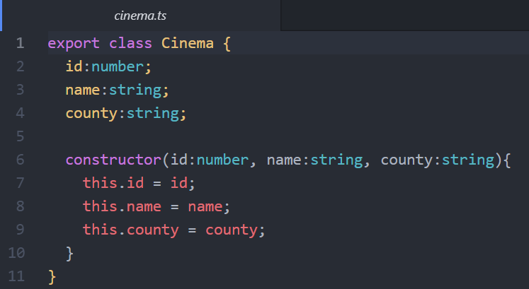

## List & App Component

Similarly, to the movie class I then made both a list component html and TypeScript file, as well as, what I called an app component html and TypeScript file. Their goal was to display the movie class to the web page and also construct the class component. The app component html file also displayed a drop-down option list that displayed all thirty-two of the counties in Ireland. However, I was unable to make so that the county selected would display the cinemas only in that county. I attempted using an if statement or a while statement that would check if the selected value equalled the county value assigned to the cinema, but this proved to be more difficult than I had anticipated. Similar to the movie class whenever the cinema was clicked a message would be sent to the console saying which cinema was selected. The original plan was for this to simply be a test to see if it was functional and that actual goal was that when the cinema was clicked it would display all the movies being displayed in that cinema. Due to the fact that I could not linked the movie and cinema class I was unable to make it so that specific movies would be displayed when the cinema was clicked. 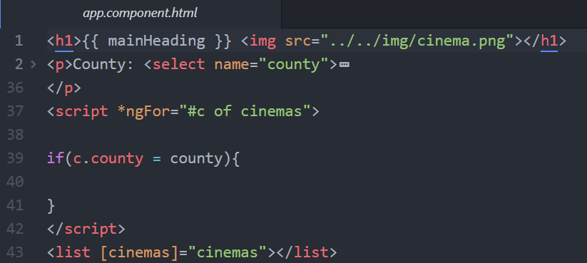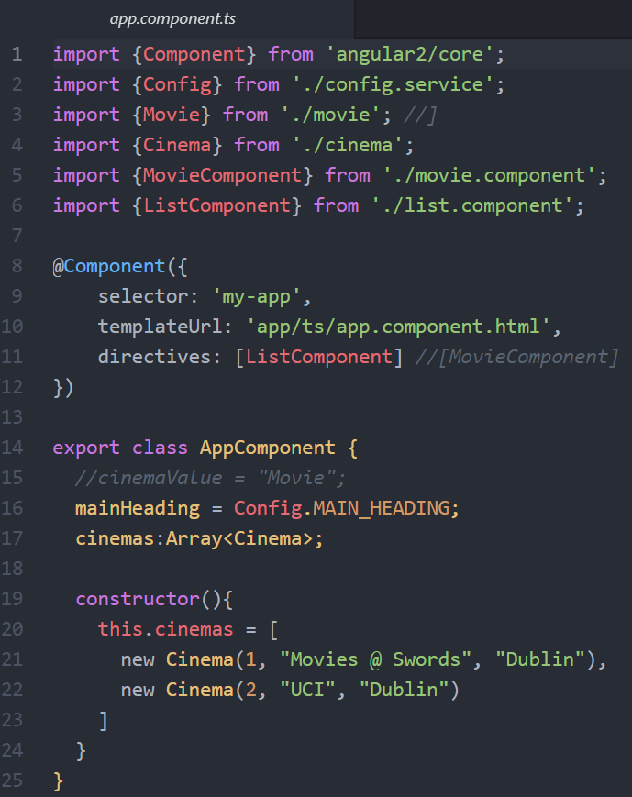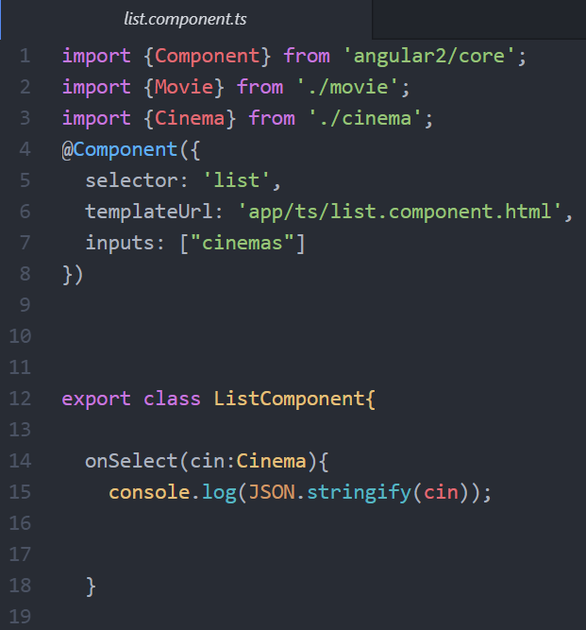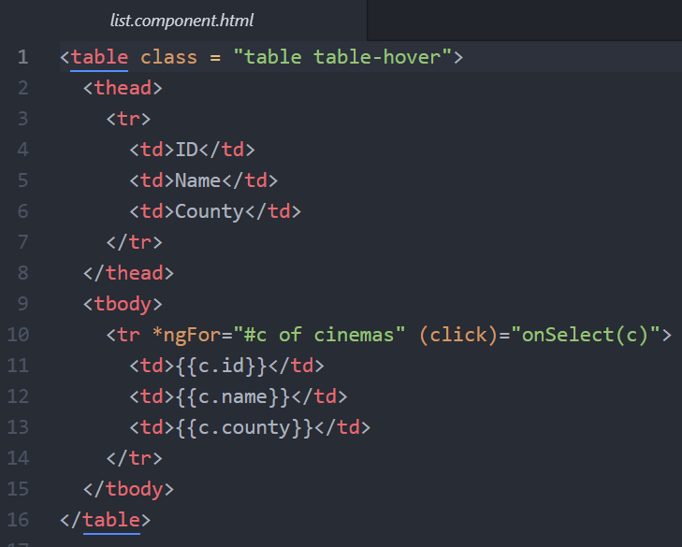

## CSS & Index Page

Furthermore, I decided to create a CSS (Cascading Style Sheets) file to make the web page look more appealing. Adding a little cinema icon and separating the background, table and heading though colours. I also added curved edges to the borders to make it look less unprofessional.

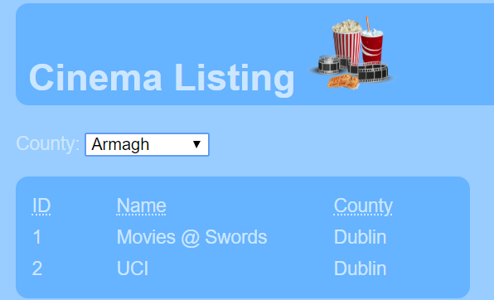

# What I Have Learnt

Although, it appears that I did not learn a lot from this assignment it is actually more the contrary. Before this assignment I had a very poor grasp of Angular 2 and TypeScript, I even struggled with some basic JavaScript (although it was not needed to be directly coded in this assignment). By watching online tutorials and reading lecture notes I was able to understand how to create components and their functions in Angular. I also learned about how to write TypeScript code and I am now more comfortable with using TypeScript. Although it seems quite simple, I now understand the importance of the package.json file and how npm install works, how they work together to download any needed dependencies for the project. Although it was not used heavily throughout my project I also understand bootstrap some amount more than I did before the assignment. However, I still do not fully understand data binding, more specifically two-way data binding, but I do understand it a lot more than I did before the project and I have a strong grasp of it’s benefits. Overall, I believe I benefited completing this assignment and I am under the impression that my skills with Angular 2 and TypeScript have improved exceptionally from creating this single page web application. Although I did struggle to come to grips with Angular 2 I do believe I am more adept at handling it now.