Lab 08

- Required
  - Download sample code from Lab 06, Lab 07 and Lab08
  - Add UI Components that Enhance Gameplay / Immersion
  - Implement an Immersive Gameplay Effect
- Sample Screen
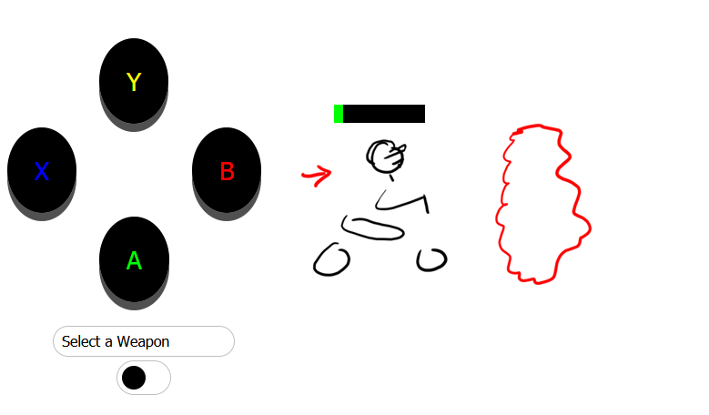
- Rubric
0 - 35 Basic Attempt
35 - 75 Intermediate Requirements as Published
75+ Expert mark with immersive engaging UI Component

