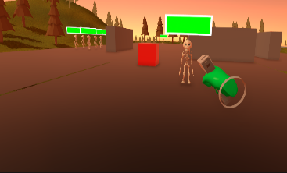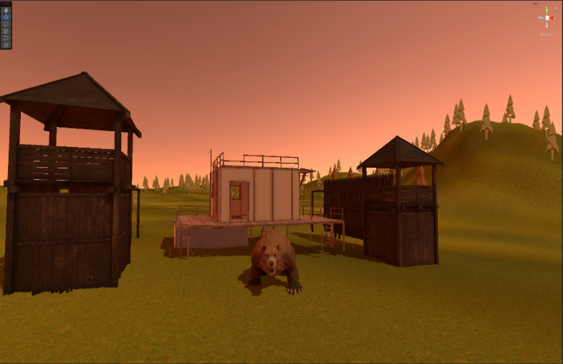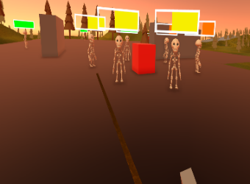

The player has found themselves stuck in a treacherous wasteland where they must find and repair a vehicle all while ruthless enemies are roaming the area. The player must scavenge for various resources such as consumables, ammo and vehicle parts. The player must use their wits and whatever weapons they can find to defend themselves against these enemies to stay alive and escape.

The game has many different technical features, by using Behaviour Trees for my enemy AI, it allows me to have more ‘smart’ behaviour for the AI. I’m also using random generation for the terrain so that each playthrough is different from the last.

Find me on my socials below!

[Link Tree](https://linktr.ee/adammcguigan?utm_source=linktree_profile_share&ltsid=98770f09-0d20-4016-9ff2-f446629eecc3)

d

**Adam Mcguigan**

**After Dusk - VR Survival Game**

**Adam Mcguigan**