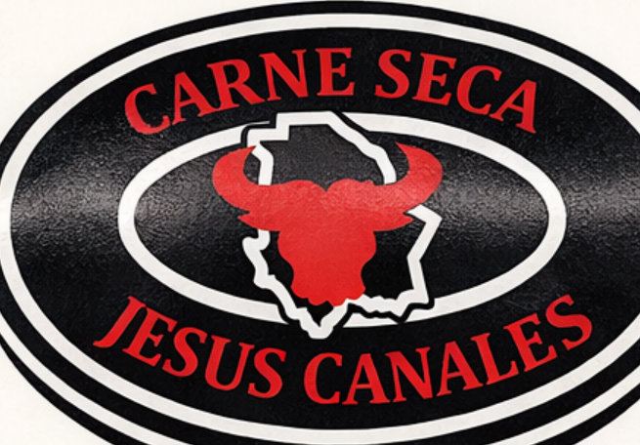
HACCP PLAN
Heat-treated, shelf-stable, ready-to-eat beef jerky
Carne Seca Jesus Canales, LLC
411 E Main St, Delta, UT 84624
(435) 406-1178
Process category: Heat-Treated — Shelf Stable. 9 CFR 417.2(b)(1)(vi).
Equipment: the establishment’s gas oven. The oven vent stays open.
This plan replaces the returned May plan.
1. What this plan is
This plan is for the beef jerky made at this plant, in this gas oven. The meat is cooked while it is still moist, inside a sealed moisture-impermeable bag. The bag is then opened and the same oven dehydrates the meat. The finished jerky is ready to eat and shelf-stable.
A lot is released when the critical-control-point records meet the limits in Section 6 and the pre-shipment review is signed. A finished-product laboratory test is not the release step. The scientific reasons for the numbers are in the companion document, Scientific Support for the Critical Limits. That document names the hazard, the number, and the page the number comes from.
The May plan was returned because the critical limits were not tied to a stated criterion. Its cooking limit was 160°F with no come-up time, no moisture criterion, and no page citation. This plan keeps 160°F as the internal temperature and adds the two criteria Appendix A requires with that table: come-up time, and moisture maintained in a sealed bag. Drying is its own critical control point.
2. Charts
Chart 1 is the process. Chart 2 is the limits. Both are the same numbers as Section 6.
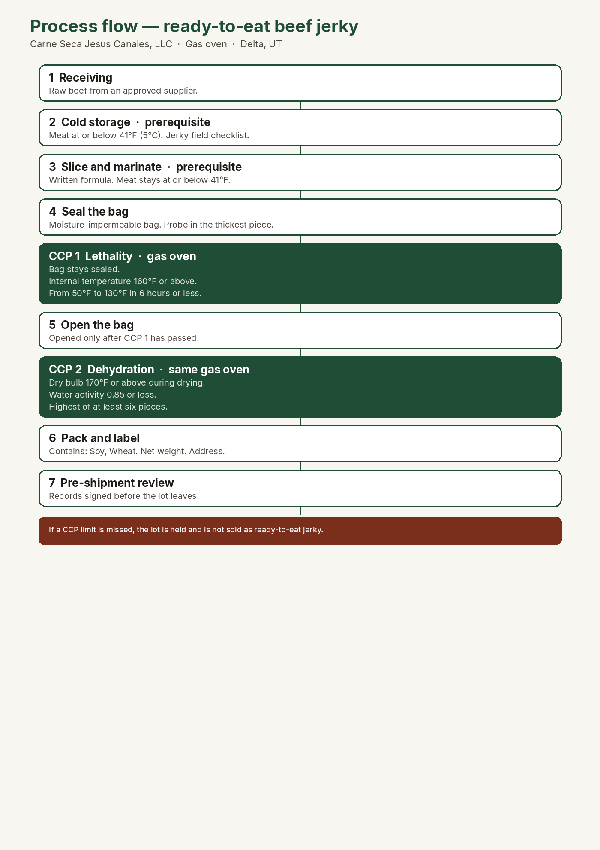
Chart 1. Process flow.
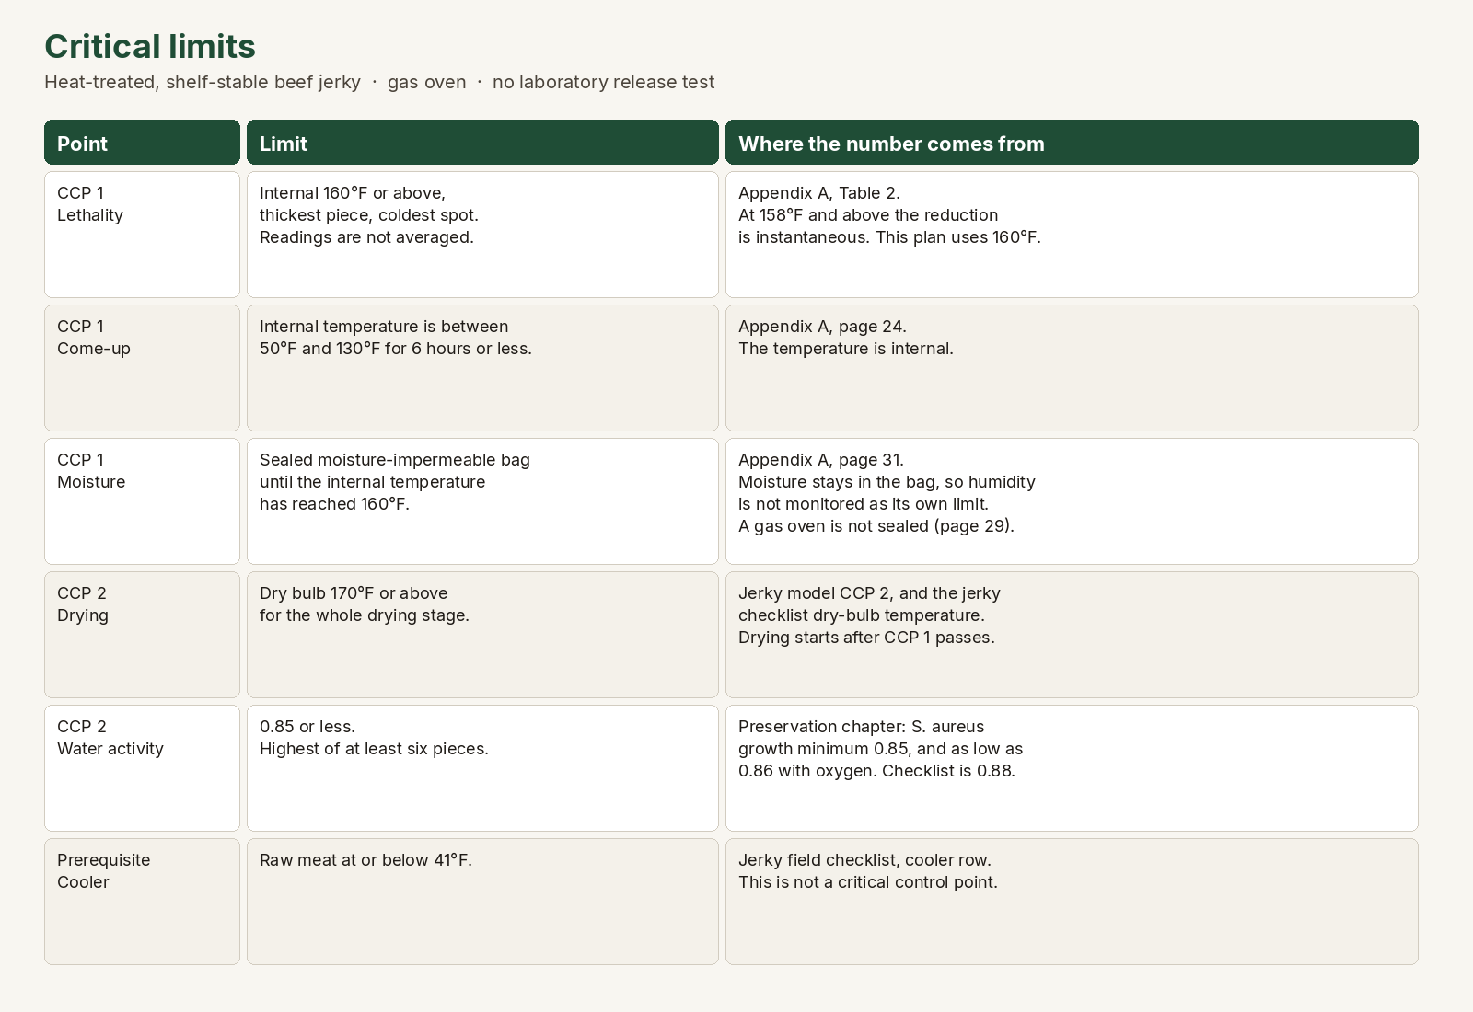
Chart 2. Critical limits and the criterion for each number.
3. Product description
Item | This product
Name | Beef jerky (carne seca). Ready to eat. Heat-treated. Shelf-stable. The bag may also say Traditional Beef Jerky.
Process | Whole-muscle beef, sliced, marinated, sealed in a moisture-impermeable bag, cooked in the gas oven to an internal temperature of 160°F or above, then dehydrated in the same oven to a water activity of 0.85 or less.
Equipment | Gas oven. The burner vent stays open, so the oven is not a sealed oven. Appendix A, page 29, says the sealed-oven humidity method is not used when an opening cannot be closed.
Water activity | Finished jerky: 0.85 or less.
pH | Not a control. This jerky is not fermented and is not acidified.
Cure | Uncured. No nitrite, no nitrate, no erythorbate.
Intended use | Ready to eat by the general public. No further cooking. 9 CFR 417.2(a)(2).
Package | Heat-sealed food-grade bag. The bag states the net weight of the jerky in that bag. The retail unit used on the returned plan is 3 oz (85 g).
Storage on the bag | Unopened: cool, dry, at or below 70°F (21°C). Once opened: refrigerate and consume within 3 days. Safety of the unopened jerky is the water activity of 0.85 or less, not the 70°F line.
Shelf life | The number of days is written here after this plant’s own holding records support it: __________ days.
Where sold | Local retail, markets, and direct sale to household consumers.
Allergens | Soy and wheat, from Worcestershire sauce and soy sauce. Every bag says Contains: Soy, Wheat.

3.1 Ingredients — the same list as the bag
Beef, sea salt, garlic powder, onion powder, black pepper, paprika, Worcestershire sauce (vinegar, molasses, corn syrup, water, soy sauce (water, soybeans, wheat, salt), onion, garlic, cloves, tamarind, natural flavor), soy sauce (water, soybeans, wheat, salt), apple cider vinegar, liquid smoke.
Contains: Soy, Wheat.
Salt is for flavor. It does not replace the cook or the water-activity limit. No ingredient is added after the bag is opened. A batch whose weights do not match the batch sheet for this list is not cooked.
3.2 Label
• Product name includes Beef Jerky. English is required. “Carne seca” may be added.
• Ingredient statement matches Section 3.1, in descending order of predominance.
• Contains: Soy, Wheat.
• Net weight, the inspection legend and establishment number, the address 411 E Main St, Delta, UT 84624, and a handling statement consistent with a ready-to-eat product.
• The word “Traditional” is on the current artwork. Before that artwork is used under inspection, the establishment confirms whether the word is a special statement or claim that requires sketch approval under 9 CFR 412.1(c). A bag with no special claim is generically approved under 9 CFR 412.2 when every required feature is present and true.
• The safe-handling label for raw meat is not used. This jerky is ready to eat.
• The name “jerky” has a standard of identity. The moisture-to-protein ratio is 0.75:1 or less. That ratio is checked on validation lots for the name on the bag. It is not a critical limit.
Before a lot ships, the packer checks the bag against the batch sheet. A bag that fails that check is not sold.
4. Process steps
Step | What happens
1. Receiving | Raw beef enters from an approved supplier.
2. Cold storage | The meat is held at or below 41°F. This is a prerequisite.
3. Slicing | Whole muscle is sliced. Bone and foreign material are removed by looking at the meat.
4. Marination | The formula in Section 3.1 is weighed onto the batch sheet. The meat stays at or below 41°F.
5. Bag | Strips go into a moisture-impermeable bag. A probe is placed in the thickest piece. The bag is sealed so moisture stays inside, including around the probe entry.
6. CCP 1 — Lethality | The sealed bag goes into the heated gas oven. The limits in Section 6 apply. Drying does not start until this step has passed.
7. Open | The bag is opened only after the internal temperature of 160°F or above is recorded.
8. CCP 2 — Dehydration | The strips are racked in the same gas oven. Dry bulb stays at 170°F or above. The lot is dried until water activity is 0.85 or less.
9. Cool and handle | Finished jerky is handled only in the clean ready-to-eat area. Bare hands do not touch it.
10. Pack and label | The bag is checked against Section 3.2.
11. Storage | Dry storage. The safety control is the water activity already met at CCP 2.
12. Pre-shipment review | The lot’s records are reviewed and signed before the lot ships.

The flow was walked in the plant on __________ by ______________________________.
5. Hazard analysis
9 CFR 417.2(a). A hazard that is controlled by a prerequisite, and is not reasonably likely to occur because of that program, is not a critical control point. Biological hazards at the cook and at drying are reasonably likely to occur and are the two critical control points.
Step | Hazard | CCP? | Reason
1 Receiving | Biological: pathogens on raw beef | No | Approved supplier. The cook is CCP 1.
2 Cold storage | Biological: outgrowth | No | Prerequisite. Meat at or below 41°F. Jerky checklist cooler row.
3 Ingredients | Chemical: soy, wheat; nitrite | No | The formula contains soy and wheat and no nitrite. The batch sheet and the label check control the allergen statement.
4 Packaging | Biological: contamination | No | Food-grade bags, stored clean and dry.
5 Slicing | Physical: bone, metal. Biological: contamination from people | No | Visual inspection while slicing. Employee health and hygiene prerequisite.
6 Marination | Biological: outgrowth. Chemical: wrong allergen statement | No | Held at or below 41°F. Weights match Section 3.1.
7–8 CCP 1 Cooking | Biological: STEC (O157:H7, O26, O45, O103, O111, O121, O145), Salmonella, L. monocytogenes | Yes | Raw beef may carry these organisms. The bag keeps the surface moist while the internal temperature reaches 160°F.
9 CCP 2 Drying | Biological: C. perfringens and C. botulinum while the meat is still moist; S. aureus toxin; L. monocytogenes in storage | Yes | Drying at 170°F or above, then water activity 0.85 or less.
10 Handle | Biological: L. monocytogenes after the cook | No | Sanitation SOP in the ready-to-eat area. Growth in storage is prevented by CCP 2, because 0.85 is below the 0.92 growth minimum.
11 Pack | Chemical: undeclared soy or wheat | No | Every bag is checked for Contains: Soy, Wheat before the lot ships.
12 Storage | Biological: growth | No | Water activity is already 0.85 or less.
13 Returns | Biological: unknown holding | No | Opened bags are not resold.

6. Critical control points
9 CFR 417.2(c). Every limit in a critical control point is required. The criterion for each number is named here and is set out page by page in the scientific-support document. 9 CFR 417.3: a miss identifies the cause, brings the point back under control, stops it from happening again, and keeps injurious product out of commerce.
6.1 CCP 1 — Lethality in the gas oven
The bag is sealed and the meat is still moist. Drying does not start until every CCP 1 limit has passed. The probe is in the thickest piece, in the coldest part of the load. That cold spot is confirmed during initial validation. Readings are not averaged.
Critical limit | Criterion | Monitoring, each lot
Internal temperature 160°F or above. | Appendix A, December 2021, Table 2, footnote 5. The required reduction is achieved instantly when the internal temperature reaches 158°F or above. This plan uses 160°F, which is above that line. The temperature is the minimum in the meat, not the oven air. | Time the probed piece reaches 160°F, the temperature read, the probe identity, and the place in the oven.
The internal temperature is between 50°F and 130°F for 6 hours or less. | Appendix A, page 24. Come-up time is an internal temperature. The meat enters from a cooler at or below 41°F, so it enters below 50°F. | Clock time the probed piece reaches 50°F and clock time it reaches 130°F. The difference is written in hours and minutes.
The moisture-impermeable bag stays sealed until the internal temperature is 160°F or above. | Appendix A, page 31. Cooking in a sealed moisture-impermeable bag keeps moisture around the product, so relative humidity is not monitored as its own limit. Page 29: this gas oven cannot use the sealed-oven method. | The seal is checked when the bag enters the oven and again at the 160°F reading. The time the bag is opened is written. It is not opened before that reading.

Who monitors: the person running the oven, named on the log.
If any CCP 1 limit is missed: the lot is stopped and Jesús Canales is told. The lot is held. It is not opened for dehydration and it does not ship. The cause is written. The oven or the bag practice is corrected before the next lot. Product that missed the cook is not sold as ready-to-eat jerky. A laboratory test is not the release step.
The cook may continue inside the same sealed bag only when the piece can still reach 160°F and the time between 50°F and 130°F is still 6 hours or less. Appendix A states that a come-up clock does not start over when the first cook did not reach a lethal temperature. If that time is already over 6 hours, the lot is not released under this plan.

6.2 CCP 2 — Dehydration
This step starts only after CCP 1 has passed. The bag is opened and the strips are racked so the gas oven can dry them.
Critical limit | Criterion | Monitoring, each lot
Dry-bulb temperature 170°F or above during drying, read before the jerky is taken out. | The jerky field checklist prints a dry bulb above 170°F (77°C). The FSIS beef-jerky model, CCP 2, uses an oven temperature of 170°F or above so Clostridium perfringens and Clostridium botulinum do not grow while water activity is still above 0.93. That model cites the FSIS Stabilization Guideline, Revised Appendix B, December 2021. The checklist’s wet-bulb line is not a limit in this plan. Appendix A, page 27, says a wet bulb of 125–130°F for one hour is not, by itself, the humidity support for Appendix A. | Dry-bulb reading during drying, thermometer identity, and the time.
Finished water activity 0.85 or less. At least six pieces, from different places in the lot, including a thick piece. The highest reading is the lot result. Every piece checked is 0.85 or less. | Principles of Preservation of Shelf-Stable Dried Meat Products: the aerobic growth minimum for Staphylococcus aureus is 0.85, and it can grow as low as 0.86 when oxygen is present. The same table gives Escherichia coli O157:H7 a minimum of 0.95, Salmonella 0.94, Listeria monocytogenes 0.92, and Clostridium perfringens and proteolytic Clostridium botulinum 0.93. The jerky checklist prints water activity below 0.88. A result of 0.85 or less meets that sheet. The jerky section of the preservation chapter says safety is judged by water activity, not by the moisture-to-protein ratio. | After drying, before packing. Calibrated water-activity meter. All six readings are written. The highest is circled.

Who monitors: the person running the oven, named on the log.
If the dry bulb is below 170°F, or if any of the six readings is above 0.85: the lot is not packed. Jesús Canales is told. If CCP 1 passed, the lot may be dried longer at 170°F or above and measured again. If it still fails, it does not ship. It is not wetted and cooked again under this plan.
7. Prerequisite programs
These programs are part of the HACCP system. They are not critical control points. A failure is corrected under the program and recorded. If a failure creates an unforeseen hazard, 9 CFR 417.3(b) applies: the product is held, the cause is found, injurious product does not ship, and a trained person reassesses whether the hazard belongs in the plan.
• Cold storage. Raw beef for this jerky stays at or below 41°F (5°C), measured in the meat. The jerky field checklist prints this cooler limit. The FSIS model’s example prerequisite is below 45°F. This plan uses 41°F.
• Employee health. The establishment uses the FDA Employee Health Policy Tool (2022 Food Code, part 2-201; tool dated August 23, 2023) for restriction and exclusion of ill employees. A person who is ill does not handle meat or jerky. Hands are washed. Bare hands do not touch finished jerky. This tool does not set a critical limit.
• Sanitation SOP, 9 CFR 416. After the bag is opened, jerky is handled only in the clean area. The sanitation SOP names Alternative 2 of 9 CFR 430.4: the finished water activity of 0.85 or less is the antimicrobial process that prevents growth of Listeria monocytogenes, together with sanitation in the ready-to-eat area. The food-contact-surface testing frequency required for that alternative is written in the sanitation SOP before a lot ships.
• Allergens. The batch sheet lists soy and wheat. The pack-out check confirms the bag says Contains: Soy, Wheat.
• Thermometers and the water-activity meter are checked by the method in Section 9.5. An instrument that fails calibration is removed, and the lots checked with it since the last good calibration are reviewed.
The curing-and-smoking field checklist is not a prerequisite for this jerky and is not support for these limits. This product is not brine-cured, is not dry-cured, and is not hung to dry before a smoke schedule. That checklist was read so the wrong process would not be copied into this plan.
8. Verification and records
• Initial validation, 9 CFR 417.4(a)(1). The scientific support is the companion document and the pages it cites. The in-plant part is repeated lots on this gas oven, this load, and this thickness, showing that CCP 1 and CCP 2 were met and showing the cold spot. The validation date below stays blank until those logs have been reviewed.
• Ongoing verification. Each production week, a person other than the monitor watches one CCP check when product is being made. Thermometers are checked in ice water at 32°F. The water-activity meter is checked with the manufacturer’s standards. Records are reviewed before shipment.
• Reassessment, 9 CFR 417.4(a)(3). At least once a year, and when the oven, the bag, the formula, the thickness, or the load changes. The responsible official signs the reassessment.
• Pre-shipment review, 9 CFR 417.5(c). Before the lot ships, a person reviews that lot’s records, writes that every critical limit was met or that the corrective action is finished, and signs and dates the review. Where practical, that person did not produce the record. The lot does not ship until this review says it may ship.
• Records, 9 CFR 417.5. Each record shows the plant, the date, the product, the lot, the actual number measured, the initials of the monitor, and the review. Shelf-stable product records are kept for at least two years.
• Training, 9 CFR 417.7. At least one person has completed training in the seven HACCP principles for meat and poultry. Name: ______________________________ Date of training: ______________.
8.1 Signature — inspection item 1
9 CFR 417.2(d). The responsible official signs before the plan is used. The signature is in ink. A typed name is not the signature. The same person signs the scientific-support document on the same day. The plan is signed again at least once a year and whenever it is changed.
I am the responsible establishment official of Carne Seca Jesus Canales, LLC. I have reviewed this HACCP plan for ready-to-eat beef jerky made in this gas oven. Signing accepts the hazard analysis, the critical limits, the monitoring, the corrective actions, the verification, and the records in this plan.
Signature, Jesús Canales: ______________________________________________
Printed name: ______________________________________________
Date: ______________________________________________
Initial validation completed (blank until Section 13 is reviewed): ______________________________________________
Annual reassessment: ______________________________________________
9. How to measure each limit
Three instruments are used. A leave-in probe thermometer stays in the meat. A second thermometer hangs in the oven air during drying. A water-activity meter reads the finished jerky. The oven dial is the setting. The number written on the log is the number on the instrument.
9.1 Cold meat, before cooking
Put the probe in the meat, not in the air of the cooler. Write the time and the temperature on Form 10.3. The limit is 41°F or below.
9.2 Lethality — the probe stays inside the sealed bag
Choose the thickest strip and place it in the part of the oven that heats last. Put the tip of the probe in the center of that strip. The tip does not stick out into the air and does not touch the rack. Seal the bag around the probe cable so moisture stays in the bag. The bag is not opened to read the temperature.
On Form 10.1, with that same probe, write the clock at three points.
When the meat reads | What is written
50°F | The clock time.
130°F | The clock time.
160°F or above | The clock time and the exact temperature.

Come-up time is the 130°F clock time minus the 50°F clock time. Example: 50°F at 8:00 and 130°F at 10:30 is 2 hours 30 minutes. The limit is 6 hours or less. If the bag is still sealed when the meat reaches 160°F, the cook has passed. Write the time the bag is opened. If the bag is opened before that reading, the lot is held.
9.3 Drying — oven air, after the bag is opened
Hang a thermometer in the oven air, away from the wall, not stuck in the meat. Before the strips are taken out, read that thermometer. The limit is 170°F or above. Write the degrees and the time on Form 10.2.
9.4 Water activity — before packing
The meter reads a number between 0 and 1, such as 0.81. A meter that reports only percent moisture is not this instrument.
Let the pieces cool, covered, to the temperature in the meter’s manual. Most meters read correctly near 77°F. A strip just out of a 170°F oven gives a false reading.
Take six strips from different places: front, middle, back, top rack, bottom rack, and one thick piece. Place each piece in the sample cup the way the manual describes. Write all six readings on Form 10.2. The lot result is the highest reading. If that reading is 0.85 or less, the lot passes. If any one reading is above 0.85, the lot is not packed.
9.5 Checking the instruments
Once each week that jerky is made:
• Probe. A glass of ice with a little water. The probe stays in the ice water and does not touch the glass. It must read 32°F. If it does not, adjust it by the manufacturer’s instructions or remove it from use.
• Water-activity meter. Use the salt standards supplied with the meter.
An instrument that fails the check is not used. Lots measured with it since the last good check are reviewed.
9.6 Measurements that are not taken on every lot
A Listeria swab is taken from tables, trays, and any surface that touches the jerky after the bag is opened. The swab goes to a laboratory. It is not a test of the bag of jerky. Moisture and protein, for the name “jerky,” are sent once on the validation lots. Neither result releases the lot. The lot is released by the probe, the clock, the dry-bulb thermometer, and the water-activity meter.
9-A. Cómo medir cada límite
Esta sección es la misma instrucción, para la persona que opera el horno. Los límites siguen siendo los de la sección 6.
Se usan tres instrumentos. Una sonda se queda dentro de la carne. Otro termómetro cuelga en el aire del horno durante el secado. Un medidor de actividad de agua lee el producto terminado. La perilla del horno es el ajuste. El número que se anota es el del instrumento.
• Frío. La sonda va en la carne, no en el aire del refrigerador. Límite: 41°F o menos. Hoja 10.3.
• Cocido. La tira más gruesa va en la parte del horno que se calienta menos. La punta de la sonda queda en el centro de esa tira, sin salir al aire y sin tocar la rejilla. La bolsa se cierra alrededor del cable. No se abre para ver la temperatura.
• En la hoja 10.1 se anota la hora a 50°F, la hora a 130°F, y la hora y los grados al llegar a 160°F o más. El tiempo de subida es la hora de 130°F menos la hora de 50°F. Ejemplo: 8:00 y 10:30 son 2 horas 30 minutos. Límite: 6 horas o menos. Si a 160°F la bolsa sigue cerrada, el cocido pasó. Se anota la hora en que se abre. Si se abre antes, el lote se detiene.
• Secado. Un termómetro cuelga en el aire del horno, lejos de la pared, sin clavarlo en la carne. Se lee antes de sacar las tiras. Límite: 170°F o más. Hoja 10.2.
• Actividad de agua. El aparato marca un número entre 0 y 1, por ejemplo 0.81. No sirve un medidor que solo dé el porcentaje de humedad. Las piezas se enfrían tapadas hasta la temperatura del manual, casi siempre cerca de 77°F. Una tira a 170°F da una lectura falsa. Se toman seis tiras: adelante, en medio, atrás, rejilla de arriba, rejilla de abajo, y una gruesa. El resultado del lote es la lectura más alta. Si es 0.85 o menos, pasa. Si una marca más de 0.85, no se empaca.
• Cada semana de producción: la sonda en hielo con un poco de agua, sin tocar el vaso, tiene que marcar 32°F. El medidor de actividad de agua se comprueba con las sales del fabricante. Si un aparato falla, no se usa, y se revisan los lotes medidos desde la última prueba buena.
• El hisopo de Listeria es de mesas, charolas y superficies que tocan la carne después de abrir la bolsa. Va al laboratorio. No es un análisis de la bolsa. Humedad y proteína, para el nombre “jerky”, se mandan una vez en los lotes de validación. El lote lo sueltan la sonda, el reloj, el termómetro del aire y el medidor de actividad de agua.
10. Forms
10.1 CCP 1 log — lethality
Lot __________ Date __________ Oven __________ Probe __________
Bag sealed on entry: yes / no. Probe in the thickest piece: yes / no. Cold-spot location: __________
Reading | Clock time | Internal °F | Initials
Internal temperature reaches 50°F
Internal temperature reaches 130°F
Come-up (130 minus 50), hours and minutes. Limit: 6 hours or less.
Internal temperature reaches 160°F or above
Bag still sealed at that reading, then time opened

Limit met: yes / no. If no, lot held and Form 10.4 is completed. Reviewer __________ Date __________
10.2 CCP 2 log — dehydration
Lot __________ Date __________ Dry-bulb thermometer __________ Water-activity meter __________
CCP 1 passed before the bag was opened: yes / no.
Dry bulb during drying: __________ °F. Limit: 170°F or above. Time read: __________
Piece | Place in the lot | Water activity | Initials
1
2
3
4
5
6 (include a thick piece)

Highest reading: __________. Limit: 0.85 or less. Limit met: yes / no. Reviewer __________ Date __________
10.3 Cooler log — prerequisite, not a CCP
Date __________ Time __________ Product temperature __________ °F Limit: 41°F or less Initials __________
10.4 Corrective action
Lot __________ CCP __________ Date __________ Time __________
What was measured: ________________________________
Limit that was missed: ________________________________
Cause: ________________________________
Action that brought the point back under control: ________________________________
Action that keeps it from happening again: ________________________________
Disposition. The lot is held. It is not sold as ready-to-eat jerky unless every limit is met on the records. A laboratory test is not the release step.
Jesús Canales: ______________________________________________
10.5 Pre-shipment review
Lot __________ Date __________
• CCP 1: 160°F internal, come-up 6 hours or less, bag sealed until that reading.
• CCP 2: dry bulb 170°F or above, highest of six water-activity readings 0.85 or less.
• Bag says Contains: Soy, Wheat, and the ingredients match the batch sheet.
• Any corrective action is finished. No injurious product is in this shipment.
Reviewer signature and date: ______________________________________________
11. Documents kept with this plan
• Scientific Support for the Critical Limits, the companion to this plan.
• FSIS Cooking Guideline for Meat and Poultry Products (Revised Appendix A), December 2021, FSIS-GD-2021-14.
• Principles of Preservation of Shelf-Stable Dried Meat Products, October 31, 2011.
• HACCP Field Verification Checklist, Jerky (fully cooked, shelf-stable, ready-to-eat).
• FDA Employee Health Policy Tool, August 23, 2023, for the employee-health prerequisite.
• FSIS HACCP Model for Ready-to-Eat, Heat-Treated, Shelf-Stable Beef Jerky, 2021-0004, CCP 2, for the 170°F drying temperature.
• FSIS Stabilization Guideline (Revised Appendix B), December 2021, as cited by that model.
The curing-and-smoking checklist is on file as a document that was reviewed and not used. The returned May plan is on file as the plan this one replaces. Sections 12 through 16 complete the five items an inspector still checks before this plan can be used.
12. Item 1 — signature
The signature block is Section 8.1 of this plan and Section 6 of the scientific support. Both are signed in ink by Jesús Canales before the packet is sent. The validation date on that block stays blank until the three lots in Section 13 have been reviewed.
13. Item 2 — in-plant validation
9 CFR 417.4(a)(1). The scientific support is already written. The in-plant part is three lots on this gas oven, with the load and the strip thickness that will be used in production. A lot that misses a limit does not count. The cause is corrected before the next validation lot. The validation date is written only after all three lots meet every limit and Jesús Canales reviews the logs.
• Lot 1 also finds the cold spot. The same thick strip size is probed in three places in the oven: front, center, and back, or top, middle, and bottom if that is how the racks sit. The place that reaches 160°F last is the cold spot. It is written here: __________.
• Lots 2 and 3 use that cold spot and the thickest strip. Each lot completes Form 10.1 and Form 10.2.
• All three instruments in Section 16 have passed their checks before lot 1 starts.
Validation lot | Date | Load and thickness | CCP 1 met | CCP 2 met | Reviewer
1 (cold spot) |  |  | yes / no | yes / no
2 |  |  | yes / no | yes / no
3 |  |  | yes / no | yes / no

Cold spot found on lot 1: __________. Thickness used: __________. Validation date, filled only when all three lots passed: __________.
14. Item 3 — how this gas oven is run
The meat is not dehydrated until the cook in the sealed bag has passed. One lot follows these steps.
• Hold the raw beef at or below 41°F. Weigh the formula in Section 3.1 onto the batch sheet.
• Put the thickest strip in the cold spot. Place the probe in the center of that strip. Seal the moisture-impermeable bag around the meat and the probe cable.
• Put the sealed bag in the heated gas oven. Leave the burner vent as the oven requires. Do not treat this oven as a sealed oven.
• Write the clock at 50°F, at 130°F, and at 160°F or above. Open the bag only after 160°F is written and the come-up is 6 hours or less.
• Rack the strips so air can dry them. Keep the dry-bulb thermometer at 170°F or above. Read it before the strips come out.
• Cool six pieces, covered, to the meter temperature. Record the water activity. Pack only if the highest reading is 0.85 or less and the pre-shipment review is signed.
Para quien opera el horno: la carne no se seca hasta que la bolsa cerrada llegó a 160°F por dentro. La sonda se queda en la tira más gruesa. La bolsa se abre después de anotar 160°F y de comprobar que de 50°F a 130°F pasaron 6 horas o menos. Luego se seca a 170°F en el aire del horno y se miden seis piezas. Si la más alta pasa de 0.85, no se empaca.
15. Item 4 — Listeria sanitation program
After the bag is opened, the jerky is post-lethality exposed. This plant uses Alternative 2, Choice 2, of 9 CFR 430.4. The antimicrobial process is the finished water activity of 0.85 or less, which is below the 0.92 growth minimum for Listeria monocytogenes. Sanitation in the ready-to-eat area goes with that process. This section is the sanitation program the regulation requires for that choice.
15.1 Clean before the bag is opened
On each production day, before exposed jerky is handled, the person in charge looks at the racks, the table, the scale, and the utensils. They are clean to sight and touch. The result is written on the pre-operational line of Form 10.6. Jerky is not laid on a surface that fails that check.
15.2 Food-contact surface testing
The laboratory test is for Listeria spp. on food-contact surfaces. It is not a test of the jerky in the bag.
• Frequency. One sampling event in the first validation week, before a lot ships, and then one event each calendar quarter while jerky is made. There is one line.
• Why this frequency is enough. FSIS recommends quarterly food-contact testing per line for Alternative 2. This plant has one line. The finished water activity prevents growth of Listeria monocytogenes during storage. The first event is done before product ships.
• Sites, each event. (1) The rack or tray that holds jerky after the bag is opened. (2) The table where jerky is placed before packing. (3) The scale pan or the tongs that touch the jerky. If a glove or the sealer touches the meat, that surface is added.
• Size. Up to 12 inches by 12 inches of the food-contact area. If the surface is smaller, the whole food-contact face is swabbed.
15.3 When a swab is positive
A positive Listeria spp. result on a food-contact surface: packing stops, the lot in the room is held, the site is cleaned and sanitized, and the site is swabbed again before the next lot. If that second swab is positive, or if the laboratory reports Listeria monocytogenes, the held lot does not ship. Jesús Canales tells the inspector. The lot is not released by a finished-product laboratory test. Disposition is written on Form 10.4 and Form 10.6.
Date | Site | Area swabbed | Lab result | Lot held | Initials
 | Rack / tray |  |  | yes / no
 | Table |  |  | yes / no
 | Scale or tongs |  |  | yes / no

Form 10.6. Pre-operational check the same day: clean to sight and touch, yes / no __________. Person __________.
16. Item 5 — instruments on site
The first validation lot does not start until these three instruments are in the plant and the checks below are written. The oven dial is not one of the three.
Instrument | What it measures | Mark the ID | Check before use
Leave-in probe thermometer | Internal meat temperature, °F. It stays in the strip inside the sealed bag. | Probe __________ | Ice water reads 32°F. The probe does not touch the glass.
Oven-air thermometer | Dry-bulb temperature during drying, °F. It hangs in the air, off the wall, not in the meat. | Oven __________ | Ice water reads 32°F if the thermometer can be removed. If it is fixed, hold the calibrated probe in the oven air beside it and write both numbers. The probe is the record if they differ.
Water-activity meter | Finished jerky, a number from 0 to 1. It is not a percent-moisture meter. | Meter __________ | Salt standards supplied with the meter, in the week jerky is made.

An instrument that fails its check is not used. Lots measured with it since the last good check are reviewed. Form 10.7: date __________, probe 32°F yes / no, oven thermometer yes / no, water-activity standards yes / no, initials __________.
17. Example of a passing lot
The field checklist asks whether monitoring records exist. This section shows how one passing lot is written. Every line below is an example. It is not a lot produced at this plant. It does not validate the plan and it is not a signature. The blank forms in Section 10 are the ones used in production. Section 8.1 is signed in ink only after a real review.
Ejemplo nada más. Estos números no son un lote de la planta. No validan el plan y no sustituyen la firma.
17.1 Example — CCP 1, lot EX-001
Probe P-1. Cold spot: back, lower rack. Bag sealed on entry: yes. Thickest piece: yes.
Reading | Clock time | Internal °F
Reaches 50°F | 8:00 a.m. | 50
Reaches 130°F | 10:15 a.m. | 130
Come-up. Limit: 6 hours or less. | 2 hours 15 minutes | Met
Reaches 160°F or above | 10:42 a.m. | 162
Bag still sealed, then opened | Opened 10:43 a.m. | 162

Example result: every CCP 1 limit met. This page is not signed as a real review.
17.2 Example — CCP 2, lot EX-001
CCP 1 passed before the bag was opened: yes. Dry bulb during drying: 176°F at 2:10 p.m. Limit: 170°F or above.
Piece | Place in the lot | Water activity
1 | Front | 0.78
2 | Middle | 0.80
3 | Back | 0.81
4 | Top rack | 0.79
5 | Bottom rack | 0.82
6 | Thick piece | 0.81

Highest reading: 0.82. Limit: 0.85 or less. Example result: met. Cooler example the same morning: 38°F in the meat, at or below 41°F.
17.3 Example — pre-shipment review, lot EX-001
• CCP 1 met: 162°F internal, come-up 2 hours 15 minutes, bag sealed until that reading.
• CCP 2 met: dry bulb 176°F, highest water activity 0.82.
• Bag says Contains: Soy, Wheat, and the ingredients match the batch sheet.
A real pre-shipment review is signed on Form 10.5 for a real lot. Do not sign this example.

