

**Faculty of Engineering & Technology**

**Electrical & Computer Engineering Department**

**COMMUNICATION SYSTEMS ENEE3309**

**Prepared by:**

Adam Nassan 1202076

**Instructor:**

Dr. Ashraf Rimawi

**Section:** 3

**Date:** 22/1/2023

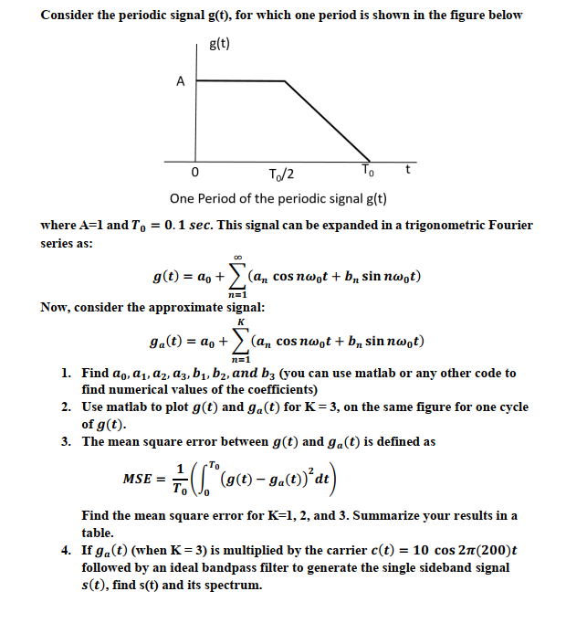

Solution for 1,2, and 3:

syms d x

T = 0.0001;

d= 0:T:0.1;

T0=0.1;

w0 = 2*pi/T0;

n = 1:100;

t1=0:T:0.05;

t2=0.05:T:0.1;

t=[t1 t2];

a01 = int(1,x,0,T0/2);

a02 = int(-20*x+2,x,T0/2,T0);

a0=1/T0*(a01+a02)

an = (2/T0)*(int(cos(n*w0*x),x,0,T0/2)+int((-20*x+2)*cos(n*w0*x),x,T0/2,T0))

bn = (2/T0)*(int(sin(n*w0*x),x,0,T0/2)+int((-20*x+2)*sin(n*w0*x),x,T0/2,T0))

ga_t=a0;

for c = 1:1:3

ga_t = ga_t + an(c)*cos(c*w0*t) + bn(c)*sin(c*w0*t);

end

g_t=a0;

gt=a0;

for c = 1:1:100

g_t = g_t + an(c)*cos(c*w0*t) + bn(c)*sin(c*w0*t);

gt = gt + an(c)*cos(c*w0*x) + bn(c)*sin(c*w0*x);

end

g1=a0 + an(1)*cos(w0*x) + bn(1)*sin(w0*x);

g2=a0 + an(1)*cos(w0*x) + bn(1)*sin(w0*x)+ an(2)*cos(2*w0*x) + bn(2)*sin(2*w0*x);

g3=a0 + an(1)*cos(w0*x) + bn(1)*sin(w0*x)+ an(2)*cos(2*w0*x) + bn(2)*sin(2*w0*x)+ an(3)*cos(3*w0*x) + bn(3)*sin(3*w0*x);

MSE1 = (1/T0)*vpa(int((gt-g1).^2,x,0,T0))

MSE2 = (1/T0)*vpa(int((gt-g2).^2,x,0,T0))

MSE3 = (1/T0)*vpa(int((gt-g3).^2,x,0,T0))

figure

plot(t,g_t)

hold on

plot(t,ga_t)

hold off

Q1:

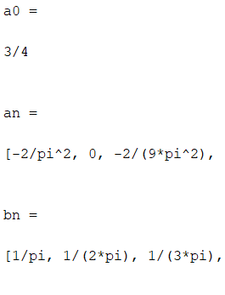

I got an and bn as an array so the first 3 elements in the screen represents a1,a2 and a3 and same for bn.

We noticed that an=0 for ---> even n –{0}

Q2:

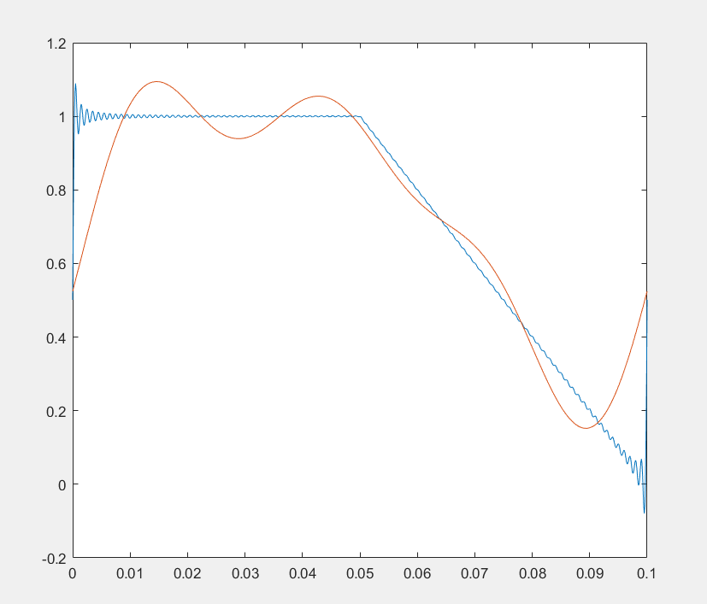

The red figure represents ga(t) for k=3.

And the blue figure represents g(t) for k=100 in the code because we can't do infinity in Matlab.

So we notice that the higher the value of k, the closer the graph is to g(t).

Q3:

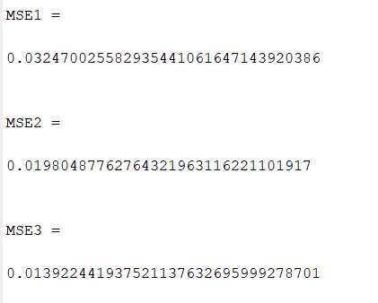

These are the three values of the mean square error.

We notice that the higher the value of k, the less value of MSE become, because as I said above the higher the of k the closer the graph is to g(t).

Q4:

