

**Faculty of Engineering & Technology**

**Electrical & Computer Engineering Department**

**Department of Electrical and Computer Engineering**

**ENCS3130-LINUX LAB**

**Python Project**

**Prepared by:**

Adam Nassan 1202076

Layth Abdalrazzaq 1190715

**Instructor:**

Dr. Mohammed Jubran

**Teacher Assistant:**

Eng. Ahed Mafarjeh

**Section:** 3

**Date:** 9/9/2023

**Table of Contents**

**Main Menu: -** 3

**Files used: -** 3

**Menu options** 4

1. Add Product (only admin) 4

2. Place an item on sale (admins only) 7

3. Update product (admin-only) 9

4. Add a new user (admin-only) 11

5. Update user (admin-only) 14

6. Display all users (admin-only) 16

7. List products (admin and shopper) 17

8. List shoppers (admin) 19

9. Add product to the basket (shopper-only) 21

10. Display basket (shopper-only) 23

11. Update basket (shopper-only) 24

12. Place order (shopper-only) 26

13. Execute order (admin-only) 27

14. Save products to a file (admin-only) 29

15. Save users to a text file (admin-only) 30

16. Exit (admin and shopper) 31

Important note: I ran the program multiple times while taking the screenshots to edit some parts, so in the report the changes from previous parts like adding updating or removing products or users may not be shown in the parts after.

# **Main Menu: -**

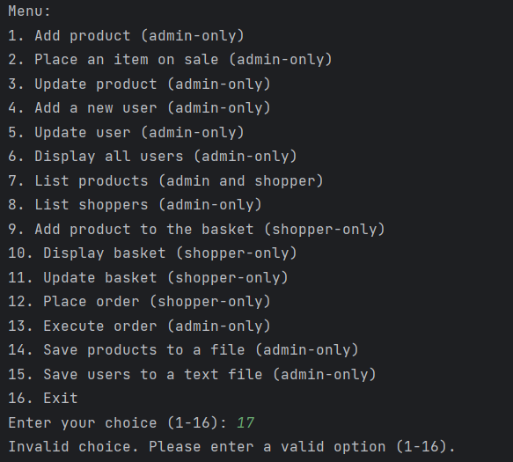

* Here when trying to enter a value not in the menu the program prevents you.

# **Files used: -**

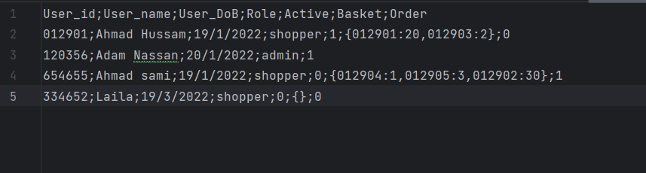

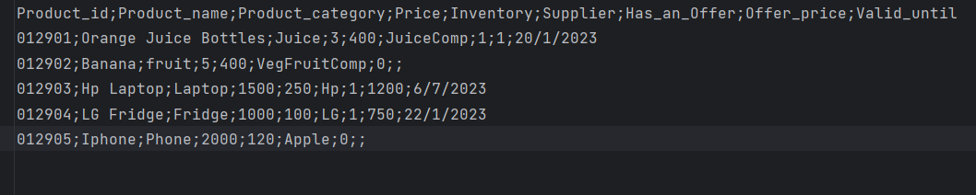

# **Menu options**

## Add Product (only admin)

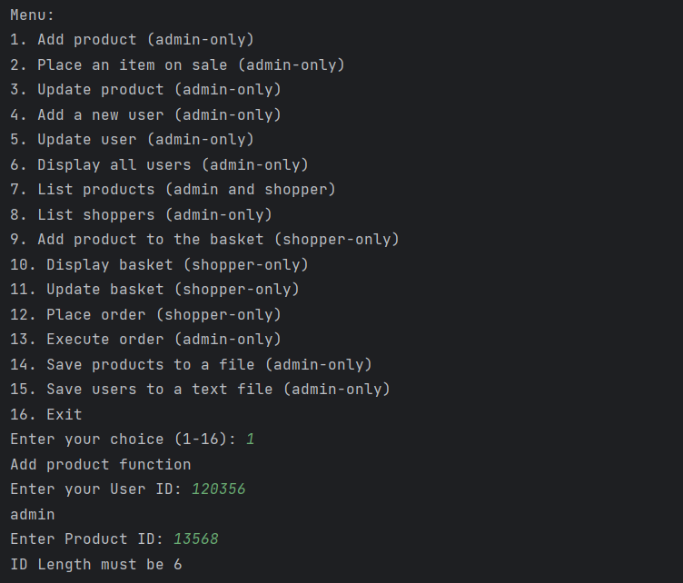

* ID must have length 6 condition.

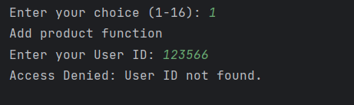

* Deny message for any user not in the list.

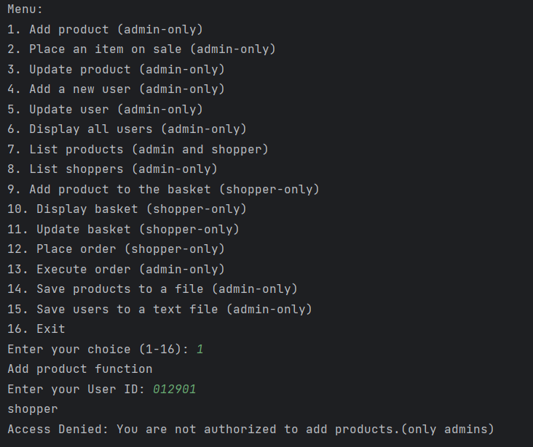

* Deny message when shopper try to do this option.

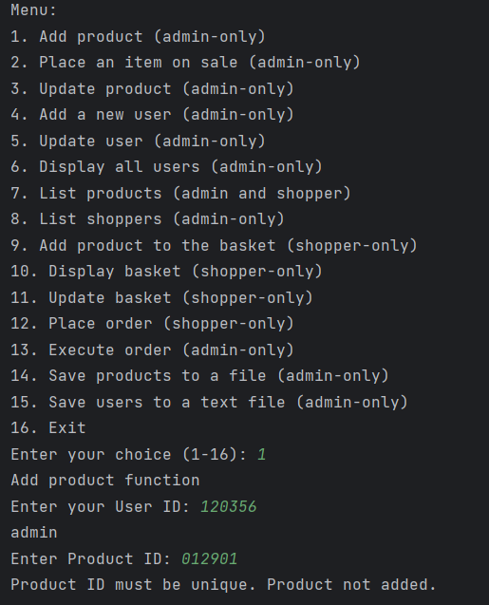

* Deny message when try to add product with same id of another product.

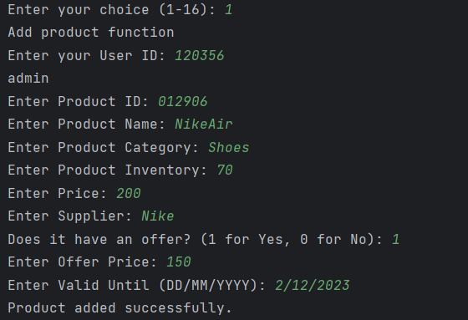

* Here we added this product

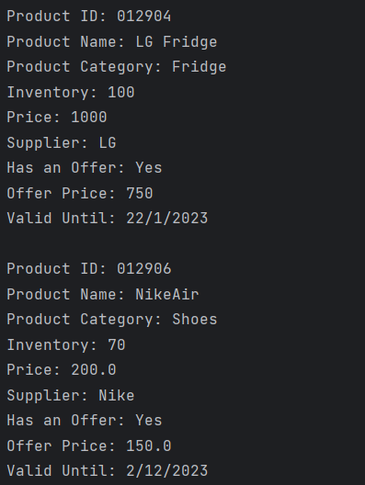

* When I listed the products, it has been added **successfully**.

## Place an item on sale (admins only)

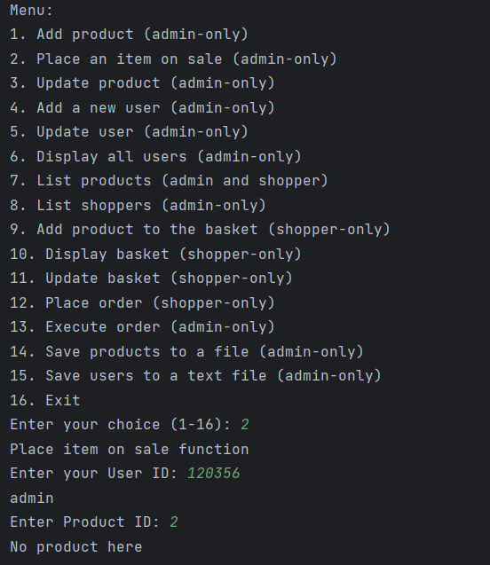

* When trying to enter a product id not in the list.

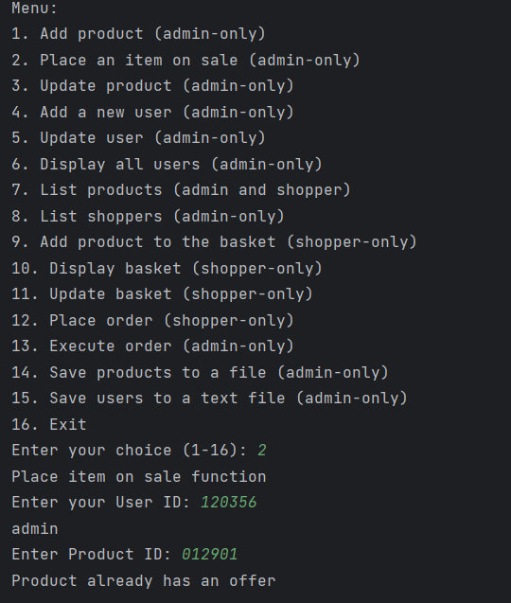

* When trying to place a product that already has an offer.

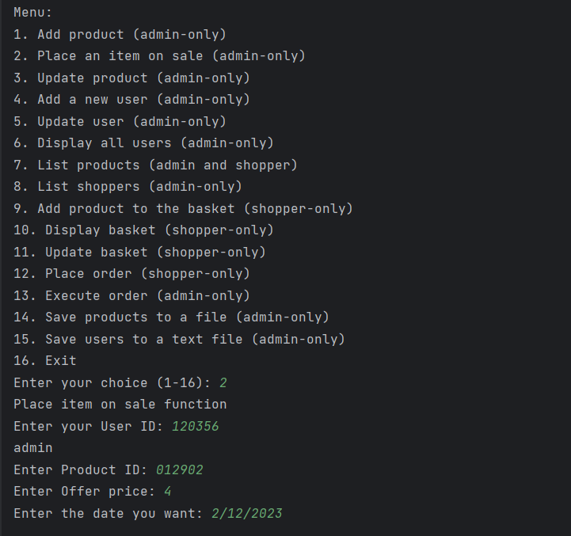

* Here we set offer for product 012902.

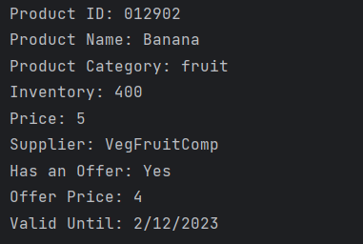

* When I listed the products offer set **successfully**.

## Update product (admin-only)

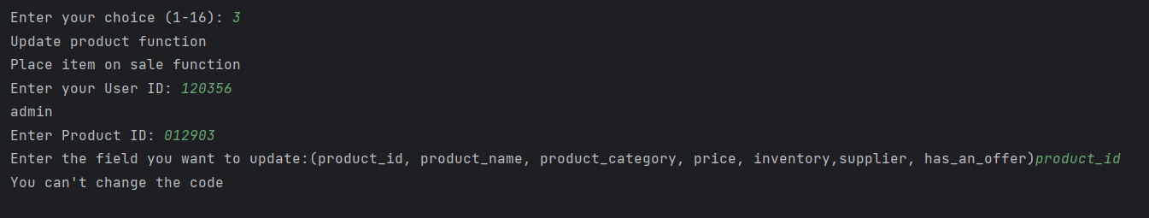

* Here the program prevents you from changing the product id

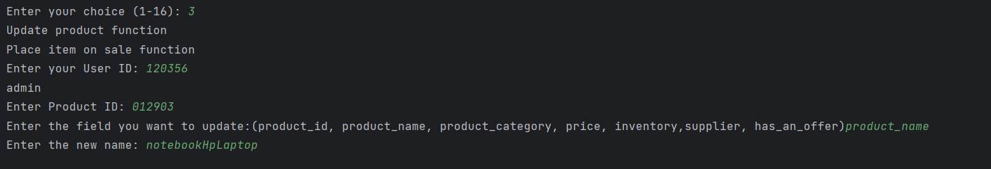

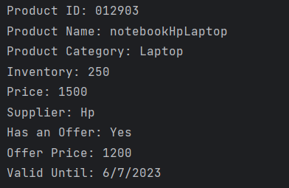

* Here the name changed **successfully**.

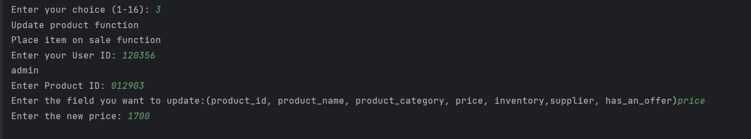

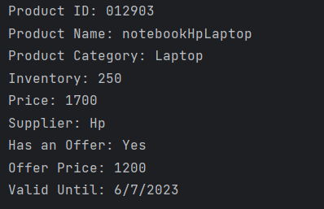

* Here the price changed **successfully**.
* And all other fields can be changed **successfully**.

## Add a new user (admin-only)

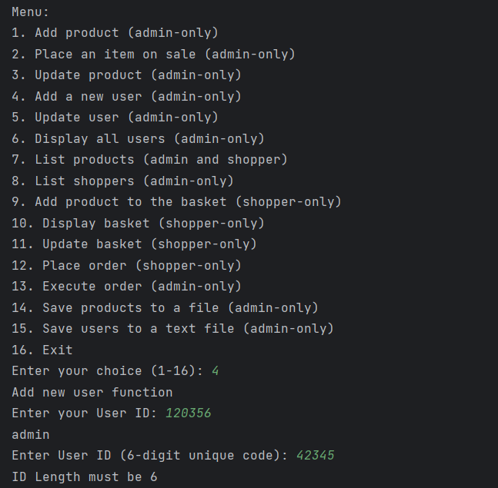

* Here User ID must be 6 digits

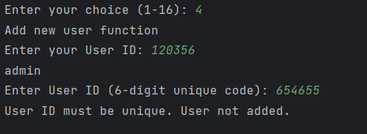

* Here ID must be unique.

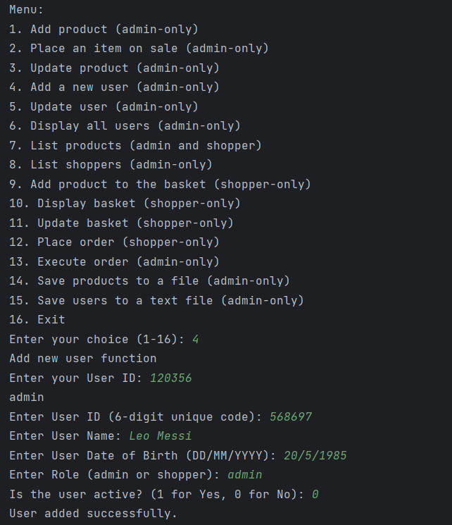

* Here I added the new user as admin.

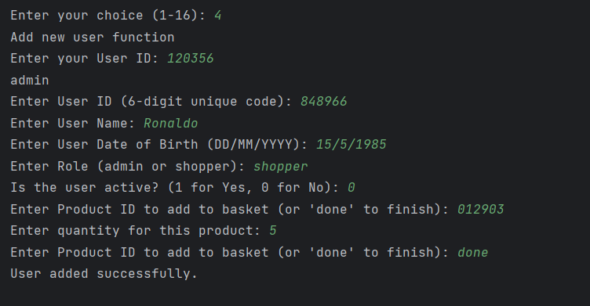

* Here I added the new user as shopper.

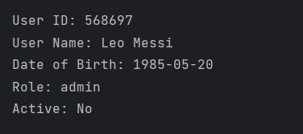

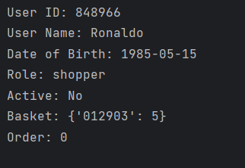

* From the users list in (option 6) I make sure the they have been added **successfully**.

## Update user (admin-only)

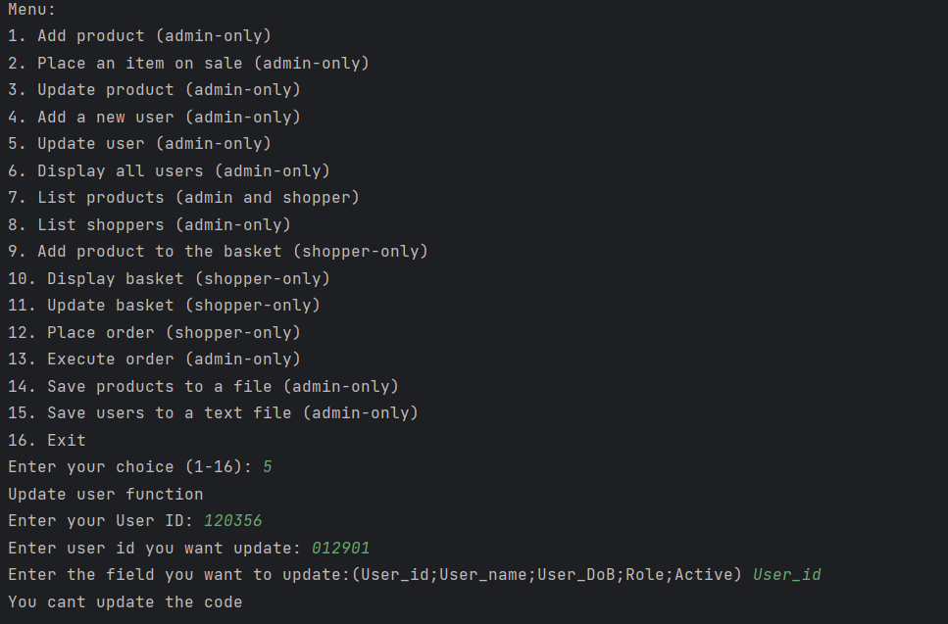

* Here it prevents you from changing the ID.

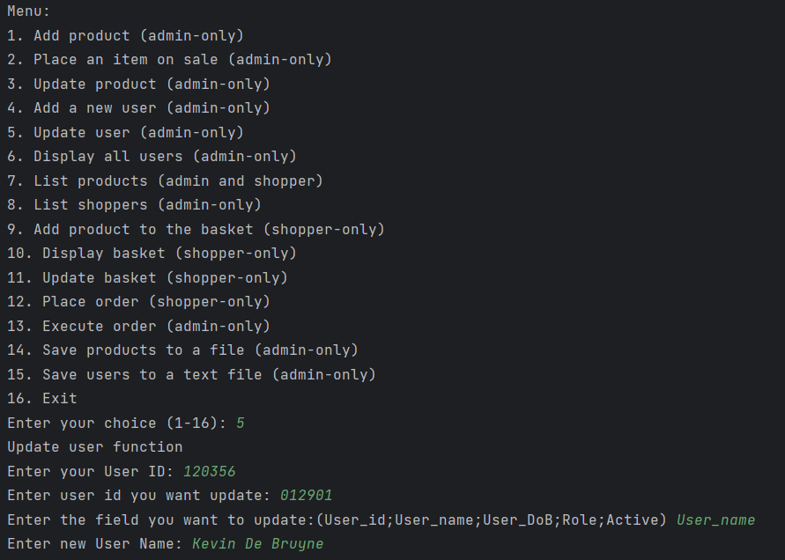

* Here I changed the name of the user of ID 012901

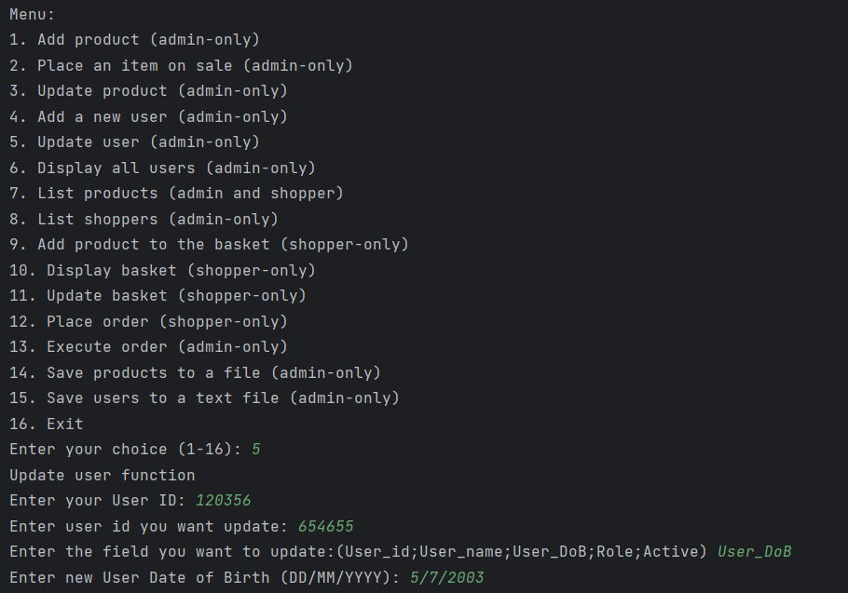

* Here I changed the date of birth of the user of ID 654655.

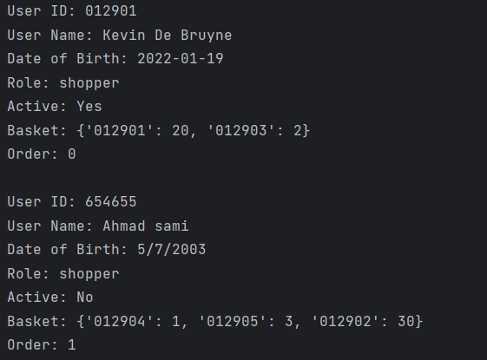

* From the users list in (option 6) I make sure the they have been updated **successfully**.
* Note: all other fields can be updated also.

## Display all users (admin-only)

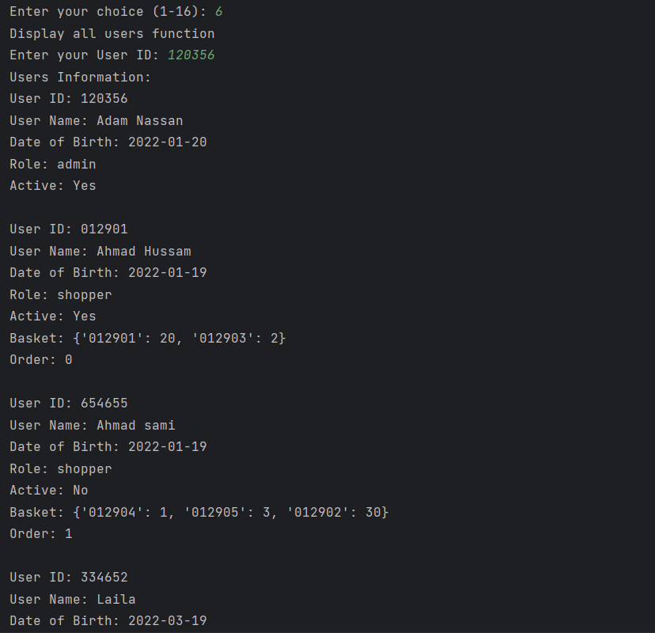

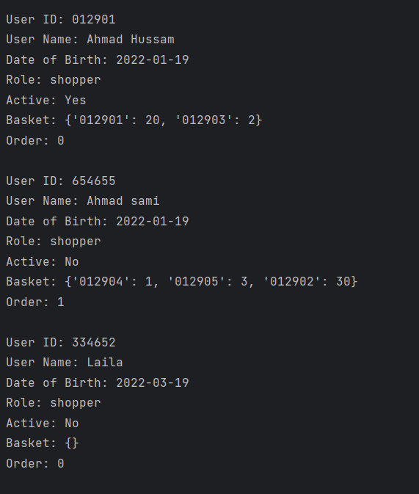

* As you see all the users show.
* Back to the note in the beginning that’s why added users from previous part are not here.

## List products (admin and shopper)

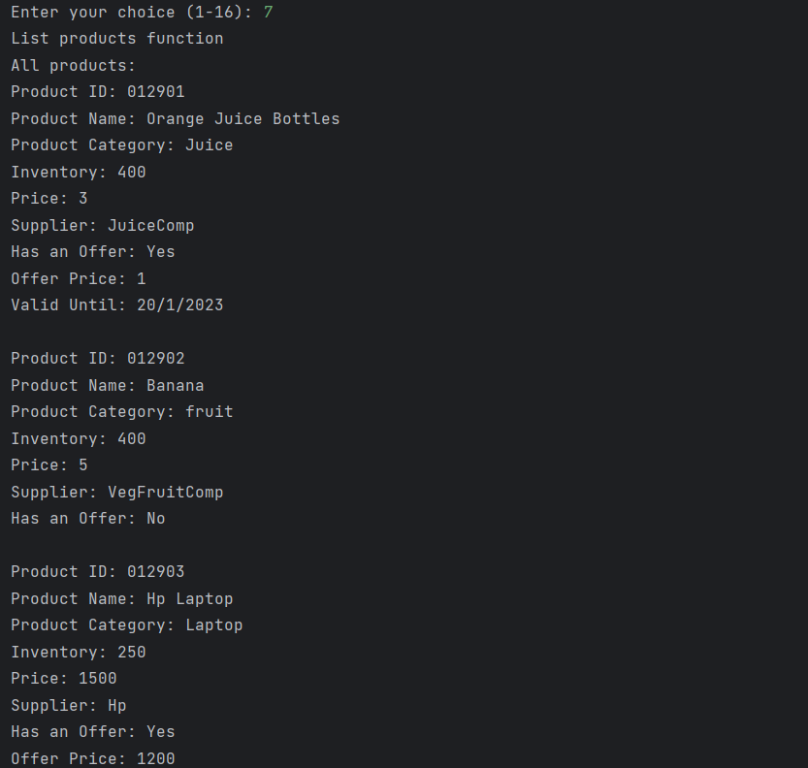

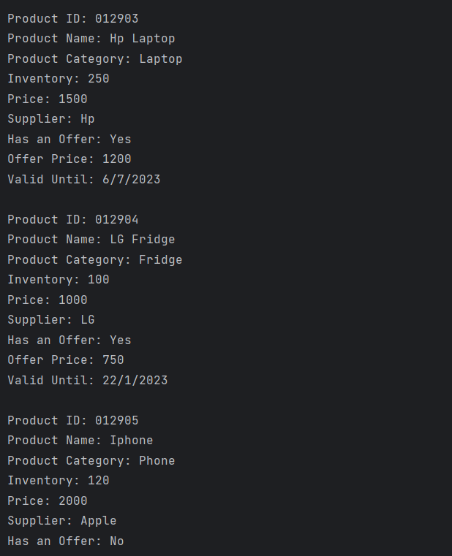

* Here you can see a list of all products.

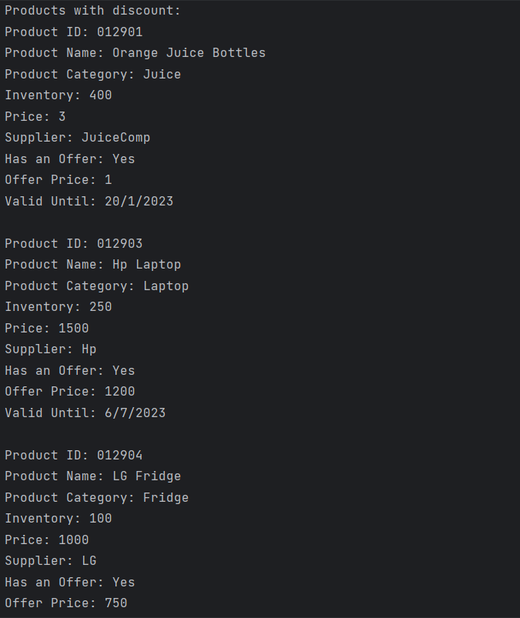

* Here list of all products that have discounts.

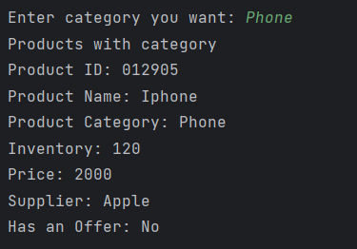

* Here List of all products under phone category.

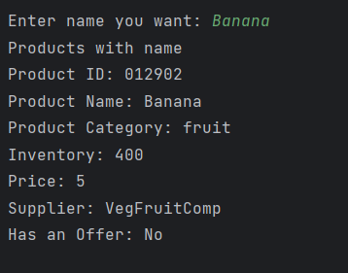

* Here details of product under name banana.

## List shoppers (admin)

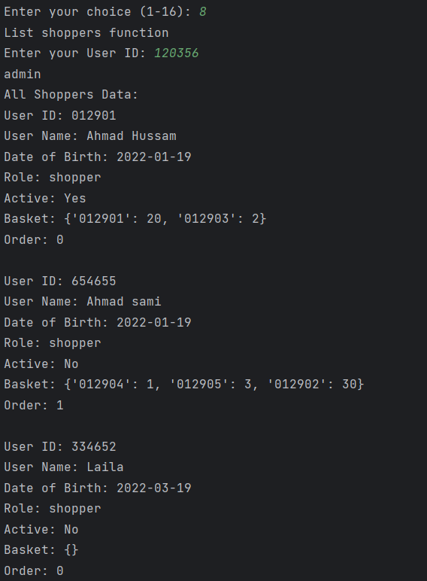

* Here a list of all shoppers data.

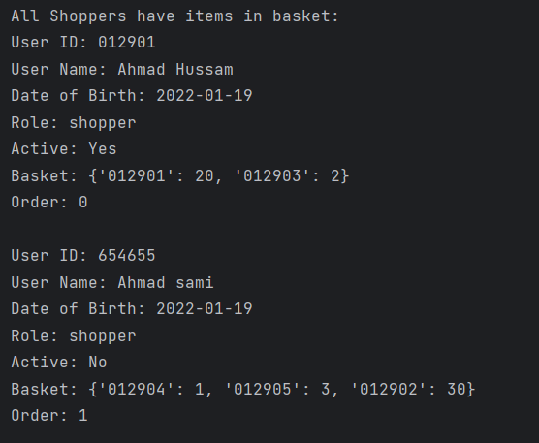

* Here a list of all shoppers that have non empty basket data.

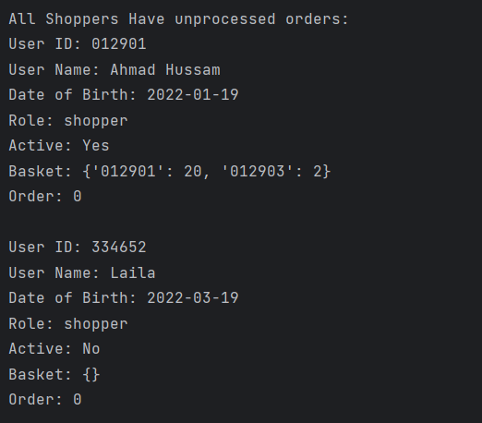

* Here a list of all shoppers that have unprocessed orders data.

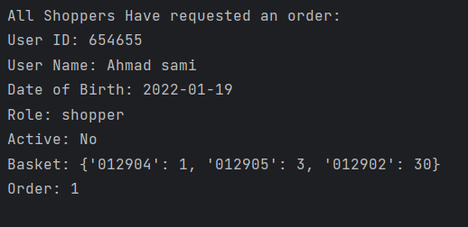

* Here a list of all shoppers that have requested orders data.

## Add product to the basket (shopper-only)

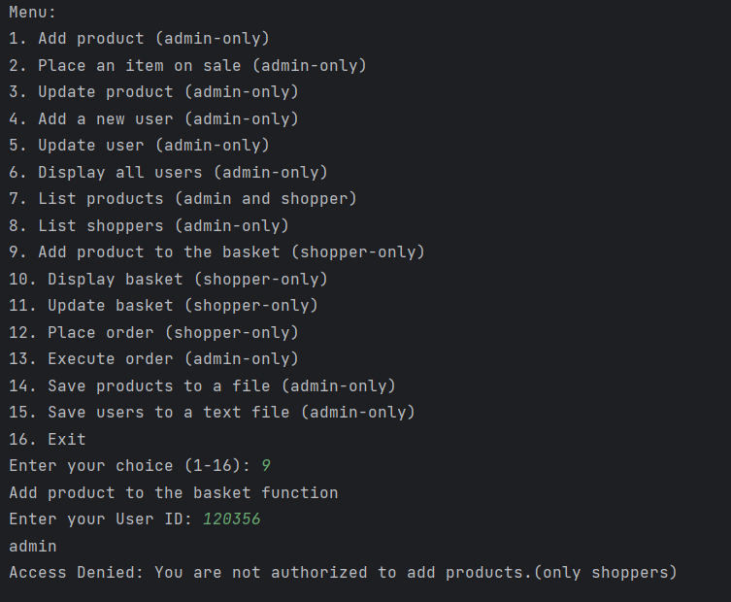

* Deny message when enter admin ID only shopper can enter this option.

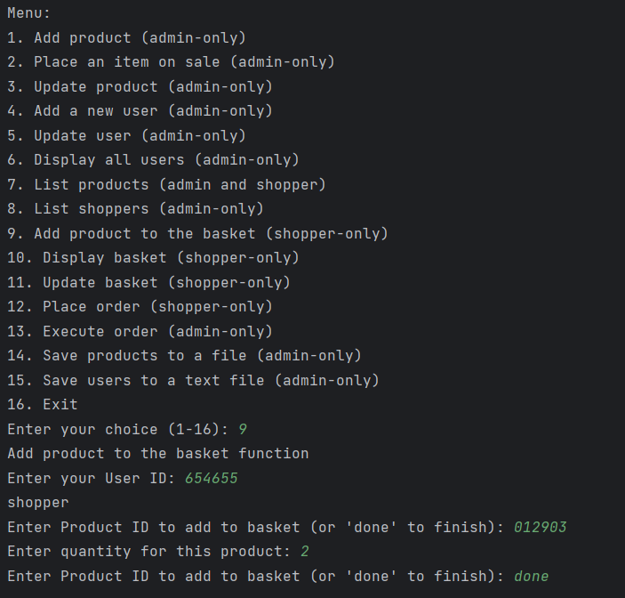

* Here we added product 012903 with quantity 2 to shopper 654655.

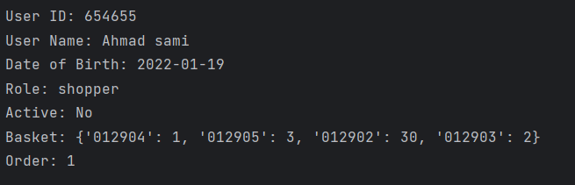

* Here from shopper list (in option 8) we make sure it has been added **successfully**.

## Display basket (shopper-only)

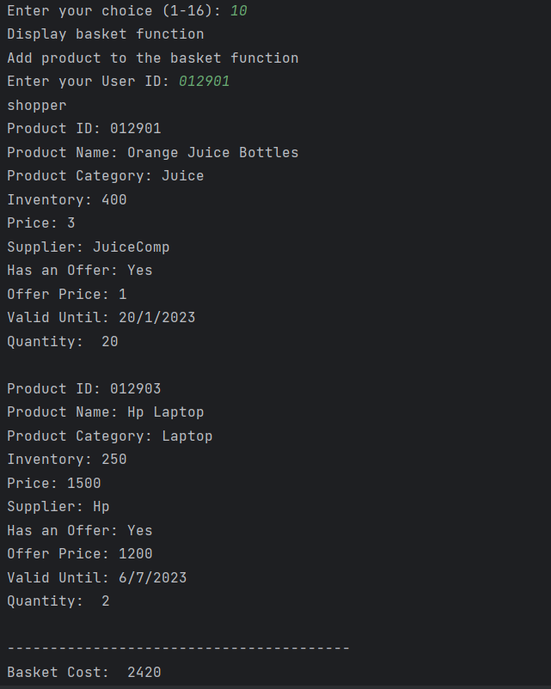

* Here I displayed basket of shopper 012901 and calculated the price **successfully**.

## Update basket (shopper-only)

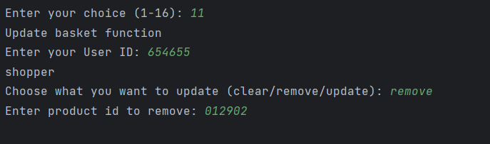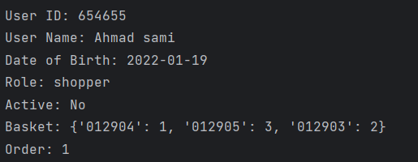

* Here we removed the product 012902 from user 654655 basket **successfully**.

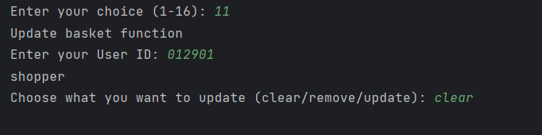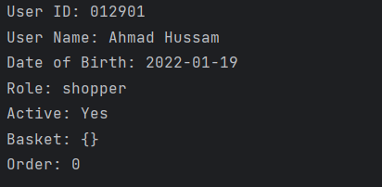

* Here we cleared the basket from user 012901 **successfully**.

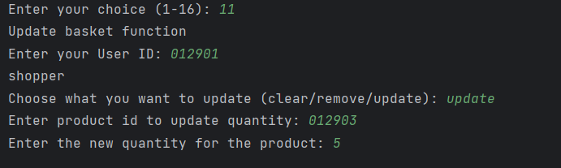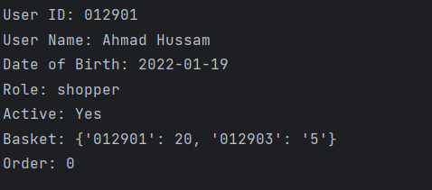

* Here we updated the quantity of product 012903 in user 012901 basket to 5 **successfully**.

## Place order (shopper-only)

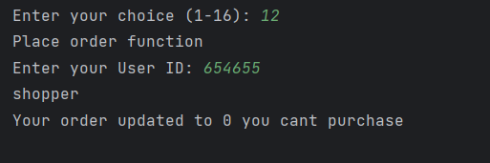

* Here I prevented user 654655 from order.

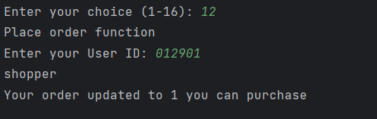

* Here I placed user 012901 in order.

## Execute order (admin-only)

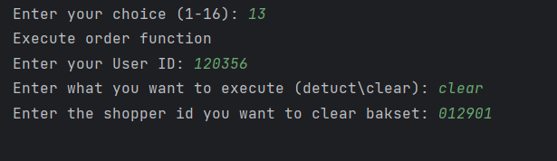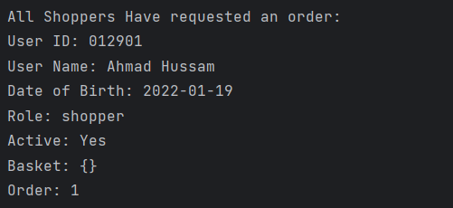

* Here I cleared user 012901 basket successfully as an admin.

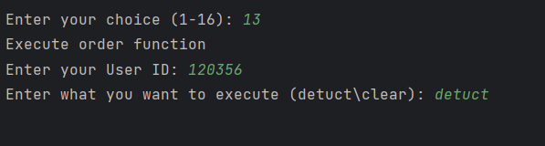

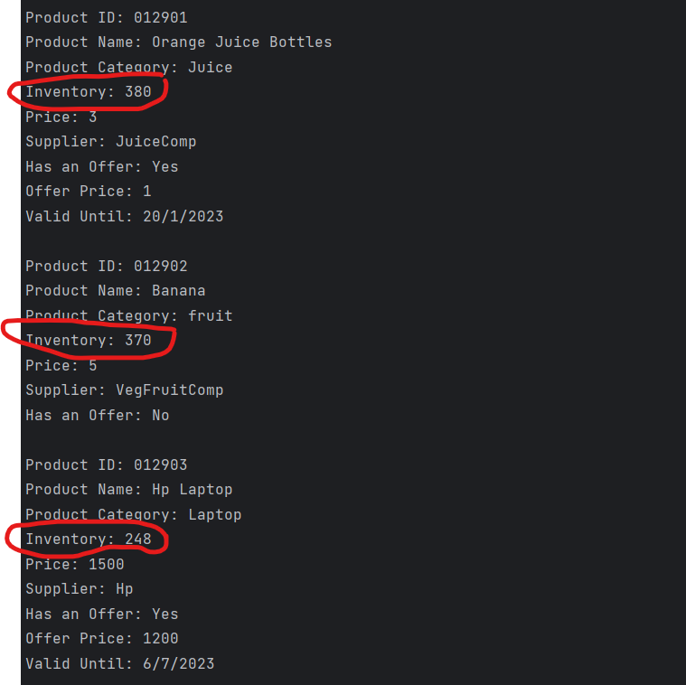

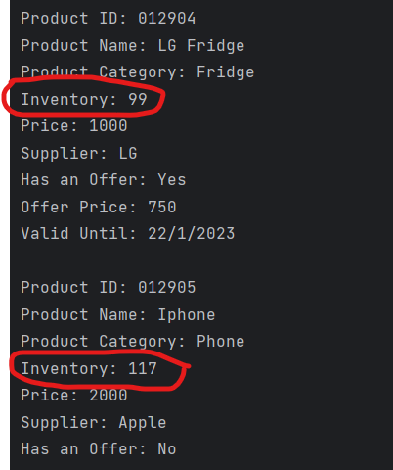

* Here I deducted the selected items from the product's inventory depending on the shoppers basket successfully.

## Save products to a file (admin-only)

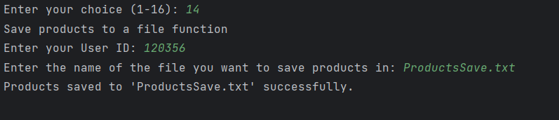

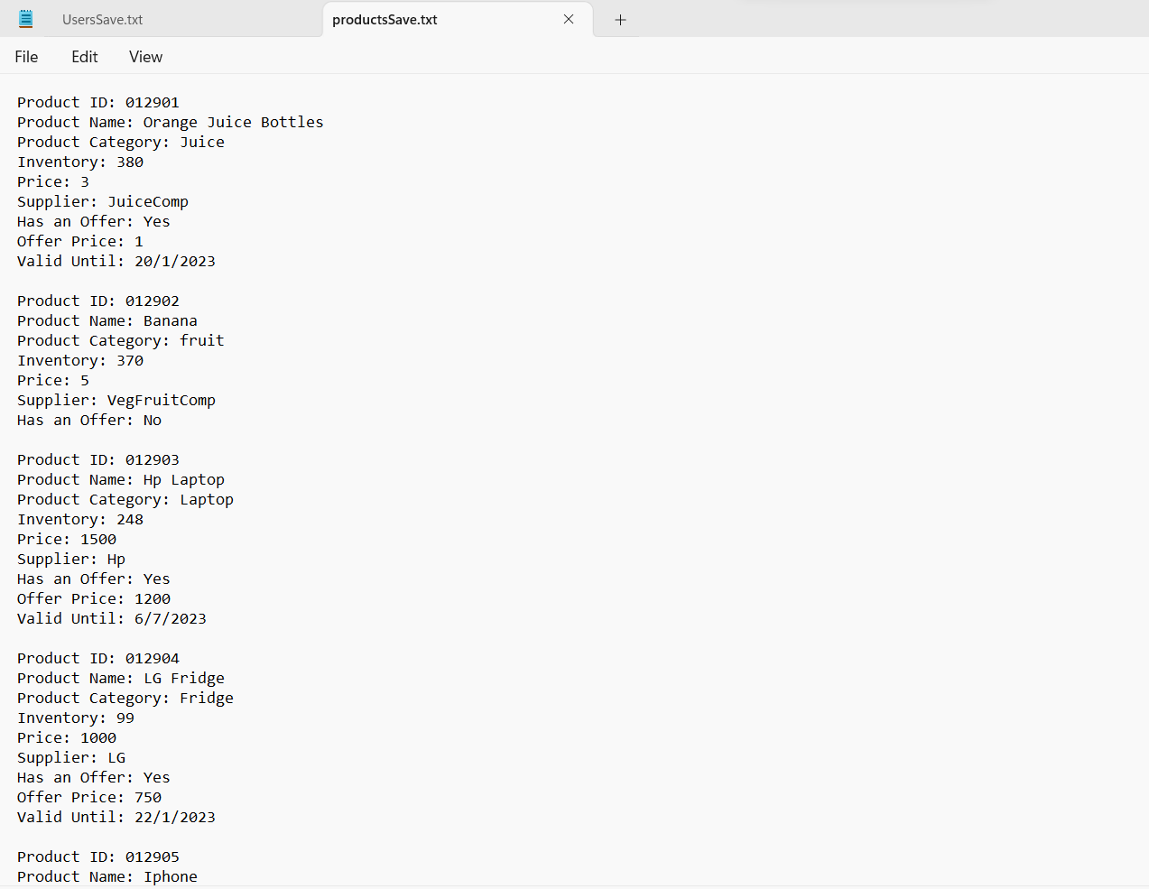

* All Products after all the edits saved to the file that we named successfully.

## Save users to a text file (admin-only)

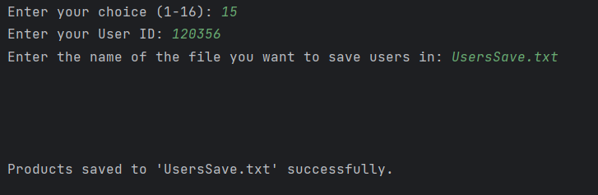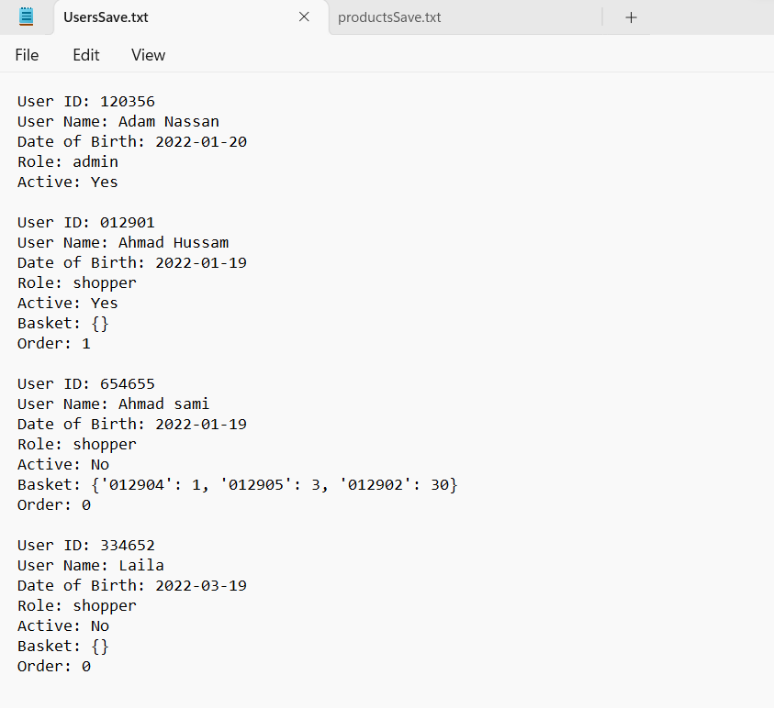

* All Users after all the edits save to the file that we named successfully.

## Exit (admin and shopper)

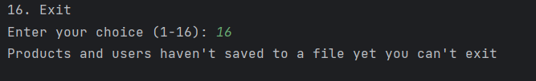

* When trying to exit before saving users and products to a file.

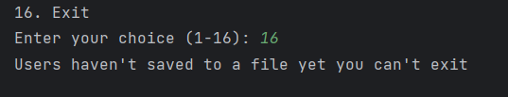

* When trying to exit before saving users to a file.

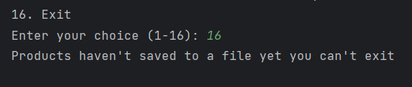

* When trying to exit before saving products to a file.

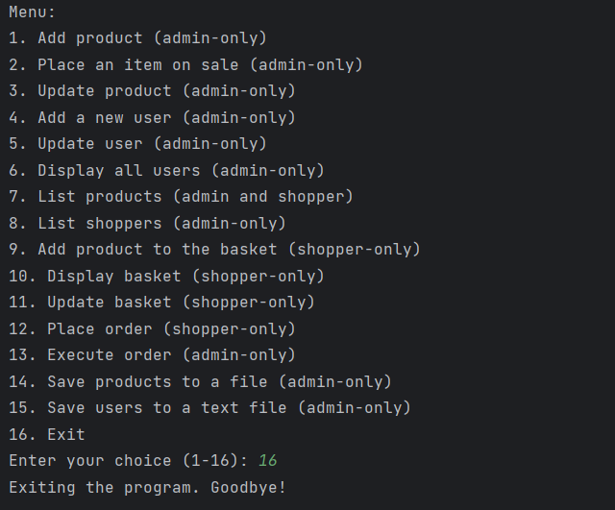

* Here we exited and finished the program.