



**Database Management System – Phase 3**

**Instructor: Dr.Majed Ayyad**

**Section: 6**



**grand pharm pharmacy**

**Adam Nassan – 1202076**

# Queries:-

## Medicine Queries

* Retrieve a list of all medicines in the inventory.
* Get details about a specific medicine, including supplier information.
* Get a specific medicine by its name,id or manufacture
* Get Expired Date Medicines

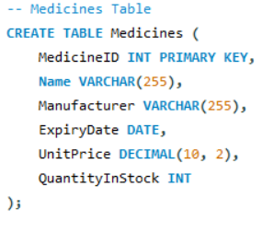

## Supplier Queries

* List all suppliers along with their contact information.
* Find suppliers who provide a specific medicine.

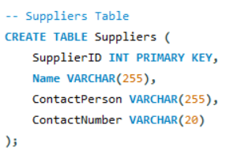

## Customer Queries:

* Retrieve a list of all customers.
* Get details about a specific customer, including prescription history.
* Get A Customer by its name or id

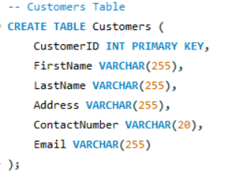

## Prescription Queries:

* List all prescriptions, including the prescribing doctor and issue date.
* Retrieve details of a specific prescription, including prescribed medicines.

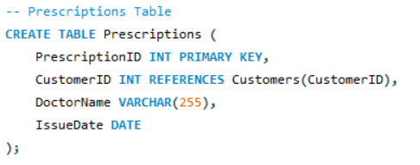

## Sales Queries:

* Get a list of all sales transactions, including the total amount.
* Find sales made by a specific customer
* List all the sold medicine in a specific sale

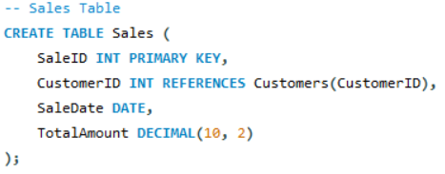

## Inventory Queries:

* Retrieve purchase history for a particular medicine.

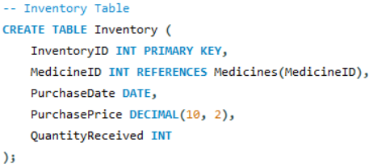

# Relationships Queries:

## SuppliedMedicines Relationship:

* Get a list of all medicines supplied, including details about the supplier and quantity supplied.
* Identify medicines supplied by a particular supplier, including details like supply date and quantity.

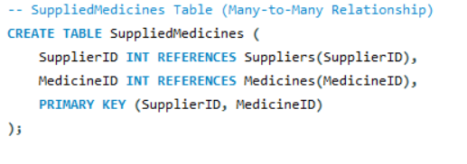

## PrescribedMedicines Relationship:

* Obtain a list of all medicines prescribed in prescriptions, including dosage information.
* Retrieve details about medicines prescribed in a specific prescription, including dosage information.

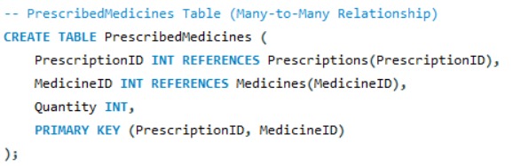

## SoldMedicines Relationship:

* Get a list of all medicines sold, including quantity sold and unit price.
* Identify medicines sold in a specific sale, including quantity and total price.

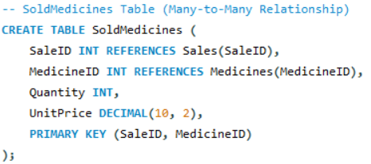

Creation of the tables done in order to insert appropriate information and data into them using SQL as shown in the provided files.