**Title Page – Chatbot Resume**

Team Members: Adam Nielsen

Description of project:

A “chatbot” web application that will be able to answer simple questions about me and about my resume. It will be hosted on my CV site https://adamnielsen.dev which I will be working on alongside this project.

**Section 1:**

Introduction (A paragraph on your reasons for this project. WHY this idea?):

I would like to impress potential future employers in a fun and professional way that shows where some of my interests are. I remember my first time encountering a chatbot online and immediately being curious to find out how it worked. Chatbot’s seem like an extremely useful technology that will continue to be more relevant, and I would like to get a little experience developing one.

Purpose (A paragraph on WHAT your project/app will accomplish):

A chatbot is a program that can converse with users through a text interface. This chatbot will be trained to answer questions regarding information on my CV page. There are many companies that offer software as a service to do similar tasks, but I will have the opportunity to customize my solution in a more personal way. Additionally, I would like to implement a way to see where the chatbot struggled and be able to update or retrain it to be better in that area.

Scope (A paragraph on what your project will do and what it will not):

This project will be for my personal use only. It will be able to answer simple questions about me, my job relevant experience, and some basic information about me. I have decided for the scope of this project to build an app that runs locally and keep the integration into my web cv page as a stretch goal.

Technologies Used:

Python – with Pandas, TensorFlow, NLTK, and streamlit libraries

(For Stretch Goals)

Streamlit

HTML, CSS, JavaScript

Telegram?

**Section 2a:**

Must Have Requirements: “shall”

The app shall accept user input and return a relevant response about my life. (Relevancy is subjective and will be based on user trials, >80% of responses must be considered relevant to user.)

The app shall display all user input and responses to user input to the user.

**Section 2b:**

Stretch Requirements:

The app will be accessible online.

The app will store all user input and responses for me to see.

The app will be able to accept an updated corpus of text to retrain itself on automatically.

The app will suggest questions that the user can input.

The app will detect if user input is relevant to me and respond with “I don’t know the answer to that question” if user input is outside of the scope of the project.

**Section 2c:**   
Weekly schedule:

Week 7: Create corpus and train TensorFlow model

Week 8: Application can create responses to input

Week 9: Test Application and fine tune TensorFlow model

Week 10: GUI, testing

Week 11: Stretch goals, testing

Week 12: Document Project & Stretch Goals

Week 13: Present Project

**Section 3:** Design Overview of the Product.

Workflow:

The user has a text input box, they enter text and submit by button or the enter key. The input text is tokenized character by character and converted to a tensor. A TensorFlow model uses the tensor to generate a predicted appropriate response. The user’s input and the response is displayed to the user and the user can continue to input text.

Resources:

NLTK (<https://www.nltk.org/>) includes functions to convert text to tokens and vice versa.

TensorFlow (<https://www.tensorflow.org/>) has machine learning algorithms and will be used to train the model and generate responses to user input.

Streamlit (<https://streamlit.io/>) Turns python scripts into web apps, I’m hoping to use this to complete my stretch goals

Data at Rest:

Storing user data is a stretch goal for me, I have not decided how I will accomplish this yet.

Data on the Wire:

Again this is a stretch goal for me.

Data State:

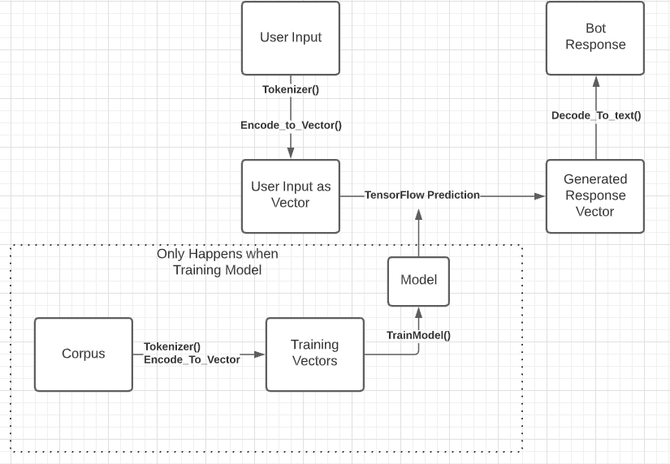

HMI/HCI/GUI:

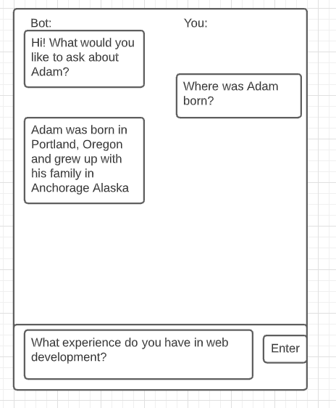

Pictures/ Diagrams:

**Section 4:** Verification:

**Demo:** The application will have a simple UI that will be usable. I will also prepare a video showing some questions and responses.

**Testing:** I have several family members and friends who are available to help me test the product. I will record their inputs and the responses given to ensure valid responses are being generated.

**Sources/Citation/Resources** Links: