Instructions for running the full release 1 code for Tetris and Pong:

* Here, we have decided to use an external emulator to test our games while our group’s emulator is currently being bug-fixed/polished.

Step 1. Open the “External Emulator” file.

Step 2. Launch the “CHIP-8.exe” file as seen below.

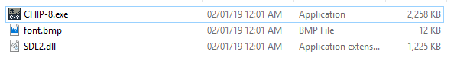

Step 3. Hit “F3” to open the file directory and navigate to /CHIP-8-Emulator/Games

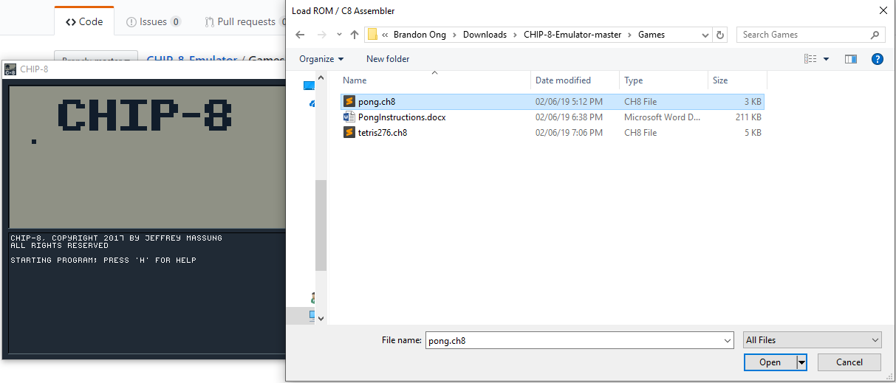

Step 4. Open either pong.ch8 or tetris276.ch8

Side note: If the game is loads up while paused, hit space to start it again.