Instructions for running the full version of the games on our team’s emulator.

Step 1. Launch the emulator homepage via the index.html file.

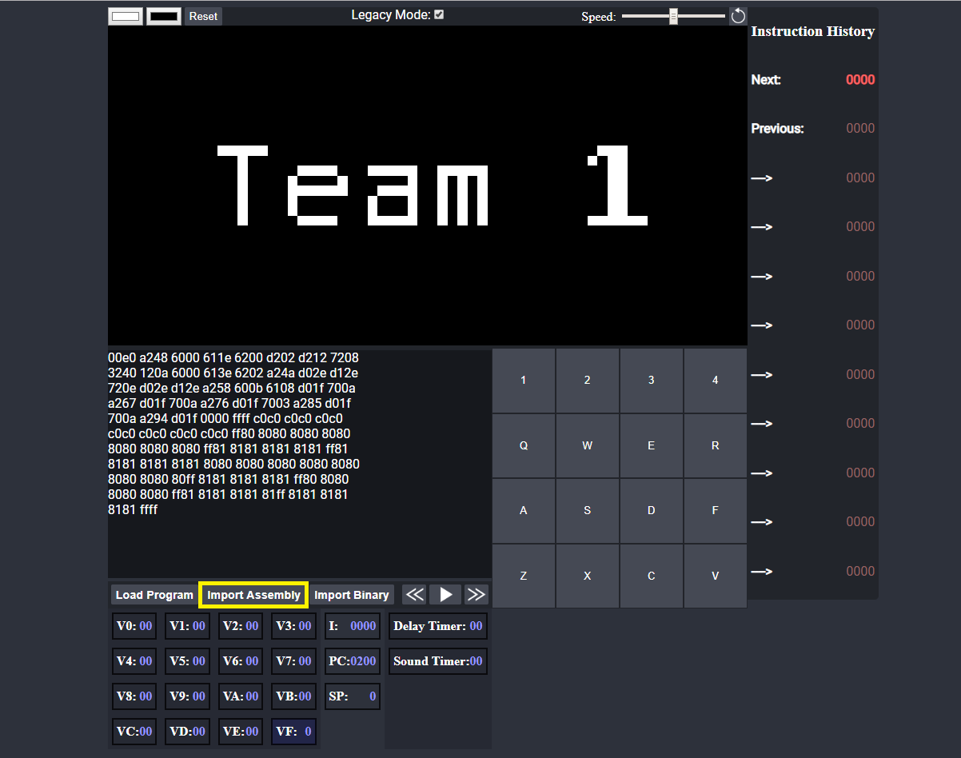

Step 2. Press the “Import Assembly” button.

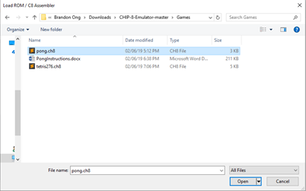Step 3. Select the game you want to play.

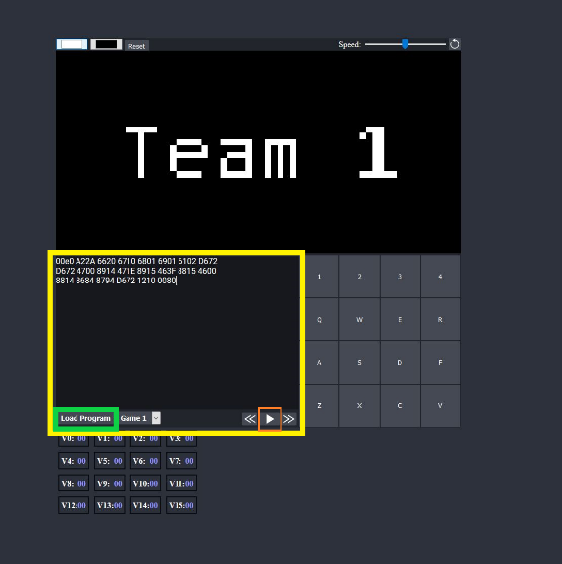Step 4. Press the “Load Program” button (as shown in the orange box within the yellow box in the beside image. Then press play.