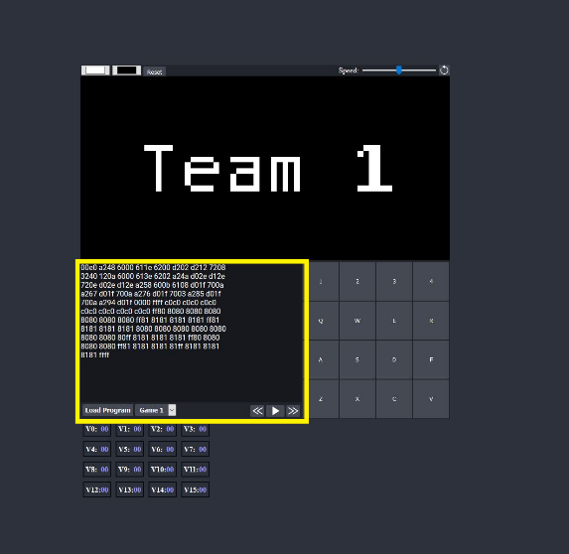Instructions for running Release 1 Pong:

Step 1. Launch the emulator homepage via the index.html file.

Step 2. Delete the default opcodes from the text field, shown in the yellow box of the image.

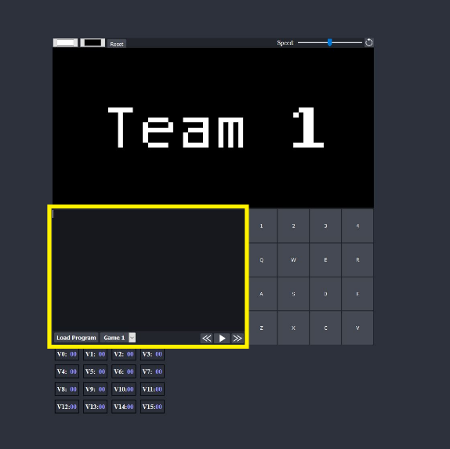Step 3. In the space where the default opcodes were deleted, copy and paste the following opcodes in:

00e0 A22A 6620 6710 6801 6901 6102 D672

D672 4700 8914 471E 8915 463F 8815 4600

8814 8684 8794 D672 1210 0080

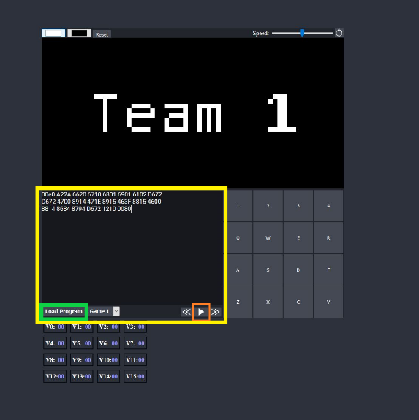Step 4. Press the “Load Program” button (as shown in the green box within the yellow box in the beside image).

Step 5. Press the “Play” button (as shown in the orange box within the yellow box in the beside image.