**Student Name: Adam Noone**

**Student Number: C16448216**

When I initially tried to compile the program labTest.c I got these 3 warnings

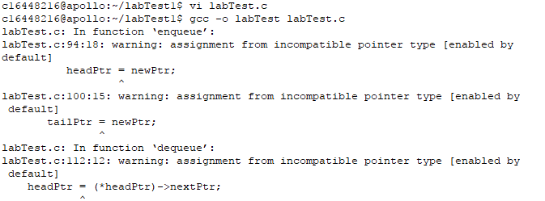

2.

Warning 1

Code changed

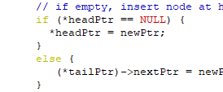

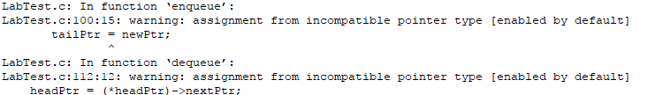

Warning 2

Code changed



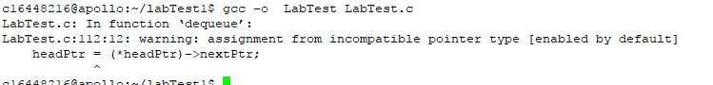

Warning 3

Code changed

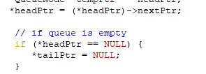



3

My program worked after I fixed warning 1 because ,The new pointer being inserted into the list was not pointing to the start of the list .

My program worked after I fixed warning 2 because ,head pointer is now pointing to the next pointer.

My program worked after I fixed warning 3, because tail pointer now points to NULL