# Installation

To install this application

1. Import the code into eclipse.
2. Add the java mail jar and Apache-commons jar to the class.
3. You can add a jar in Eclipse by right-clicking on the Project → Build Path → Configure Build Path. Under Libraries tab, click Add Jars or Add External JARs and give the Jar.

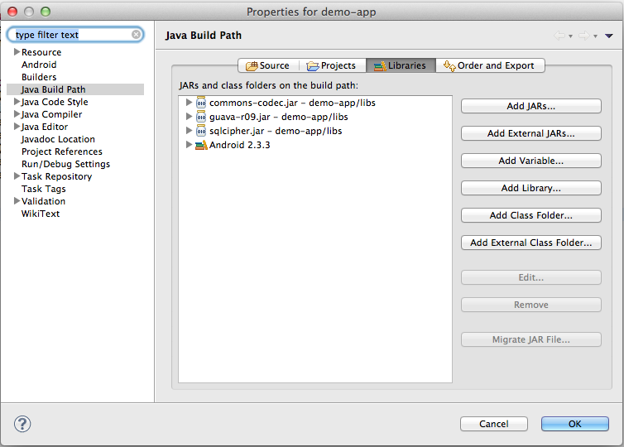

1. Install OpenCv 2.4.11 exe in folder.

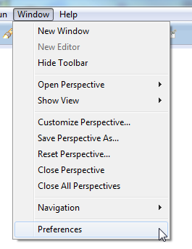

1. Navigate under *Java –> Build Path –> User Libraries* and click *New...*.

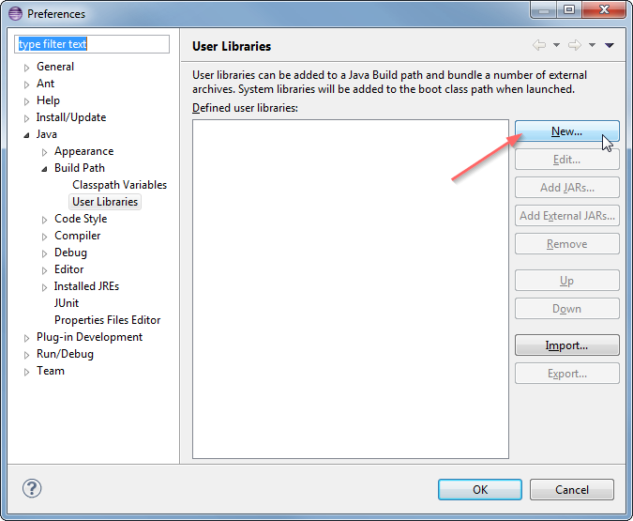

1. Enter a name, e.g. OpenCV-2.4.11, for your new library.

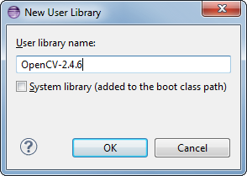

1. Now select your new user library and click *Add External JARs...*.

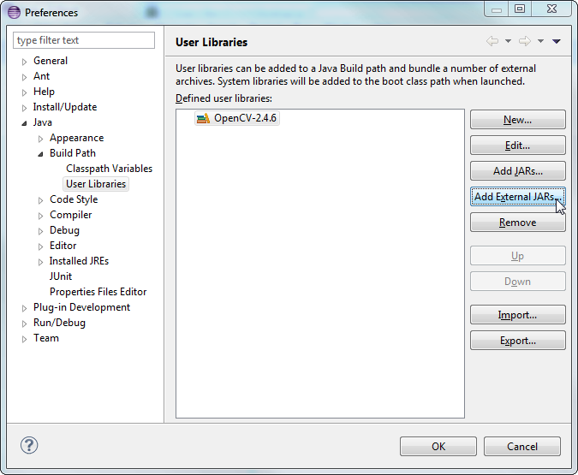

1. Browse through C:\OpenCV-2.4.11\build\java\ and select opencv-2411.jar. After adding the jar, extend the *opencv-2411.jar* and select *Native library location* and press *Edit...*.

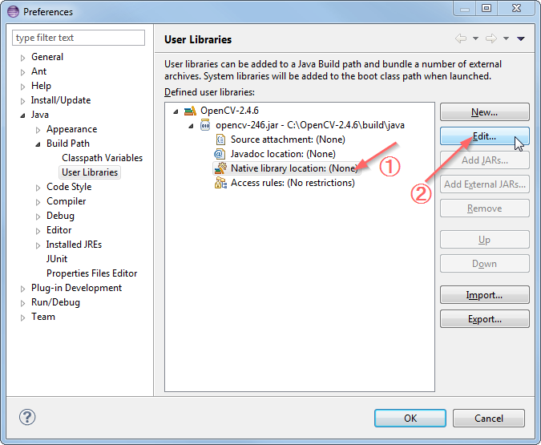

1. Select *External Folder...* and browse to select the folder C:\OpenCV-2.4.6\build\java\x64. If you have a 32-bit system you need to select the x86 folder instead of x64.

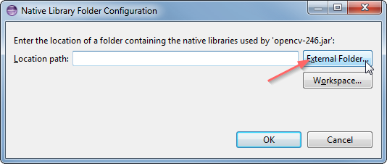

1. Your user library configuration should look like this:

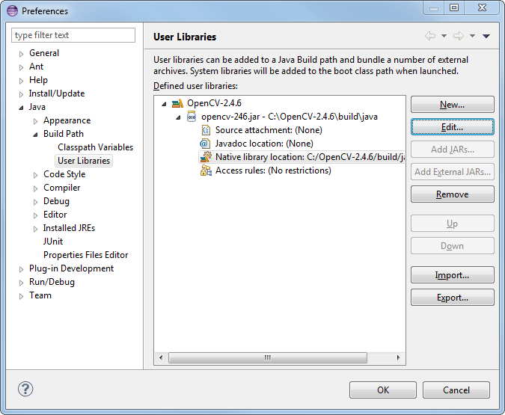

1. Setting the running configuration in eclipse.
2. Go to run in the tab at the top of eclipse 3rd from the left.
3. Go to running configurations.
4. Tab of environment variable.
5. Make sure variable is PATH
6. And navigate to the OpenCv folder where installed /build
7. Select x86 or x64
8. Select vc12 and navigate to bin
9. Copy the address and add to environment variable.
10. 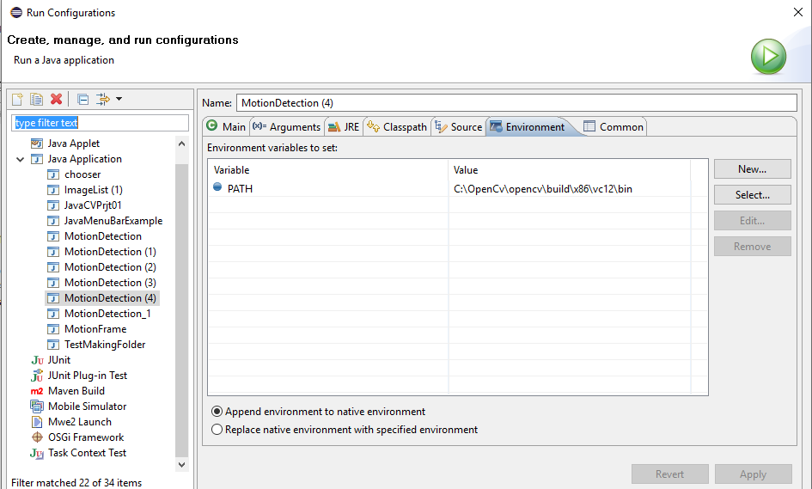Setting Environment variable in eclipse.
11. Click apply and run the application.