# Manual

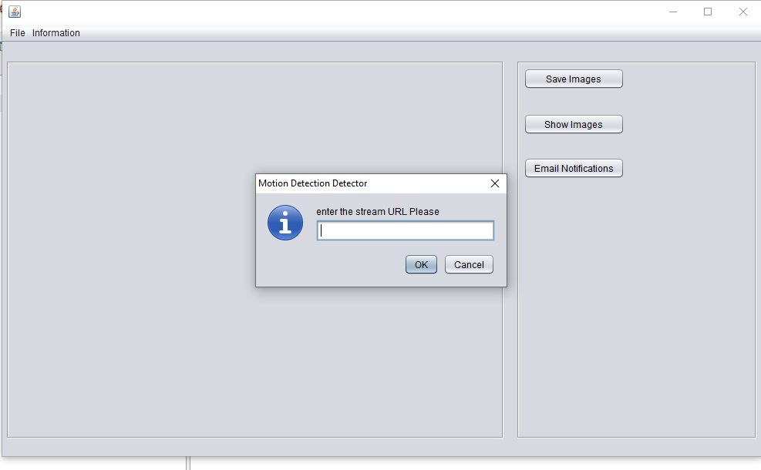On running the application this is the first screen you will see.

You will now need to enter an IP camera stream for the camera to work.

Here is a College Stream from an IP Camera: <http://c-cam.uchicago.edu/mjpg/video.mjpg>

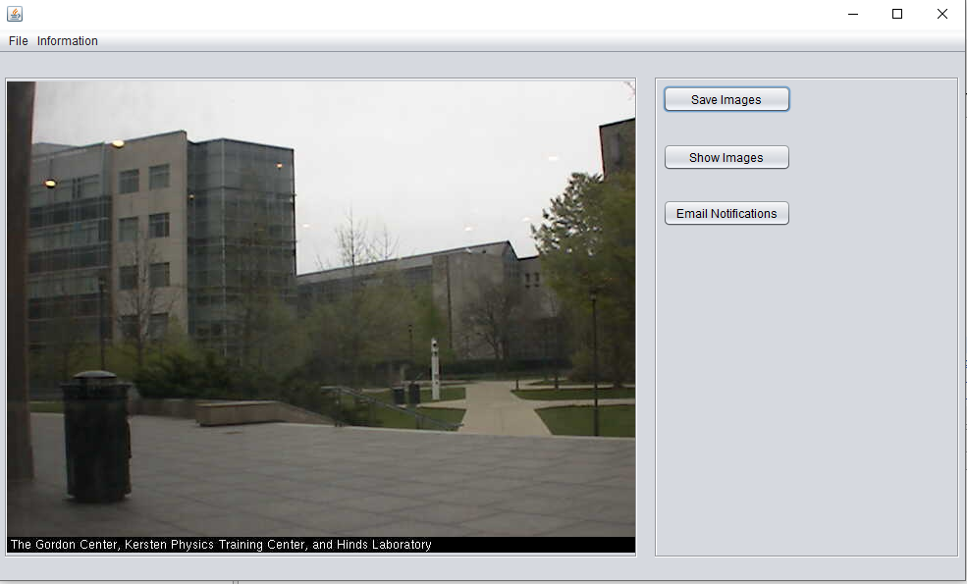This is the view of the stream when connected it takes depending on internet connection. 37 secs to connect.

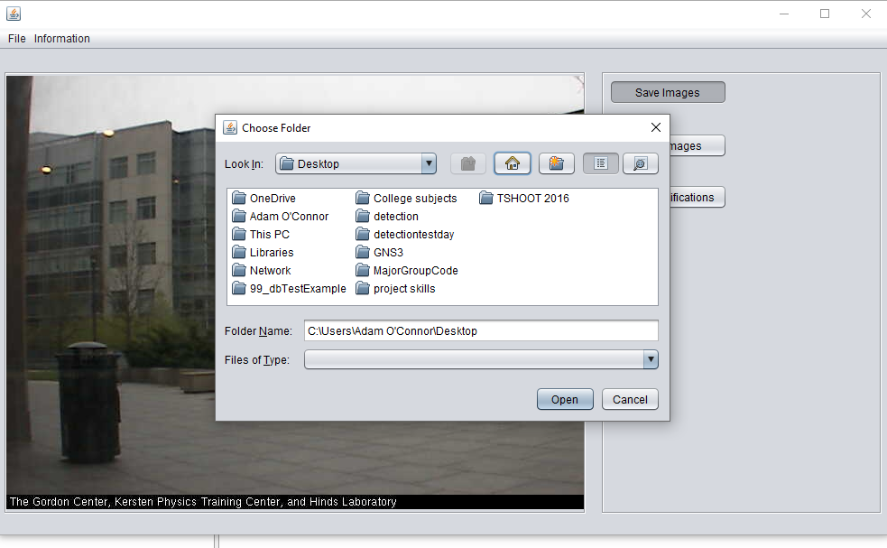Saving the images displays a select folder, you can make your own folder here and select it. This will then save all the images that have been detected in the area. Will then be saved with the date and timestamp when it was taken.

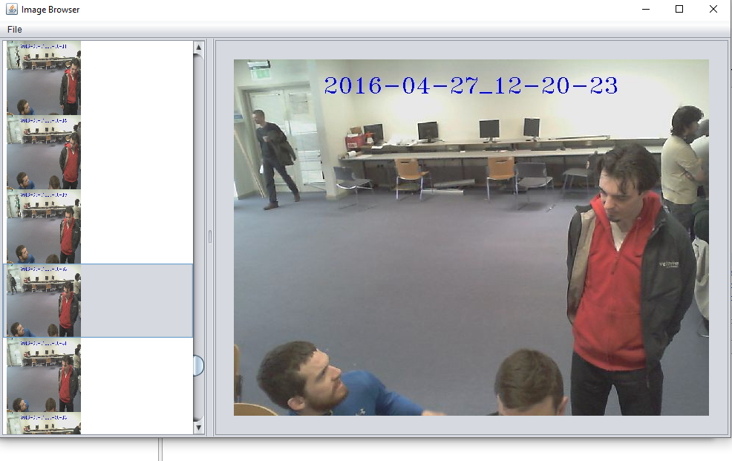On clicking the show images button the file tab will be on the top left corner. Select the folder that the images have been saved in and all images will then be displayed.

The image on the page last was on the code demonstration day we were testing the code even at the time and captured our project supervisor Dr Simon Mcloughlin while coming through the door of the demonstrations.

Date and time is the actual date and time of the system.

Email notifications can be turned on by clicking the button and entering in your valid email address.