First of all, the carbon subgraph is used. One single fictional atom, namely “HA” is hypothesized to be inside all species from carbon subgraph. For example, to $C_{3}H_{8}$, instead of having 3 carbon atoms, it is assumed that $C_{3}H_{8}$ has one single “HA”. The new species composition dictionary is like in Table 1,

Table . Hypothesized atom composition of species from carbon subgraph

|  |  |  |
| --- | --- | --- |
| Species name | Carbon | HA |
| $$C_{3}H_{8}$$ | 3 | 1 |
| $$npropyl$$ | 3 | 1 |
| $$QOOH_1$$ | 3 | 1 |
| $$well_1$$ | 3 | 1 |
| $$prod_1$$ | 3 | 1 |
| $$frag_1$$ | 3 | 1 |
| $$CO$$ | 1 | 1 |
| $$⋮$$ | $$⋮$$ | $$⋮$$ |

The reaction network is constructed in the conventional way, that treating species as vertices, all possible reactions as edges. Since the tagged atom now becomes a hypothesized “HA”, when it comes to generate pathway and evaluate pathway probability, “HA” is presumably be followed. For example to the top 3 most probably pathways from time 0 to time 0.9 $τ$, ($τ is$ ignition delay time, has a value of 0.78s in n-propane combustion mechanism with $T_{0}=650$ K, $P_{0}$ =10 bar, $ϕ$ =1) as below,

$$npropyl,npropyloo,QOOH_1,well_1\overset{→}{-OH}prod_1\overset{→}{-OH}frag_1\overset{→}{-CH_{2}O}vinoxy\begin{matrix}+O_{2} \\ \overset{→}{-CH_{2}O,OH}\end{matrix}CO$$

$$npropyl,npropyloo,QOOH_1,well_1\overset{→}{-OH}prod_1\overset{→}{-OH}frag_1\overset{→}{-vinoxy}CH_{2}O\begin{matrix}+OH \\ \overset{→}{-H_{2}O}\end{matrix}HCO\begin{matrix}+O_{2} \\ \overset{→}{-HO_{2}}\end{matrix}CO$$

$$npropyl,npropyloo,QOOH_1,well_1\overset{→}{-HO_{2}}C_{3}H_{6}$$

The pathway probabilities and number of net OH being produced along each pathway is summarized as in Table 2 below,

Table . Pathway probabilities and net number of OH being produced along top 3 most probable pathways

|  |  |  |
| --- | --- | --- |
|  | Pathway probability | Net OH produced |
| Path 1 | 0.20 | 3 |
| Path 2 | 0.14 | 1 |
| Path 3 | 0.13 | 0 |

Then the Merchant f value, using top 3 pathway, is simply calculated as

$$f=p_{1}×3+p_{2}×1+p_{3}×0=0.20×3+0.14×1+0.13×0=0.74$$

Instead of using top 3 pathways, larger number of pathways can be used. I actually top 100 most probable pathways to calculate the Merchant f value. Beyond time 0.9 $τ$, f value at more time points was calculated.

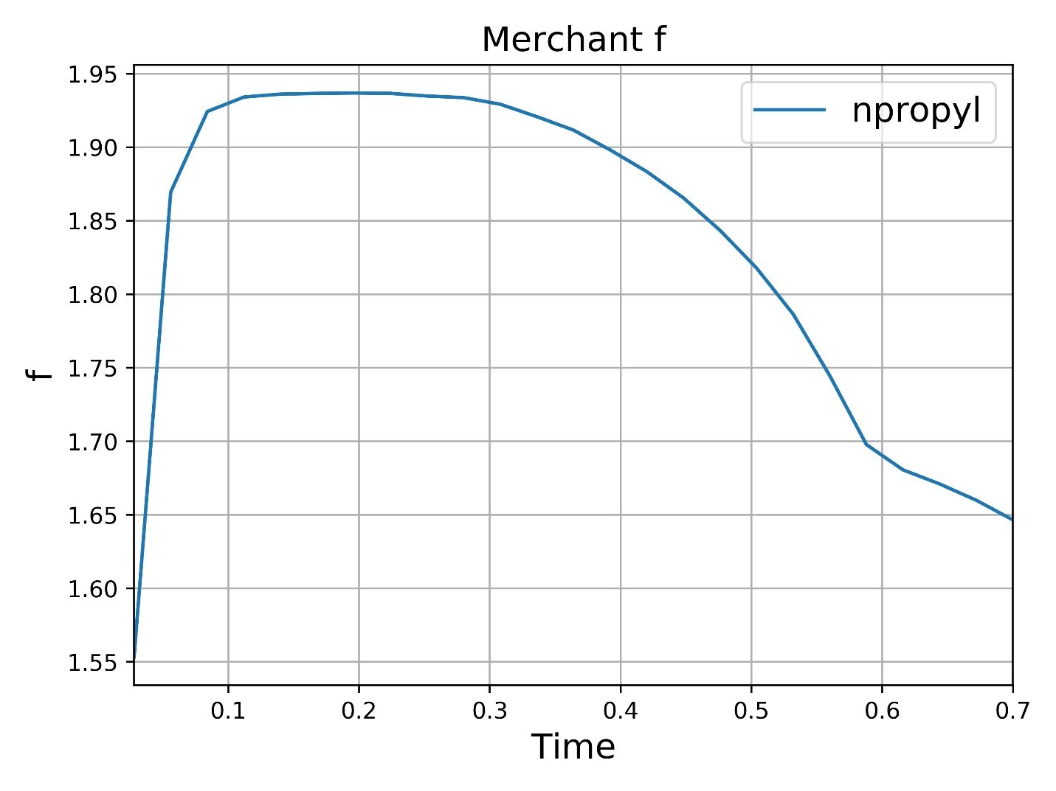

Figure . Merchant f value of n-propyl subgraph

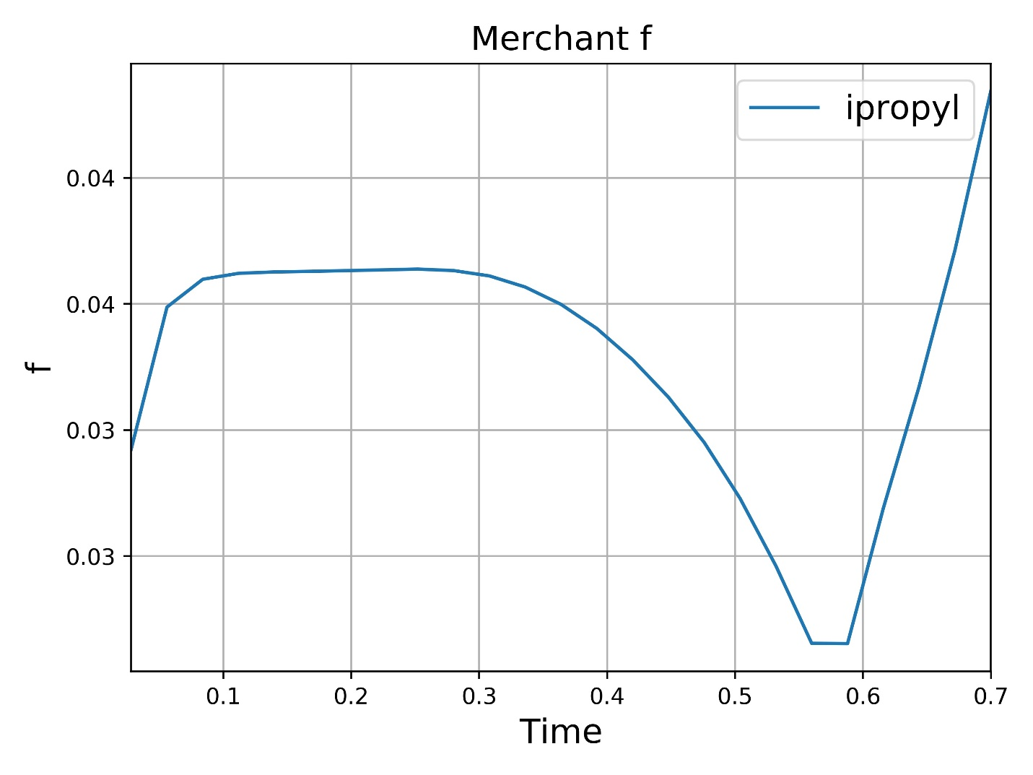

Figure . Merchant f value of i-propyl subgraph

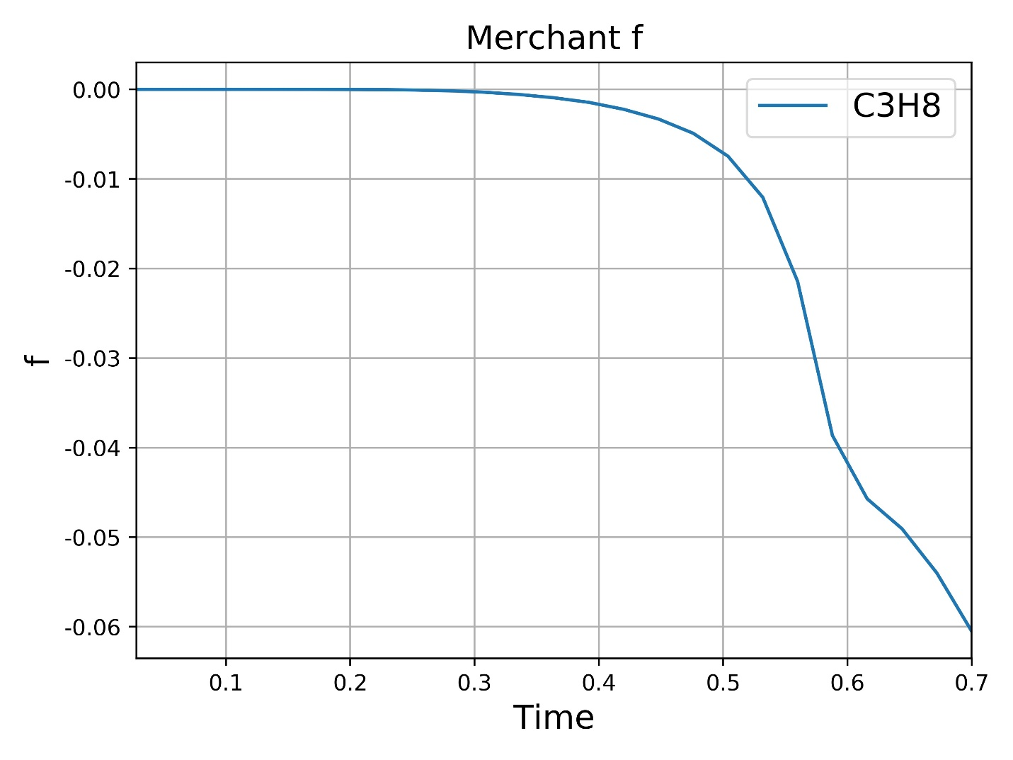

Figure . Merchant f value of n-propane subgraph