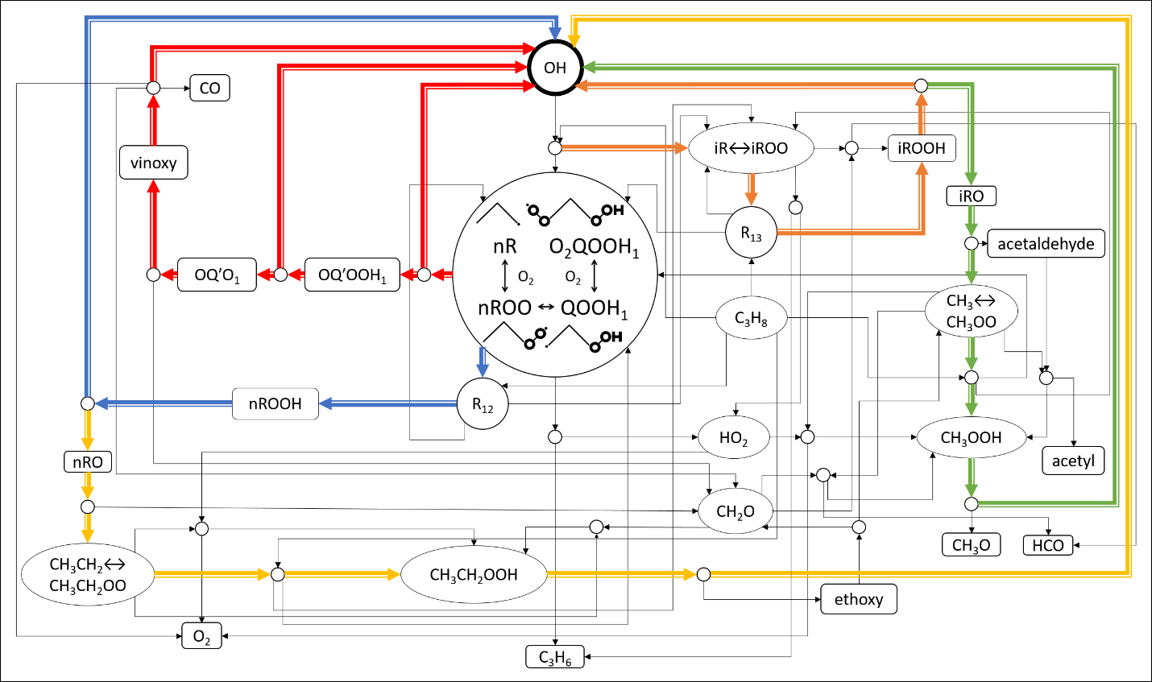

|  |  |
| --- | --- |
|  | Primary Cycle |
| 1 | ***OH***+RH Z4(nR, O2QOOH1)OQ′OOH1+***OH*** |
| 2 | ***OH***+RH Z4(nR, O2QOOH1)OQ′OOH1OQ′O1+***OH*** |
| 3 | ***OH***+RH Z4(nR, O2QOOH1)OQ′OOH1OQ′O1vinoxyCO+***OH*** |
|  | nR Spur Cycle 1 |
| 4 | ***OH***+RH Z4(nR, nROO) $\underset{→}{R12, R21,R37,R75}$ nROOHnRO+***OH*** |
|  | nR Spur Cycle 2 |
| 5 | ***OH***+RH Z4(nR, nROO)nROOHnRO Z2(C2H5, CH3CH2OO)CH3CH2OOHethoxy+***OH*** |
|  | nR Spur Cycle 3 |
| 6 | ***OH***+RH Z4(nR, nROO)nROOHnRO Z2(C2H5, CH3CH2OO)CH3CH2OOHethoxy Z1(CH3, CH3OO)CH3OOH CH3O+***OH*** |
|  | iR Spur Cycle 1 |
| 7 | ***OH***+RH Z5(iR, iROO) $\underset{→}{R13,R14,R35,R74}$ iROOHiRO+***OH*** |
|  | iR Spur Cycle 2 |
| 8 | ***OH***+RH Z5(iR, iROO) iROOHiRO Z1(CH3, CH3OO) CH3OOHCH3O+***OH*** |

